
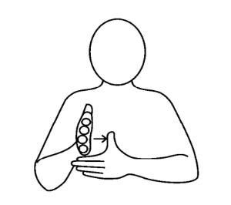
FIRST

Who we are:

The aim of FIRST is to provide information, workshops and training around sleep (including anxiety), and distressed & dysregulated behaviour. The team comprises of Sleep Practitioners, Therapeutic Thinking and Foundations for Attachment Practitioners and a Family Support Worker. The team can offer parents / carers who reside in the Wokingham Borough and have a child aged 3-18 with a disability, autism or are on the pathway for an autism assessment, an opportunity to explore different ways of thinking about sleep, anxiety and distressed and dysregulated behaviour. We can provide strategies and resources to support your child. When capacity allows, we can also offer spaces on some of our workshops and courses to parents / carers whose child does not have a disability.
Coffee Morning
Top Tips for Healthy Sleep

Date: Thursday 5 March
Time: 9.00
Venue: Alfred Sutton Primary School


Come and join us for our top tips to support healthy sleep for children and young people but equally beneficial for adults!

Delivered by Helen Tracey & Simone Hall – trained by The Sleep Charity & Southampton University Hospital Sleep Disorder Service

For more information, contact us on: first@wokingham.gov.uk

