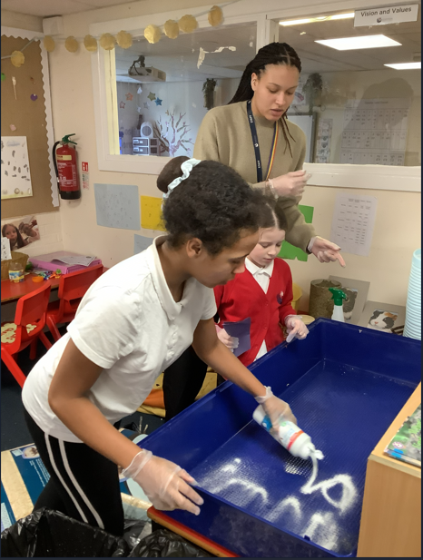
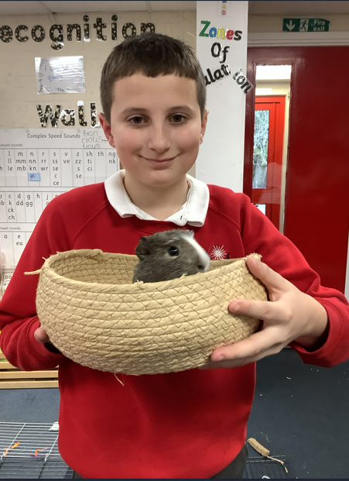
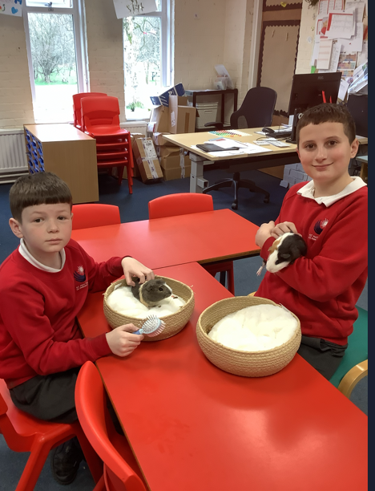
A huge thank you to Miss Storer and the children in Blossom for making sure of beautiful guinea pigs have a clean and well looked after home this weekend. We love how gentle and caring the children are with Brownie and Blossom, they always treat them with such kindness!

