🌱 Spring 2 Half Term – A Positive Start
We have made a wonderfully positive start to the second half of the Spring term, and it has been a real pleasure to see the children returning with such enthusiasm, energy and focus.

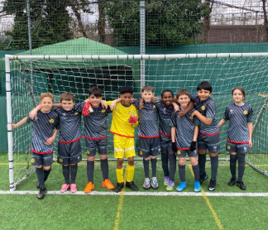
⚽ A Winning Start for Our Footballers
Earlier this week, our Year 5 and Year 6 footballers looked fantastic in their brand-new football kits and delivered an equally impressive performance, winning 8–1 against St Mary’s.
A huge thank you to our PTA for helping to fund the kit purchase, and well done to the children who were involved in designing it — it is a kit the whole school can be proud of.

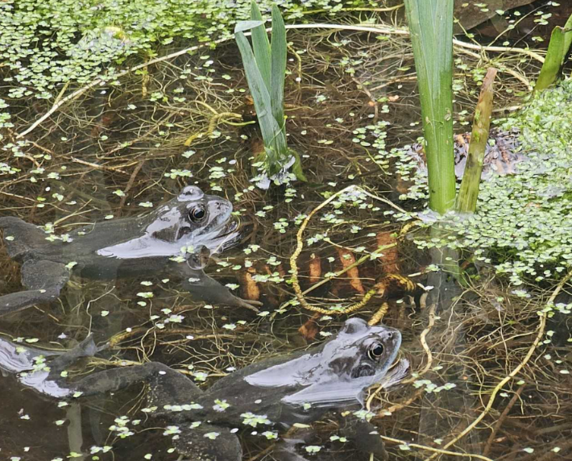
🌿 Our Pond and Wildlife Garden in Bloom
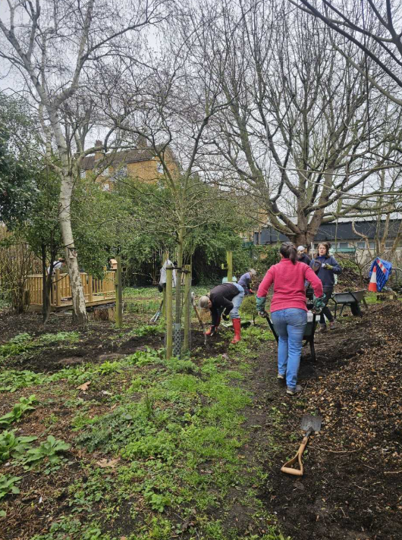
Around the school grounds, our pond and wildlife gardens are buzzing with life and activity. We are incredibly grateful to our community helpers who have been visiting regularly to offer guidance on selecting the right plants for a healthy pond ecosystem.

Thank you also to the parent gardening team for their willingness to pop on their wellies and get stuck in. This area is becoming a wonderful curriculum resource, and we know our Reception and Year 5 children will be delighted to observe the life cycles that they are learning about in Science lessons unfolding right before their eyes.

🤝 Learning Together Across Generations
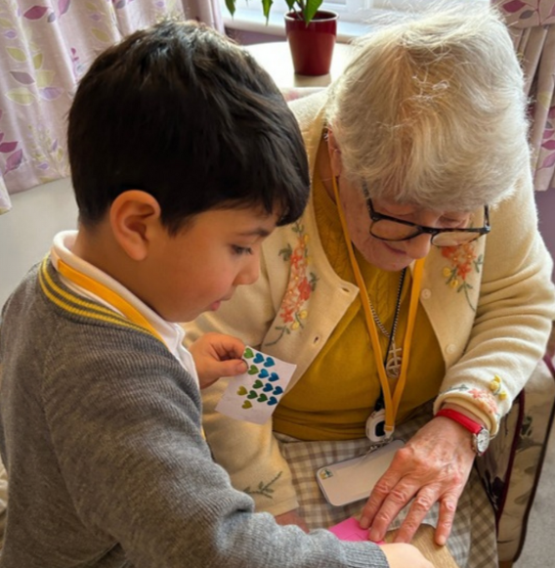
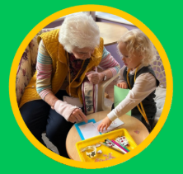
Our youngest children in Nursery continue to visit St Mary’s Convent Nursing Home weekly as part of their regular programme of learning. Brighter Together have published a wonderful impact report demonstrating the positive difference this community connection has on both the elderly residents and the children involved. Please do have a look – it makes for wonderful reading.
Building on this success, we are strengthening our community links further with Clifton Gardens Care Home. Year 6 will be visiting regularly on Friday afternoons during Learning 2 Lead sessions, taking part in a programme of shared activities with residents.

🎉 A Brilliant Quiz Night
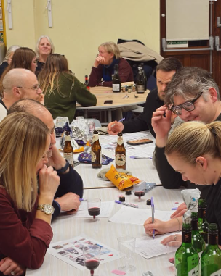
Thank you to everyone who attended our first Headteacher’s Quiz Night at the end of January to raise funds for our new whole school Writing Curriculum. It was a brilliant evening — lots of fun, great company and plenty of laughs and, as a result of the funds raised, we have been able to launch the curriculum in school this week. We are confident that this will make a real and lasting difference to the children’s learning.
If you didn’t manage to make the quiz night this year, I have a feeling that this event will become a feature on the school calendar calendar, and we look forward to welcoming you next time.

🏆 National Recognition for Our School Environment
We are delighted to share that the school has been nominated for the national 2026 Play Space Award. This recognition reflects the significant effort and care that has gone into improving our school environment for the benefit of all children, and we are extremely proud of this achievement.

📅 Important Reminders and What’s Coming Next
- Parent–Teacher consultations will take place on 9th and 10th March. Please remember to sign up — these meetings are a valuable opportunity to discuss your child’s progress and next steps.
- We are exploring exciting plans to develop an Art Hub in school, providing creative opportunities for our children during the week and a space for the wider community to enjoy at weekends.
- A questionnaire will be sent out shortly to help us refresh our after-school club offer for the summer term, ensuring it reflects the children’s interests.
- We are very much looking forward to World Book Day next week and can’t wait to see the children arrive dressed as their favourite book characters.

Thank you, as always, for your continued support and partnership.
Avril Stockley and Team

