What will you be doing with the kid on the June Inset Day?
Get Cheap LegoLand Tickets!
Mon 15th June
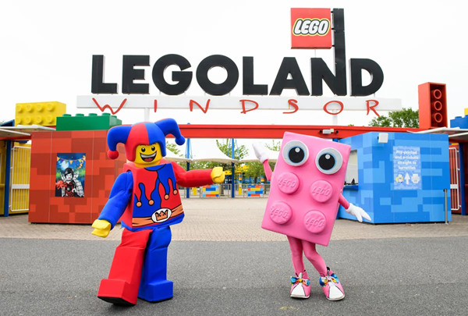

The PTA are planning a trip (at reduced prices) to Lego Land on the Inset day on 15th June. Tickets are £22 each.

This is just for entry tickets, transportation is not included, nor is car parking (parking at Lego land can be booked for around £12 per car).  Children will need to be accompanied by an adult.  Please Scan the QR Code to get tickets | 

