Home Learning Project – Spring 1 – Monday 9th February 2026

This half term the Celebration of Learning Event will be open to the wider curriculum again.

There are a number of ideas below for you to complete as a learning project. Please work with an adult and complete the project together if you can.

Option 1: History – World War 2  Research what life was like for a child during WW2 – evacuation, rationing, air raids and school life.  You could make a diary entry letter home from an evacuee, scrapbook with pictures and captions or a short video with role-play.   | Option 2: Science – Evolution  Choose an animal to research about its habitat and adaptations. Predict how the animal might change in the future if its environment changes.  You could create a poster, a slideshow or a 3D model.  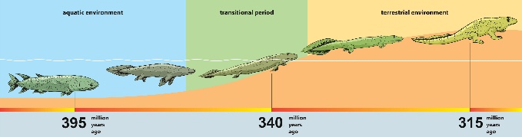
Option 3: Computing – Variables on Scratch  Create a scratch game (catching objects / maze / quiz / runner) and use variables such as a score, time, lives or level.  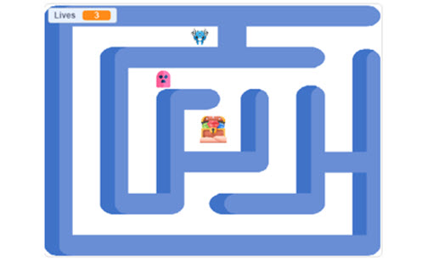 | Option 4: Your choice – Art, DT, Music or RE.  You could create art related to Riley or WW2.  You could perform on an instrument such as a piano or guitar.

