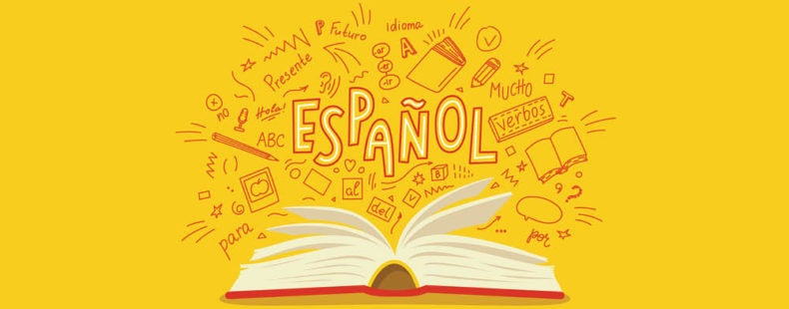

Year 7
Spanish
Knowledge Organisers
Student Name:
Teacher: Room:

- Year 7 Learning Cycle 1 Sentence Builder 1: Greetings
- Year 7 Learning Cycle 1 Sentence Builder 2: Ages and birthdays
- Year 7 Learning Cycle 1 Sentence Builder 3: Friends and personality
- Year 7 Learning Cycle 1 Sentence Builder 4: Family and physique
- Year 7 Learning Cycle 1 Sentence Builder 5: Hair and eyes
- Year 7 Learning Cycle 2 Sentence Builder 1: Favourite teacher
- Year 7 Learning Cycle 2 Sentence Builder 2: Opinions on lessons
- Year 7 Learning Cycle 2 Sentence Builder 3: Lesson activities
- Year 7 Learning Cycle 2 Sentence Builder 4: Future studies
- Year 7 Learning Cycle 2 Sentence Builder 5: Breaktime
- Year 7 Learning Cycle 3 Sentence Builder 1: House
- Year 7 Learning Cycle 3 Sentence Builder 2: Weather
- Year 7 Learning Cycle 3 Sentence Builder 3: Weekend
- Year 7 Learning Cycle 3 Sentence Builder 4: Local area
- Year 7 Learning Cycle 3 Sentence Builder 5: Opinion on region
- High Impact Vocabulary
- High Frequency Verbs
- Verb Tables Present
- Verb Tables: Future and Past
- Golden Phrases
- Chatty Mat 1
- Chatty Mat 2

Year 7 Learning Cycle 1 Sentence Builder 1:
¿Cómo estás? – How are you?
Salutation | Verb | Adjective | Connective | Adjective | Salutation
Buenos días =  Good day  Buenas tardes =  Good afternoon  Buenas noches =  Good night  Mucho gusto =  Pleased to meet you | estoy =  I am (feeling) | fenomenal = amazing  bien = well  regular = ok  mal = bad  fatal =terrible  triste= sad  alegre = happy  cansad@ = tired  motivad@ = motivated  hart@ = fed up | y = and  pero = but | fenomenal = amazing  bien = well  regular = ok  mal = bad  fatal =terrible  triste= sad  alegre = happy  cansad@ = tired  motivad@ = motivated  hart@ = fed up | Adiós = goodbye  Hasta luego =  until later  Hasta pronto =  until soon  Although the literal translation of hasta is until, we often say ‘see you’ in this situation

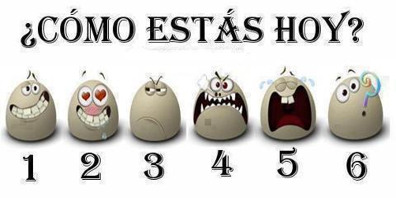

Year 7 Learning Cycle 1 Sentence Builder 2: ¿Cuántos años tienes? – How many years do you have?
Verb | Number | Noun | Connective | Phrase | Number | Preposition | Month
Tengo =  I have | uno = 1  dos = 2  tres = 3  cuatro = 4  cinco = 5  seis = 6  siete = 7  ocho = 8  nueve = 9  diez = 10  once = 11  doce = 12  trece = 13  catorce = 14  quince = 15  dieciséis = 16  diecisiete = 17  dieciocho = 18  diecinueve = 19  veinte = 20  veintiuno =21  veintidós = 22  veintitrés = 23  veinticuatro = 24  veinticinco = 25  veintiséis = 26  veintisiete = 27  veintiocho = 28  veintinueve = 29  treinta = 30  treinta y uno = 31 | años = years | 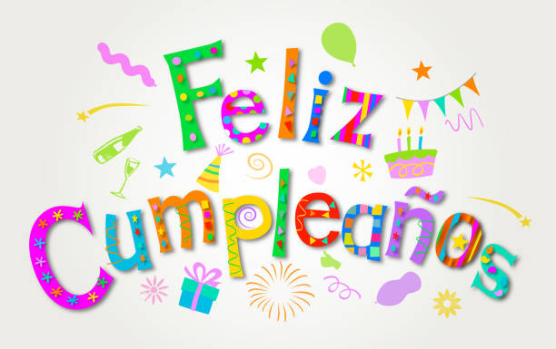  y = and | mi cumpleaños es el =  my birthday is the | uno = 1  dos = 2  tres = 3  cuatro = 4  cinco = 5  seis = 6  siete = 7  ocho = 8  nueve = 9  diez = 10  once = 11  doce = 12  trece = 13  catorce = 14  quince = 15  dieciséis = 16  diecisiete = 17  dieciocho = 18  diecinueve = 19  veinte = 20  veintiuno =21  veintidós = 22  veintitrés = 23  veinticuatro = 24  veinticinco = 25  veintiséis = 26  veintisiete = 27  veintiocho = 28  veintinueve = 29  treinta = 30  treinta y uno = 31 | de = of | enero = January  febrero = February  marzo = March  abril = April  mayo = May  junio = June  julio = July  agosto = August  septiembre = September  octubre = October  noviembre = November  diciembre = December
Year 7 Learning Cycle 1 Sentence Builder 3:
¿Cómo es tu mejor amigo? – What is your best friend like?
Adjective | Noun | Verb | Modifier | Adjective
mi = my | amigo = friend (male)  amiga = friend (female)  mejor amigo = best friend (male)  mejor amiga = best friend (female)  novio = boyfriend  novia = girlfriend  media naranja = half orange | es = (he/she/it) is | (muy) = very  (bastante) = quite   | sincer@ = sincere  tímid@ = shy  tranquil@ = calm  divertid@ = fun  gracios@ = funny  seri@ = serious  simpátic@ = kind  tont@ = silly  list@ = smart  loc@ = crazy  rar@ = weird
mis = my | amigos = friends (all male or mixed)  amigas = friends (all female) | son = (they) are |  | sincer@s -sincere  tímid@s = shy  tranquil@s = calm  divertid@s = fun  gracios@s = funny  seri@s = serious  simpátic@s = kind  tont@s = silly  list@s = smart  loc@s = crazy  rar@s = weird

Year 7 Learning Cycle 1 Sentence builder 4:
¿Cómo es tu familia? – What is your family like?
Verb | Connective | Possessive | Noun | Verb | Adjective | Connective
Creo=  I believe  Pienso =  I think  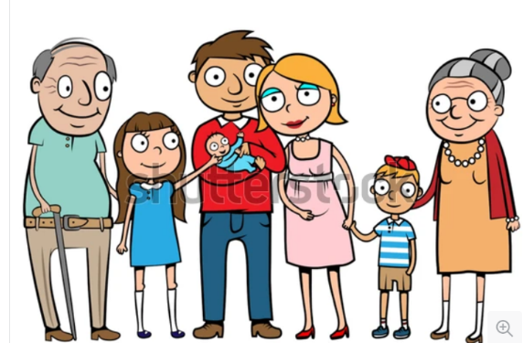 | que = that | (yo) = I |  | soy = I am  no soy =  I am not | alt@ = tall  baj@ = short  gord@ = fat  delgad@ = thin  guap@ = good looking  fe@ = ugly | y = and  pero = but  también = also
 | que = that | mi =my | padre = dad  madre = mum  padrastro = stepdad  madrastra = stepmother  hermano = brother  hermana = sister  hermanastro = stepbrother  hermanastra = stepsister  abuelo = grandpa  abuela = grandma  perro = dog  gato = cat  conejo = rabbit  cobayo = guinea pig  ratón (m) = mouse  serpiente (f) = snake | es = (he/she/it) is  no es = (he/she/it) is not | alt@ = tall  baj@ = short  gord@ = fat  delgad@ = thin  guap@ = good looking  fe@ = ugly | y = and  pero = but  también = also
 | que = that | mis =my | padres = parents  hermanos = siblings  abuelos = grandparents  mascotas = pets | son =  (they) are  no son =  (they) are not | alt@s = tall  baj@s = short  gord@s = fat  delgad@s = thin  guap@s = good looking  fe@s = ugly | y = and  pero = but  también = also
Year 7 Learning Cycle 1 Sentence builder 5: ¿De qué color son tus ojos y tu pelo? – Of what colour are your eyes and hair?
Subject | Verb | Noun | Adjective
(yo) = I | tengo = I have | el pelo = the hair | negro = black  rubio = blond  castaño = brown  pelirrojo = red  largo = long  corto = short
(yo) = I | tengo = I have | los ojos = the eyes | azules = blue  grises = grey  marrones = brown  verdes = green
(él) = he  (ella) = she  mi madre = my mum  mi padre = my dad  mi hermano = my brother  mi hermana = my sister  mi mejor amigo = my best friend  mi familia = my family | tiene = he/she/it has |   el pelo = the hair | negro = black  rubio = blond  castaño = brown  pelirrojo = red  largo = long  corto = short
 | tiene = he/she/it has | los ojos = the eyes   | azules = blue  grises = grey  marrones = brown  verdes = green
mis hermanos = my siblings  mis padres = my parents  mis amigos = my friends | tienen = they have | el pelo = the hair | negro = black  rubio = blond  castaño = brown  pelirrojo = red  largo = long  corto = short
 | tienen = they have | los ojos = the eyes | azules = blue  grises = grey  marrones = brown  verdes = green

Year 7 Learning Cycle 2 Sentence Builder 1:
¿Quién es tu profesor favorito? – Who is your favourite teacher?
Noun | Noun | Verb | Adjective | Connective | Indirect Object Pronoun | Verb
Mi profesor de  Mi profesora de  =  my teacher of | inglés = English  matemáticas = maths  ciencias = science  geografía = geography  historia = history  religión = BVC  español = Spanish  francés = French  deporte = PE  dibujo = art  música = music  teatro = drama  tecnología = technology  informática = IT | es = is |   sincer@ = sincere  tímid@ = shy  tranquil@ = calm  divertid@ = fun  gracios@ = funny  seri@ = serious  simpátic@ = kind  tont@ = silly  list@ = smart  loc@ = crazy  rar@ = weird  interesante = interesting  aburrid@ = boring  simpático = kind  antipático = unkind | y = and  pero = but | me = (to) me  te = (to) you  le = (to) him/her  nos = (to) us  os (to) you  les = (to) them | ayuda = helps  apoya = supports  grita = shouts  da miedo = scares

Year 7 Learning Cycle 2 Sentence Builder 2:
¿Qué opinas de tus clases? – What is your opinion on your lessons?
Verb | Noun | Connective | Verb | Modifier | Adjective
Me encanta… =  … is loveable to me  Me gusta… =  …is likeable to me | el inglés = English  la geografía = geography  la historia = history  la religión = BVC  el español = Spanish  el francés = French  el deporte = PE  el dibujo = art  la música = music  el teatro = drama  la tecnología = technology  la informática = IT |   porque =because | es =  it is | demasiado = too  tan = so  muy = very  bastante = quite  un poco = a bit | divertid@ = fun  interesante = interesting  fascinante = fascinating  guay = cool  práctic@ = practical  creativ@ = creative  aburrid@ = boring  tedios@ = tedious  repetitiv@ = repetitive  difícil = difficult  fácil = easy
Me encantan… =  … are loveable to me  Me gustan… =  …are likeable to me | las matemáticas = maths  las ciencias = sciences |  | son = they are |  | divertid@s = fun  interesantes = interesting  fascinantes = fascinating  guay = cool  práctic@s = practical  creativ@s = creative  aburrid@s= boring  tedios@s = tedious  repetitiv@s = repetitive  difíciles = difficult  fáciles = easy

Year 7 Learning Cycle 2 Sentence Builder 3:
¿Qué haces en tus clases? – What do you do in your lessons?
 | Noun | Auxiliary Verb | Infinitive phrase | Time marker
En mi clase de =  In my … class of | inglés = English  matemáticas = maths  ciencias = science  geografía = geography  historia = history  religión = BVC  español = Spanish  francés = French  deporte = PE  dibujo = art  música = music  teatro = drama  tecnología = technology  informática = IT | Me encanta =… is loveable to me  Me gusta = …is likeable to me | escribir =  to write  escuchar al profesor =  to listen to the teacher  tocar un instrumento =  to play an instrument  hacer experimentos =  to do experiments  estar en una obra =  to be in a play  jugar a los deportes =  to play at sports  crear algo =  to create something  hablar = to talk  usar los ordenadores =  to use the computers  ser activ@ =  to be active  trabajar en equipo =  to work in team  trabajar en silencio =  to work in silence | siempre = always  a menudo = often  a veces = sometimes  mucho = lots  poco= little
En mi clase de =  In my … class of |  | puedo = I can/am able to  debo = I must  quiero = I want  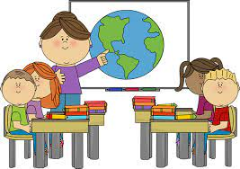

Year 7 Learning Cycle 2 Sentence Builder 4:
¿Qué vas a estudiar en el futuro? – What are you going to study in the future?
Time Phrase | Auiliary Verb | Infintive | Noun | Connective | Verb | Adjective
en el futuro =  in the future | voy a = I am going to   | estudiar = to study  hacer = to do | inglés = English  matemáticas = maths  ciencias = science  geografía = geography  historia = history  religión = BVC  español = Spanish  francés = French  deporte = PE  dibujo = art  música = music  teatro = drama  tecnología = technology  informática = IT  biología = biology  química = chemistry  física = physics  cocina = cooking  negocios = business studies | porque | (no) es | divertid@ = fun  interesante = interesting  aburrid@ = boring  tedios@ = tedious  repetitiv@ = repetitive  exigente = demanding  difícil = difficult  fácil = easy  útil = useful  importante = important

Year 7 Learning Cycle 3 Sentence Builder 5:
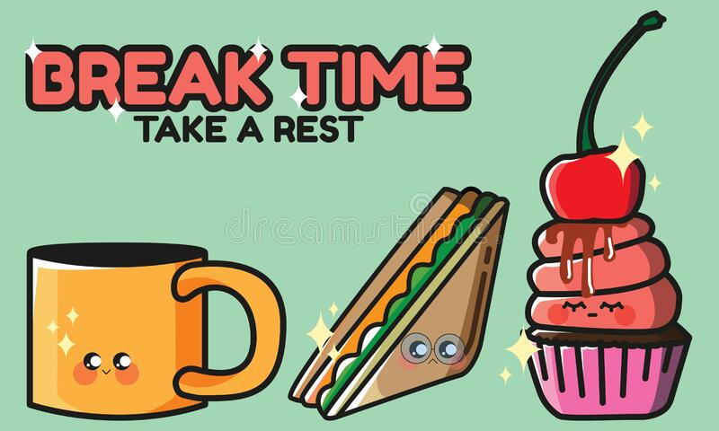
¿Qué haces durante el recreo? – What do you do during break?
Time phrase | Verb | Noun | Detail
Durante el recreo = During the break | charlo/ hablo = I chat/ I talk |  | con mis amigos = with my friends  con mi novio = with my boyfriend  con mi novia = with my girlfriend
Durante el recreo = During the break | como = I eat | comida rápida = fast food  una comida sana = a healthy meal  una bolsa de almuerzo = a packed lunch
Durante el recreo = During the break | bebo = I drink | un refresco = a fizzy drink
Durante el recreo = During the break | juego = I play | al fútbol = to the football  a los deportes = (to the) sports
Durante el recreo = During the break | hago = I do | mis deberes = my homework  ejercicio = exercise
Durante el recreo = During the break | estoy = I am (located) | en un castigo = in a detention
Durante el recreo = During the break | voy = I go | a la biblioteca = to the library  al gimnasio = to the gym
Durante el recreo = During the break | voy a charlar/hablar = I am going to chat/talk
Durante el recreo = During the break | voy a comer = I am going to eat | comida rápida = fast food  una comida sana = a healthy meal  una bolsa de almuerzo = a packed lunch
Durante el recreo = During the break | voy a beber = I am going to drink | un refresco = a fizzy drink
Durante el recreo = During the break | voy a jugar = I am going to play | al fútbol = to the football  a los deportes = (to the) sports
Durante el recreo = During the break | voy a hacer = I am going to do | mis deberes = my homework  ejercicio = exercise
Durante el recreo = During the break | voy a estar = I am going to be (located) | en un castigo = in a detention
Durante el recreo = During the break | voy a ir = I am going to go | a la biblioteca = to the library  al gimnasio = to the gym

Year 7 Learning Cycle 3 Sentence Builder 1:
¿Dónde está tu casa? – Where is your house?
Verb | Noun | Noun | Preposition | Noun
Vivo en =  I live in  Vives en =  You (s) live in  Vive en =  He/she it lives in  Vivimos en =  We live in  Vivís en =  You (pl) live in  Viven en =  They live in | una casa = a house  una granja = a farm  un piso = a flat | en Inglaterra = in England  en Escocia = in Scotland  en Gales = in Wales  en Irlanda = in Ireland  en España = in Spain  en México = in Mexico  en Argentina = in Argentina  en Costa Rica  en Cuba  en Perú  en Colombia  en Chile  en Ecuador  en los Estados Unidos =in the US | cerca de = near to  lejos de = far from  en = on/in | la playa = the beach  la costa = the coast  la montaña = the mountain  el campo = the countryside  una ciudad = a city  un pueblo = a town  un pueblito = a village
Voy a vivir en =
I am going to live in



Year 7 Learning Cycle 3 Sentence Builder 2:
¿Qué haces cuando hace buen/mal tiempo? – What do you do when its good/bad weather
Preposition | Weather idiom | Verb | Detail
cuando = when  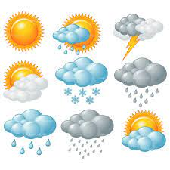  si = if | hace buen tiempo = it’s nice weather  hace mal tiempo = it’s bad weather  hace sol = it’s sunny  hace calor = it’s hot  hace frío = it’s cold  llueve = it’s raining  nieva = it’s snowy | bailo = I dance  bailamos = we dance  voy a bailar = I am going to dance  escucho música = I listen to music  escuchamos música = we listen to music  voy a escuchar música = I am going to listen to music  leo = I read  leemos = we read  voy a leer = I am going to read  juego al fútbol = I play football  jugamos al fútbol = we play football  voy a jugar al fútbol = I am going to play football  juego a los videojuegos = I play at the videogames  jugamos a los videojuegos = we play at the videogames  voy a jugar a los videojuegos = I am going to play at the videogames  hago mis deberes = I do my homework  hacemos nuestros deberes = we do our homework  voy a hacer mis deberes = I am going to do my homework  monto en bici = I ride on bike  montamos en bici = we ride on bike  voy a montar en bici = I am going to ride on bike  tomo el sol = I take the sun  tomamos el sol = we take the sun  voy a tomar el sol = I am going to take the sun | con mis amigos = with my friends  con mi familia = with my family  con mi novio =  with my boyfriend  con mi novia =  with my girlfriend

Year 7 Learning Cycle 3 Sentence Builder 3:
¿Qué haces los fines de semana – What do you do at the weekend?
Time phrase | Verb |  | Connective | Verb | Adjective
los fines de semana  = at the weekend  los sábados = the Saturdays  los domingos = the Sundays | (yo) bailo = I dance  (tú) bailas = you (singular) dance  (él/ella) baila = he/she/it dances  (nosotros) bailamos = we dance  (vosotros) bailáis = you (plural) dance  (ellos/ellas) bailan = they dance  (yo) escucho música = I listen to music  (tú) escuchas música = you (sing) listen to music  (él/ella) escucha música = he/she/it listens to music  (nosotros) escuchamos música = we listen to music  (vosotros) escucháis música = you (pl) listen to music  (ellos/ellas) escuchan música = they listen to music  (yo) leo = I read  (tú) lees = you (sing) read  (él/ella) lee = he/she/it reads  (nosotros) leemos = we read  (vosotros) leéis = you (pl) read  (ellos/ellas) leen = they read |  | porque = because | es = it is | divertid@ = fun  interesante = interesting  aburrid@ = boring  tedios@ = tedious  repetitiv@ = repetitive  difícil = difficult  fácil = easy  útil = useful  importante = important  guay = cool  
el fin de semana próximo =  next weekend  el fin de semana que viene =  next weekend | (yo) voy = I am going  (tú) vas = you (sing) are going  (él/ella) va = he/she/it is going to  (nosotros) vamos = we are going  (vosotros) vais = you (pl) are going  (ellos/ellas) van = they are going | a bailar  = to dance  a escuchar = to listen  a leer  = to read | porque = because | es = it is

Year 7 Learning Cycle 3 Sentence Builder 4:
¿Qué hay en tu zona? – What is there in your area?
Detail | Verb | Article | Noun | Connective | Verb | Infinitive
En mi región =  in my región  En mi pueblo =  In my town | hay = there is/are | un = a | parque = park  centro comercial = mall  polideportivo = sports centre  museo = museum  ayuntamiento = town hall  teatro = theatre  cine = cinema | donde = where | puedo =  I can  puedes =  You (s) can  (mi madre) puede =  (my mum) can  podemos =  we can  podéis =  you (pl) can  pueden =  they can | jugar = to play  descansar = to rest
En mi región =  in my región  En mi pueblo =  In my town | hay = there is/are | el = the
En mi región =  in my región  En mi pueblo =  In my town | hay = there is/are | una = a | piscina = swimming pool  playa = beach  biblioteca = library  plaza = town square  bolera = bowling alley | donde = where |  | jugar = to play  descansar = to rest
En mi región =  in my región  En mi pueblo =  In my town | hay = there is/are | la =the

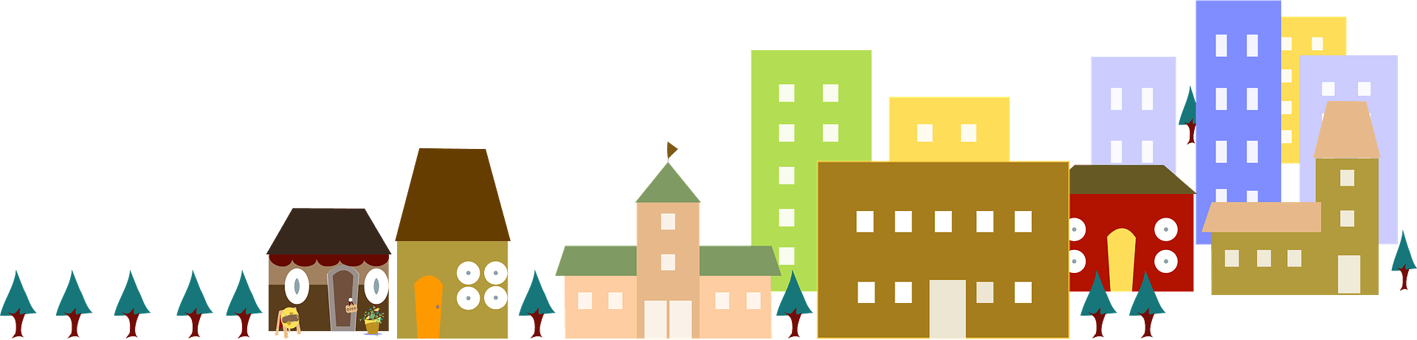

Year 7 Learning Cycle 3 Sentence Builder 5:
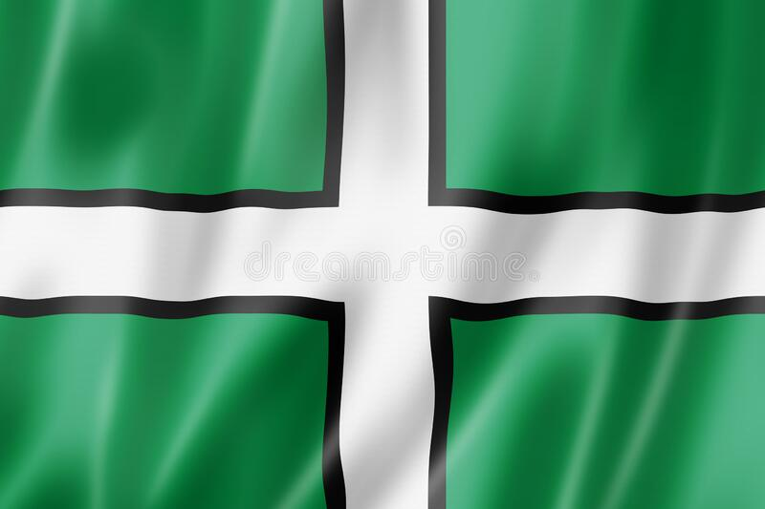
¿Como es tu zona? – What is your area like?
Opinion | Noun | Connective | Verb |  | Connective
me encanta = I love  me gusta = I like  no me gusta = I don’t like  odio = I hate  Vivo en = I live in  Vives en = You (s) live in  Vive en = He/she it lives in  Vivimos en = We live in  Vivís en = You (pl) live in  Viven en = They live in  Voy a vivir en =  I am going to live in  Vas a vivir en =  You are going to live in  Va a vivir en =  He/she/it is going to live in  Vamos a vivir en =  We are going to live in  Vais a vivir en =  You are going to live in  Van a vivir en =  They are going to live in | mi país =  my country  Inglaterra =  England  España =  Spain  mi región =  my región  mi pueblo =  my town  donde vivo= where I live | porque = because | es = it is | animad@ = lively  tranquil@ = peaceful  históric@ = historical  industrial =industrial  bonit@ =pretty  fe@ = ugly | y =  and  pero =  but  sin embargo = however  también =  also
 |  | porque = because | está = it is (located) | en la playa = on the beach  en el campo = in the countryside  en la costa = on the coast  en la montaña = in the mountains
 |  | porque = because | hay = there is | mucho que hacer = lots that to do  una playa = a beach  una piscina = a swimming pool  un cine = a cinema  un parque = a park  un centro comercial = a shopping centre
 |  | porque = because | no hay = there isn’t | nada que hacer = nothing that to do
 |  | porque = because | hace = it makes | buen tiempo = good weather  mal tiempo = bad weather

High Impact Spanish Vocabulary for Key Stage 3
By The End of Year 7 | By the End of Year 8 | By the End of Year 9

Opinions
me encanta(n) = I love  me gusta(n) = I like  no me gusta(n) = I don’t like  odio = I hate  prefiero = I prefer  me da igual = it’s all the same to me | ¡Qué bien! = How great!  ¡Qué guay! = How cool!  ¡Qué suerte! = How lucky!  ¡Qué horror! = How dreadful!  ¡Qué lástima! = What a shame!  ¡Qué rollo! What a drag! | me encantaba(n) = I used to love  me gustaba(n) = I used to like  odiaba = I used to hate  lo pasé fatal = I had a terrible time  lo pasé bomba = I had a blast  tengo muchas ganas = I’m looking forward to it
Adjectives
grande = big  pequeñ@ = small  gord@ = fat  delgad@ = thin  guap@ = good looking  fe@ = ugly  divertid@ = fun  aburrid@ = boring  interesante = interesting  modern@ = modern  antigu@ = old  simpátic@ = kind  antipátic@ = unkind | gracios@ = funny  guay = cool  emocionante = exciting  fascinante = fascinating  estupend@ = brilliant  flipante = awesome  rar@ = weird  alegre = happy  triste = sad  delicios@ = delicious  asqueros@ = disgusting  cómod@ = comfy/ convenient  incómod@ = uncomfy/inconvenient | inolvidable = unforgettable  relajante = relaxing  impresionante = impressive  barat@ = cheap  car@ = expensive  lujos@ = luxurious  tranquil@ = peaceful  trabajador(a) = hard working  perezos@ = lazy  estrict@ = strict  anticuad@ = old fashioned  elegante = smart (looking)  peligros@ = dangerous
Connectives
y = and  o = or  pero = but  también = also  sin embargo = however  porque = because | luego = then  más tarde = later  ayer = yesterday  mañana = tomorrow  por la mañana = in the morning  por la tarde = in the afternoon | lo bueno/malo es que = the good/bad thing is that  lo mejor/peor es que = the best/worst thing is that  lo que más me gusta/ gustó es que = the thing I like/liked most is that
Other
siempre = always  todos los días = every day  a menudo = often  a veces = sometimes  de vez en cuando =now and again  nunca = never | ¿Quién? = Who?  ¿Qué? = What?  ¿Dónde? = Where?  ¿Por qué? = Why?  ¿Cuándo? = When?  ¿Cómo? = How? | me hace feliz = it makes me happy  me hace triste = it makes me sad  me hace relajarme = it makes me relax  me hace reír = it makes me laugh  me hace pensar = it makes me think  me hace llorar = it makes me cry
Sentence extenders
con mi familia = with my family  con mis amigos = with my friends  con mi hermano = with my brother  con mi hermana = with my sister  con mi clase = with my class | en mi casa = in my house  en mi colegio = in my school  en el parque = in the park  en la playa = on the beach  en el centro = in the town centre | cuando hace sol = when it’s sunny  cuando hace buen/mal tiempo = when its nice/ not nice weather  cuando llueve =when it rains  cuando puedo = when I can

High Impact Verbs
ser = to be | soy = i am | es = he/she is | somos = we are | fui = I was | fuimos = we were | voy a ser = I am going to be | vamos a ser = we are going to be
tener = to have | tengo = I have | tiene = he/she has | tenemos = we have | tuve = I had | tuvimos = we had | voy a tener = I am going to have | vamos a tener = we are going to have
hacer = to do | hago = I do | hace = he/she does | hacemos = we do | hice = I did | hicimos = we did | voy a hacer = I am going to do | vamos a hacer = we are going to do
ir = to go | voy = I go | va = he/she goes | vamos = we go | fui = I went | fuimos = we went | voy a ir = I am going to go | vamos a ir = we are going to go
estudiar = to study | estudio = I study | estudia = he/ she studies | estudiamos = we study | estudié = I studied | estudiamos = we studied | voy a estudiar = I am going to study | vamos a estudiar = we are going to study
jugar = to play | juego = I play | juega = he/she plays | jugamos = we play | jugué = I played | jugamos = we played | voy a jugar = I am going to play | vamos a jugar = we are going to play
ver = to see | veo = I see | ve = he/she sees | vemos = we see | ví = I saw | vimos = we saw | voy a ver = I am going to see | vamos a ver = we are going to see
comer = to eat | como = I eat | come = he/she eats | comemos = we eat | comí = I ate | comimos = we ate | voy a comer = I am going to eat | vamos a comer = we are going to eat
trabajar = to work | trabajo = I work | trabaja = he/she works | trabajamos = we work | trabajé = I worked | trabajamos = we worked | voy a trabajar = I am going to work | vamos a trabajar = we are going to work
salir = to go out | salgo = I go out | sale = he/she goes out | salimos = we go out | salí = I went out | salimos = we went out | voy a salir = I am going to go out | vamos a salir = we are going to go out

debo = I must | quiero = I want | tengo que = I have to | puedo = I can/am able to | suelo = I tend to | sé = I know

Verb Tables
Present Tense
Regular Verbs
-ar verbs | -er verbs | -ir verbs
o  as  a  amos  áis  an | o  es  e  emos  éis  en | o  es  e  imos  ís  en

Irregular verbs:
ser  to be | estar  to be (feeling) | ir  to go
soy  eres  es  somos  sois  son | estoy  estás  está  estamos  estáis  están | voy  vas  va  vamos  vais  van
jugar  to play | tener  to have | hacer  to do
juego  juegas  juega  jugamos  jugáis  juegan | tengo  tienes  tiene  tenemos  tenéis  tienen | hago  haces  hace  hacemos  hacéis  hacen
querer  to want | poder  to be able to | decir  to say
quiero  quieres  quiere  queremos  queréis  quieren | puedo  puedes  puede  podemos  podéis  pueden | digo  dices  dice  decimos  decís  dicen

Future Tense
All Verbs (there are no irregular verbs in the future tense)
voy  vas  va  vamos  vais  van | a | [infinitive]

Preterite Tense
Regular Verbs
-ar verbs | -er verbs | -ir verbs
é  aste  ó  amos  asteis  aron | í  iste  ió  imos  isteis  ieron

Irregular verbs:
ser  to be | estar  to be (feeling) | ir  to go
fui  fuiste  fue  fuimos  fuisteis  fueron | estuve  estuviste  estuvo  estuvimos  estuvisteis  estuvieron | fui  fuiste  fue  fuimos  fuisteis  fueron
jugar  to play | tener  to have | hacer  to do
jugué  jugaste  jugó  jugamos  jugasteis  jugaron | tuve  tuviste  tuvo  tuvimos  tuvisteis  tuvieron | hice  hiciste  hizo  hicimos  hicisteis  hicieron
querer  to want | poder  to be able to | decir  to say
quise  quisiste  quiso  quisimos  quisisteis  quisieron | pude  pudiste  pudo  pudimos  pudisteis  pudieron | dije  dijiste  dijo  dijimos  dijisteis  dijeron

Golden phrases- the complete collection
a corto/largo plazo | in the short/long term
al fin y al cabo | at the end of the day
cuando sea mayor | when I grow up
diría que | I would say that
es pan comido | it's a piece of cake
es un sol | he/she is lovely
es una lástima que | it's a shame that
he decidido que | I have decided that
habría preferido + infinitive | I would have preferred
he oído que | I've heard that
lo pasé bomba | I had a great time
lo que más me gusta es que | the thing that I like the most is that
me gustaba | I used to like
me hace reír / relajarme | It makes me laugh / relax
me llevo bien con | I get on well with
me pone de los nervios | he/she/it gets on my nerves
me toma el pelo | he/she/it takes the mick out of me
no aguanto | I can’t stand
no solo… sino también… | Not only… but also…
nunca lo haría | I would never do it
una pérdida de dinero | a waste of money
por un lado...por otro lado | on the one hand...on the other hand
¡qué asco! | how disgusting!
¡qué chulo/guay! | how cool!
¡qué fuerte! | wow!
¡qué rollo! | what a drag!
se me da(n) bien… | I’m good at…
siempre he querido + infintive | I've always wanted
siempre me ha gustado + infintive | I've always liked
si fuera posible me gustaría + infinitive | if it were possible, I would like
solía + infinitive | I tended to / I used to
Sumamente | extremely
¡tengo muchas ganas! | I'm looking forward to it!

Chatty Mat 1. ¿Qué hiciste anoche? – What did you do last night?
Ayer = yesterday  Anoche = last night | fui = I went | a = to | Primark/ Tesco/ Londres/ Exeter/  un concierto = a concert |  | Add detail: Say who you did it with  con mi hermano = with my brother  con mi hermana = with my sister  con mi familia = with my family  con mis amigos = with my Friends  con mi mejor amig@ = with my best friend  con mi media naranja = with my soulmate  Can you describe that person?  Es = he/she/it is
Ayer = yesterday  Anoche = last night | fui = I went | al = to the (masc) | cine = cinema  centro = town centre  polideportivo = sports centre  gimnasio = gym
Ayer = yesterday  Anoche = last night | fui = I went | a la = to the (fem) | piscina = swimming pool  playa = beach  casa de mi amigo = my friend’s house
Ayer = yesterday  Anoche = last night | fui = I went | de compras = shopping  de paseo = for a walk
Ayer = yesterday  Anoche = last night | hice = I did | natación = swimming  equitación = horseriding  artes marciales = martial arts  los deberes = homework |  |  | Add detail: Say what sort of time you had  lo pasé bomba = I had a blast  lo pasé estupendo = I had a great time  lo pasé bien = I had a good time  lo pasé mal = I had a bad time  lo pasé fatal = I had a terrible time  Can you say why?  porque me encanta… = because I love  porque odio… = because I hate  porque es… = because it is
Ayer = yesterday  Anoche = last night | leí | una novela = a novel  una revista/ un periódico = a magazine/ newspaper  un blog sobre… = a blog about…
Ayer = yesterday  Anoche = last night | jugué = I played | al fútbol = (at football)  a los videojuegos = (at) videogames
Ayer = yesterday  Anoche = last night | hablé = I talked  charlé = I chatted | por teléfono = on the phone  en línea = online  cara a cara = face to face
Ayer = yesterday  Anoche = last night | monté = I rode | en bici = on bike  a caballo = at horse |  |  | Link ideas  y = and  también = also  primero = firstly  luego = then  más tarde = later  un poco más tarde = a bit later  finalmente = finally  después de + infinitive = after …ing  antes de acostarme = before going to bed
Ayer = yesterday  Anoche = last night | escuché = I listened | música pop/rock/rap = pop/rock/rap music  la música de Ed Sheeran = Ed Sheeran’s music
Ayer = yesterday  Anoche = last night | toqué = I touched | la guitarra = the guitar  la batería = the drums  el piano = the piano
Ayer = yesterday  Anoche = last night | vi = I saw/watched | una película de amor/acción = a love/action film  un programa de deportes = a sports show  una comedía = a comedy  un documental sobre… = a documentary about…  vídeos en YouTube = videos on Youtube

Chatty Mat 2. ¿Qué vas a hacer hoy por la tarde? – What are you going to do tonight in the afternoon/evening?
Si = if | hace buen tiempo = it’s good weather  hace mal tiempo = it’s bad weather  hace calor = it’s hot  hace frío = it’s cold  llueve = it rains |  | voy a = I am going  suelo = I tend  quisiera = I would like  quiero = I want | ir a un concierto = to go to a concert  ir al cine = to go to the cinema  ir a la casa de mi amig@ = to go to mi friend’s house  ir de compras = go shopping  ir de paseo = go for a walk  hacer ciclismo = to go biking  hacer skate = to do skating  hacer surf = to do surfing  hacer yoga = to do yoga  jugar en línea = to play online  jugar al fútbol = to play football  jugar a los videojuegos = to play videogame  jugar al ajedrez = to play chess  tocar la guitarra = to play the guitar  tocar la batería = to play the drums  tocar el piano = to play the piano  tocar el violín = to play violin  cantar = to sing  hablar con mis amigos = to talk to my friends  mandar SMS = to send text messages  hacer algo en mi blog = to do something for my blog  hacer mis deberes = to do my homework  leer una revista = to read a magazine  bailar en mi cuarto = to dance in my room  escuchar música = to listen to music  ver la televisión = to watch TV  ver un partido de fútbol = to watch a football match  hacer costura = to sew  cocinar = to cook  ayudar a mi familia = to help my family  descansar en mi dormitorio = to relax in my room  tomar un baño = to take a bath | ¡Qué chulo/guay! =  How cool!  ¡Qué divertido! =  How fun!  ¡Qué interesante! =  How interesting!  ¡Qué emocionante! =  How exciting!  ¡Qué difícil! =  How difficult!  ¡Qué gracioso! =  How funny!  ¡Qué raro! =  How weird!  ¡Qué lástima! =  What a shame  ¡Qué rollo! =  What a drag  ¡Qué suerte! =  How lucky!  ¡Qué tarde más… =  What a … evening!
Si = if | puedo = I can
Si = if | es posible = it is possible
Si = if | mi madre me permite = my mum lets me
Si = if | ya he hecho mis deberes = I’ve already done my homework
Si = if | mi amig@ está libre = my friend is free
Si = if | tengo = I have  me falta = I’m lacking | dinero = money  energía = energy  motivación = motivation  tiempo = time
- Can you say who with?
- Can you say where?
- Can you say why?
- Can you say when?

