HFW Rocket – Set 10
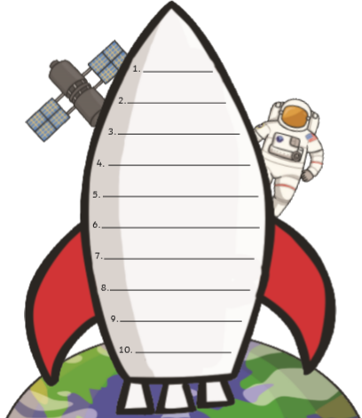
Can you practise reading and writing these sight words?
called
people
saw
oh
could
asked
look
made
very
came

