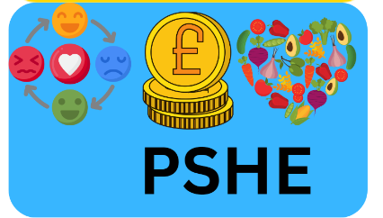

**Working together**

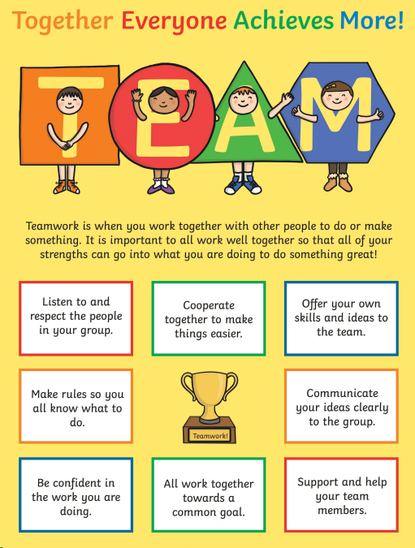

Lesson 1: To be able to identify positive things about themselves and others.

Lesson 2: To be able to identify skills they need to and would like to develop.

Lesson 3: To experience learning a new skill as a class and to reflect on that process.

Lesson 4: To be able to understand and practise some skills of a good communicator, including effective confident expression of opinions and questioning skills worries.

Lesson 6: To be able to know how different people can contribute in different ways to a group task.

Lesson 5: To be able to understand and develop effective group work skills, including problem solving and decision making.

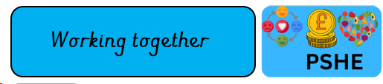

**At the end of Spring 1:**

**At the beginning of Spring 1:**