

Supporting Children with Medical Needs Policy

POLICY OWNER
Laura Kerr/Christian Lim
Headteachers

DELEGATION
Resources Committee

DATE OF APPROVAL
January 2026

DATE OF NEXT REVIEW
January 2027

REVIEW CYCLE
Annual

PUBLISHED ON WEBSITE
Yes

_______________________

Paper copies available by emailing
admin@alfredsutton.reading.sch.uk
Admin@redlands.reading.sch.uk

Alfred Sutton Primary School
148 Wokingham Road
Reading
RG6 7BL
DFE No: 870/2000
www.alfredsutton.primary.co.uk

Redlands Primary School
Lydford Road
Reading
RG1 5QH
DFE No: 870/2018
www.redlandsschool.co.uk

1. Introduction
‘Every child should have the best possible start in life through a high-quality education, which allows them to achieve their full potential. A child who has health needs should have the same opportunities as their peer group, including a broad and balanced curriculum’ DfE guidance 2013

1.1 This policy sets out how Brighter Futures for Children (BFfC), on behalf of Reading Borough Council, will comply with the local authority’s statutory duty to arrange suitable full-time (or part-time when appropriate for the child’s needs) education for children of compulsory school age who, because of illness, would otherwise not receive suitable education.

1.2 BFfC is an independent, not-for-profit company, wholly owned by Reading Borough Council, set up in December 2018 to deliver children’s services, early help, education and SEND services in Reading.

1.3 This statutory duty applies to all children and young people (CYP) of compulsory school age, living in Reading, who would normally attend mainstream schools or special schools, including academies, free schools and independent schools, or where a child is not on the roll of such a school.

1.4 This policy does not apply to children who are electively home educated, or where a young person is on roll of a post-16 institution.

1.5 The Local Authority will not normally provide support for pupils who are under or over compulsory school age. However, where pupils who would normally be in Year 12 are repeating Year 11 due to medical or other valid reasons, requests for support will be considered on an individual basis.

1.6 For post-16 students attending mainstream provision, the Local Authority would look to the host school, college or training provider to make any necessary reasonable adjustments for students who are unwell over a prolonged period.

2. Aim of the policy
2.1 BFfC recognises that schools are the best environments in which to educate children and young people; schools provide a broad and balanced curriculum alongside opportunities for social and emotional development.

2.2 BFfC’s intention is that all children, regardless of circumstances or education setting, should receive a good education to enable them to shape their own futures. Therefore, alternative provision for children medically unfit to attend school and the framework surrounding it should offer good quality education. This support should meet the child’s individual needs, including social and emotional needs and enable them to thrive and prosper in the education system.

2.3 The provision for children who are medically unfit to attend school will ensure that:
- Pupils make good progress in their education and do not fall behind their peers, particularly in key subjects;
- Disruption to learning is minimised and there is a continuity of education provision within the school curriculum;
- Pupils are able to obtain qualifications as appropriate to their age and abilities;
- Pupils are able to reintegrate successfully back into school and that this takes place as soon as their health permits;
- Pupils feel fully part of their school community and are able to stay in contact with classmates.
- BFfC is committed to providing a recovery-focused model that embraces inclusive and Therapeutic Thinking Schools principles with a clear focus on an appropriate and timely return to school-based learning.

3. Legislation and Guidance
3.1 Key legislation covering the duties and powers relating to this policy:
- Section 19 of the Education Act 1996, as amended by section 3a of the Children, Schools and Families Act 2010;
- Equality Act 2010.

3.2Some complex and/or long-term health issues may be considered disabilities under equality legislation. This legislation provides that Local Authorities (LAs) must not discriminate against disabled children and are under a duty to eliminate discrimination, foster equality of opportunity for disabled children and foster good relations between disabled and non-disabled children. LAs should make reasonable adjustments to alleviate disadvantage faced by disabled children, and plan to increase disabled children’s access to premises and the curriculum.

3.3 There is no legal deadline by which LAs must have started to provide education for children who cannot attend school because of their health needs. However, DfE guidance also suggests that this should be provided after 15 days absence (see below).

3.4 Local authorities must:
- Arrange suitable full-time education (or as much education as the child’s health condition allows) for children of compulsory school age who, because of illness, would otherwise not receive suitable education;
- Suitable provision means suitable to the child’s age, aptitude, ability and any special educational needs that he or she may have;
- Provision should be “full time” unless the pupil’s condition means that full-time provision would not be in his or her best interests. Although “Full-time education” is not defined in law, it should equate to what the pupil would normally have in school. If they receive one to-one tuition, for example, the hours of face-to-face provision could be fewer as the provision is more concentrated.

3.5 Local authorities should:
- Provide such education as soon as it is clear that the child will be away from school for 15 days or more, whether consecutive or cumulative. They should liaise with appropriate medical professionals to ensure minimal delay in arranging appropriate provision for the child;
- Ensure that the education children receive is of good quality (as defined in the Alternative Provision January 2013 statutory guidance), allows them to take appropriate qualifications, prevents them from slipping behind their peers in school and allows them to reintegrate successfully back into school as soon as possible;
- Addresses the needs of individual children in arranging provision - this may include remote learning platforms;
- Where full-time education would not be in the best interests of a child because of reasons relating to their physical or mental health, LAs should provide part-time education on a basis they consider to be in the child’s best interests. Full and part-time education should still aim to achieve good academic attainment particularly in English, Maths and Science.

3.6 Local authorities must have regard to statutory guidance when carrying out their Section 19 duty. The relevant guidance is: “Ensuring a good education for children who cannot attend school because of health needs” January 2013 https://www.gov.uk/government/publications/education-for-children-with-healthneeds-who-cannot-attend-school
This policy has been developed with regard to this guidance.

  - This policy also recognises the duties placed on Governing Bodies / Trusts set out in Section 100 of The Children and Families Act 2014 to ensure that arrangements are in place to support pupils with medical conditions. The DfE guidance ‘Supporting pupils at school with medical conditions’ (December 2015) embodies this duty and can be found via the link below: https://www.gov.uk/government/uploads/system/uploads/attachment_data/file/3069
52/Statutory_guidance_on_supporting_pupils_at_school_with_medical_conditions.pdf
The guidance contains both statutory and non-statutory advice.

  - Reading Borough Council’s Health & Safety Team has produced a model policy ‘Supporting Pupils at School with Medical Conditions’ updated in June 2020 which schools may adopt. This policy outlines staff training requirements, administration of medicines, emergency procedures, risk management and insurance to ensure the school is compliant with health and safety requirements. This supports this DfE guidance in implementing Individual Health Care Plans to enable a child to continue their attendance at school.

4. Role of Brighter Futures for Children (BFfC)
4.1 Local authorities are responsible for ensuring that there is a named senior officer with responsibility for education provision for children with health needs and parents should know who that person is. The named officer for BFfC is Gill Dunlop, Pupil & Schools Service Manager, who can be contacted by email gill.dunlop@brighterfuturesforchildren.org.

4.2 BFfC’s SEND Case Officer team will work with schools to review any changing needs of a child with an Education, Health and Care Plan (EHCP), who is unable to attend school because of their medical needs. The EHCP will link the long- term educational needs associated with the child’s medical condition to the most appropriate teaching and learning provision.

4.3 The Pupil and School Service monitors and provides advice on pupils receiving alternative education provision. The Safeguarding & Children Missing Education (CME) Officer (Fiona Holster fiona.hostler@brighterfuturesforchildren.org) within the service works closely with colleagues within BFfC, with parents, schools and with partner agencies to reduce the length of time that children are out of school or receiving reduced timetables, which may be due to their medical needs.

4.4 BFfC expects that all schools will work in partnership with it to ensure continuity of access to education for all children unable to attend school because of serious illness or injury.

5. The Role of Schools including funding
5.1 The legal mandate for schools is to ensure that they are supporting children with medical needs to the best of their ability and that each school has policies and processes in place to ensure this happens.

5.2 Under Equalities legislation schools are expected to make reasonable adjustments to meet the needs of the child if they are able to attend school and to be creative and flexible in meeting needs. It is, however, left to the school’s discretion as to how they meet the needs. Schools will need to demonstrate how they are meeting educational need. This includes meeting the needs of pupils who can attend school part- time and intermittently, particularly when there are known medical needs, and these can be planned for. The Safeguarding and Children Missing Education (CME) Officer should be notified of Reduced Hours Timetable in all cases.

5.3 There is an expectation that most children and young people will make a full or partial recovery from their illness. At this point it is important that their needs for education continue to be appropriately met; most children and young people will transition back to full time mainstream education.

5.4 Children in receipt of medical tuition should be recorded on the schools’ annual census return.

5.5 Schools retain their formula funding for pupils during the period of any alternative provision and will be charged according to the agreed formula based on the daily funding rate for educational provision.

5.6 It is the responsibility of schools to contact BFfC within 10 days of any pupil absence

6. Identification of children who need provision

6.1 This policy applies to all children and young people who:
- Have an illness which will prevent them from attending school for 15 or more school days, either in one absence or over the course of a school year and where suitable education is not otherwise being arranged;
- Have a health need and their absence has been validated as necessary by a medical professional, either a consultant community paediatrician or specialist consultant or psychiatrist from the Child and Adolescent Mental Health Service (CAMHS).

  - Children who are admitted to hospitals (including Tier 4 psychiatric units) in other areas will receive education through local hospital schools or medical pupil referral units; BFfC will be invoiced for such provision.

  - When a child who lives in Reading is admitted to hospital, or is otherwise too ill to attend school, the component elements of this framework should ensure a continuum of education provision. It also aims to establish effective mechanisms for liaison between the hospital, the alternative provider, parents, school, and in some cases, other LAs.

7. Referral and Intervention
7.1 Before considering a referral to BFfC for advice and guidance a school must satisfy itself that a children or young person’s absence is due to ill-health and that there are no other factors influencing non- attendance.

7.2 All referrals must be verified, in writing. The school in the first instance requires a letter from a Doctor and evidence of specialist referrals, if applicable. We have used “Doctor” as this means a person with a medical doctorate i.e. GP, EP, Consultant or Paediatrician. This should indicate:
- if the child/young person is unfit for school
- for how long support might be required
- a recommendation on the number of teaching hours the young person is able to manage based on their state of health • an outline of what medical intervention is currently in place
N.B: further information may be requested of the school or Doctors.

  - Subject to medical advice, BFfC/the Hospital School aims to teach children and young people in hospital from day 1 or as soon as the child is well enough. When a child is in hospital, effective liaison between hospital staff, teaching staff on the wards and the child’s school will ensure continuity of provision and consistency of curriculum, helping the child to keep up rather than having to catch up with his/her education.

For pupils who have returned from hospitals or other in-patient units out of county, medical evidence will be sought from the discharging hospital medical staff.

If a child has complex long-term health issues and the pattern of illness may be unpredictable, regular liaison between the school, medical professionals and the Hospital School will enable appropriate provision to be made.

  - The child’s progress will be reviewed at least every 6 weeks by the school in liaison with the alternative provider, in consultation with the parent / carer, and other relevant services. Reviews will be made more frequently according to need. It should be recognised that a child’s educational needs and ability to access education may change depending on their health and that the programme may need to be flexible to accommodate this.

8. Children with an Education, Health and Care Plan (EHCP)
Where a child with an EHCP is educated in the Royal Berkshire Hospital or in another venue through the alternative provider, the teaching provided will be tailored to meet the child’s needs as identified on the EHCP.
The provider will receive a copy of the EHCP and a copy of the current Provision Map or most recent Annual Review. Children who have special educational needs but no EHCP should have their needs identified in their Individual Health Care Plan.

9. Transport provision for sick children
Where a child who lives in Reading is unable to attend school due to an illness, but could attend if appropriate transport were provided, BFfC may provide transport to and from school, if the conditions mentioned in the School Transport Policy are met, including sufficient supporting evidence. https://brighterfuturesforchildren.org/wp-content/uploads/2020/07/BFFC-Transport-Policyv2b-July-2020.pdf

10. Working in Partnership
Schools and alternative providers should collaborate with parents/carers, BFfC and all relevant health services to ensure the delivery of effective education for children with additional health needs.
Parents and carers have a key role to play in their child’s education and will be involved in planning and on-going review. In the case of children looked after (CLA), BFfC Virtual School and primary carers will fulfil this role. Children should also be involved in decisions to ensure they are engaged as much as possible in this process.
Relevant services including Special Educational Needs and Disabilities (SEND), Child and Adolescent Mental Health Services (CAMHS), General Practitioners, Education
Inclusion/Attendance/ Improvement Services, educational psychologists and school nurses all have responsibilities to work together to support children who are medically unfit to attend school.
Schools and alternative providers will make arrangements to reintegrate pupils at the earliest opportunity and as soon as they are well enough. Each child should have a reintegration plan set out in their Individual Health Care Plan reviewed and amended as appropriate. Schools must consider whether they need to make any reasonable adjustments to provide suitable access for the child as part of their reintegration.
The plans for the longer-term outcome and the next steps will be agreed at the start of the commissioned support, intervention or provision, according to the statutory guidance.
Children will be supported by both their home school and alternative provision to sit public examinations. Awarding bodies will make special arrangements for children with permanent or long-standing disabilities when they are taking public examinations.

11. Complaints and Review
This policy will be reviewed every two years or in line with any changes made to statutory guidelines.
Education Support for Medical Absence is underpinned by the following Government documents in addition to the statutory documents referred to in the policy:
- Out of School Out of Mind, 2011
- Ofsted Subsidiary Guidance, 2012
- Alternative Provision Statutory Guidance, January 2013 • SEND Code of Practice, January 2015
This policy has been developed regarding the above guidance.

12. Co-production and consultation
Through the SEND Strand 2 Working Group the following teams, services and organisations have been consulted with, and contributed to, this policy:
- Reading Families Forum;
- Early Years settings and nursery schools;
- BFfC Early Years Manager and EY Adviser for SEND;
- SEND Team Manager, Special School head teachers;
- Primary and secondary School SENDCos;
- BFfC Educational Psychology Service;
- BFfC Autism Adviser, BFfC Early Help;
- BFfC Children’s Social Care;
- BFfC School Standards;
- Reading Independent Advice and Support Service for SEND;
- Berkshire NHS including School Nursing,


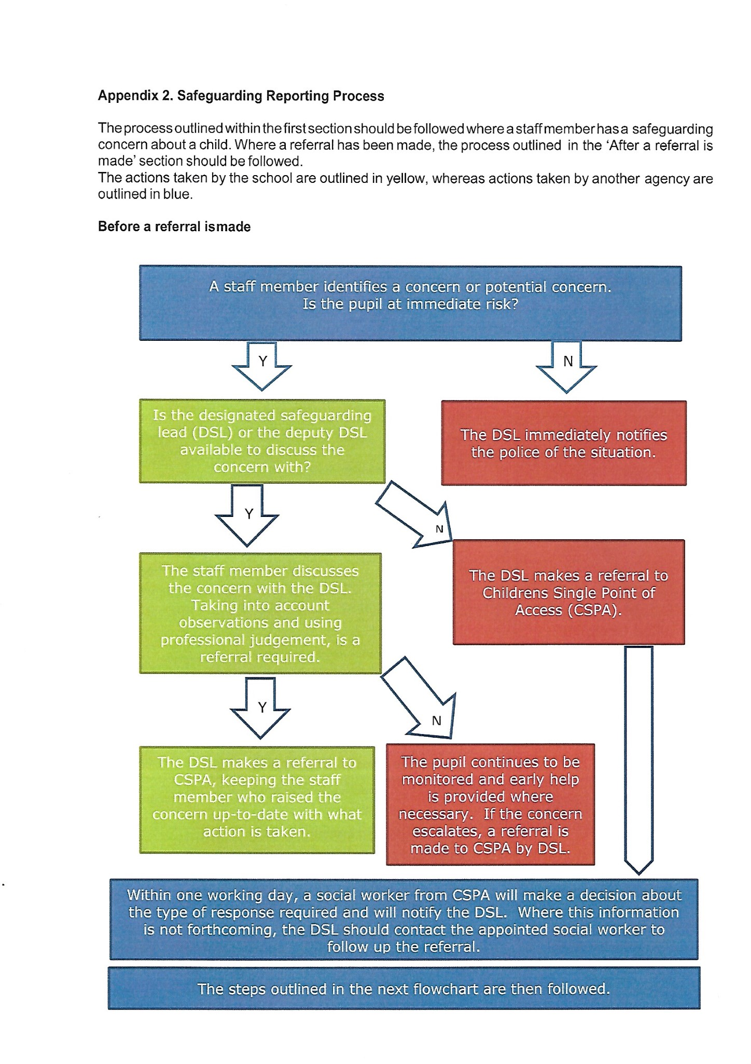
Y
N
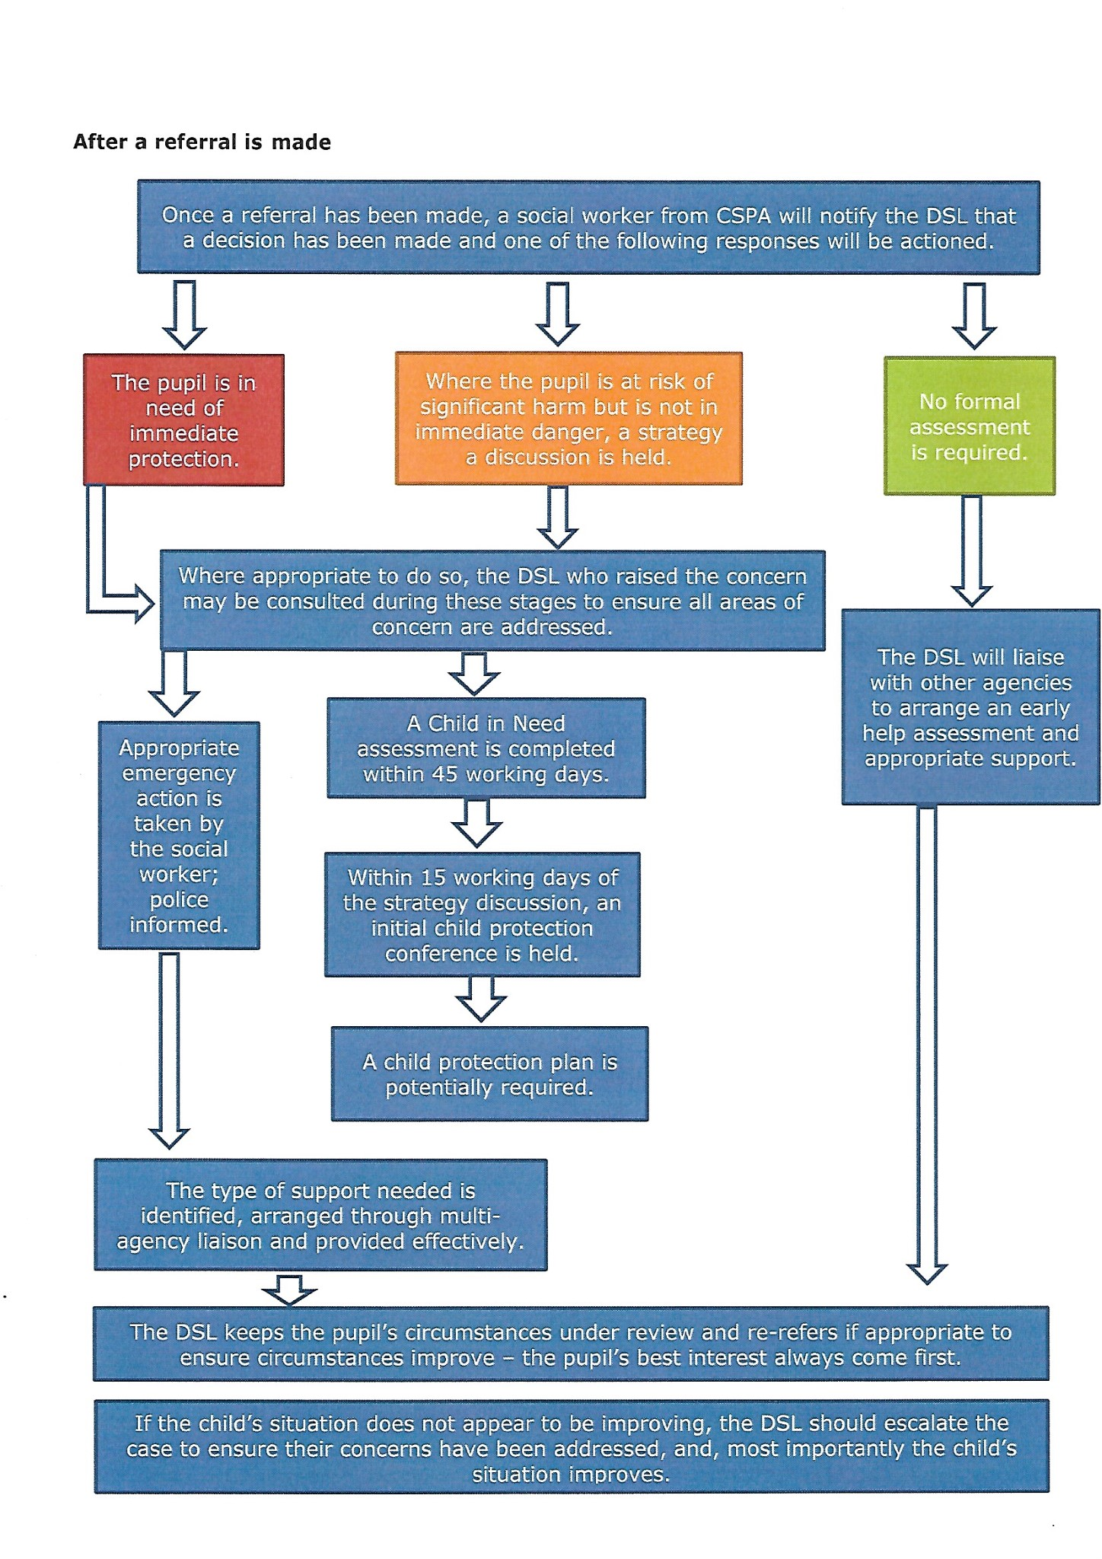

Appendix 3. Contacts and Advice

Expert organisations
  - Barnardo’s
  - Lucy Faithfull Foundation
  - NSPCC
  - Rape Crisis
  - University of Bedfordshire: Contextual Safeguarding
  - UK Safer Internet Centre

Support for victims
  - Anti-Bullying Alliance
  - MoJ Victim Support
  - Rape Crisis
  - The Survivor’s Trust
  - Victim Support

Toolkits
  - Brook
  - NSPCC
  - Safeguarding Unit, Farrer and Co, and Carlene Firmin, MBE, University of Bedfordshire

Further information on confidentiality and information sharing

  - Gillick Competency Fraser Guidelines
  - Government Information Sharing Advice
  - Information Commissioner’s Office: Education
  - NSPCC: Things to Know and Consider

Further information on sexting

  - UK Council for Child Internet Safety: Sexting Advice
  - London Grid for Learning – Collection of Advice

Support for parents

  - Parent zone
  - Parentsafe – London Grid for Learning
  - CEOP Thinkuknow – Challenging Harmful Sexual Attitudes and their Impact
  - CEOP Thinkuknow – Supporting Positive Sexual Behaviour

Appendix 4. CPOMS Safeguarding/Child Protection Reporting Guidance Notes

If you have concerns whatsoever about a child’s safety or wellbeing;

- Complete the information on the CPOMS system (Child Protection On-Line Monitoring System).
- An alert will be immediately sent to the DSL’s.
- When adding the information ensure that the information you give is clear, precise and factual.
- If the child has marks or injuries that could be of concern complete a Body Map on the CPOMS.
- Record your observations on behaviour seen.
- Record any comments by the child as verbatim as possible.
- Record any comments by the parents/adults.
- Describe what it is that leads you to think there is a concern.
- Submit via CPOMS on the same day and if so immediately.
- If you have support needs as a result of what you have observed or experienced, make these known to the Designated person now or at a later stage.

Sharing Information

- Every case is different and therefore it is impossible to write strict guidance on who needs to be information about an incident.
- The general premise should be that the child’s well-being is paramount and this should be the primary consideration when deciding what information should be shared and with whom.
- The discussion between the person reporting the incident and the Designated person should leave the person who made the report feeling clear about what, if anything, they should share and with whom.
- Do not share information with anyone else until you have discussed the situation with the Designated person.

