St John the Baptist

Calculation Policy

St John the Baptist Primary School
Calculation Policy

Mastering mathematics is essential for everyday life and understanding our world. It enables the development of the children’s natural ability to think logically, explore numbers and solve real life problems. Pupils learn to think creatively and make links between mathematical concepts through exploring patterns. They make and discuss generalisations, explaining their reasoning and justifying their answers. They develop the skills, knowledge and efficient methods of calculation – both mental and written – necessary to support their economic future and problem solving in life. Mastery in mathematics is essential for our children to possess throughout the school and beyond as this opens the rest of the curriculum and ultimately a variety of careers to them.
At St John the Baptist Primary School, we use and adapt the White Rose schemes of learning to ensure that all of our children have access to high quality teaching across the three mathematical strands of fluency, reasoning and problem solving using the concrete-pictorial-abstract (CPA) teaching sequence to ensure mastery of every strand of the mathematics National Curriculum. Teachers are encouraged to make use of our outdoor environment to make the mathematics more relevant to the children and make learning memorable. Every year group has their units sequenced in order for children to be able to build upon their previous learning and use mathematical methods and ideas in real life settings. All children are encouraged to solve problems presented in a variety of different ways using characters from many different backgrounds in order to explore their understanding further. Most topics are revisited in a spiral curriculum throughout the seven years that children spend with us. We have a strong focus on learning facts including number bonds and times tables early in a child’s mathematical career - and provide targeted interventions where these skills are absent - so that they are able to apply these skills to measurement, fractions, shape and data collection amongst others.
Our calculation policy has been adapted from the one provided by White Rose as this correlates with the representations that the children will be working with in their lessons. This focusses on depictions for each of the strands of the CPA approach for each operation in the primary national curriculum. The policy allows for progression of representations both within and between year groups whilst using resources that the children are familiar with from the beginning of their education. We endeavour for our children to become independent with their use of mathematical representations, choosing the best representation or method for their purpose autonomously.
Skill | Year Group |  | Representations and Models (Concrete, Pictorial and Abstract)
Add 1-digit numbers within 10 | 1 | When adding numbers to 10, children can explore both aggregation and augmentation.  The part-whole model, discrete and continuous bar model, number shapes and ten frame support aggregation.  The combination bar model, ten frame, bead string and number track all support augmentation. | 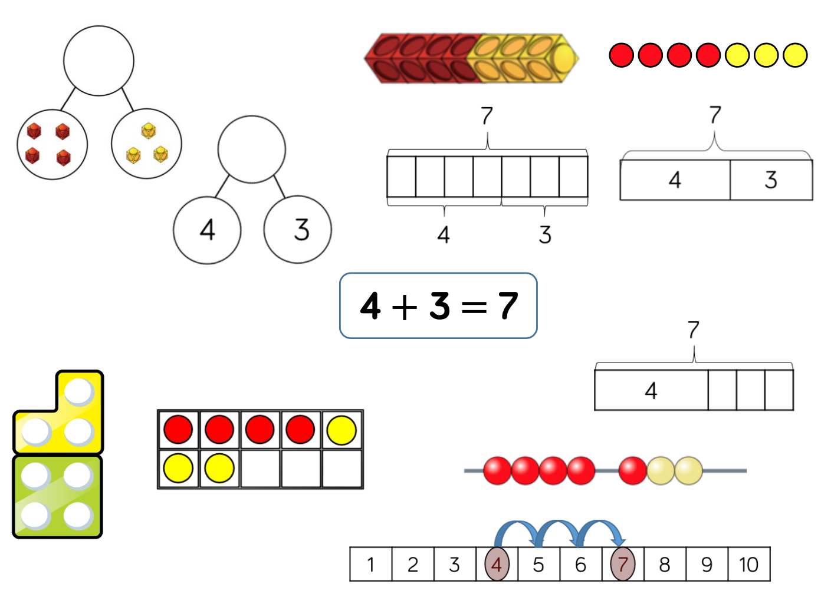
Add 1 and 2 digit numbers to 20 | Years 1/2 | When adding one- digit numbers that cross 10, it is important to highlight the importance of ten ones equalling one ten.  In Year 1, this is only done just by counting on.  From Year 2, use different manipulatives can be used to represent this exchange alongside number lines to support children in understanding how to partition their jumps. | 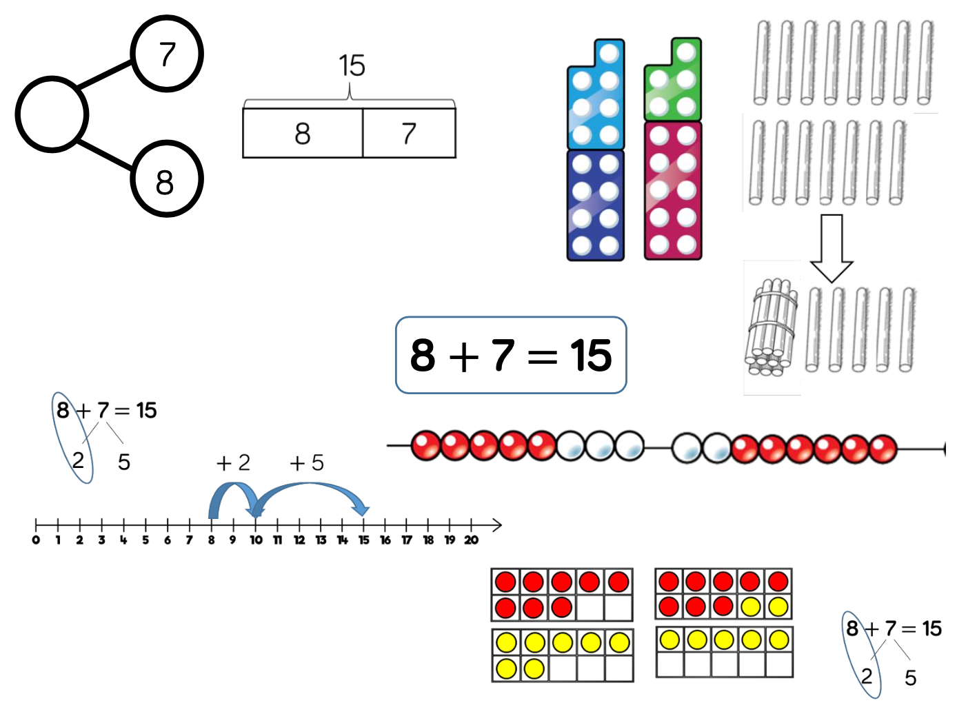
Add three 1-digit numbers | Year 2  Year 2 | When adding three 1- digit numbers, children should be encouraged to look for number bonds to 10 or doubles to add the numbers more efficiently.  This supports children in their understanding of commutativity.  Manipulatives that highlight number bonds to 10 are effective when adding three 1-digit numbers. | 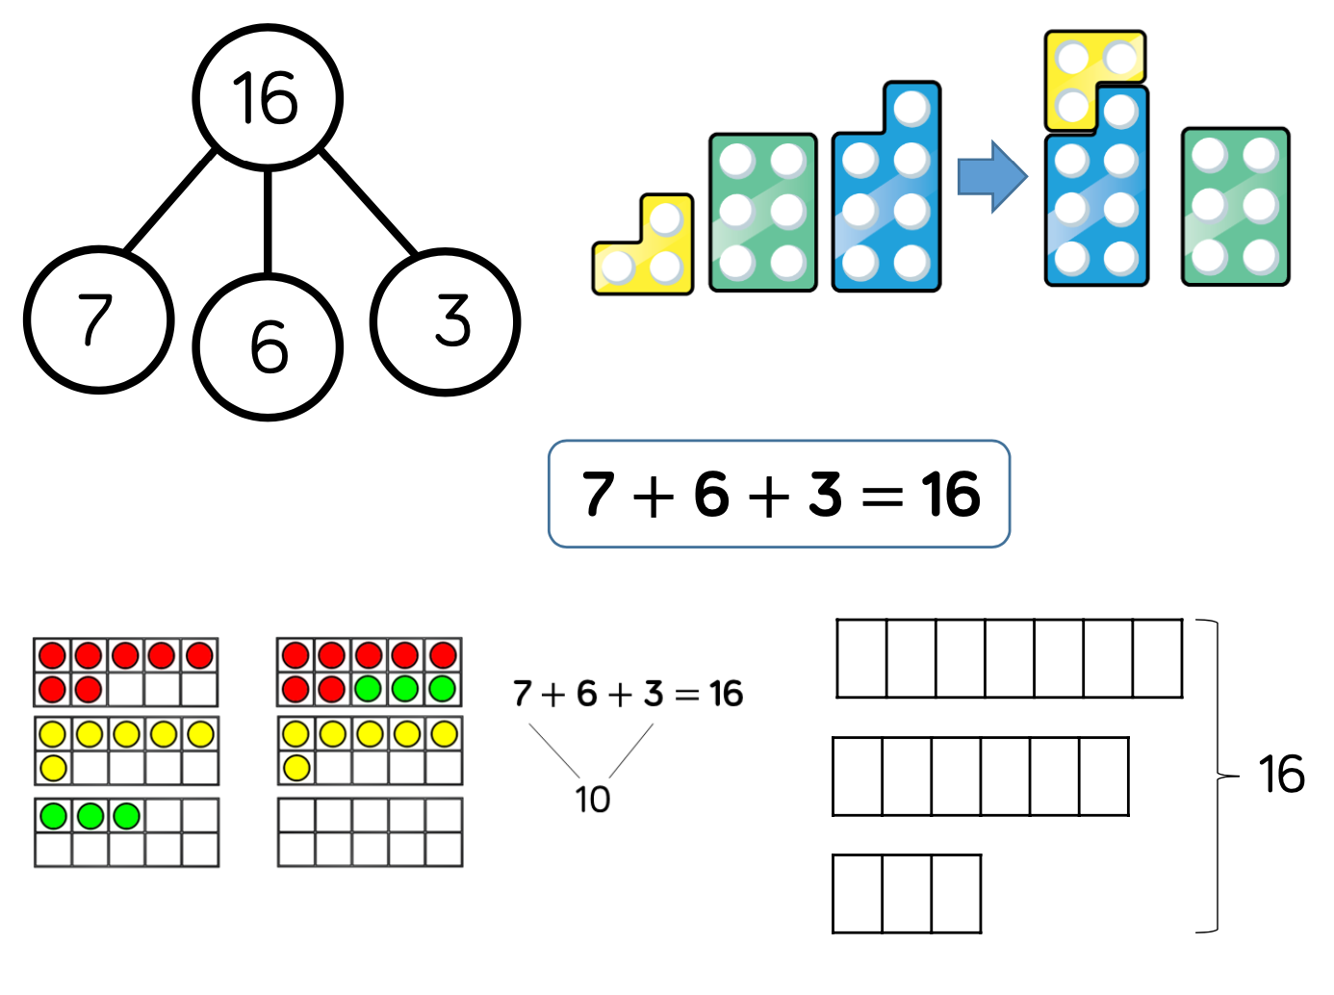
Add 1-digit and 2-dgit numbers to 100 | Year: 2/3 | When adding single digits to a two-digit number, children should be encouraged to count on from the larger number.  They should also apply their knowledge of number bonds to add more efficiently e.g. 8 + 5 = 13 so 38 + 5 = 43.  Hundred squares and straws can support children to find the number bond to 10. | 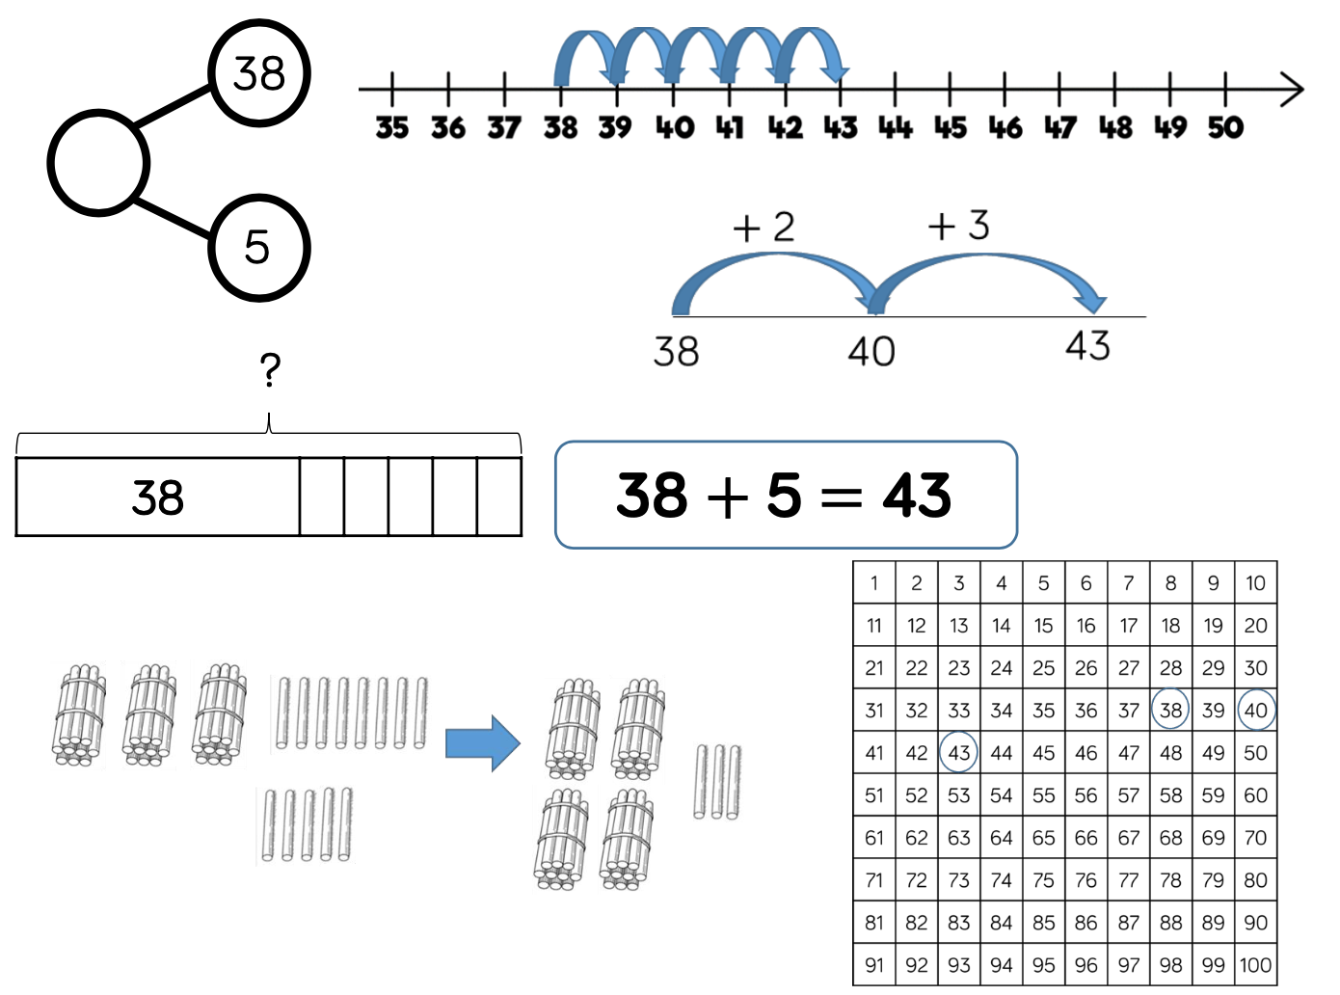
Add two 2-digit numbers to 100 | Year: 2/3 | Children can use a blank number line and other representations to count on to find the total. Encourage them to jump to multiples of 10 to become more efficient.  From Year 3, encourage children to use the formal column method when calculating alongside straws, base 10 or place value counters. As numbers become larger, straws become less efficient. | 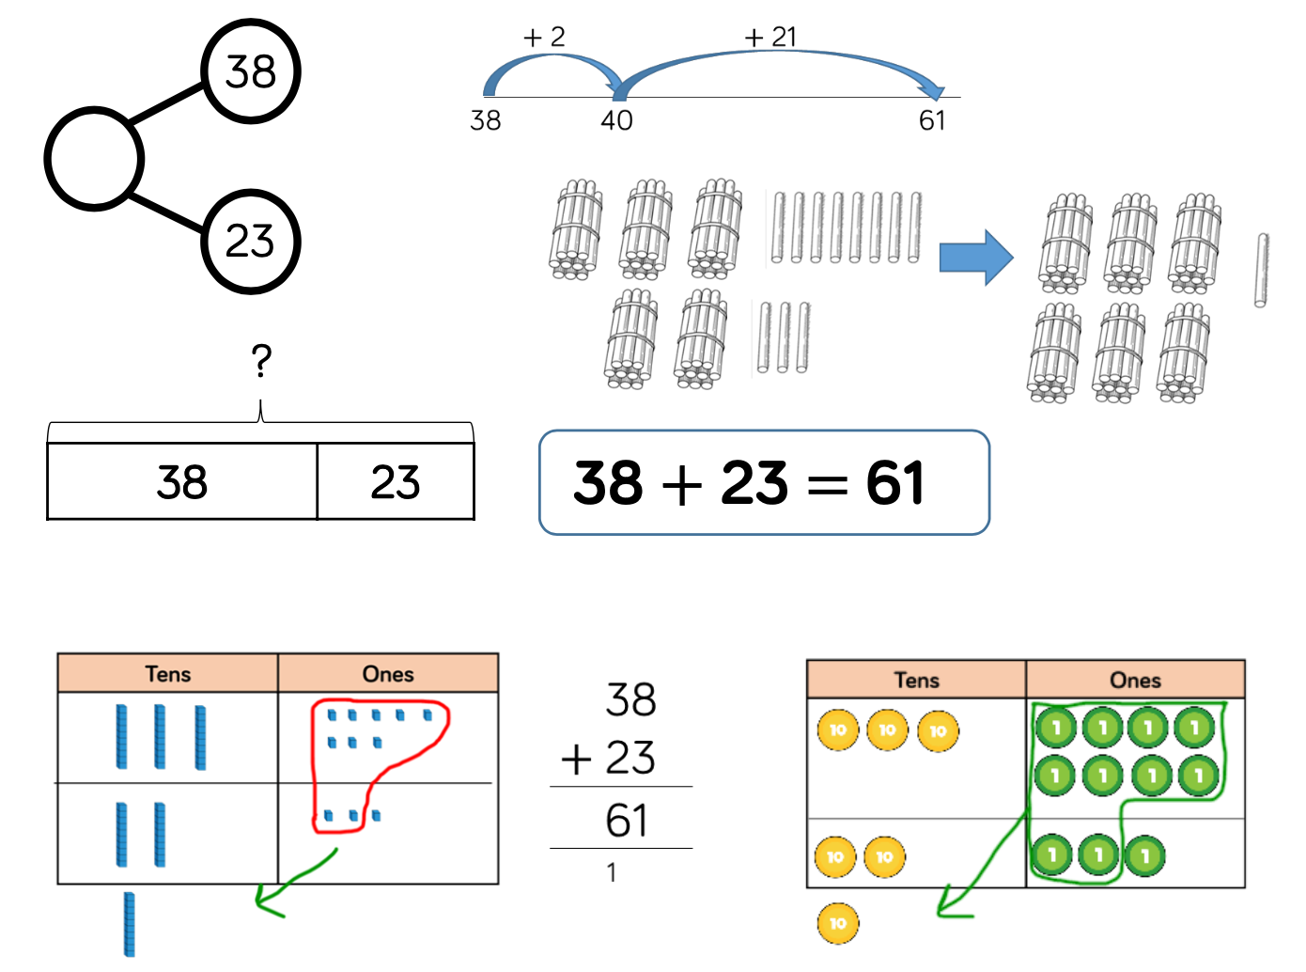
Add numbers with up to 3 digits | Year 3 | Base 10 and place value counters are the most effective manipulatives when adding numbers with up to 3 digits.  Ensure children write out their calculation alongside any concrete resources so they can see the links to the written column method.  Plain counters on a place value grid can also be used to support learning. | 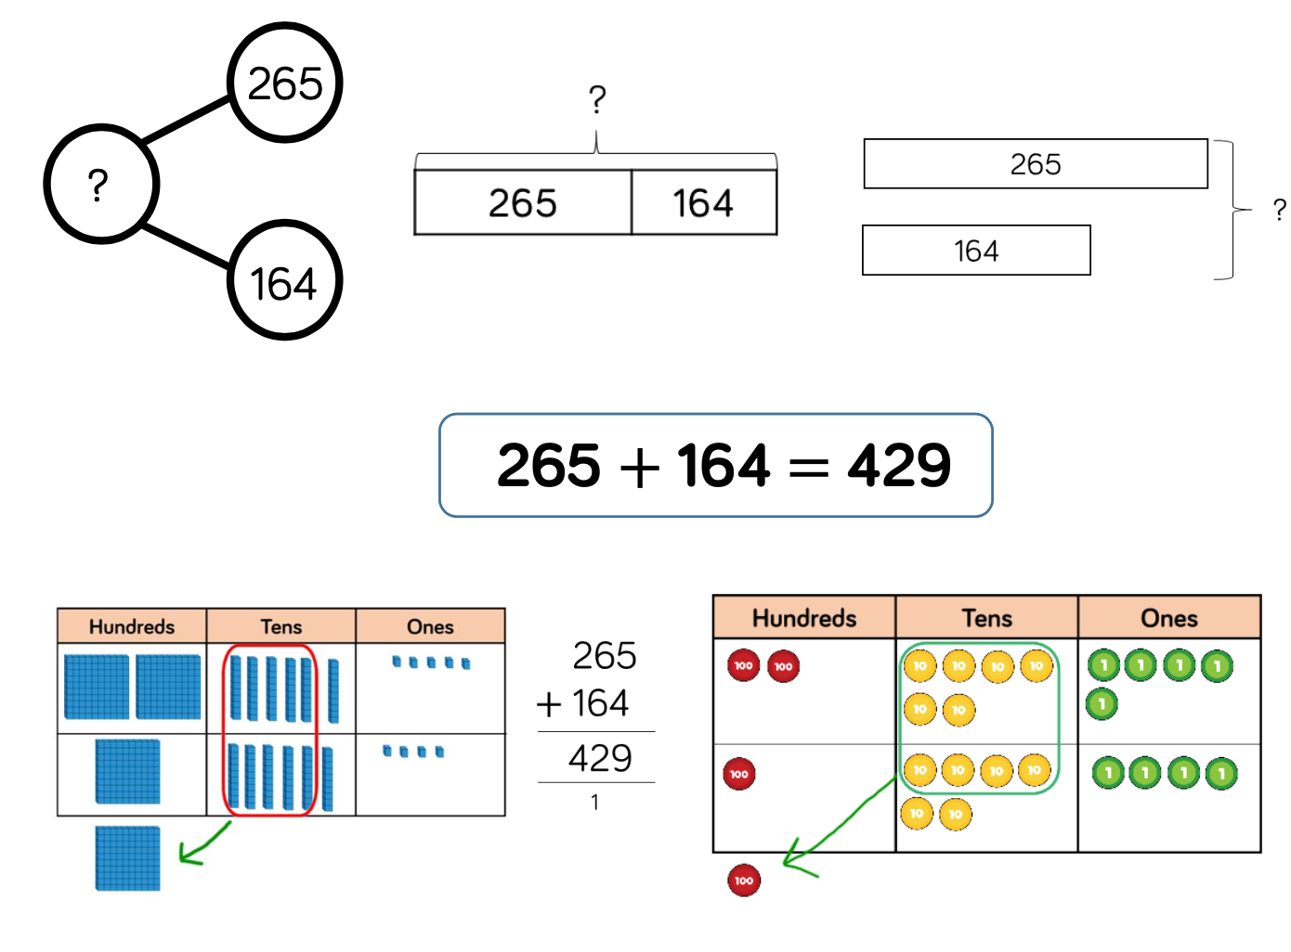
Add numbers with up to 4 digits | Year 4 | Base 10 and place value counters are the most effective manipulatives when adding numbers with up to 4 digits.  Ensure children write out their calculation alongside any concrete resources so they can see the links to the written column method.  Plain counters on a place value grid can also be used to support learning. | 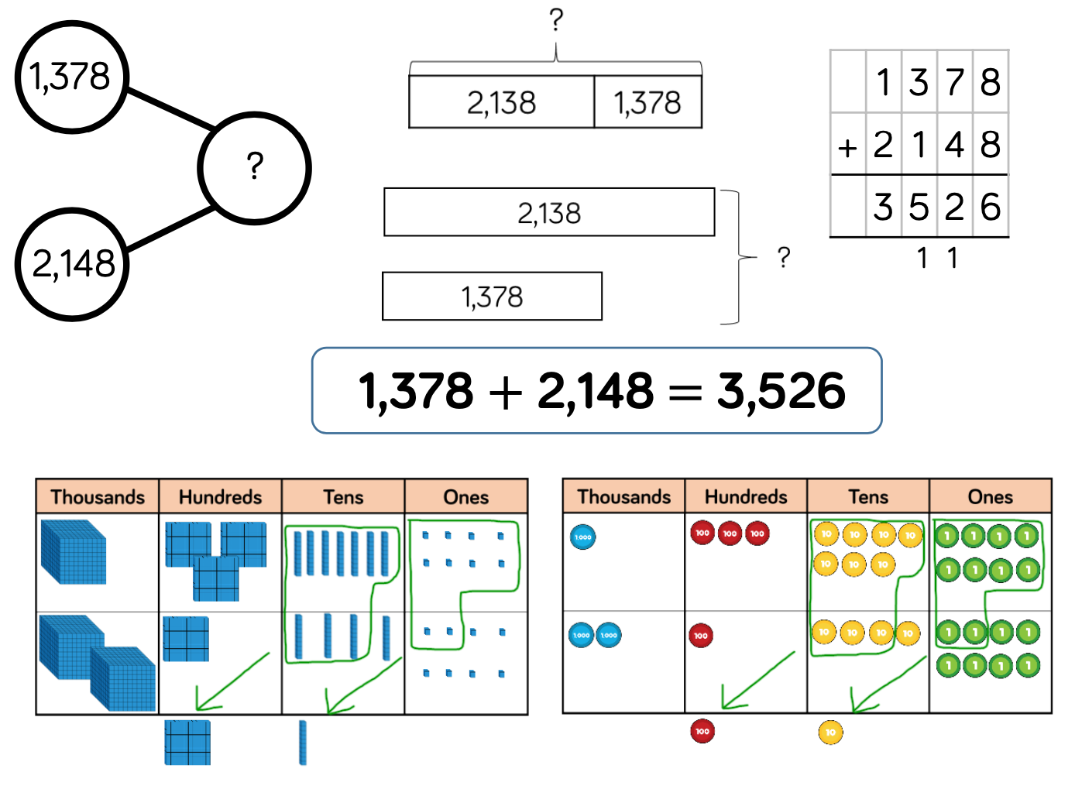
Add numbers with more than 4 digits | Year 5/6 | Place value counters or plain counters on a place value grid are the most effective concrete resources when adding numbers with more than 4 digits.  At this stage, children should be encouraged to work in the abstract, using the column method to add larger numbers efficiently. | 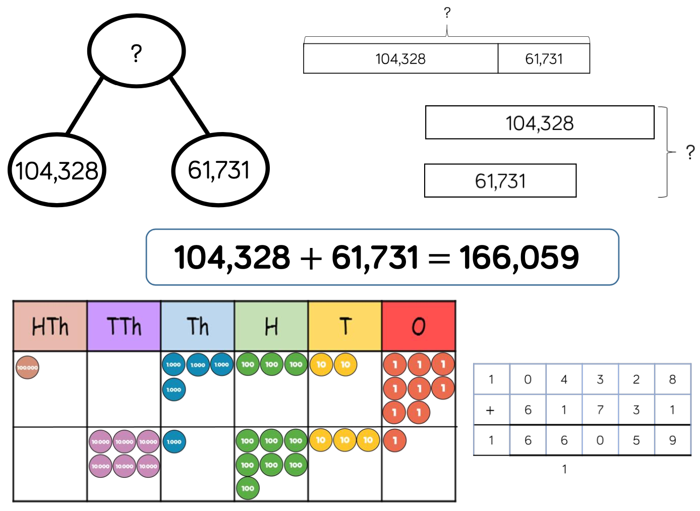
Add with up to 3 decimal places | Year 5 | Place value counters and plain counters on a place value grid are the most effective manipulatives when adding decimals with 1, 2 and then 3 decimal places.  Ensure children have experience of adding decimals with a variety of decimal places. This includes putting this into context when adding money and other measures. | 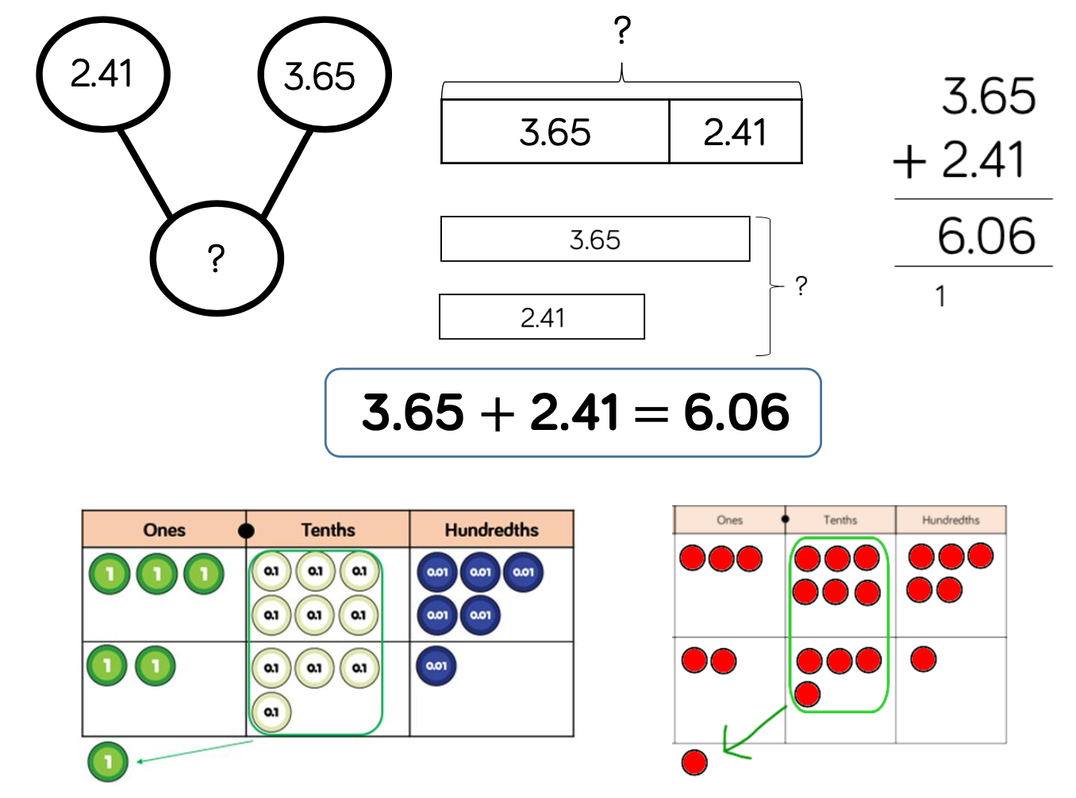

Skill | Year Group |  | Representations and Models (Concrete, Pictorial and Abstract)
Subtract 1-digit numbers within 10 | 1 | Part-whole models, bar models, ten frames and number shapes support partitioning.  Ten frames, number tracks, single bar models and bead strings support reduction.  Cubes and bar models with two bars can support finding the difference. | 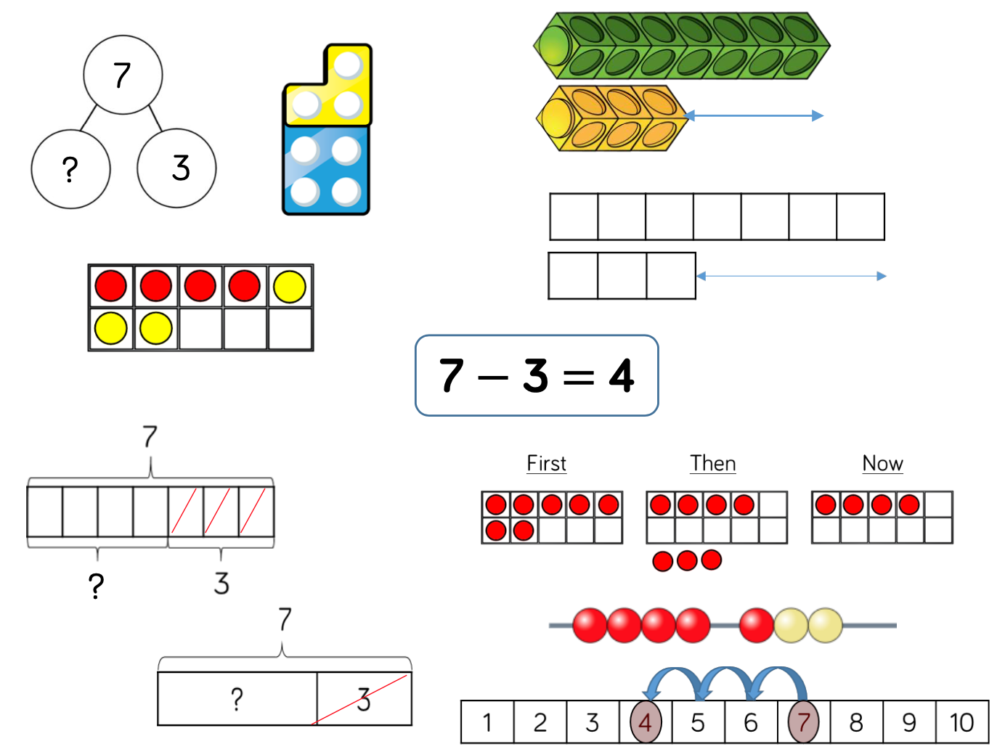
Subtract 1 and 2-numbers digits to 20 | Year 1/2 | In Year 1, subtracting one-digit numbers that cross 10, is done by counting back, using objects, number tracks and number lines.  From Year 2, children should be encouraged to find the number bond to 10 when partitioning the subtracted number. Ten frames, number shapes and number lines are particularly useful for this. | 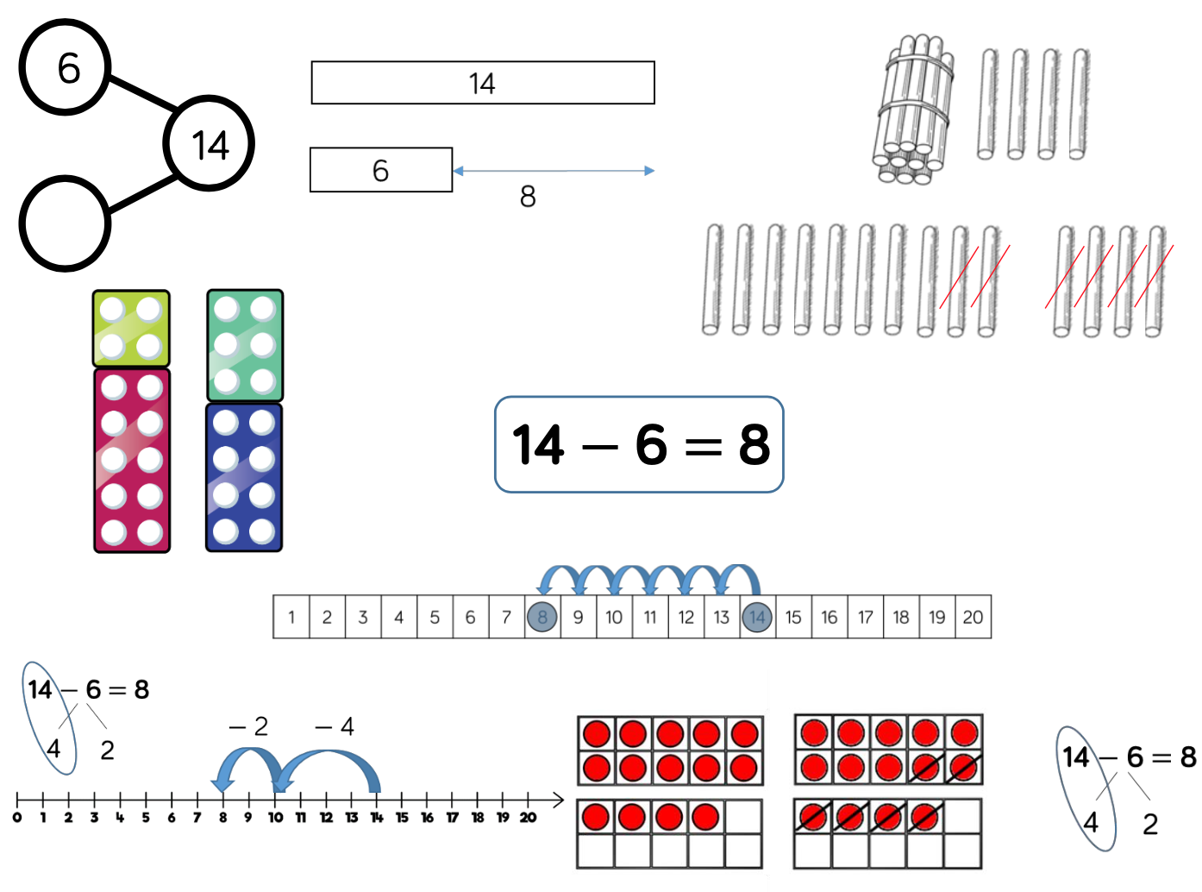
Subtract 1 and 2-digit numbers to 100 | Year 2/3 | Children can also use a blank number line to count back to find the difference. Encourage them to jump to multiples of 10 to become more efficient.  From Year 3, encourage children to use the formal column method when calculating alongside straws, base 10 or place value counters. As numbers become larger, straws become less efficient. | 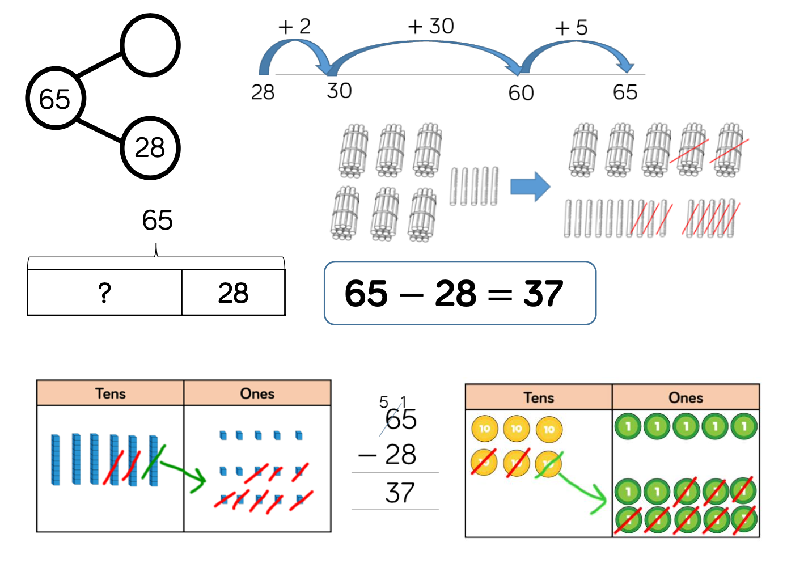
Subtract numbers with up to 3 digits | Year 3 | Base 10 and place value counters are the most effective manipulative when subtracting numbers with up to 3 digits.  Ensure children write out their calculation alongside any concrete resources so they can see the links to the written column method.  Plain counters on a place value grid can also be used to support learning. | 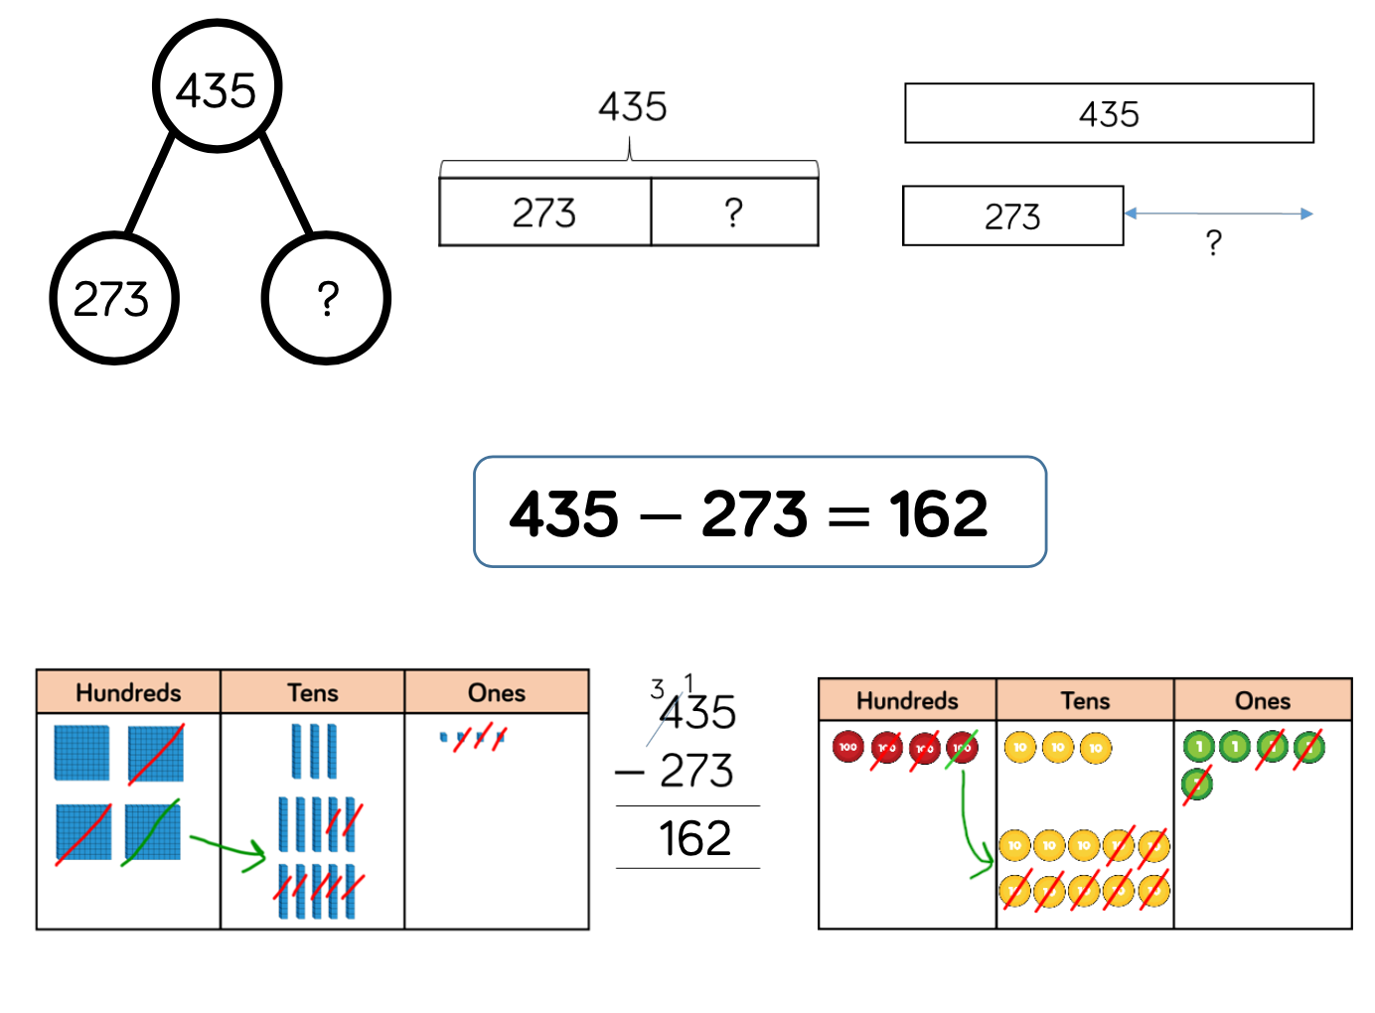
Subtract numbers with up to 4 digits | Year 4 | Base 10 and place value counters are the most effective manipulatives when subtracting numbers with up to 4 digits.  Ensure children write out their calculation alongside any concrete resources so they can see the links to the written column method.  Plain counters on a place value grid can also be used to support learning. | 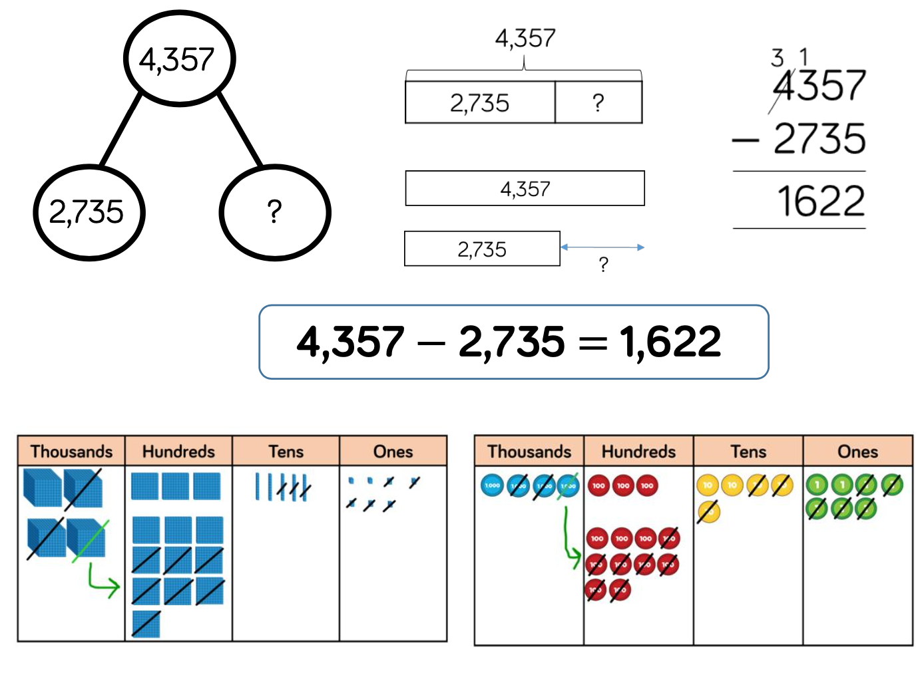
Subtract numbers with more than 4 digits | Year 5/6 | Place value counters or plain counters on a place value grid are the most effective concrete resource when subtracting numbers with more than 4 digits.  At this stage, children should be encouraged to work in the abstract, using column method to subtract larger numbers efficiently. | 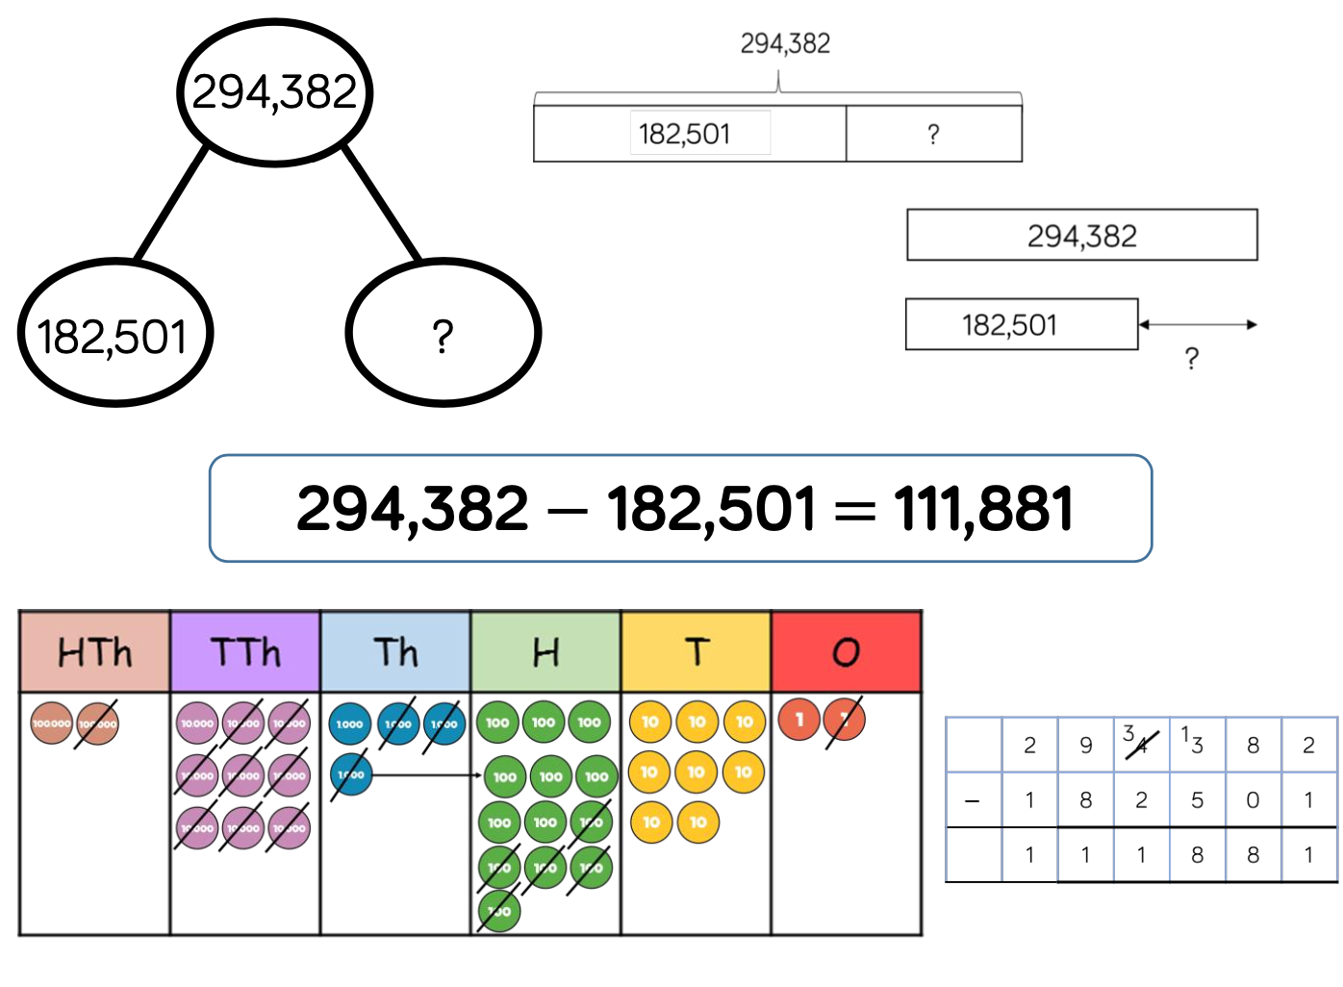
Subtract with up to 3 decimals places | Year 5/6 | Place value counters and plain counters on a place value grid are the most effective manipulative when subtracting decimals with 1, 2 and then 3 decimal places.  Ensure children have experience of subtracting decimals with a variety of decimal places. This includes putting this into context when subtracting money and other measures. | 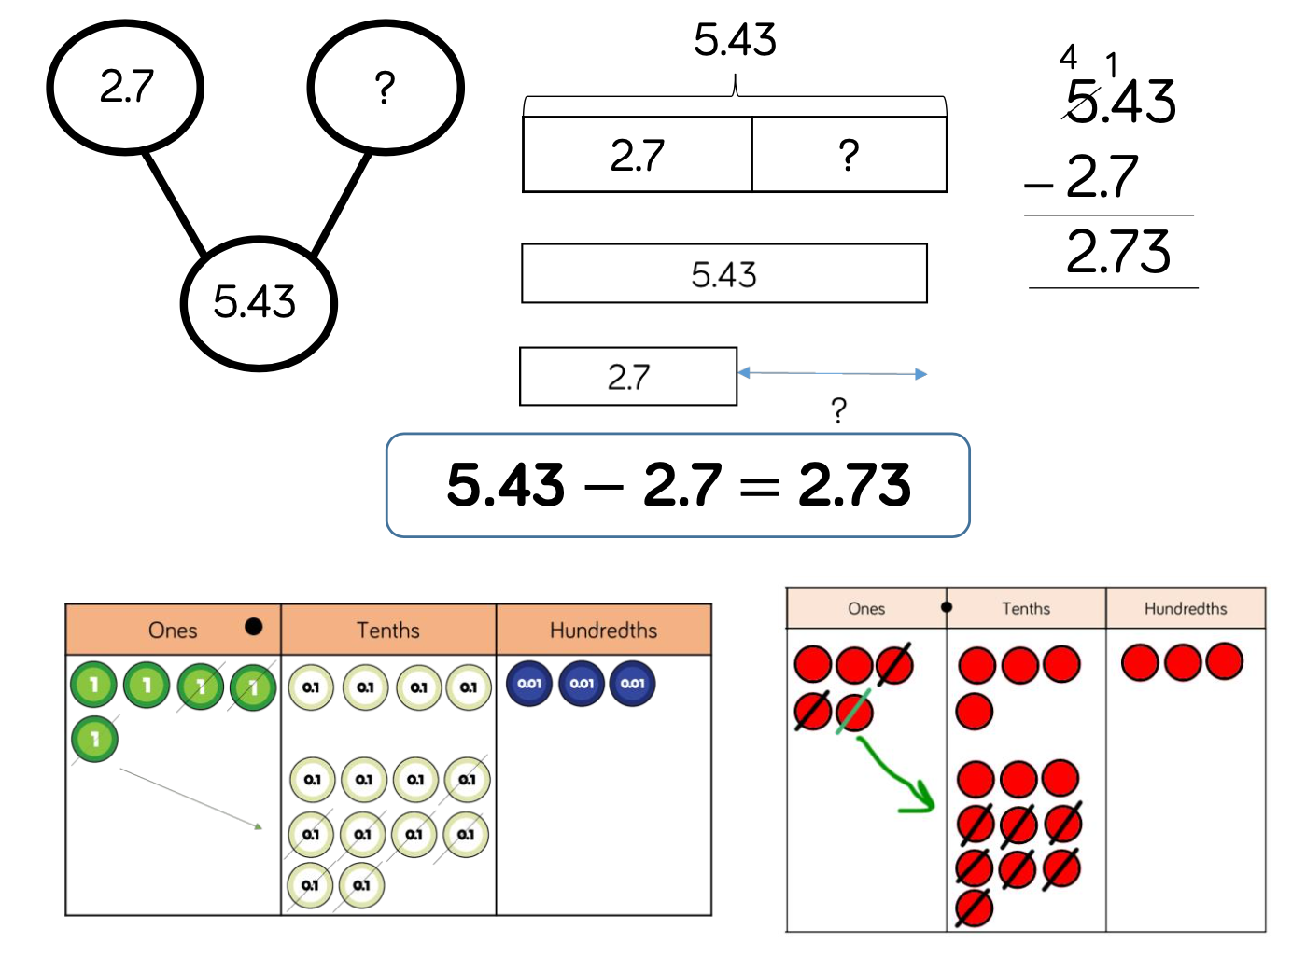

Skill | Year Group |  | Representations and Models (Concrete, Pictorial and Abstract)
Solve 1-step problems using multiplication | Year 1/2 |      | 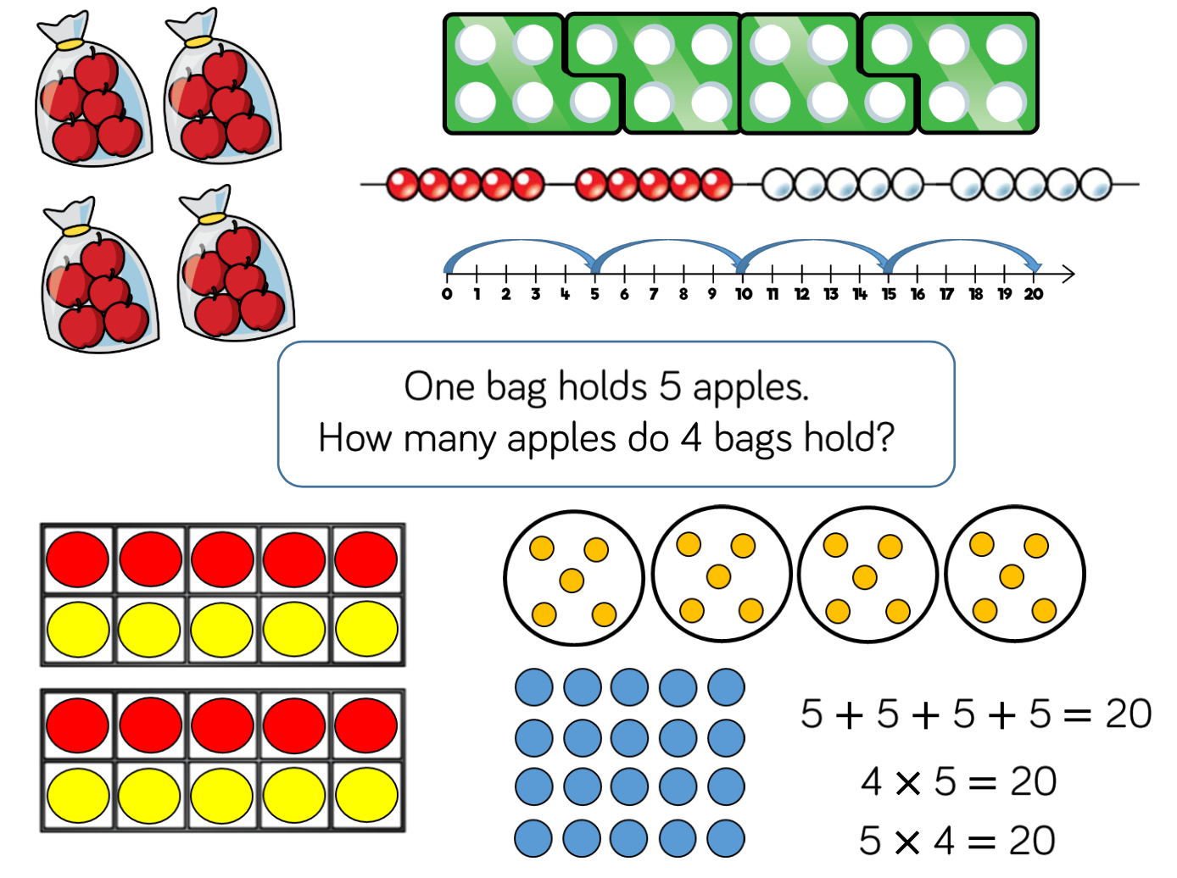
Multiply 1-digit numbers by 2-digit numbers | Year 3/4 |      | 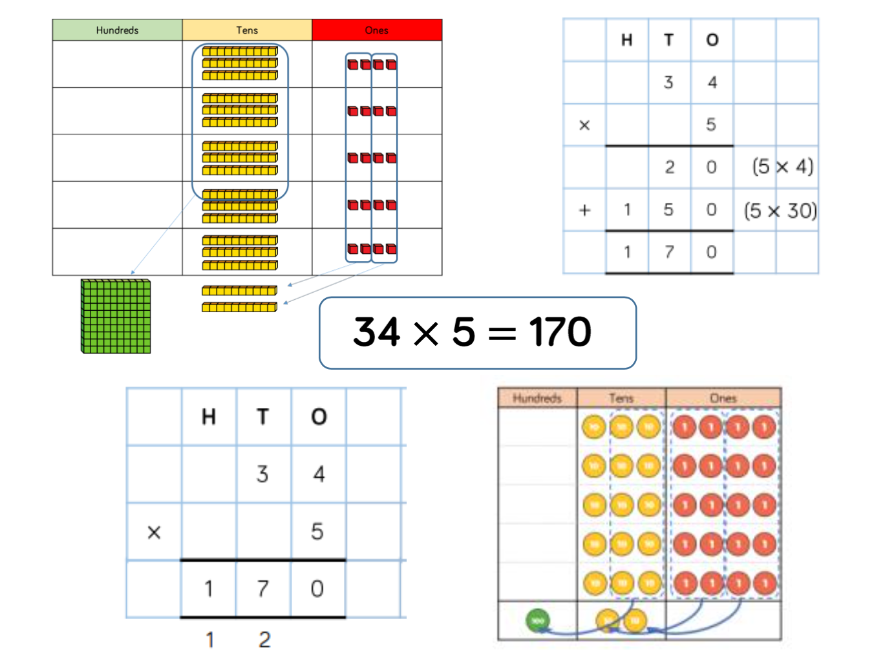
Multiply 3-digit numbers by 1-digit numbers | Year 3/4 |        | 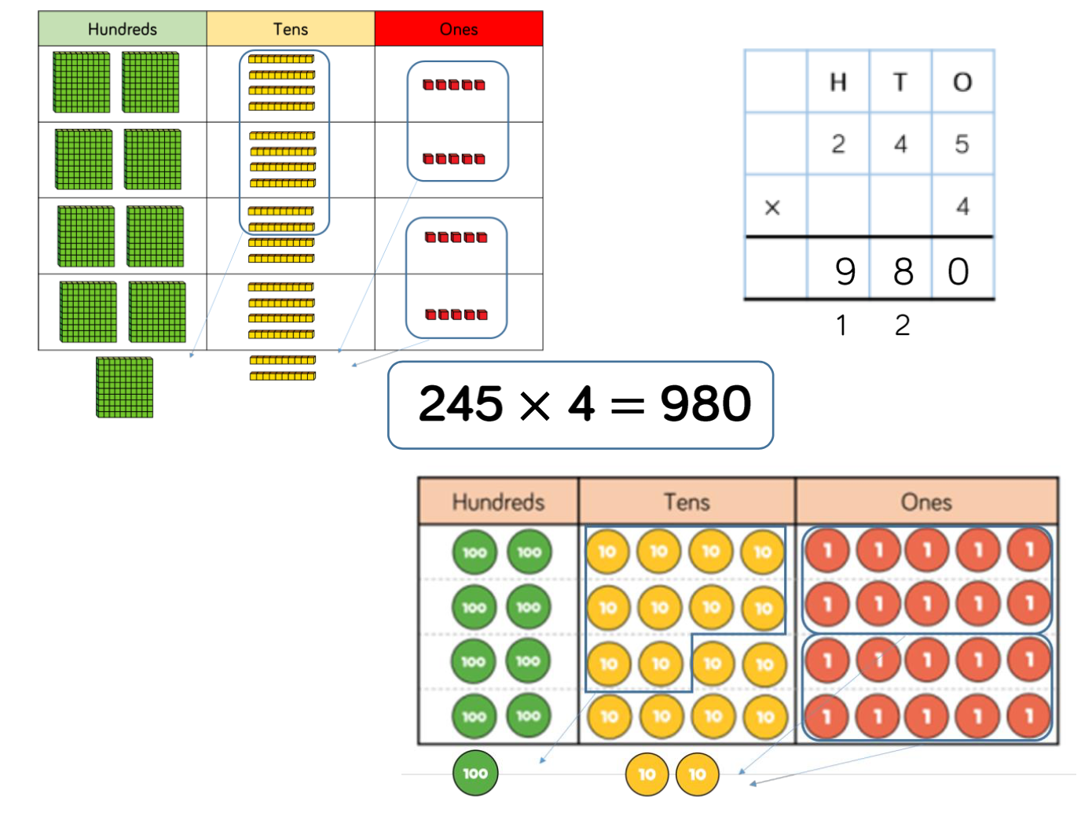
Multiply 4-digit numbers by 1-digit numbers | Year 5 |  | 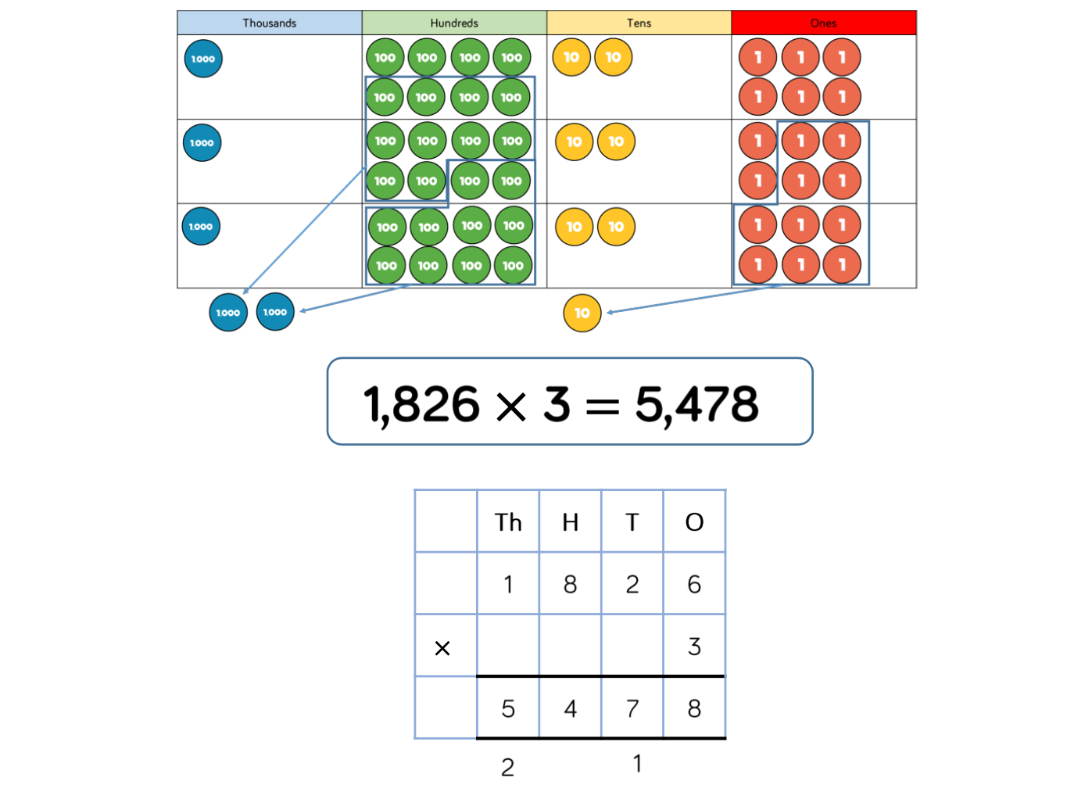
Multiply 2-digit numbers by 2-digit numbers | Year 5 | 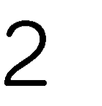 | 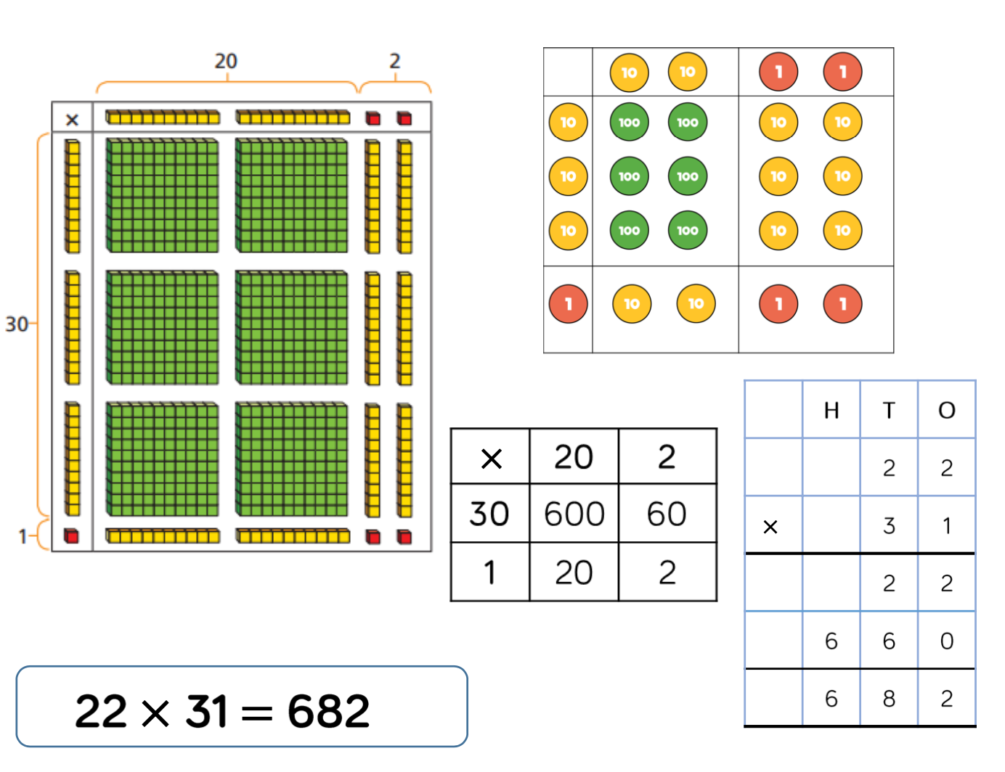
Multiply 3-digit numbers by 2-digit numbers | Year 5 |  | 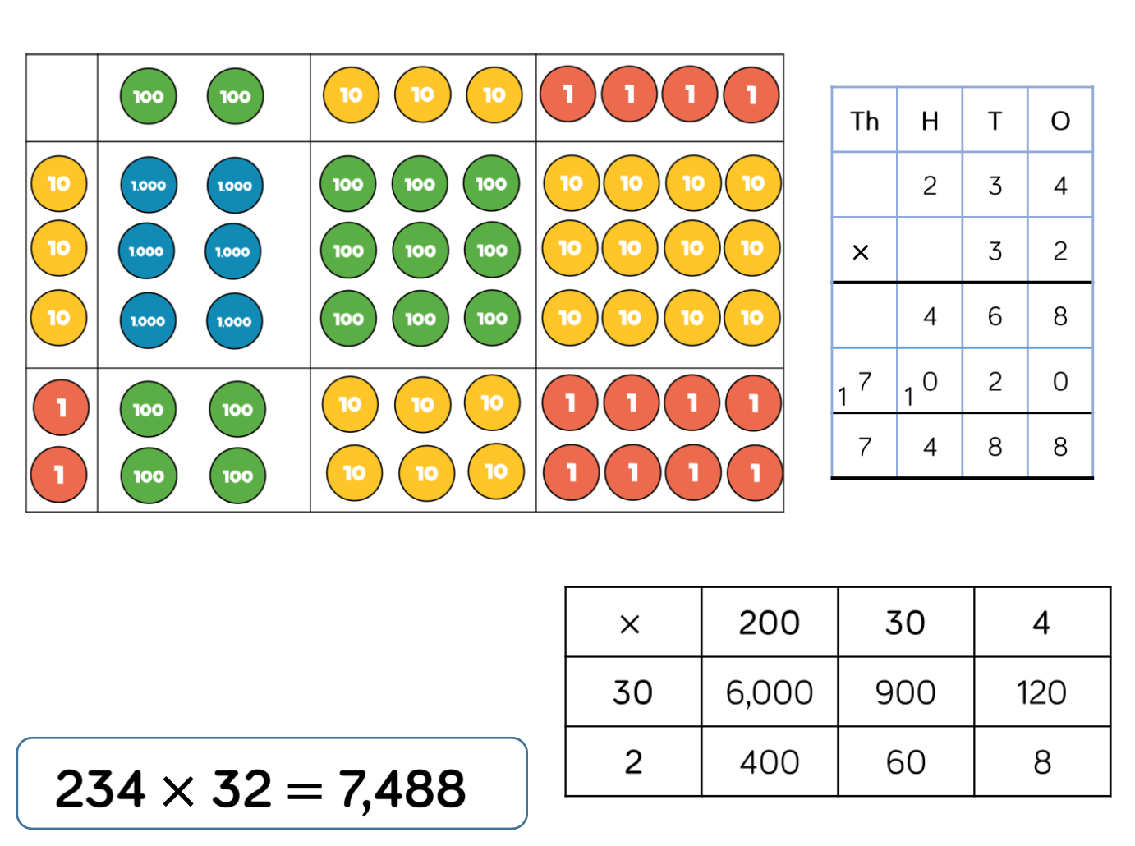
Multiply 4-digit numbers by 2-digit numbers | Year 5/6 |  | 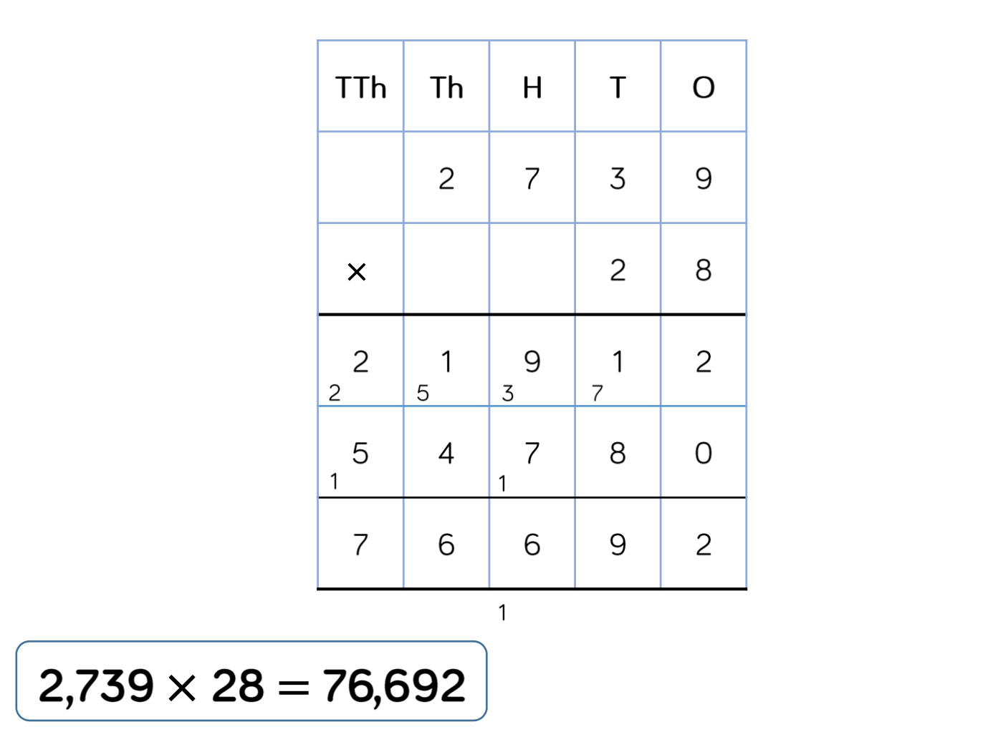

Skill | Year Group |  | Representations and Models (Concrete, Pictorial and Abstract)
Solve 1-step problems using multiplication (Sharing) | Year 1/2 |  | 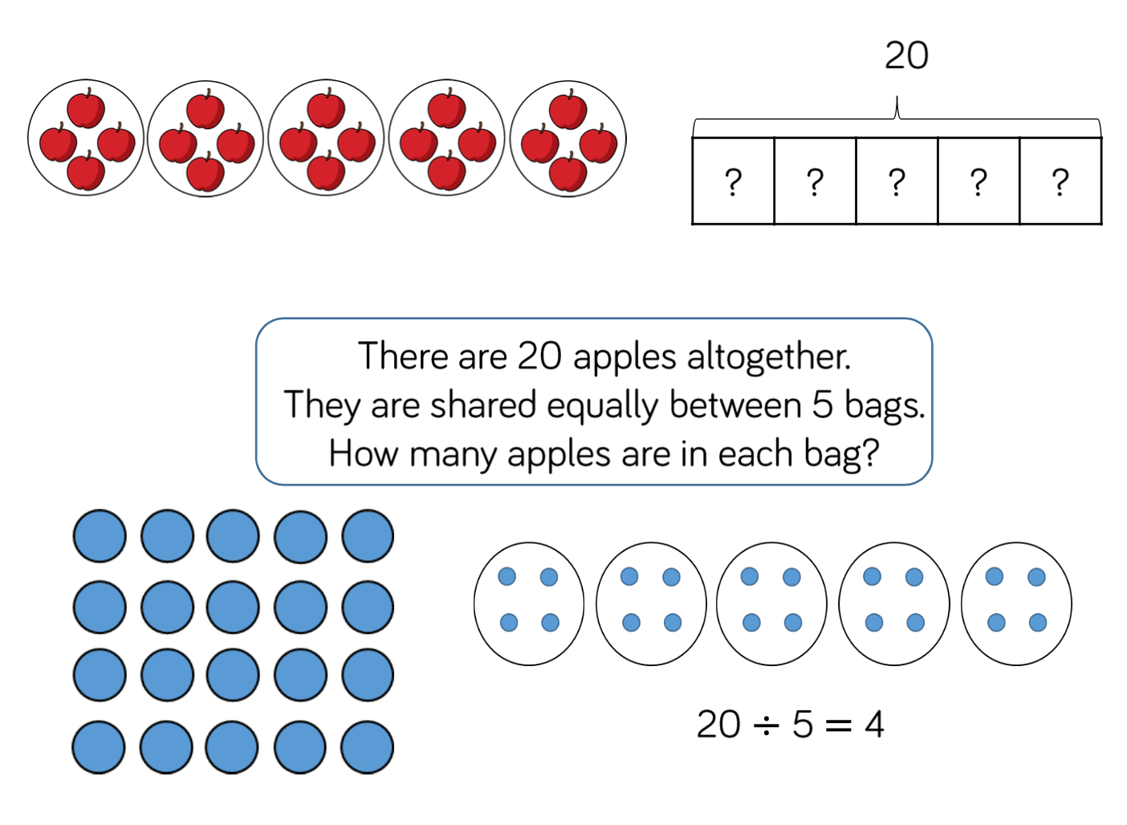
Solve 1-step problems using multiplication (Grouping) | Year 1/2 |  | 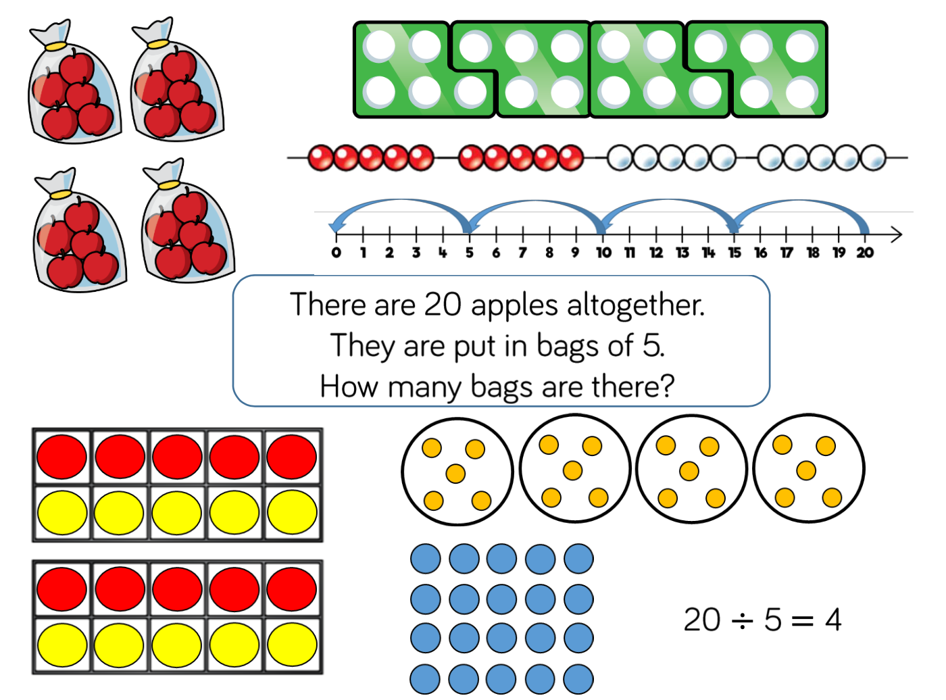
Divide 2-digit by 1-digit (Sharing with no exchange) | Year 1/2 | 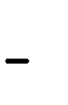 | 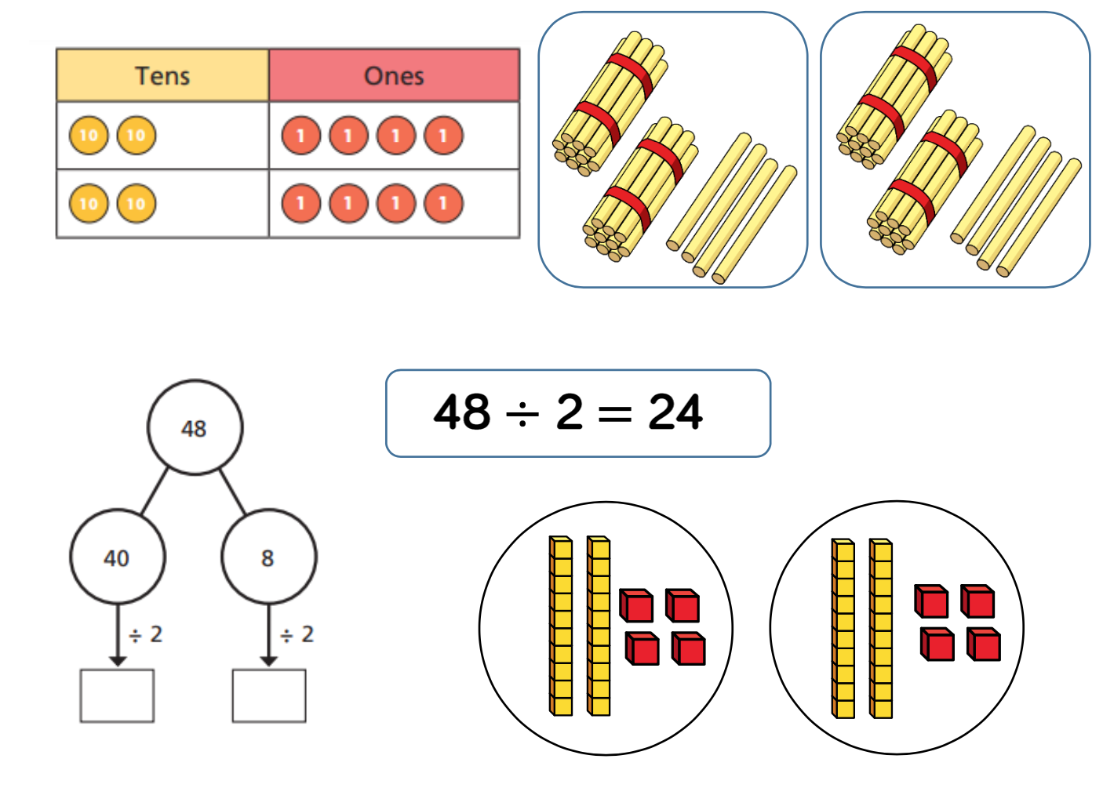
Divide 2-digit by 1-digit (Sharing with exchange) | Year 3/4 |  | 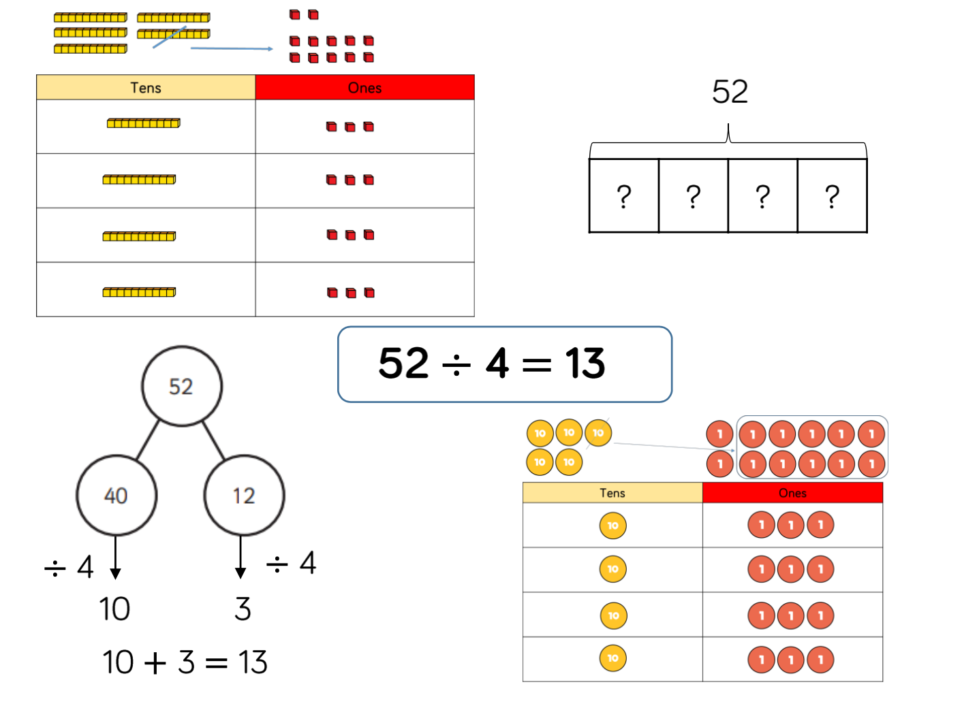
Divide 2-digit by 1-digit (Sharing with remainders) | Year 3/4 |  | 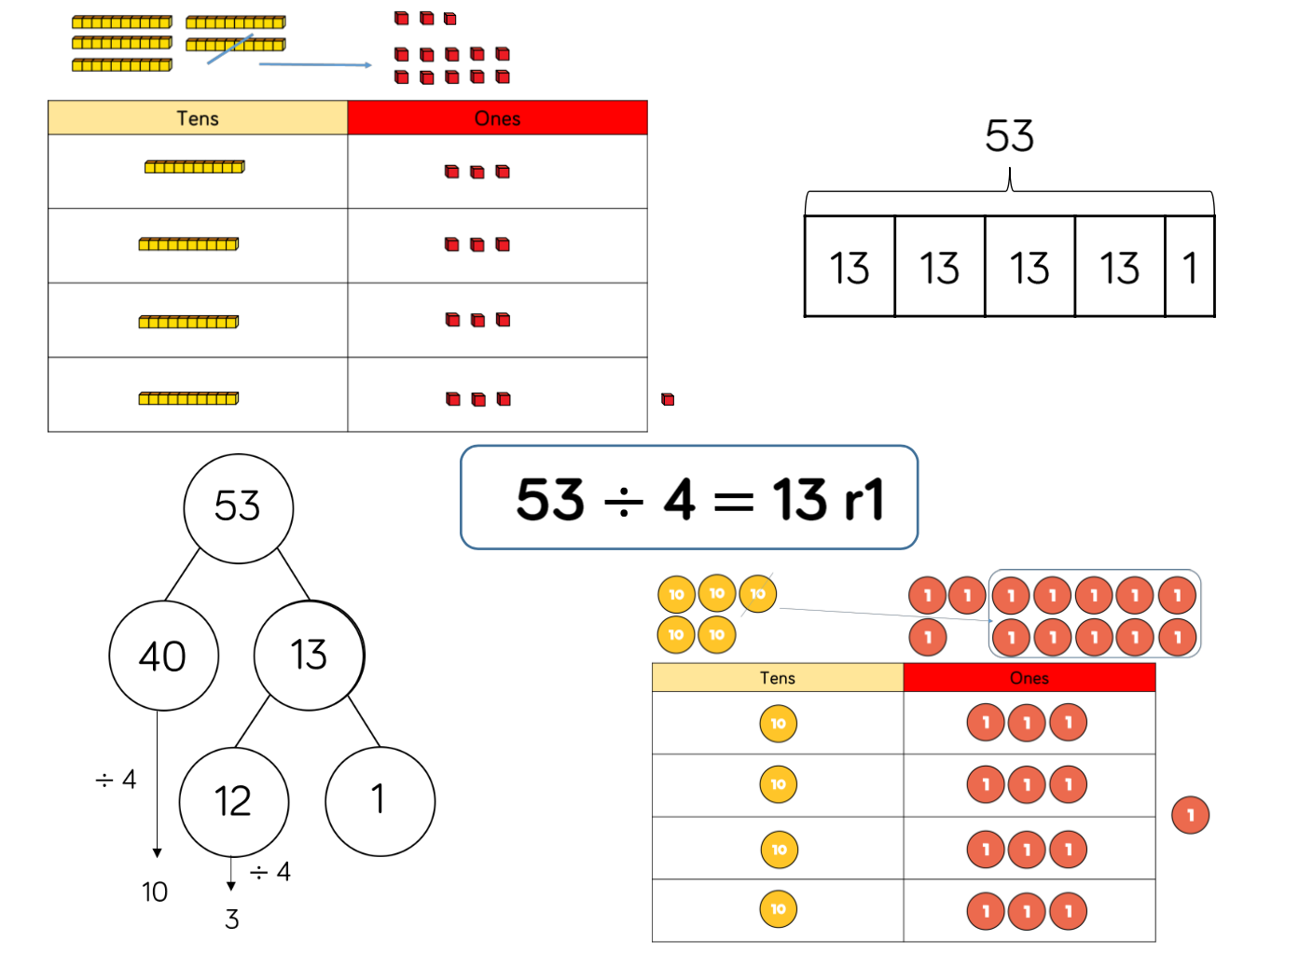
Divide 2-digit by 1-digit (Grouping) | Year 4/5 |  | 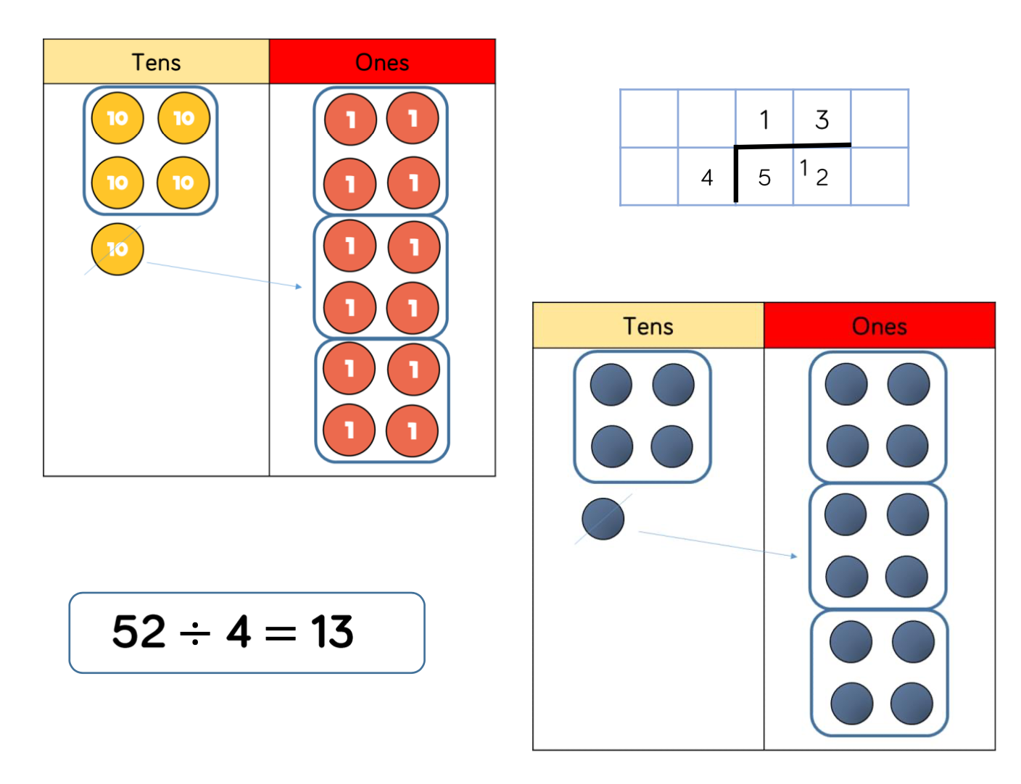
Divide 3-digit by 1-digit (Sharing) | Year 4 |  | 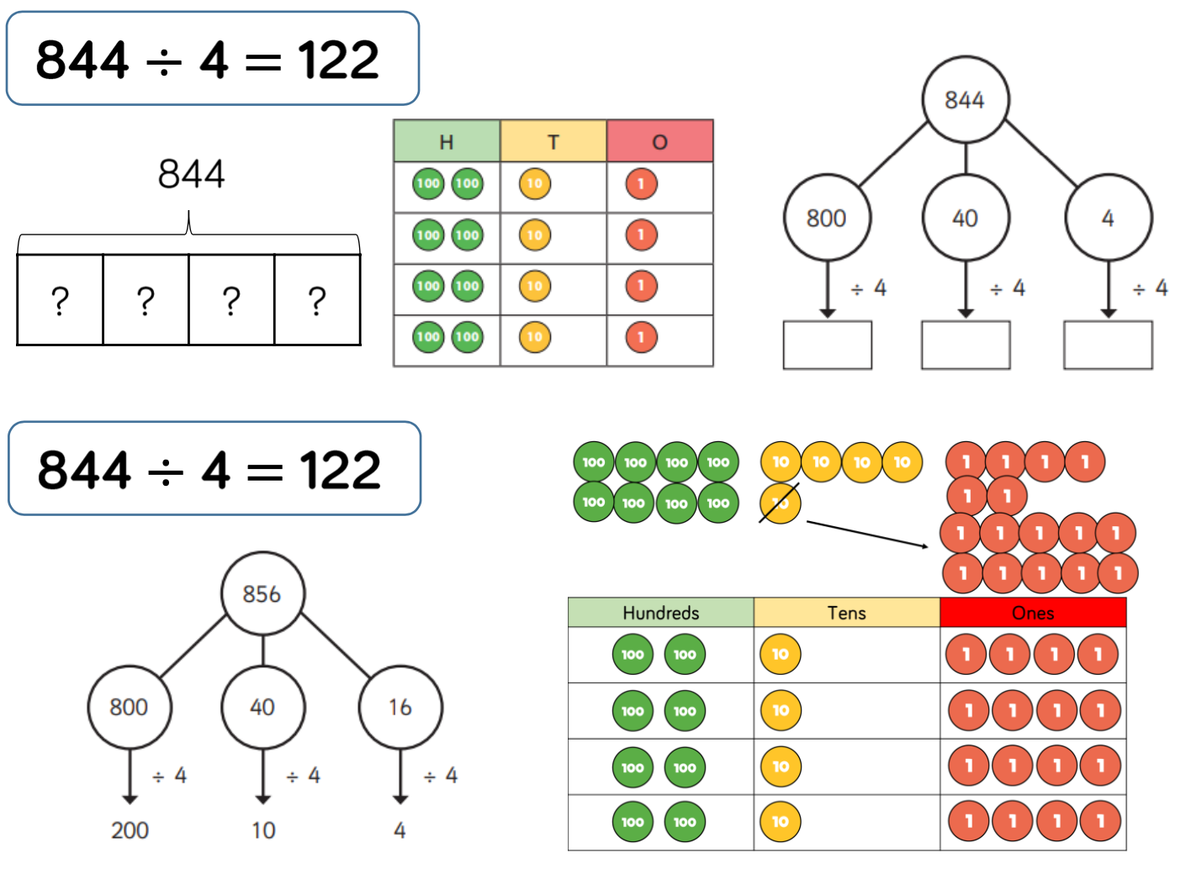
Divide 3-digit by 1-digit (Grouping) | Year 5 | 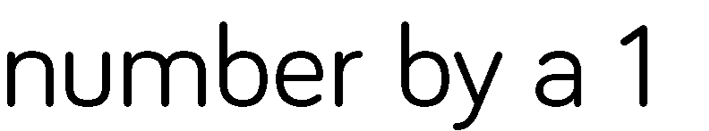 | 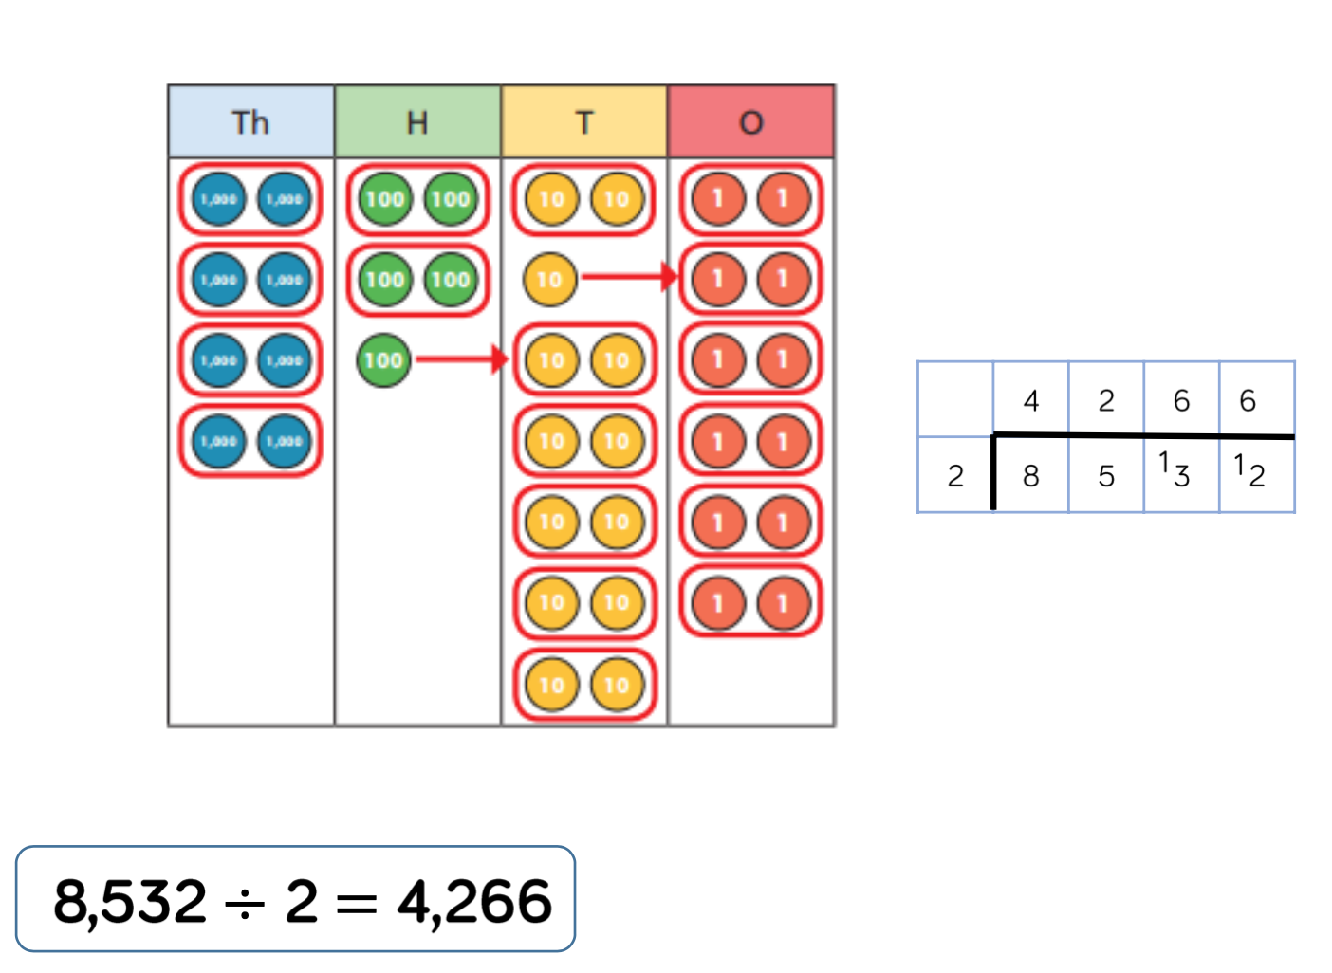
Divide multi-digits by 2-digits (Short Division) | Year 6 |  | 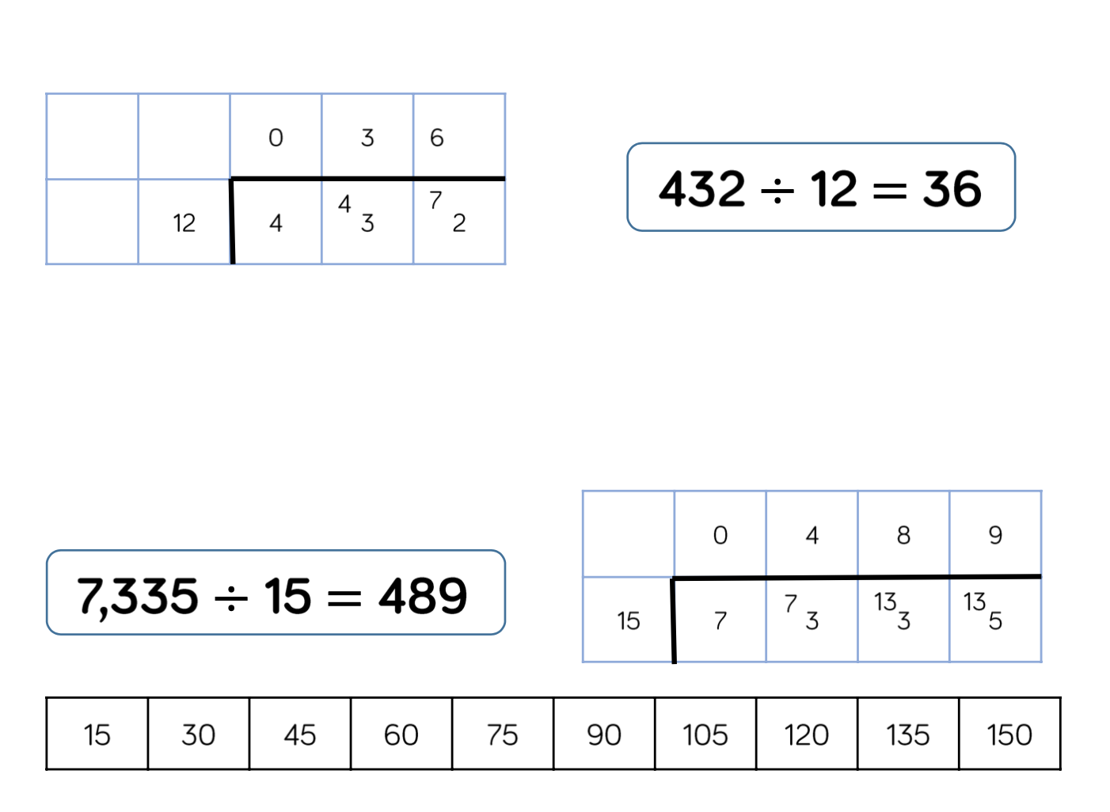
Divide multi-digits by 2-digits (Long Division) | Year 6 |  | 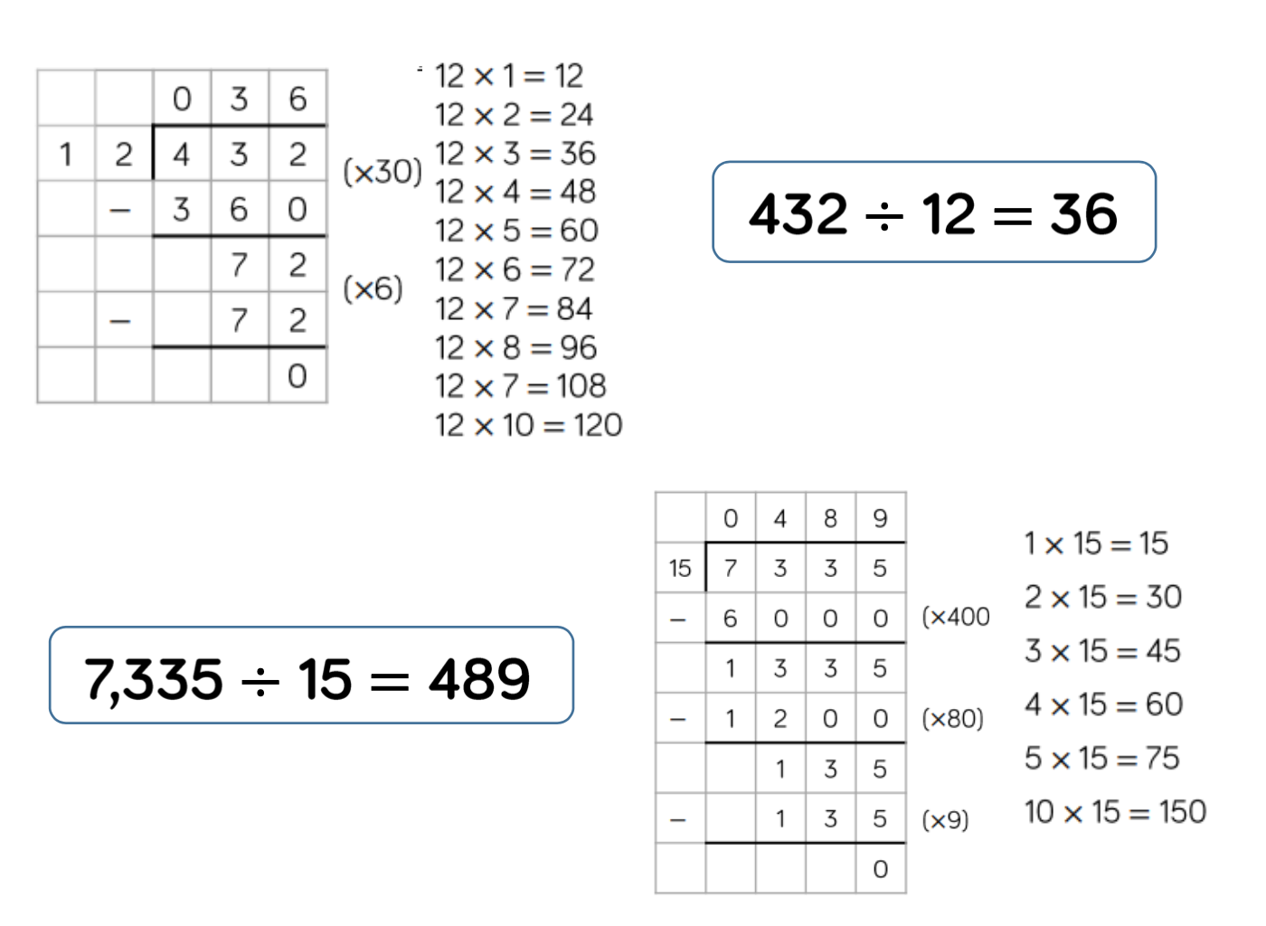
Divide multi-digits by 2-digits (Long Division - remainder) | Year 6 |      | 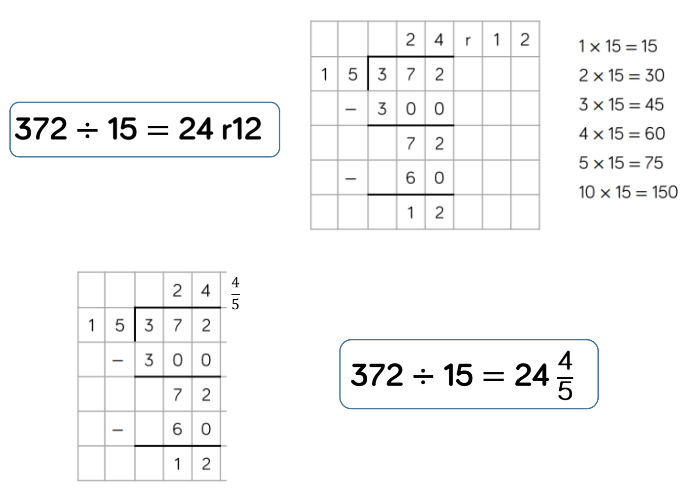

Skill | Year Group |  | Representations and Models (Concrete, Pictorial and Abstract)
2 Times tables | Year 2 | Encourage daily counting in multiples forwards and backwards. This can be supported using a number line or a hundred square.  Look for patterns in the two times table, using concrete manipulatives to support. Notice how all the numbers are even and there is a patterns in the ones.  Use different models to develop fluency. | 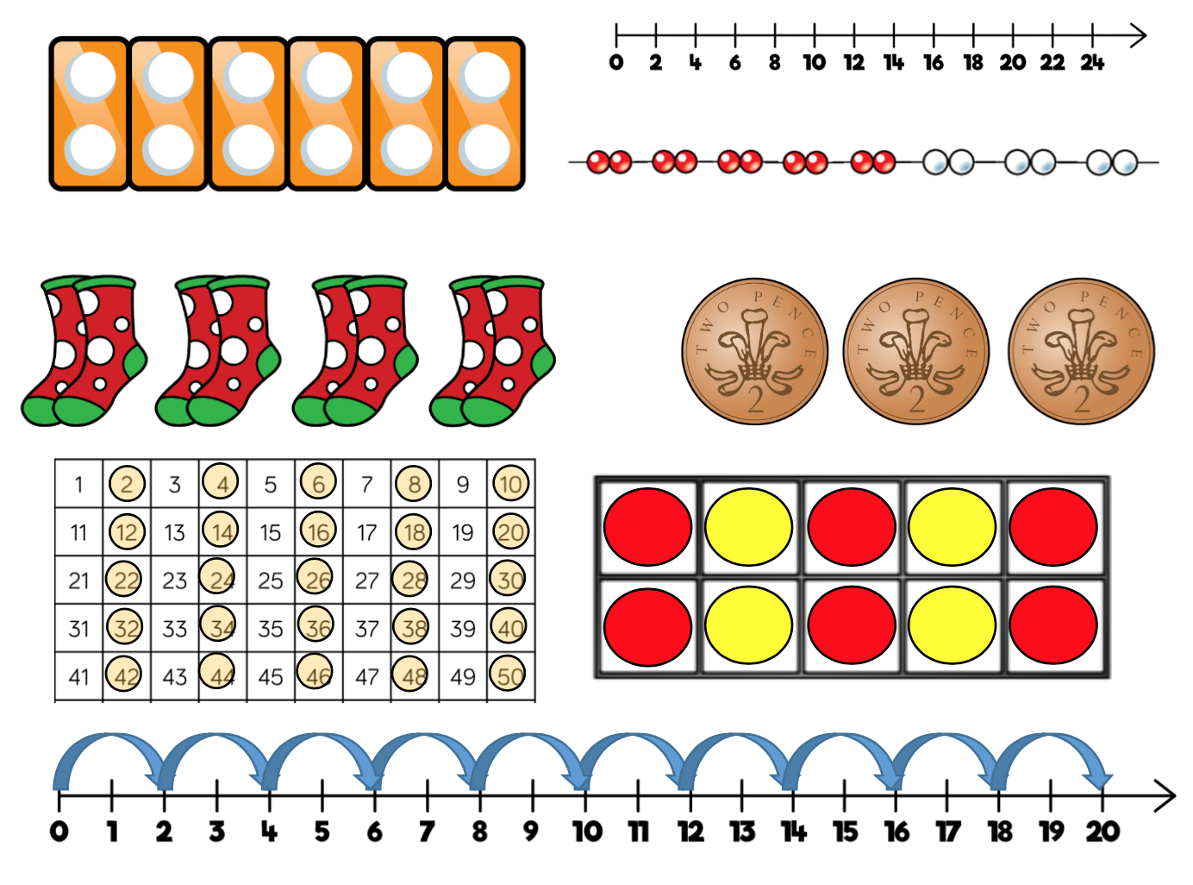
5 Times tables | Year 2 | Encourage daily counting in multiples forwards and backwards. This can be supported using a number line or a hundred square.  Look for patterns in the five times table, using concrete manipulatives to support. Notice the patterns in the ones as well as highlighting the odd, even, odd, even pattern. | 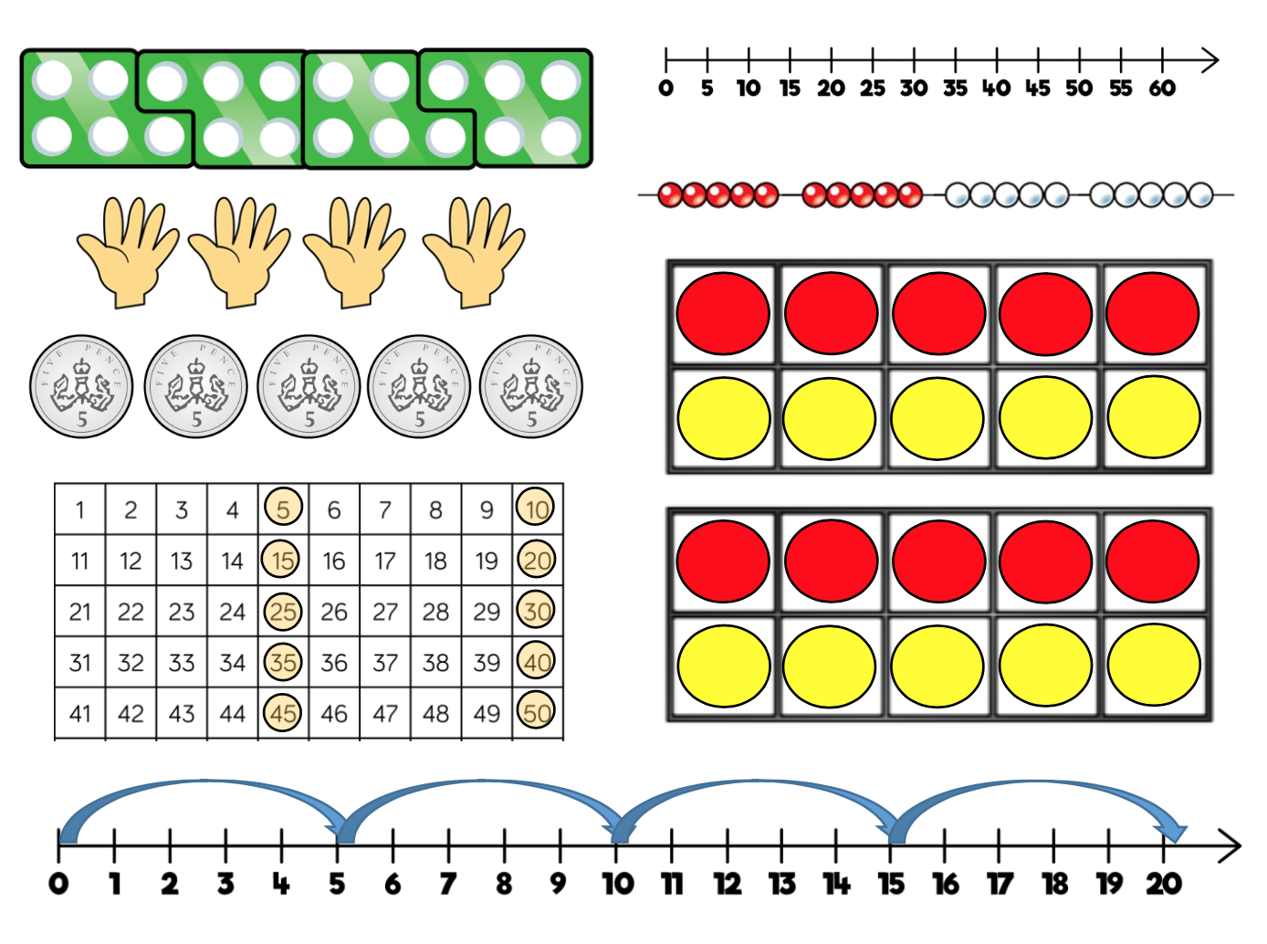
10 Times tables | Year 2 | Encourage daily counting in multiples forwards and backwards. This can be supported using a number line or a hundred square.  Look for patterns in the ten times table, using concrete manipulatives to support. Notice the pattern in the digits, the ones are always 0, and the tens increase by 1 ten each time. | 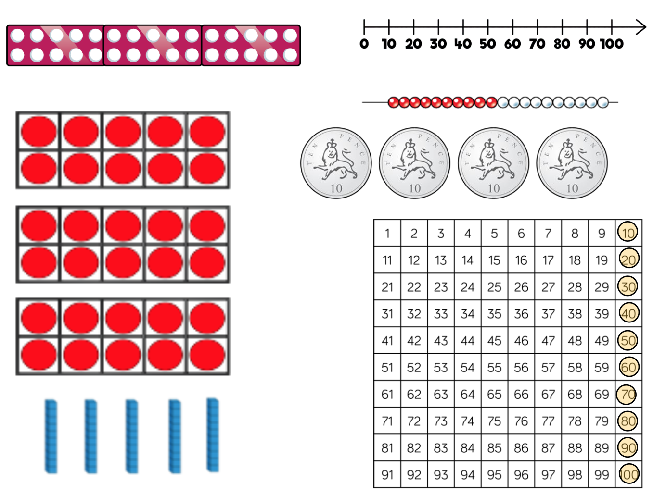
3 Times tables | Year 3 | Encourage daily counting in multiples forwards and backwards. This can be supported using a number line or a hundred square.  Look for patterns in the three times table, using concrete manipulatives to support. Notice the patterns in the ones as well as highlighting the odd, even, odd, even pattern, using number shapes to support. Highlight the pattern in the ones using a number square. | 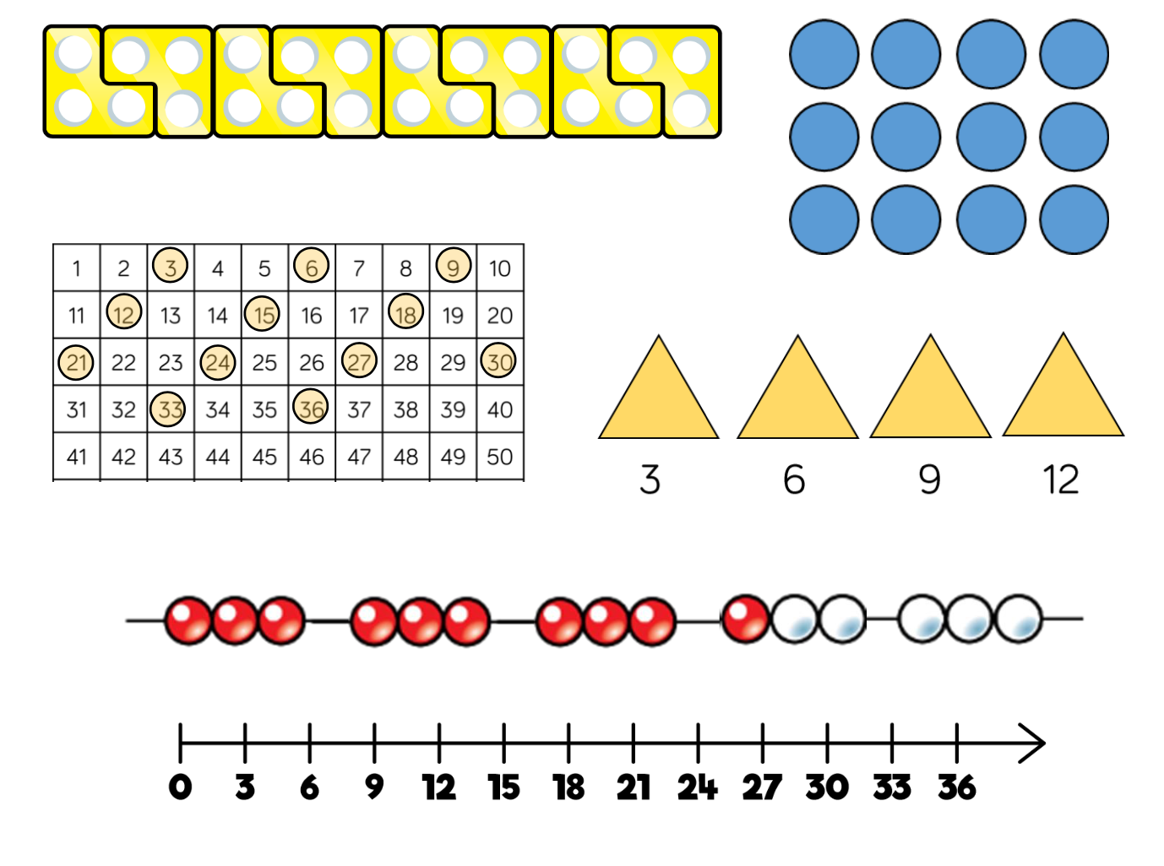
4 Times table | Year 3 | Encourage daily counting in multiples forwards and backwards. This can be supported using a number line or a hundred square.  Look for patterns in the four times table, using manipulatives to support. Make links to the 2 times table, seeing how each multiple is double the twos.  Notice the pattern in the ones within each group of five multiples. Highlight that all the multiples are even using number shapes to support. | 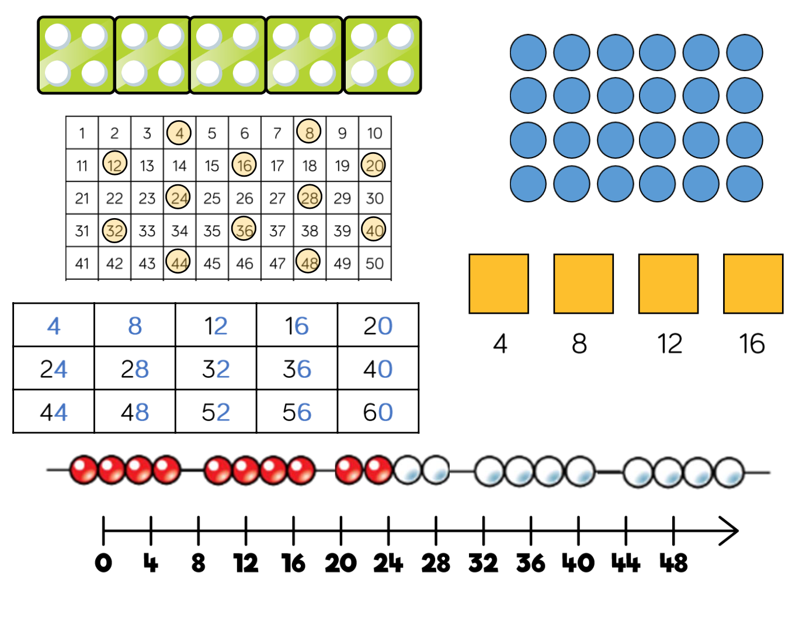
8 Times table | Year 3 | Encourage daily counting in multiples forwards and backwards. This can be supported using a number line or a hundred square.  Look for patterns in the eight times table, using manipulatives to support. Make links to the 4 times table, seeing how each multiple is double the fours.  Notice the pattern in the ones within each group of five multiples. Highlight that all the multiples are even using number shapes to support. | 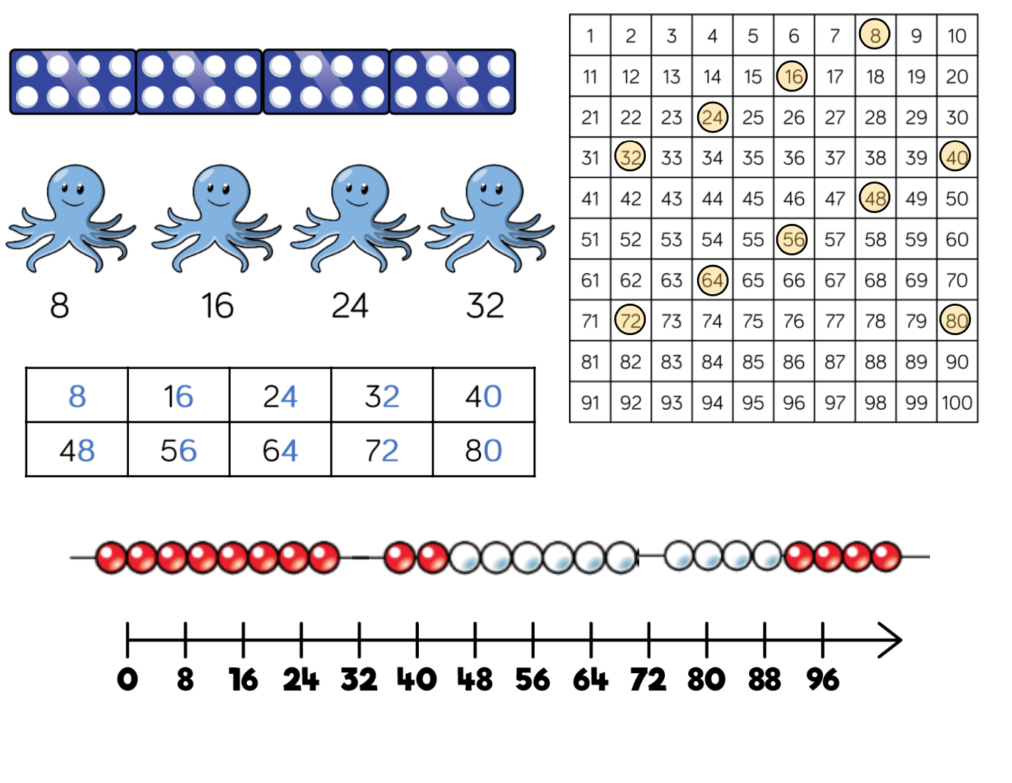
6 Times table | Year 4 | Encourage daily counting in multiples forwards and backwards. This can be supported using a number line or a hundred square.  Look for patterns in the six times table, using manipulatives to support. Make links to the 3 times table, seeing how each multiple is double the threes.  Notice the pattern in the ones within each group of five multiples. Highlight that all the multiples are even using number shapes to support. | 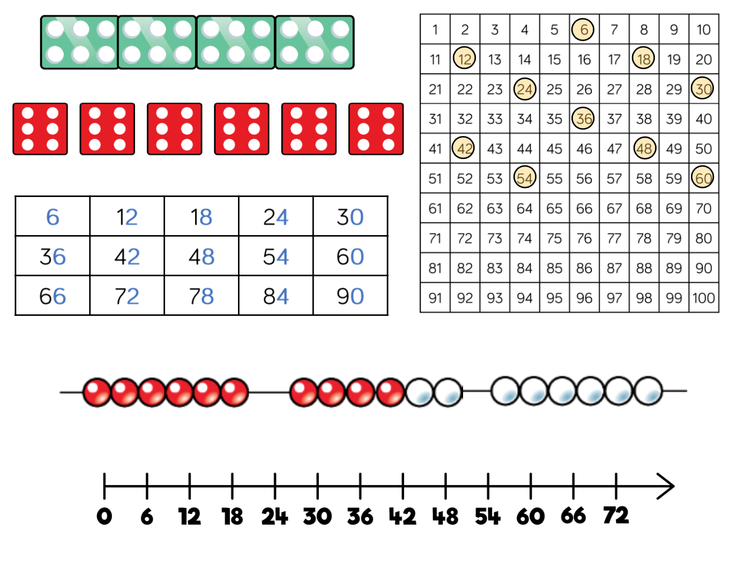
9 Times Table | Year 4 | Encourage daily counting in multiples forwards and backwards. This can be supported using a number line or a hundred square.  Look for patterns in the nine times table, using concrete manipulatives to support.  Notice the pattern in the tens and ones using a hundred square to support as well as noting the odd, even pattern within the multiples. | 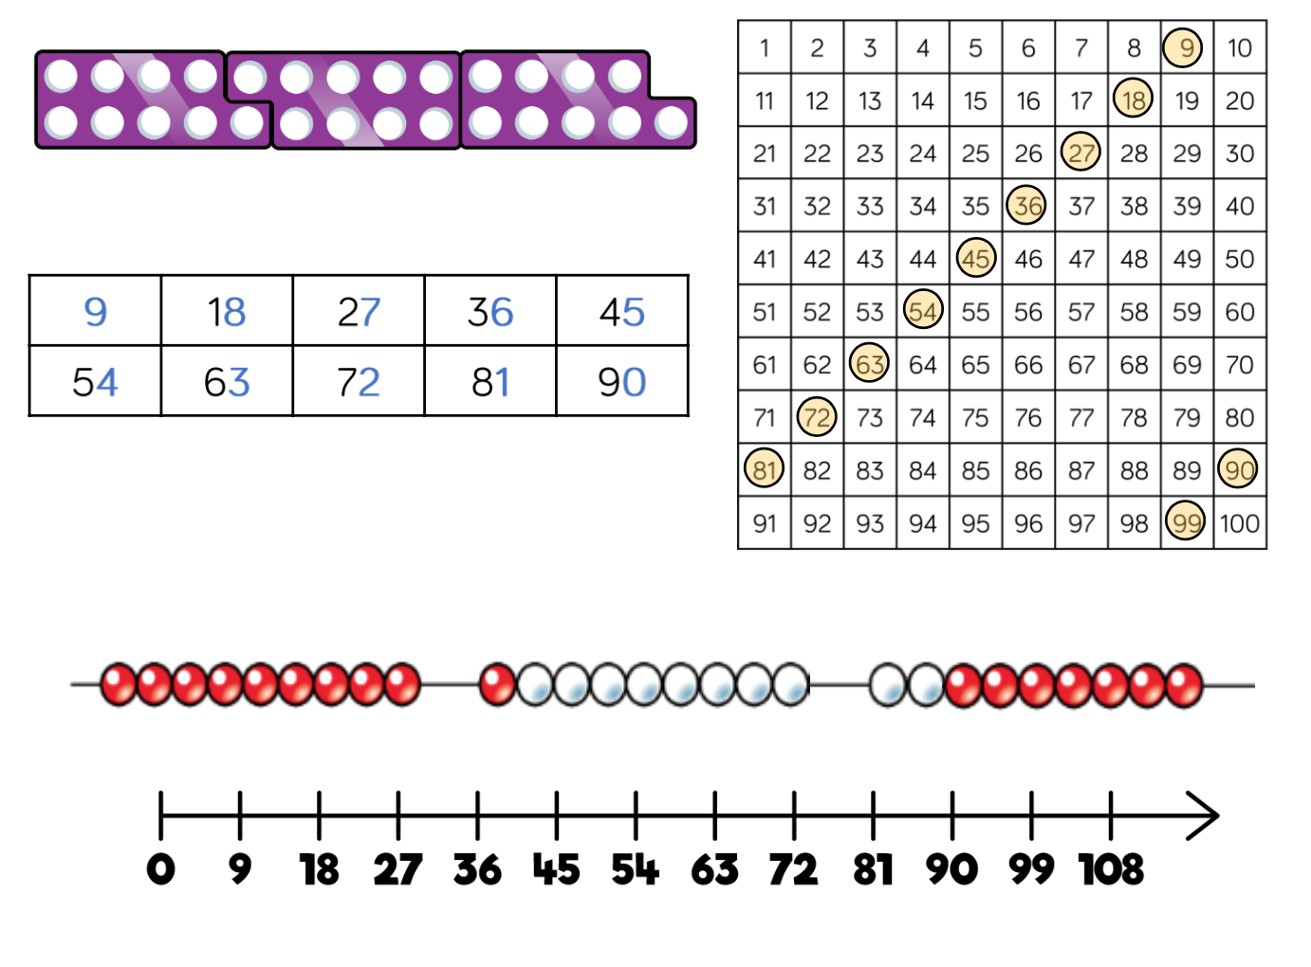
7 Times Table | Year 4 | Encourage daily counting in multiples forwards and backwards. This can be supported using a number line or a hundred square.  The seven times table can be trickier to learn due to the lack of an obvious pattern in the numbers, however they already know several facts due to commutativity. Children can still see the odd, even pattern in the multiples using number shapes to support. | 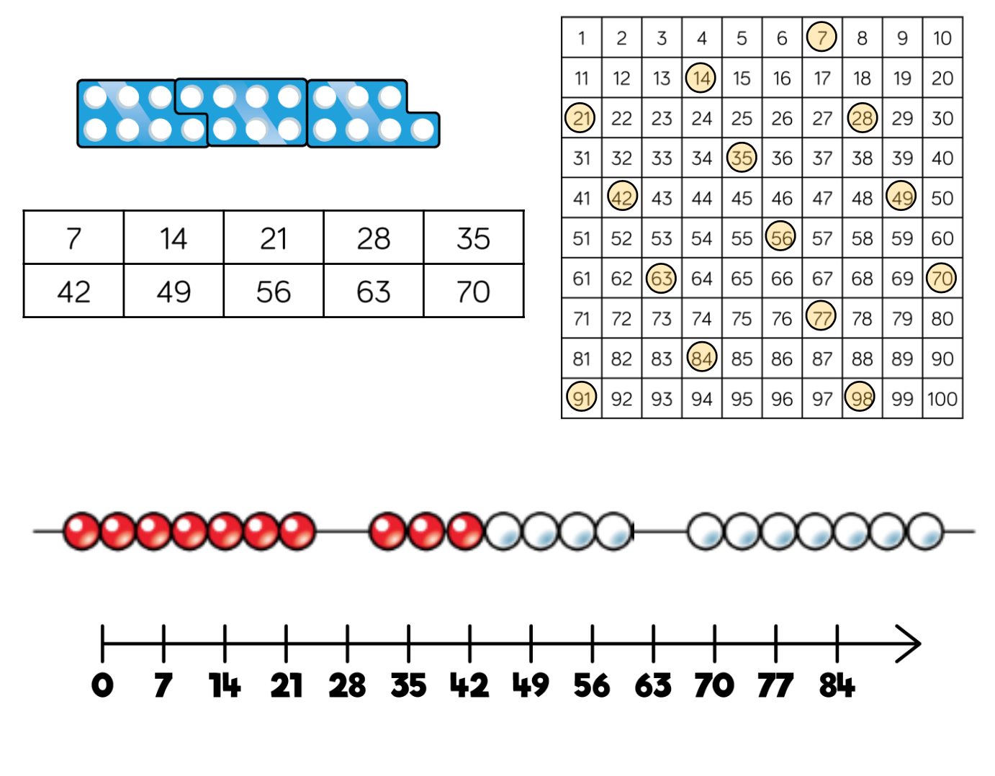
11 Times Table | Year 4 | Encourage daily counting in multiples forwards and backwards. This can be supported using a number line or a hundred square.  Look for patterns in the six times table, using manipulatives to support.  Notice the pattern in the tens and ones using a hundred square to support. Also consider the pattern after crossing the 100. | 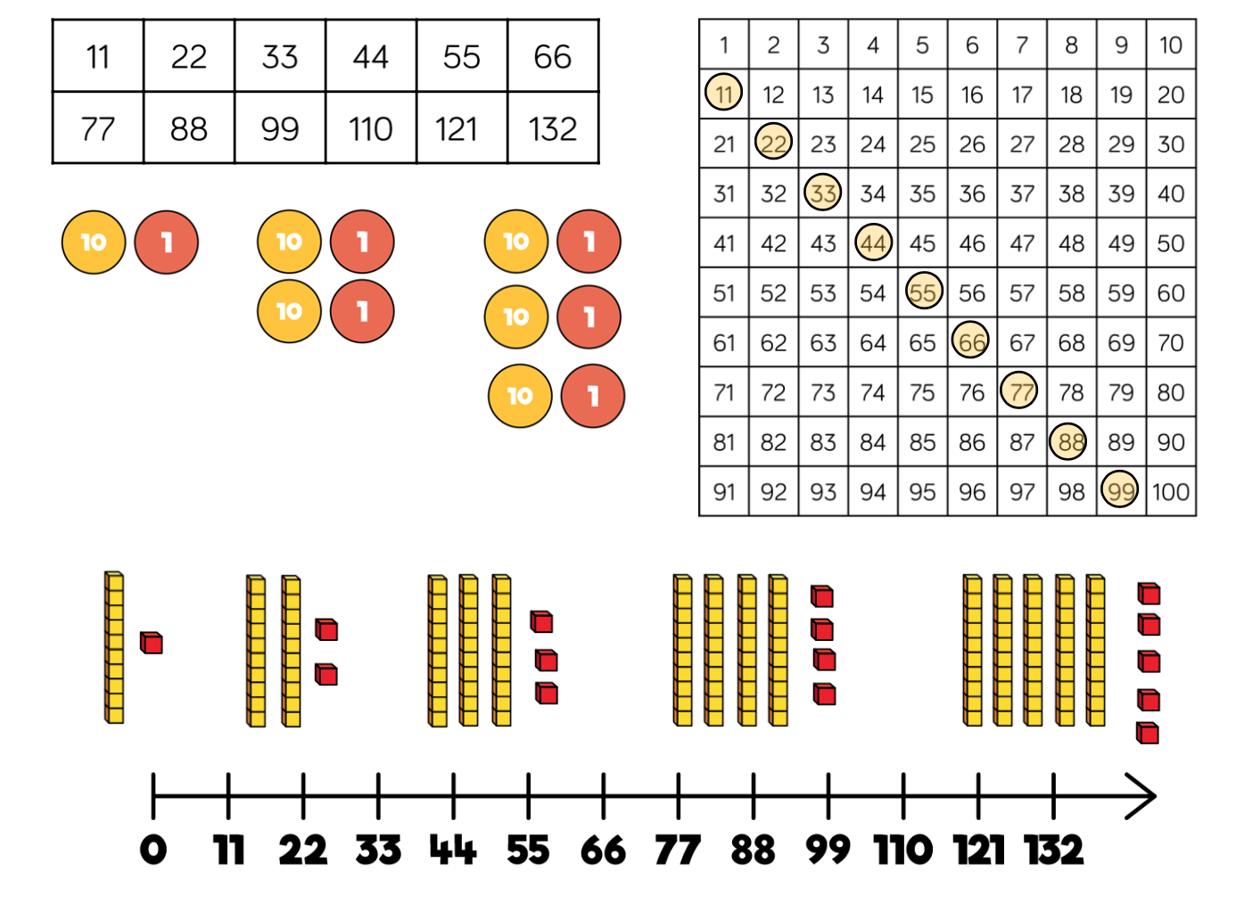

12 Times Table | Year 4 | Encourage daily counting in multiples forwards and backwards. This can be supported using a number line or a hundred square.  Look for patterns in the twelve times table, using manipulatives to support. Make links to the 6 times table, seeing how each multiple is double the sixes.  Notice the pattern in the ones within each group of five multiples. The hundred square can support in highlighting the pattern. | 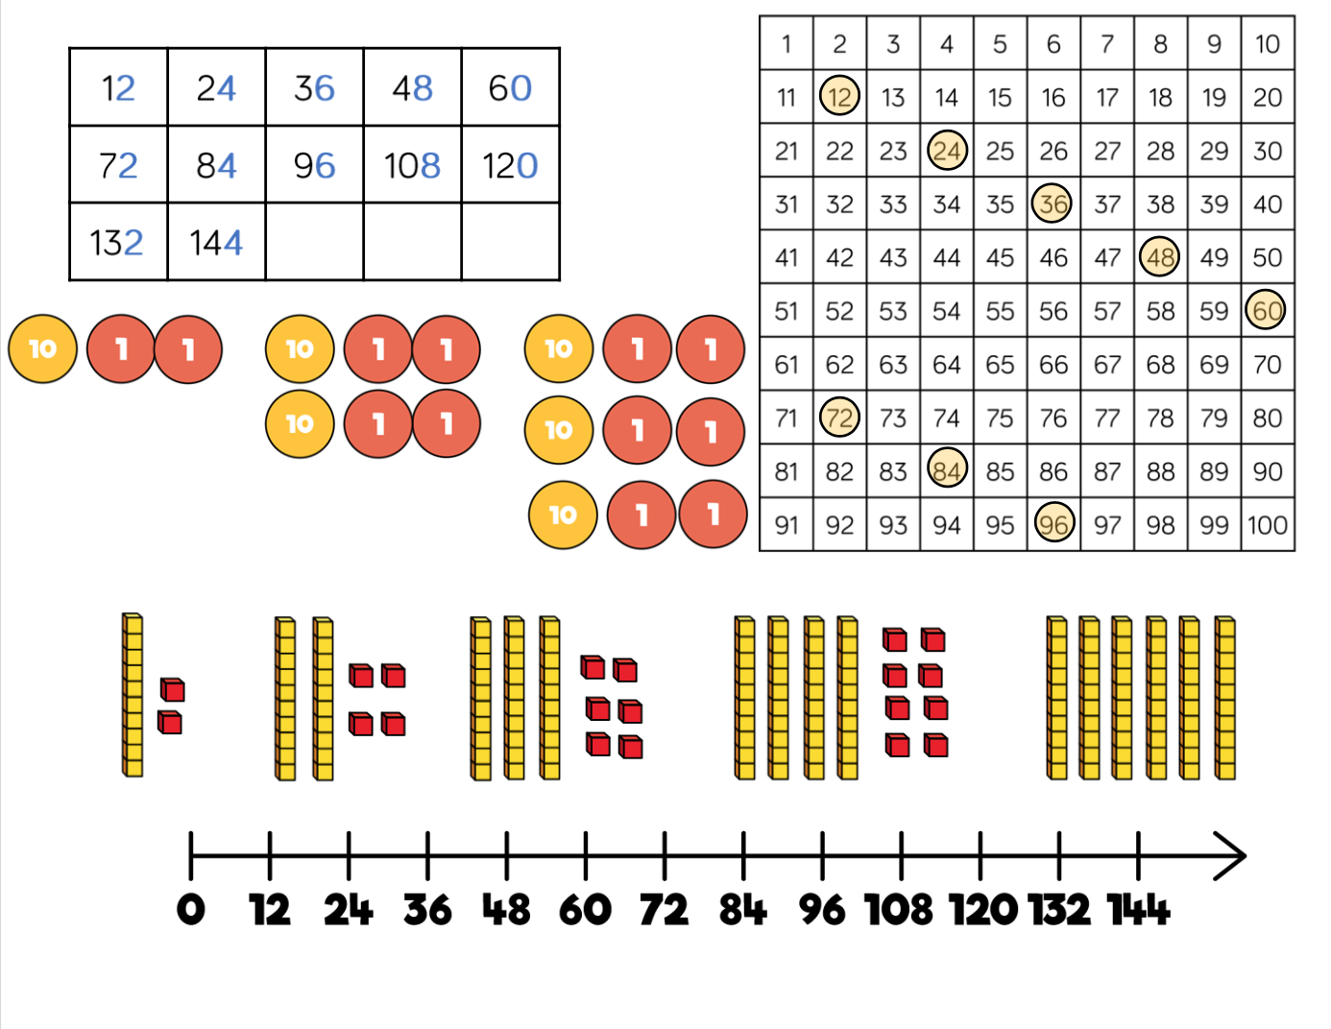

Addend | A number to be added to another. |  | Minuend | A quantity or number from which another is subtracted.
Aggregation | Combining two or more quantities or measures to find a total. |  | Multiplicand | In multiplication, a number to be multiplied by another.
Array | An ordered collection of counters, cubes or other item in a rows or columns. |  | Partitioning | Splitting a number into its component parts.
Augmentation | Increasing a quantity or measure by another quantity. |  | Product | The result of multiplying one number by another.
Commutative | Numbers can be added in any order. |  | Quotient | The result of a division
Complement | In addition, a number and its complement make a total e.g. 300 is the complement to 700 to make 1,000 |  | Reduction | Subtraction as take away.
Difference | The numerical difference between two numbers is found by comparing the quantity in each group. |  | Remainder | The amount left over after a division when the divisor is not a factor of the dividend
Dividend | In division, the number that is divided. |  | Scaling | Enlarging or reducing a number by a given amount, called the scale factor.
Divisor | In division, the number by which another is divided. |  | Subitise | Instantly recognise the number of objects in a small group without needing to count.
Exchange | Change a number or expression for another of an equal value. |  | Subtrahend | A number to be subtracted from another.
Factor | A number that multiples with another to make a product. |  | Sum | The result of an addition.
 |  |  | Total | The aggregate or the sum found by addition.

