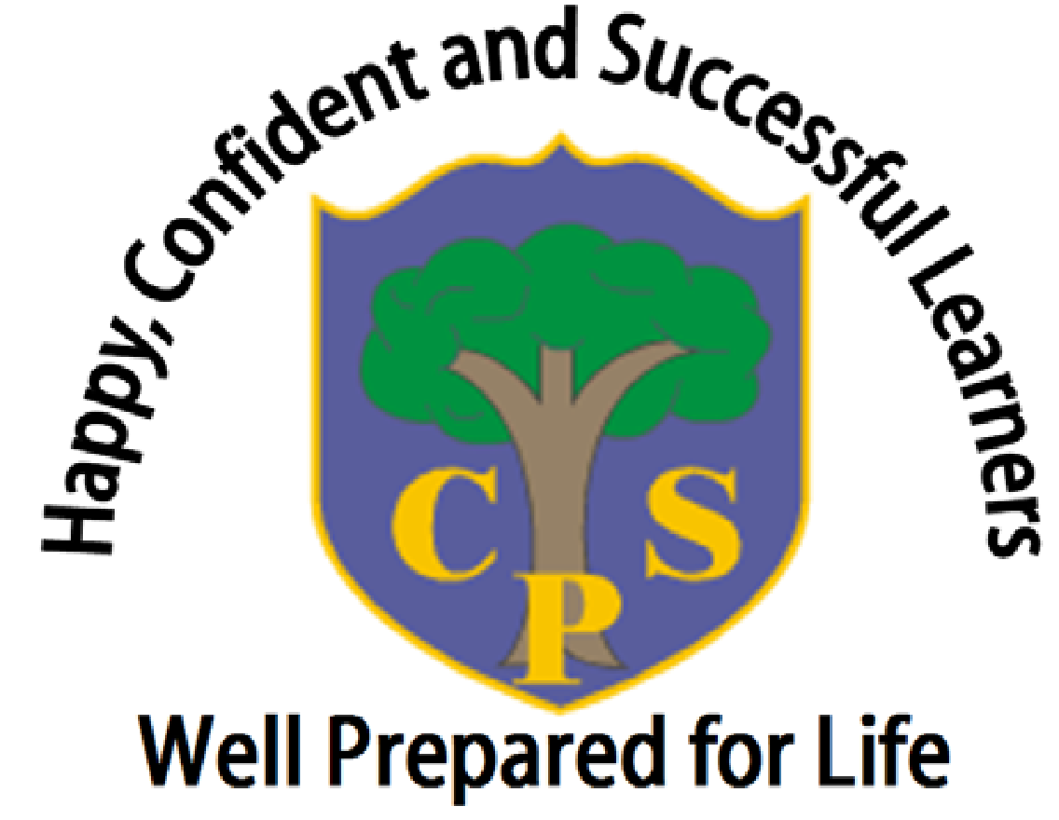

The Coppice Primary School
Healthy Lunchbox and Breaktime Snack Policy

Written by | Billy Hutt and Lindsey Ashwell
Approved by Trustees | March 2025
Date for Review | March 2028

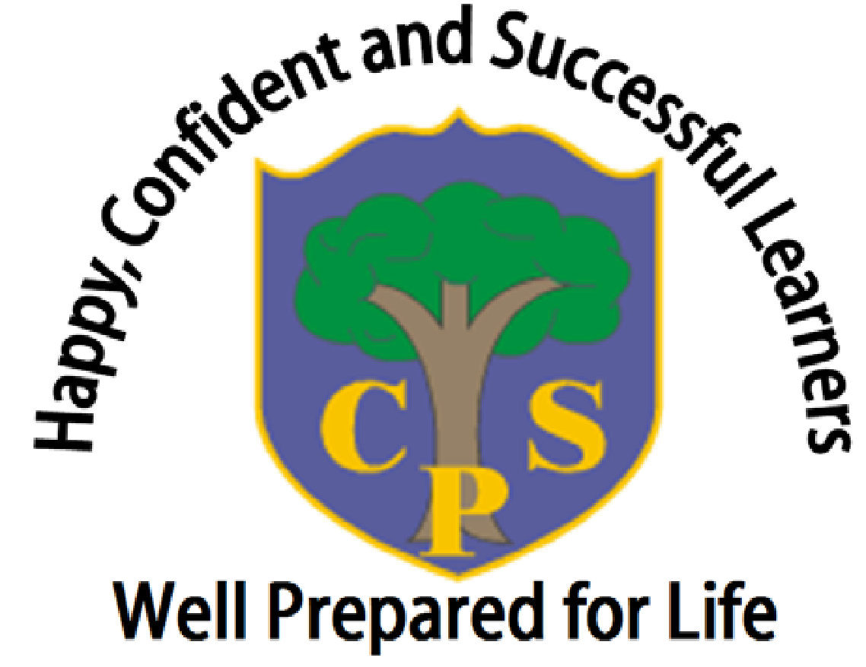

1. School vision

“Happy, confident and successful learners that are well prepared for life”

2. Purpose of the policy:

To ensure that all snacks and packed lunches brought from home provide the pupil with healthy and nutritious food that is similar to food served in schools, which is now regulated by national standards.

Childhood is an important time to establish good eating habits for future health. School healthy eating education gives pupils the knowledge and opportunity to make healthier choices. Therefore, it is a school’s job to educate its children in eating a balanced, healthy diet and we have a responsibility to ensure that our children are eating as healthily as possible when on the school grounds and avoid eating or drinking items that contain unnecessary sugar and salt.

2.1 This document is intended for:

- All teaching and school management staff
- All Teaching Assistants and pupil support staff
- School Trustees
- Parents
- Inspection teams

  - Aims and objectives of the policy:

- To ensure that the school makes a positive contribution to children’s overall health.

- To encourage parents who send snacks or packed lunches in to school, to follow the national standards that schools adhere to when providing meals for children (https://www.gov.uk/government/publications/school-food-standards-resources-for-schools/school-food-standards-practical-guide)

- To provide support and clarity to parents when choosing what food items to send in to school.

3. Drinks in school

It is important that children drink enough during the day so that they don’t become dehydrated and tired. Due to this, we make sure that water is freely available throughout the school day, both at break time and lunchtime.

- We allow children to bring refillable water bottles to school. These bottles should contain plain, unflavoured water.
- Milk is available to order from Nursery through to Yr6 (https://coolmilk.com)
- Squash or flavoured milk can be sent in separately with a packed lunch.
No fizzy drinks are allowed.

4. Lunchboxes:

4.1 Children eating a packed lunch from home:

- The school will provide appropriate dining room facilities where pupils can eat their packed lunches (Nursery, Yrs 3,4,5 and 6 in the Junior hall. Yrs R,1 and 2 in the Infant hall.)

- The school will ensure that free, fresh drinking water is always readily available.

- Fridge space for packed lunches is not available, so during particularly hot weather, it is advisable to bring packed lunches in insulated bags with freezer blocks to keep the food as cool and fresh as possible.

- Packed-lunch pupils and school-dinner pupils are timetabled so they can eat together as a class/year group.

4.2 Lunchbox recommendations:

A healthy snack at break time can help pupils with both their concentration and behaviour in the classroom. Suitable drinks and snacks help prevent tooth decay and reduce salt intake. It will also help children meet the healthy target of five or more portions of fruit and vegetables a day.
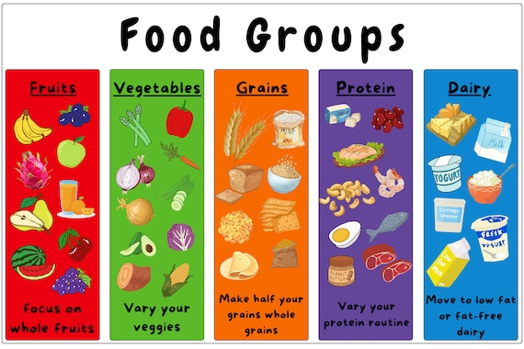
- A healthy packed lunch is a balanced meal
providing a variety of nutrients.

- Try to provide food from across the 5 food groups.

- Do not send in nuts or nut-based products, as several children in school have severe nut allergies.

4.3 Healthier ideas for lunchboxes:

- Replace sweets and chocolate with fresh fruit, such as a small bunch of grapes or fruit salad.
- Replace cakes and pastries with fruit bread, low-sugar muesli bars or malt loaf.
- Replace salted savoury snacks such as crisps with rice cakes or breadsticks.
- Limit confectionaries such as chocolate bars, chocolate-coated biscuits and sweets.
- Water is the preferred drink - Fizzy drinks must not be sent to school.
- Please do not include chocolate spread or peanut butter fillings for sandwiches (nut allergies)

Visit the following website for more ideas for a healthy lunch box: https://www.nhs.uk/healthier-families/recipes/healthier-lunchboxes/

5. School breaktime snacks

5.1 Guidance on what to bring in for school breaktime snacks

- Most children will benefit from a snack during the morning break to keep them going until lunchtime.

- We encourage children to bring in healthy snacks that contain no added salt, fat or sugar. Many of these help contribute towards their five daily portions of fruit and vegetables, keeps them alert, and helps them concentrate. It can be hard during the week to think of suitable items for them to bring in to school, but we are aiming with the help of the children, to not only support them in making healthy choices regarding snacks but also to reduce food packaging and waste.

- Providing snacks in a small, named container is ideal. Children in EYFS and KS1 have a daily snack of fruit or vegetable provided for free by the government, so additional snacks for these ages may not be required.

 | Recommended healthy snacks include:  • Fresh fruit, such as grapes, apples, satsumas, oranges, bananas, kiwi, melon,  mango, strawberries, blueberries, raspberries, peach, etc..  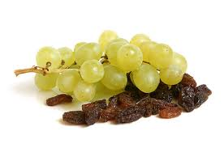    • Fresh vegetables, such as sliced red/orange pepper, cucumber, celery, carrot sticks,  sugarsnaps, mange tout, tomatoes, broccoli, etc..    Alternative snacks could also include:  • Hummus with chopped vegetables or crackers/breadsticks  • Crackers or breadsticks  • Dried fruit (e.g. raisins, mango, banana, etc..)  • Rice Cakes (not chocolate-covered)
 | • Crisps, biscuits, chocolate and cereal bars are not permitted.  • Some fruit snacks, such as fruit winders and fruit flakes, are classed as ‘sweets’ due  to the high amount of sugar they contain and are not considered a healthy option.

6 .Special diets and allergies:

To protect some of our children who have nut allergies, we do not allow nuts as snacks under any circumstances.

The school also recognises that some pupils may require special diets that do not allow for the standards to be met exactly. Consideration will be given if your child has special dietary requirements, identified by a health professional, meaning they can’t meet the above guidance. However, we still ask that their lunches remain as healthy as possible. Copies of the relevant documentation relating to their specific dietary requirements will be asked for.

For these reasons, pupils are also not permitted to swap food items.

7. Assessment, evaluation and reviewing:

Class teachers and lunchtime supervisors will monitor snacks and packed lunches. Parents may be spoken to if we have concerns about the food being provided.

The Government supports schools with lunchbox policies, making it clear that schools have the right to inspect lunch boxes for food items that are prohibited under their school food policy (see http://www.schoolfoodplan.com/actions/school-food-standards/ for more information that underpins this policy). If found, a member of staff may remove such items for the safety of other children.

8. Involvement of parents/carers:

Parents can order a sandwich, provided by the school, for their child as part of our school lunch offer. However, parents of children wishing to have packed lunches are expected to provide a packed lunch that conforms to the school packed lunch policy.

9. Data Protection Statement:
The procedures and practices created by this policy have been reviewed in the light of our GDPR Data Protection Policy.
All data will be handled in accordance with the school’s GDPR Data Protection Policy.
Name of policy | Content | Reason for policy | Who does it relate to? | Where is it stored?
Healthy Lunchbox Policy | Guidelines for healthy packed lunches | To improve healthy eating | Pupils & Parents | Secure Network drive

As such, our assessment is that this policy:
Has Few / No Data Compliance Requirements | Has A Moderate Level of Data Compliance Requirements | Has a High Level Of Data Compliance Requirements
√

