Coombeshead Academy – Registration and the Tutor Reading Programme
At Coombeshead, form tutors read to all students from Years 7 to Year 10 every morning. The books have been chosen to introduce our students to a diverse and challenging literary canon. Here is a list of the books for Year 9, together with some information about each one.

Book Title and Author | Cover | Synopsis
Ender’s Game  by Orson Scott Card | 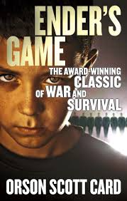 | Ender is a gamer but now he must decide what is morally justified in the name of survival. An alien threat is on the horizon and, if humanity is to be defended, the government must create the greatest military commander in history. The brilliant young Ender Wiggin is their last hope. But first he must survive the rigours of a brutal military training program. A saviour for mankind must be produced, through whatever means possible. But are they creating a hero or a monster?
Mythos  by Stephen Fry | 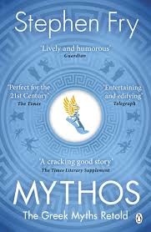 | In Stephen Fry's vivid retelling of the Ancient Greek myths, we gaze in wonder as wise Athena is born from the cracking open of the great head of Zeus and follow doomed Persephone into the dark and lonely realm of the Underworld. We shiver in fear when Pandora opens her jar of evil torments and watch with joy as the legendary love affair between Eros and Psyche unfolds. All human emotions are explored through the tales of the gods and goddesses.
Touching the Void  by Joe Simpson | 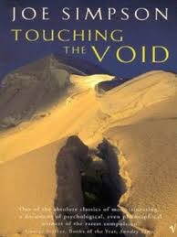 | This true story is a moving account of two friends’ difficult, terrifying and heart-breaking journey in the Peruvian Andes. Joe Simpson and his climbing partner, Simon, reached the summit of the remote Siula Grande in June 1985. A few days later, Simon staggered into Base Camp, exhausted and frost-bitten, with news that Joe was dead. What happened to Joe when Simon was forced into the appalling decision to cut the rope, makes not only an epic of survival but a compelling testament of friendship.
The Diary of a Young Girl  by Anne Frank | 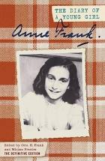 | Originally of German origin, until she was made stateless by the Nazis in 1941, this young Jewish girl is possibly the most well-known victim of the Holocaust. In July 1942, thirteen-year-old Anne Frank and her family, fleeing the Nazi occupation of The Netherlands, went into hiding in an Amsterdam warehouse. Over the next two years Anne vividly describes in her diary the frustrations of living in such close quarters, and her thoughts, feelings and longings as she grows up. Her diary ends abruptly when, in August 1944, they were all betrayed.
The Book Thief  by Markus Zusak | 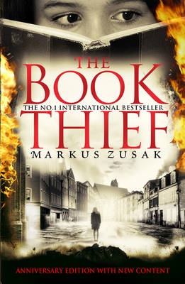 | By her brother's graveside, Liesel's life is changed forever when she picks up a single object, abandoned in the snow. It is The Gravedigger's Handbook, and this is her first act of book thievery. Set in Nazi Germany in 1939, soon she is stealing from Nazi book-burnings, the mayor's wife's library . . . wherever there are books to be found. But these are dangerous times, and when Liesel's foster family hides a Jew in their basement, nothing will ever be the same again.
Stay Where You Are and Then Leave  by John Boyne | 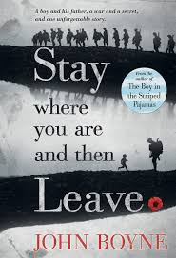 | The day the First World War broke out, Alfie Summerfield's father promised he wouldn't go away to fight - but he broke that promise the following day. Four years later, Alfie doesn't know where his father might be, other than that he's away on a special, secret mission. Then Alfie unexpectedly sees his father's name - on a sheaf of papers belonging to a military doctor….. This story explores the courage of those who fought, those who refused to fight and of those left at home and the mental health cost of this terrible conflict.
Refugee Boy  by Benjamin Zephaniah | 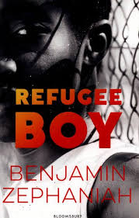 | This story examines the treatment of child refugees in this country and what parents will do to try to keep their children safe. Alem is on holiday with his father for a few days in London. He wakes one morning to find his father has left him. Alem is now on his own, in the hands of Social Services and the Refugee Council. His fate rests in their hands. He will be in danger if he is sent back to Ethiopia. With an Ethiopian father and an Eritrean mother, and both countries at war, he is welcome in neither place. He is now an asylum seeker…..
Q&A (Slumdog Millionaire)  by Vikas Swarup | 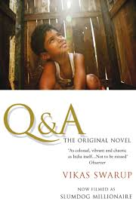 | Set in Mumbai and Delhi the story opens in a jail cell, where Ram Mohammad Thomas is being held after correctly answering all twelve questions on India's biggest quiz show, Who Will Win a Billion? The authorities do not believe that a poor orphan who has never read a newspaper or gone to school could win such a contest. But through a series of exhilarating tales, full of humour and drama, Ram explains to his lawyer how episodes in his life gave him the answer to each question.
Hidden Figures  by Margot Lee Shetterly | 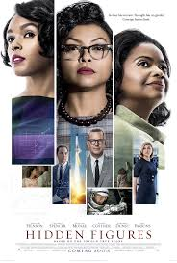 | With themes of racial and sexual inequality this novel exposes the lie of the ‘American Dream’ for many of its citizens. Moving from WWII through NASA's golden age, the civil rights era, the Space Race, the Cold War, and the women's rights movement, Hidden Figures interweaves a rich history of mankind's greatest adventure with the stories of five courageous women whose work forever changed the world. Segregated from their white counterparts, these 'coloured computers' used pencil and paper to write the equations that would launch rockets, and astronauts, into space.
The Hound of the Baskervilles  by Arthur Conan Doyle | 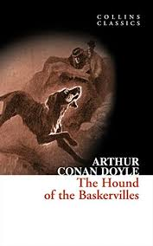 | This gothic murder mystery finds Sherlock Holmes and Dr Watson investigating the death of Sir Charles Baskerville, whose body is found on the misty and desolate Devon moors, at Grimpen Mire. The superstitious locals blame his death on the fearsome, supernatural, phantom hound that they claim has haunted the Baskerville family for generations. When the heir to the family fortune, Sir Henry, also comes under threat Holmes uses logic and rational thought to discover the truth behind the legend.
Wolf Children  by Paul Dowswell | 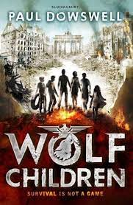 | Much has been written about the Second World War and how lives were changed but few books have focussed on what life was like for the children living in Berlin, some of them committed Nazis.  It is July 1945, Hitler's Third Reich has fallen, and Berlin is in ruins. Living on the edge of survival in the cellar of an abandoned hospital, Otto and his ragtag gang of kids have banded together in the desperate, bombed-out city. The war may be over, but danger lurks in the shadows of the wreckage as Otto and his friends find themselves caught between invading armies, ruthless rival gangs and a strange Nazi war criminal who stalks them ...
Welcome to Nowhere  by Elizabeth Laird | 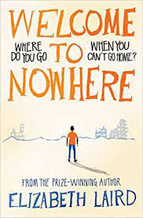 | With multiple conflicts continuing around the world and the plight of migrants a focus for many countries, this story is very much of the moment.  Set in Syria we follow the efforts of a family to survive in a war-torn country before they finally realise they have to flee if they are to survive. Mixed in is the reality of being a female in a country which does not value an education for girls, and also how a child with a disability is viewed and treated.  But the journey they undertake is not easy and there is no guarantee of a happy ending.
Black Flamingo  by Dean Atta | 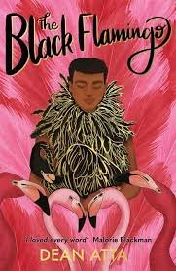 | This verse novel follows Michael, a young mixed race boy, from the age of six into his late teens as he tries to work out his identity in terms of both his race and his sexuality. Many young people face one or the other of these issues but Michael is facing both and must navigate his way to the person he wants to be.  This is not about being ready, it’s not even about being fierce, or fearless, IT’S ABOUT BEING FREE.​  He waits in the stage wings, wearing a pink wig, pink fluffy coat and black heels. One more step will see him illuminated by spotlight. He has been on a journey of bravery to get here, and he is almost ready to show himself to the world in bold colours. Can he emerge as The Black Flamingo?​

