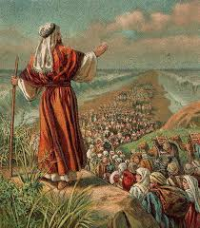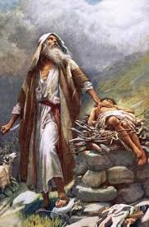

Moses led the Jewish people to escape from slavery.

Moses was a descendant of Abraham.

Abraham helped people understand there is only one God.

Abraham answered God’s call to go on an unknown journey.

**OUR BIG QUESTION**

Why is Abraham special?

**JUDAISM – Abraham & Moses**

Year 1

Abraham is the father of the Jewish nation.

**KEY VOCABULARY**

Abraham Moses

leaders promised

Pharaoh