St Chad’s C.E. Primary and Nursery School
Justice and Equality
Reflection areas from the Vision Group (Display on reflection board)
Video to introduce the theme of Justice https://www.youtube.com/watch?v=KSBhsEoKYvY
Questions to explore:
Do I always act fairly? Am I fair to other people? What unfair things make me cross? How can our school /community /world be a fairer place? What does God think is unfair in this world?
Use the PPT which explores racial justice.
Watch the Treasure Champ video about Zacchaeus https://www.bbc.co.uk/teach/class-clips-video/articles/zc3kjfr
In what ways was Zacchaeus unfair in the story? (He took money that wasn’t his.)
Were the other people unfair to Zaccheus, or did he deserve to be left out?
How did Jesus treat Zacchaeus?
How did Zacchaeus change at the end of the story? Do you think he acted fairly?
Use the Fairness resources for your Key Stage to explore fairness in Sport and the world
Learn the Speak up song https://www.youtube.com/watch?v=mXfXlin2D4E
Watch the stories of the Ant and the Dove or the Fox and the Crane to discuss fairness

Week Beginning |  | Value – Courage | Leader
Week 1 2/6/25  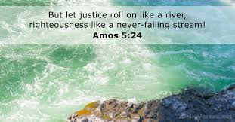 | Monday | INSET REPORT WRITING
 | Tuesday | KS1 Rev Callum Good Samaritan  KS2 Class worship | FD and DW
 | Wednesday | Cadbury Justice https://www.assemblies.org.uk/pri/3463/do-you-like-chocolate https://www.assemblies.org.uk/pri/2173/honesty-and-fairness | Year 2 and HS  EC and EB
 | Thursday | Window on the World KS2  KS1 Class worship | CS and KS2 staff
 | Friday | Celebration Worship  Prayers – Year 5 | CS  All Staff
Week 2 9/6/25  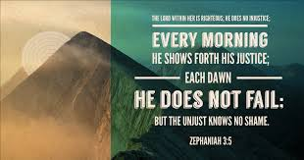 | Monday | Composer Launch | JH  PA and HB
 | Tuesday | KS2 Rev Callum Esther  Class worship | CHa and KA
 | Wednesday | Justice for the Hungry https://www.assemblies.org.uk/pri/1677/what-if-world-leaders-were-kids | Rec and FD  JH and NH
 | Thursday | KS1 Godly Play:  KS2 Class worship | CS  KS1 teachers
 | Friday | Celebration Worship  Prayers Year 6 | CS  All staff
Week 3 16/6/25  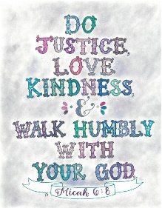 | Monday | Singing Worship | JH  LB and JM
 | Tuesday | KS1 Rev Callum Blind Bartimaeus  KS2 Class worship | FD and DW
 | Wednesday | Justice for slavery https://www.assemblies.org.uk/pri/2075/patience | Year 6 and CHa  LE and HP
 | Thursday | Sports Day
 | Friday | Celebration Worship  Prayer Rec | CS  All Staff
Week 4 23/6/25  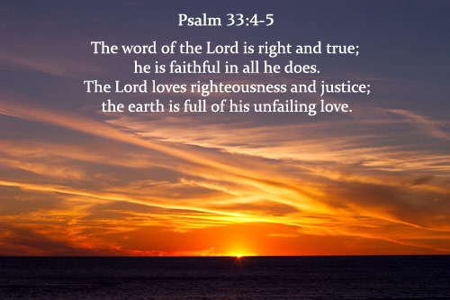 | Monday | Sing and Praise Worship | JH  EB and HS
 | Tuesday | KS2 Rev Callum The rich young man and Lazarus  KS1 Class Worship | Cha and HB
 | Wednesday | Small Justice https://www.assemblies.org.uk/pri/779/tackling-injustice | Year 5 and JM  EC and KA
 | Thursday | KS1 Godly play  KS2 Class worship | FD and KS1 staff
 | Friday | Celebration Worship  Prayers Year 1 | FD all staff
Week 5 30/6/25  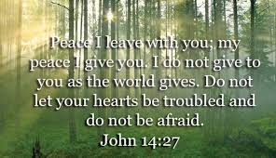 | Monday | Singing Worship | JH  JM and LB
 | Tuesday | KS1 Worship Rev Callum Through the roof  KS2 Class Worship | CHa and LE
 | Wednesday | Ghandi Justice and peace  https://www.assemblies.org.uk/pri/2619/peace | Year 4 and PA  HP and JH
 | Thursday | KS2 Window on the World  KS1 Class Worship | CS and KS2 staff
 | Friday | Celebration Worship  Prayers Year 2 | CS  All Teachers
Week 6 7/7/25  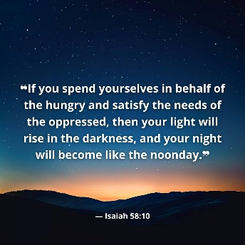 | Monday | Singing worship | JH  NH and PA
 | Tuesday | KS2 Rev Callum Elisha and the Widow  KS1 Class worship | JM and HP
 | Wednesday | Justice in voting https://www.assemblies.org.uk/pri/1770/its-not-fair | Year 3 and EC  LE and HB
 | Thursday | KS1 Godly play  KS2 Class worship | FD and KS1 staff
 | Friday | Celebration worship – privilege cards  Prayers Year 3 | CS and all staff
Week 7 14/7/25  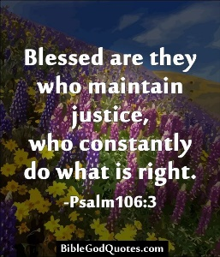 | Monday | Singing Worship | JH  KA and EC
 | Tuesday | KS1 Rev Callum Jesus washes feet/servant  KS2 Class worship | JH and DW
 | Wednesday | Thor’s persitence  https://www.assemblies.org.uk/sec/3918/being-right | Year 2 and HS  NH amd EB
 | Thursday | Celebration of the Year | CS and all staff
 | Friday | Year 6 lead school worship  1.30pm Year 6 Leavers Service | CHa and Year 6
Songs | Entry music https://www.youtube.com/watch?v=E1f8Tn5UOpU  Nothing’s too big (with actions) (16) Nothing's Too Big - Actions - YouTube  (16) Nothing's Too Big Lyric video - YouTube  We will go (16) We Will Go Lyric Video By Watoto Children's Choir - YouTube  I’ve got the power https://youtu.be/5CAL3OC-Qfk  Shine from the inside out https://www.youtube.com/watch?v=UFplX5o754Y  Justice https://www.youtube.com/watch?v=Z22TF2i8_Tw  Speak up https://www.youtube.com/watch?v=mXfXlin2D4E

