**St Marys - Religious Education Knowledge Organiser**

**Year 2**

**2.3 THE GOOD NEWS**

Key Vocabulary

What should I already know?

Believe

Cure

Disease

Forgiveness

To have faith in something you do not know

To make someone better when they have been ill

An illness or sickness

When someone pardons you for something you have done

wrong.

•

Various miracle stories from The Gospels including: The calming of the storm (Mk 4:

35-41); Curing a paralysed man (Mk 2: 1-12); and making a blind man see (Mk 10:

46-52).

•

How to reflect on The Good News of Jesus in our lives and how it makes us feel.

Good News

News that makes you happy. The Good News about Jesus is

that he loves us and came back to life after he died.

To make a sick person better.

What will I know at the end of the unit?

Heal

Joy

A feeling of great happiness.

•

•

Retell, in any form, at least two Religious stories on the theme of the Good News.

Give at least three examples of how to follow the teachings about forgiveness and

bringing good news to the friendless.

Use religious words like – good news, Jesus, miracle, Jairus, believe, cure, heal, leper,

leprosy, disease, bread, fish, Lent.

Leper

Leprosy

Lent

A person affected by a disease called leprosy

An illness that affects the skin and nerves.

Season in the Church’s year when we prepare for Easter.

Something extraordinary that happened through a

supernatural power.

•

Miracle

•

•

Give clear, simple descriptions of what these stories tell us about God.

Ask and answer questions about the feelings and experiences of characters in the

stories.

Give examples of how our beliefs in God can be put into practise e.g charity, visiting the

sick, saying thank you and sending thank you cards.

Answer questions like ‘are our actions more important than our words’. ‘why?’ Is it

important to say ‘thank you.’ ‘why?’

Recognise that some questions are hard to answer.

Paralysed

A person who is unable to move or feel a part or parts of

their body.

The ability to be able to do or control something.

A man who serves God and his people in a special way.

Power

Priest

•

•

•

We will be using stories and drama to

help us reflect on the Good News of

Jesus.

Key people and places

Books to read at home

People: Jesus, Jairus and his daughter, The Ten

Key Scripture

Key Prayers

lepers

Mark 5: 21-24, 35-43(The

daughter of Jairus raised to

life)

Luke 17: 11-19 (The Ten

lepers)

Place: mountain side during feeding of 5000

Our Father

Glory Be

Hail Mary

John 6: 1-15 (The Miracle of

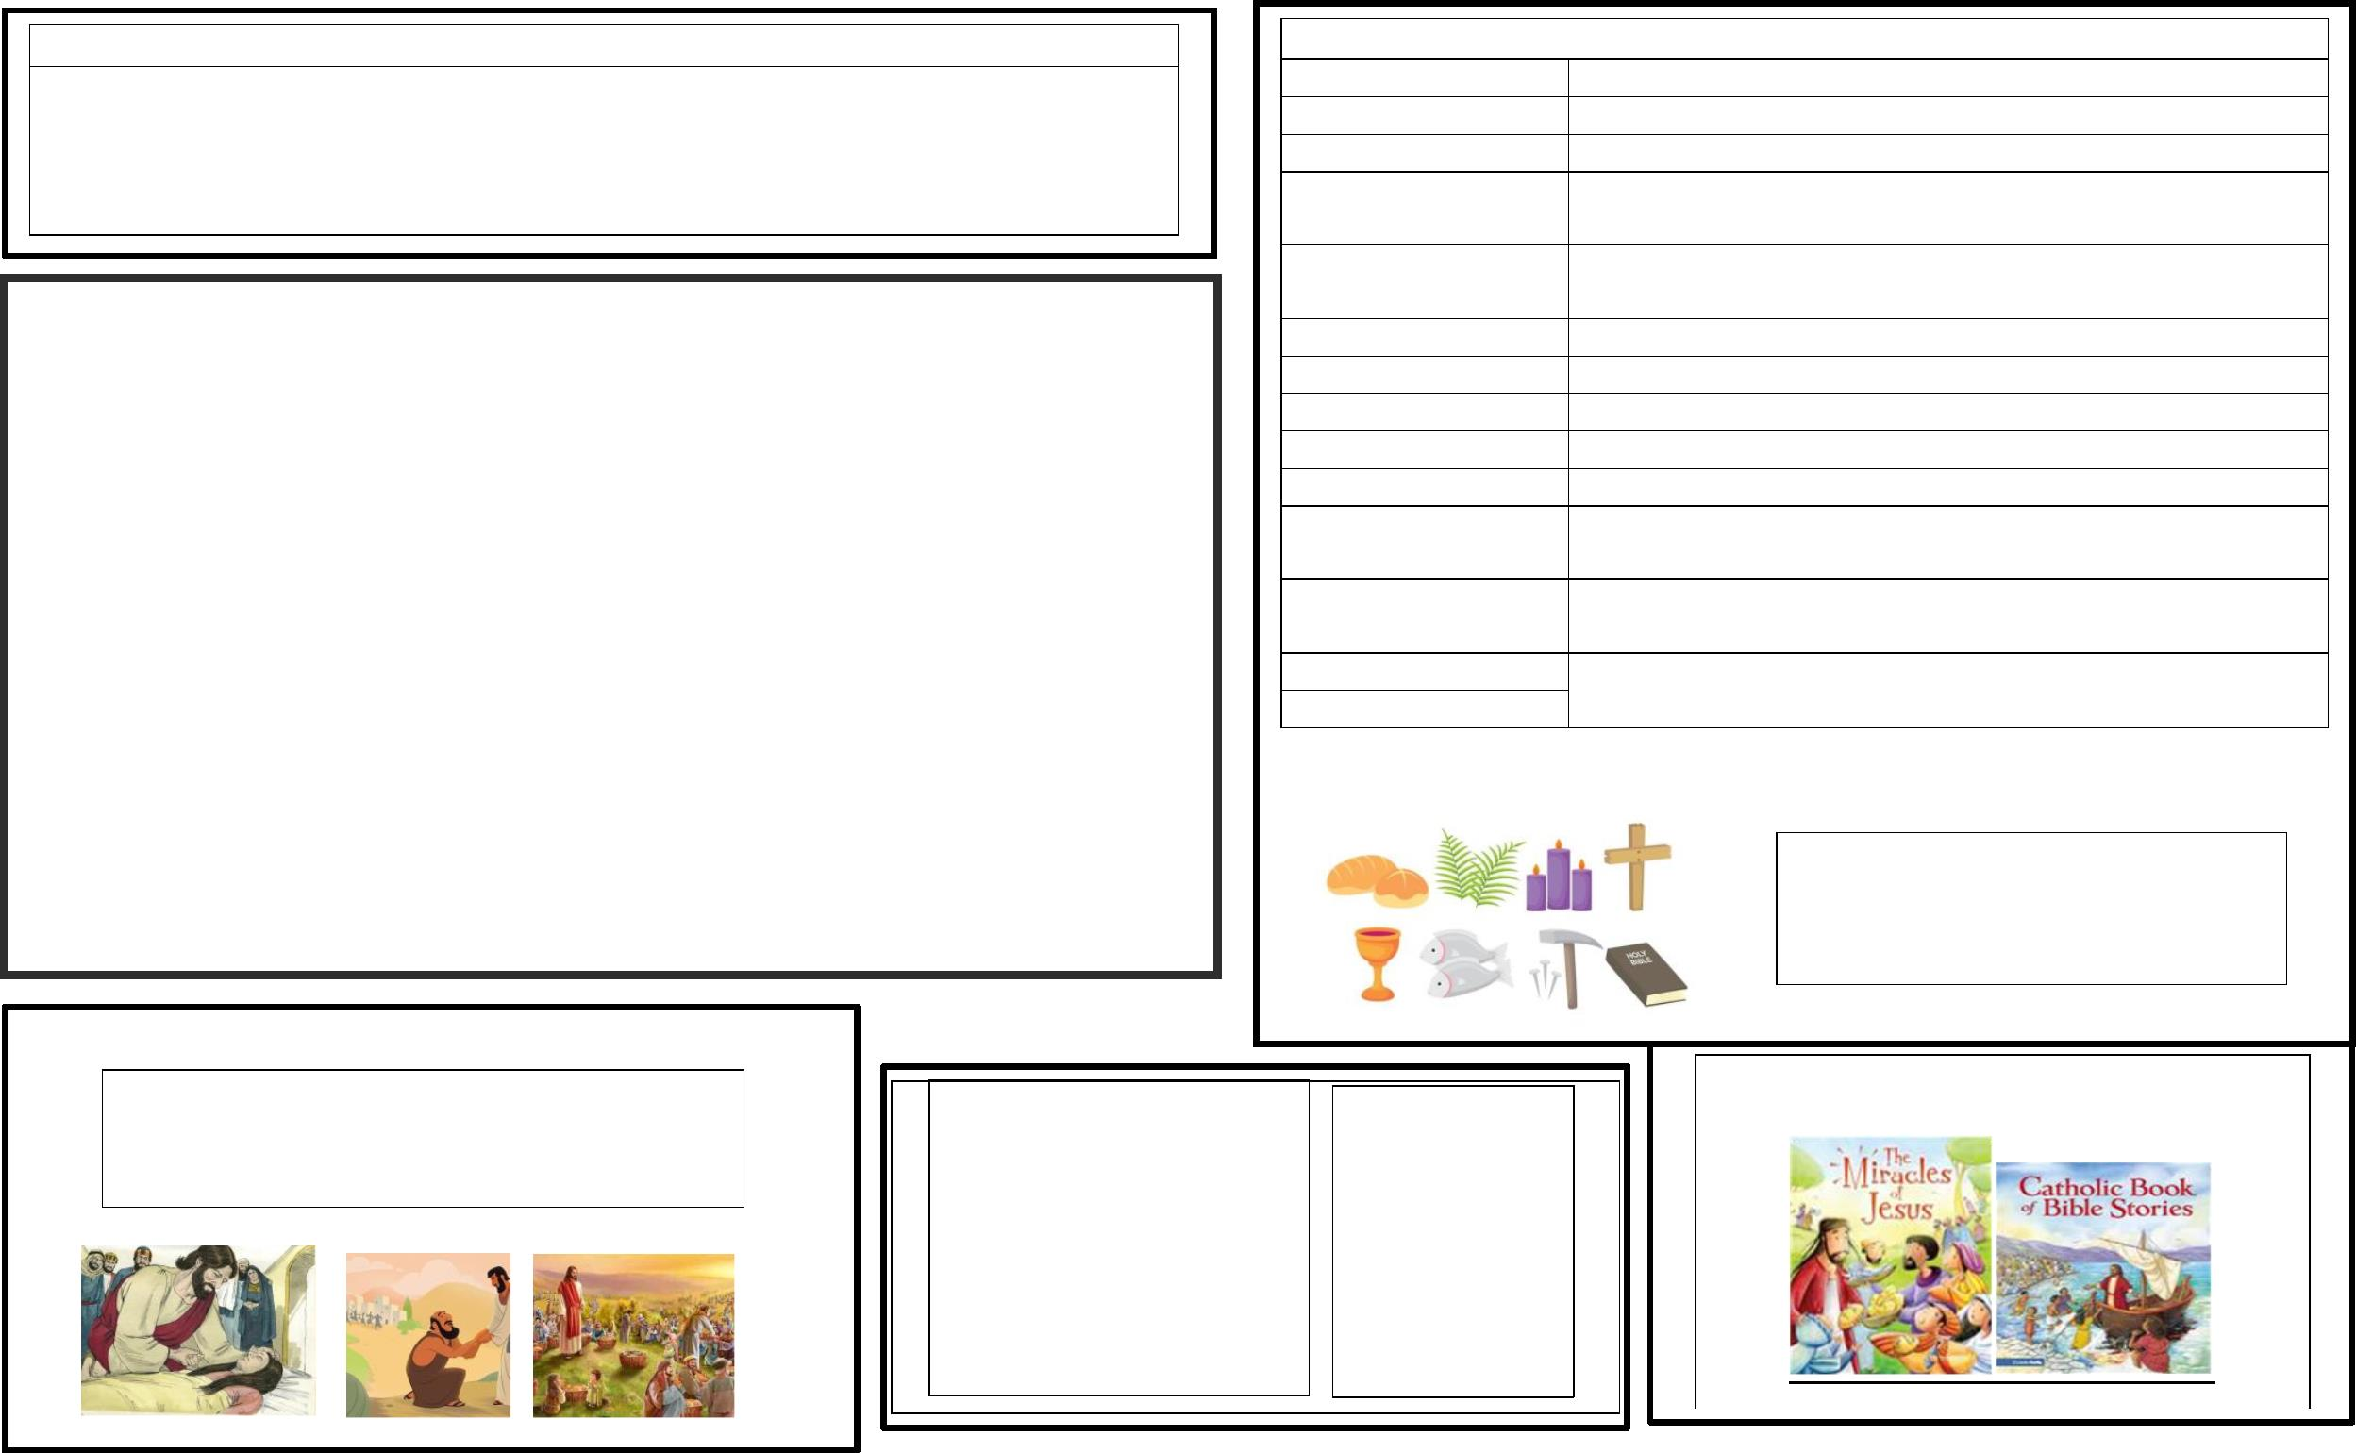ooxWord://word/media/image4.jpeg