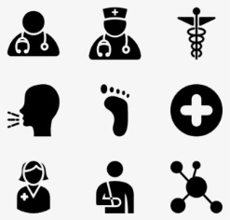
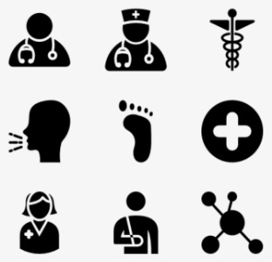
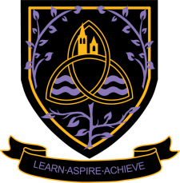
Health and Social Care Level 3 Cambridge Extended Certificate 2024 - 2026
Wigston College

Examination Board
OCR (Extended Certificate – 5831)
Entry Requirements:
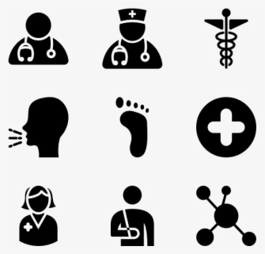
Level 2 Pass in Health and Social Care or if you have not studied this subject at Level 2 you will need a Grade 4 in English Language or English Literature.

What will I be studying?

In the Level 3 Extended Certificate, there are six units; three in year 12 and three in year 13.
Year 12: Unit 1: Building positive relationships, Unit 2: Equality, diversity and rights in health and social care settings, Unit 3: Health, safety and security in health and social care, Unit 10: Nutrition for Health
Year 13: Unit 4: Anatomy and Physiology, Unit 13: Sexual Health, Reproduction & Early Development Stages.

How will I be studying?

Through discussion, group work, individual work, presentations, written coursework and conducting research.

How will I be assessed?

Year 12: Unit 1: Building positive relationships. Internally assessment: coursework. Unit 2: Equality, diversity and rights in health and social care settings. External assessment: 90 minute written examination. Unit 3: Health, safety and security in health and social care. External assessment: 90 minute written examination.
Year 13:
Unit 4: Anatomy and Physiology. External assessment: 2 hour written examination. Unit 13: Sexual Health, Reproduction & Early Development Stages. Internally assessment: coursework. Unit 10: Nutrition for Health. Internal assessment: coursework
Where Next?

This specification provides a suitable foundation for the study of health and social care or a related area through a range of higher education courses, progression to the next level of vocational qualifications or employment. In addition, the specification provides a coherent, satisfying and worthwhile course of study for learners who do not progress to further study in this subject.
Students studying health and social care can move successfully on to courses in nursing, midwifery, psychology, sociology, criminology, law and police studies, social work, teaching and human resources and many others. These can be studied via the usual apprenticeship or university route.

