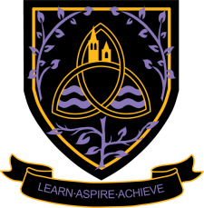
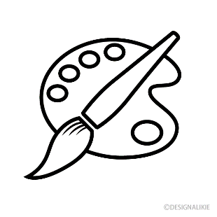
Art & Design
A Level 2024 - 2026
Wigston College

Examination Board
AQA
Entry Requirements
GSCE Grade 5 in any Art or Design GCSE or equivalent qualification. If you have not studied this subject at GCSE level you will need to provide a portfolio of work that demonstrates GCSE Grade 5 standard.
What will I be studying?
You will be learning to develop your skills using a number of Art and Design techniques such as drawing, painting, sculpture, architecture and product design. You will be working with a range of materials and exploring different areas depending upon your chosen Art and Design specialism. You will develop your own personal ideas using the knowledge that you have gained from studying the work of artists and designers.
Component 1 (Portfolio):
At least one extended collection of work or project, based on an idea, concept, theme or issue.
Portfolios may also include:
Critical/contextual work could include written material such as journals, reviews, reflections and evaluations, annotations and historical background material.
Sketchbooks, workbooks or journals.
You will also be required to submit an extended piece of written work (between 1000 and 3000 words of continuous prose) to accompany your personal investigation.
Component 2 (Externally Set Assignment):
Students will select one question from the five starting points.
Separate question papers are provided for each Art and Design title.
How will I be studying?
Most of the work produced will be your own personal response to projects of your own choosing. This will involve lots of independent learning. You will be researching themes and the work of others and will be expected to provide written evidence to show that you have a clear understanding of how they achieved their outcomes. You will need to provide ideas of your own and then show that you can develop them in depth in order to produce a good quality personal piece.

How will I be assessed?
• Component 1 - Personal investigation No time limit • 60% of A-level.
• Component 2 – Externally set assignment Preparatory period + 15 hours supervised time • 40% of A-level

Where Next?
On completing the course students will be well prepared to move on to higher education which is usually a Foundation course in Art and Design but can also be degree level entry. Art and Design A-level is also sought after by employers who offer more practical apprenticeships such as building and engineering.

