Mrs C Wloch
Add 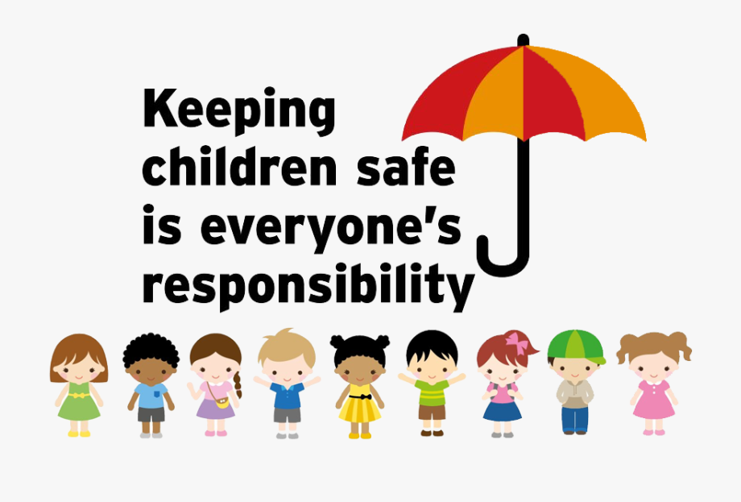photo
Add photo

Safeguarding Governor

Safeguarding Concerns
Telephone 01895 633 240

