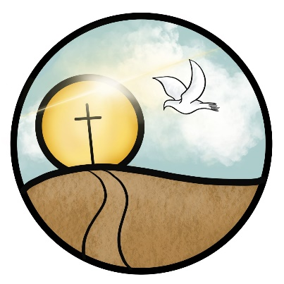
St. John The Baptist
Church of England (Aided) Primary School
Loving Learning, Building Community, Growing in Faith

Wednesday 11th June 2025

Dear Parents/Carers,

Welcome to your transition pack! This pack should contain all of the information you need to ensure your child has a smooth transition into school. In this pack you will find the following documents:

- Diary dates – These are very important so please make a note of these or stick them up on your fridge!
- New Parent Meeting slides – Your guide to all things EYFS at St Johns.
- Parent checklist – A list of things you can do between now and the first day of school to prepare yourself and your child.
- Child checklist – Some handy suggestions of ways to prepare your child for school.
- Getting to know you – A set of questions to help us get to know you and your child.
- Meet your teachers – Photographs and introductions of your child’s teachers. It is really helpful to regularly show these to your child so that we become familiar to them before they start school.
- Transition booklet – A photo story of a day at school. Again, it will really help your child to prepare for school if they familiarise themselves with their classrooms before they start.
- Tapestry letter – Tapestry is our main form of recording your child’s learning, but we need permission slips returned to us before we can share that learning with you.
- Permissions forms – These have all the crucial information needed by the office, and need to be returned to school as soon as possible.

Please take the time to read each of these documents carefully as they contain lots of important information. It would be really helpful if you could return all forms to your child’s class teacher on Transition Day.

Thank you for your cooperation and support – we look forward to meeting you all soon!
The EYFS Team

