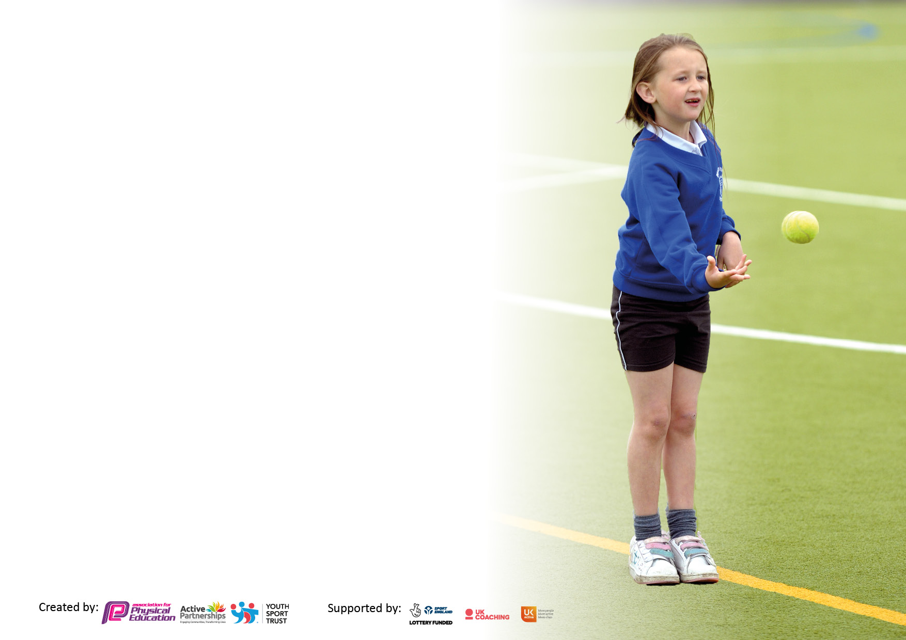

It is important that your grant is used effectively and based on school need. The Education Inspection Framework makes clear there will be a focus on **‘whether leaders and those responsible for governors all understand their respective roles and perform these in a way that enhances the effectiveness of the school’**.

Under the Quality of Education Ofsted inspectors consider:

**Intent** - Curriculum design, coverage and appropriateness

**Implementation** - Curriculum delivery, Teaching (pedagogy) and Assessment

**Impact** - Attainment and progress

To assist schools with common transferable language this template has been developed to utilise the same three headings which should make your plans easily transferable between working documents.

Schools must use the funding to make **additional and sustainable** improvements to the quality of Physical Education, School Sport and Physical Activity (PESSPA) they offer. This means that you should use the Primary PE and sport premium to:

* Develop or add to the PESSPA activities that your school already offer
* Build capacity and capability within the school to ensure that improvements made now will benefit pupils joining the school in future years
* The Primary PE and sport premium should not be used to fund capital spend projects; the school’s budget should fund these.

Please visit gov.uk for the revised DfE guidance including the5keyindicatorsacrosswhichschoolsshoulddemonstrate an improvement. This document will helpyoutoreviewyourprovisionandtoreportyourspend.DfEencouragesschools to use this template as an effective way of meeting the reporting requirements of the Primary PE and Sport Premium.

We recommend you start by reflecting on the impact of current provision and reviewing the previous spend.

Schools are required to publish details of how they spend this funding, including any under-spend from 2021/2022, as well as on the impact it has on pupils’ PE and sport participation and attainment. The funding **should** be spent by 31st July but the DfE has stated that there will be **no clawback** of any unspent money so this can be carried forward into 2023/24.

We recommend regularly updating the table and publishing it on your website throughout the year. This evidences your ongoing self-evaluation of how you are using the funding to secure maximum, sustainable impact. Final copy must be posted on your website by the end of the academic year and no later than the 31st July 2023. To see an example of how to complete the table please click HERE.

**Details with regard to funding**

Please complete the table below.

|  |  |
| --- | --- |
| Total amount carried over from 2021/22 | £0 |
| Total amount allocated for 2022/23 | £17,530 |
| How much (if any) do you intend to carry over from this total fund into 2023/24? | £1,014.04 |

**Swimming Data**

Please report on your Swimming Data below.

|  |  |
| --- | --- |
| Meeting national curriculum requirements for swimming and water safety.  N.B. Complete this section to your best ability. For example you might have practised safe self-rescue techniques on dry land which you can then transfer to the pool when school swimming restarts.  **Due to exceptional circumstances priority should be given to ensuring that pupils can perform safe self rescue even if they do not fully meet the first two requirements of the NC programme of study** |  |
| What percentage of your current Year 6 cohort swim competently, confidently and proficiently over a distance of at least 25 metres?  **N.B.** Even though your pupils may swim in another year please report on their attainment on leaving primary school at the end of the summer term 2023.  Please see note above | n/a We are an infant school – please see Park Hill Junior School (our federated Junior school) for information |
| What percentage of your current Year 6 cohort use a range of strokes effectively [for example, front crawl, backstroke and breaststroke]? | n/a |
| **What percentage of your current Year 6 cohort perform safe self-rescue in different water-based situations?** | n/a |
| Schools can choose to use the Primary PE and sport premium to provide additional provision for swimming but this must be for activity **over and above** the national curriculum requirements. Have you used it in this way? | Yes – we have a swimming pool to allow children to swim every other half term |

**Action Plan and Budget Tracking**

Capture your intended annual spend against the 5 key indicators. Clarify the success criteria and evidence of impact that you intend to measure to evaluate for pupils today and for the future.

|  |  |  |  |  |
| --- | --- | --- | --- | --- |
| **Academic Year:** 2022/23 | **Total fund allocated:** | **Date Updated:** | |  |
| **Key indicator 1:** The engagement of all pupils in regular physical activity – Chief Medical Officers guidelines recommend that primary school pupils undertake at least 30 minutes of physical activity a day in school | | | | Percentage of total allocation: |
| 17% |
| **Intent** | **Implementation** | | **Impact** |  |
| Your school focus should be clear what you want the pupils to know and be able to do and about  what they need to learn and to  consolidate through practice: | Make sure your actions to achieve are linked to your intentions: | Funding allocated: | Evidence of impact: what do pupils now know and what can they now do? What has changed?: | Sustainability and suggested next steps: |
| We want all children to be active for at least 30 minutes a day in school through PE lessons, after school clubs, daily mile, active playtimes and forest school | We replenished our playground toys so there were plenty of active games available.  We continued to pay for forest school leaders to work with all children over the year. | £2,955.76 | All children have 2 PE lessons a week and also take part in the daily mile on any afternoon where they do not have PE. Children enjoy and use the playground toys to have active lunch and playtimes | Playground toys need regular updates.  The daily mile is well-established across the school |
| **Key indicator 2:** The profile of PESSPA being raised across the school as a tool for whole school improvement | | | | Percentage of total allocation: |
| 0% |
| **Intent** | **Implementation** | | **Impact** |  |
| Your school focus should be clear what you want the pupils to know and be able to do and about  what they need to learn and to  consolidate through practice: | Make sure your actions to achieve are linked to your intentions: | Funding allocated:  £0 | Evidence of impact: what do pupils now know and what can they now do? What has changed?: | Sustainability and suggested next steps: |
| We want children to know about a range of different sporting activities that are open to them and to have the opportunity to represent their house or school | Additional PE leadership time for our PE leader so that he can plan year’s events and ensure that we take part in a wide range of PE opportunities. |  | PE lead now leads the local sports network and almost all local events have re-started after the pandemic. |  |

|  |  |  |  |  |
| --- | --- | --- | --- | --- |
| **Key indicator 3:** Increased confidence, knowledge and skills of all staff in teaching PE and sport | | | | Percentage of total allocation: |
| 5% |
| **Intent** | **Implementation** | | **Impact** |  |
| Your school focus should be clear | Make sure your actions to | Funding | Evidence of impact: what do | Sustainability and suggested |
| what you want the pupils to know | achieve are linked to your | allocated: | pupils now know and what | next steps: |
| and be able to do and about | intentions: |  | can they now do? What has |  |
| what they need to learn and to |  |  | changed?: |  |
| consolidate through practice: |  |  |  |  |
| We want to develop teachers’ skills in assessing children’s PE to ensure that children make good progress across our federation | Our PE lead attended at local CWSP meetings and training and used these to plan and deliver whole staff training during an INSET day. | £945 | Staff have been introduced to a way of assessing children’s PE skills linked to our school end points and staff used these to make assessments at the end of the year. | Staff will continue to use these ideas and they will become embedded over the next year. |
| **Key indicator 4:** Broader experience of a range of sports and activities offered to all pupils | | | | Percentage of total allocation: |
| 69% |
| **Intent** | **Implementation** | | **Impact** |  |
| Your school focus should be clear | Make sure your actions to | Funding | Evidence of impact: what do | Sustainability and suggested |
| what you want the pupils to know | achieve are linked to your | allocated: | pupils now know and what | next steps: |
| and be able to do and about | intentions: |  | can they now do? What has |  |
| what they need to learn and to |  |  | changed?: |  |
| consolidate through practice: |  |  |  |  |
| We found that fewer children were having out of school swimming lessons so we want to continue to offer a greater number of swimming lessons  We also wanted to offer a range of after school sports clubs and our PE lead was keen to introduce Tchoukball as a sport to complement our PE aims. | 3 sets of half termly swimming lessons for all children  Free or subsidized sports clubs  Purchase of Tchoukball resources to improve rainy day PE provision | £12,030.20 | Children’s swimming ability is improving and a significant chunk of children took part in after school clubs. | We will continue to offer a range of sports clubs. |

|  |  |  |  |  |
| --- | --- | --- | --- | --- |
| **Key indicator 5:** Increased participation in competitive sport | | | | Percentage of total allocation: |
| 3% |
| **Intent** | **Implementation** | | **Impact** |  |
| Your school focus should be clear | Make sure your actions to | Funding | Evidence of impact: what do | Sustainability and suggested |
| what you want the pupils to know | achieve are linked to your | allocated: | pupils now know and what | next steps: |
| and be able to do and about | intentions: |  | can they now do? What has |  |
| what they need to learn and to |  |  | changed?: |  |
| consolidate through practice: |  |  |  |  |
| We aim to take part in some competitive sport each year even thought there is a limited amount of opportunities. | We have taken part in running and football competitions and used the funding to pay for coaches, entry fees and adult cover for this. | £585 | Children really enjoyed the competitions and tell us that they want to do more! | Continue to look for opportunities to enter competitions |

|  |  |
| --- | --- |
| Signed off by | |
| Head of School: | E Bradbury |
| Date: | 26.7.23 |
| Subject Leader: | Paul Farrington |
| Date: | 26.7.23 |
| Governor: | Rebecca Harrison |
| Date: | 26.7.23 |