

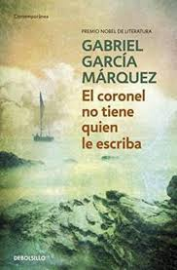

A-Level Spanish
2024-2026

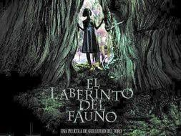


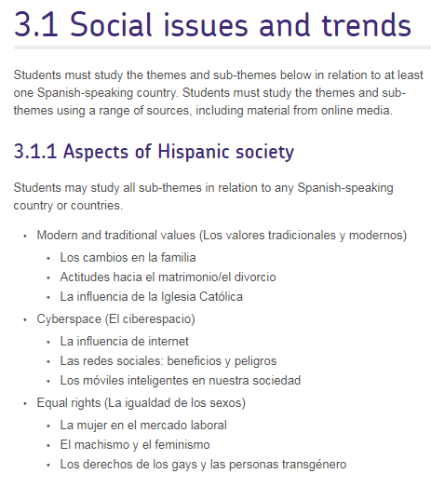

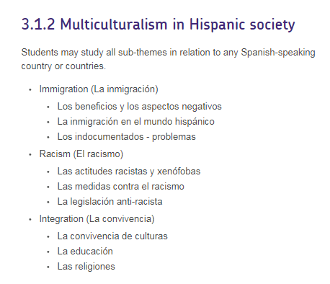

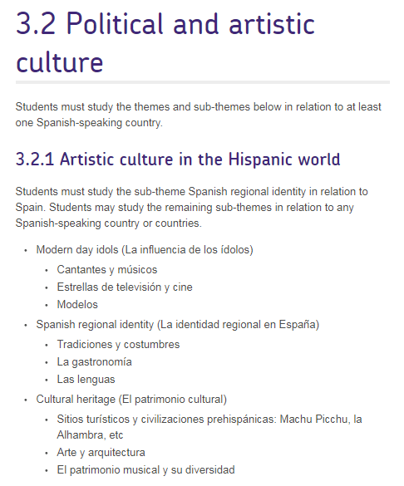

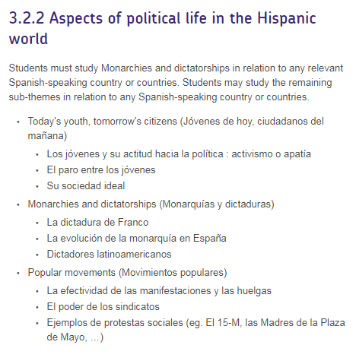

Grammar
Nouns
Gender
Singular and plural forms
Plural of male/female pairs (eg los Reyes)
Affective suffixes (R)
Articles
Definite and indefinite
El with feminine nouns beginning with stressed a (el agua)
Lo + adjective
Adjectives
Agreement
Position
Relative (cuyo)
Apocopation (eg gran, buen, mal, primer)
Comparative and superlative (eg más fuerte; mejor, peor, mayor, menor)
Use of adjectives as nouns (eg una triste, la roja, las norteamericanas)
Demonstrative (eg este, ese, aquel)
Indefinite (eg alguno, cualquiera, otro)
Possessive (weak and strong forms) (eg mi / mío)
Interrogative and exclamatory (eg ¿cuánto? / ¡cuánto!, etc, including use of ¿qué? / ¡qué!)
Relative (cuyo) (R)
Numerals
Cardinal (eg uno, dos)
Ordinal 1–10 (eg primero, segundo)
Agreement (eg cuatrocientas chicas)
Expression of time and date
Adverbs
Formation of adverbs in -mente
Comparative and superlative (eg más despacio)
Use of adjectives as adverbs (eg rápido, claro)
Adjectives as equivalents of English adverbs (eg Salió contenta)
Interrogative (eg ¿cómo?, ¿cuándo?, ¿dónde?)
Quantifiers/intensifiers
(eg muy, bastante, poco, mucho)
Pronouns
Subject
Object: direct and indirect; use of se for le(s); ‘redundant’ use of indirect object (eg Dale un beso a tu papá)
Reflexive
Unstressed/stressed forms (eg me/mí)
Position and order
Relative (que, quien, el que, el cual)
Demonstrative (este, ese, aquel; esto, eso, aquello)
Indefinite (eg algo, alguien)
Possessive (eg el mío, la mía). Expression of possession by the use of the indirect object pronoun (Le rompió el brazo) must also be included.
Interrogative
Verbs
Regular and irregular verbs, in all tenses and moods, finite and non-finite forms
Agreement of verb and subject
Use of hay que in all tenses
Use of tenses:
present
preterite
imperfect
future
conditional
perfect
future perfect
conditional perfect
pluperfect.
Use of the infinitive, the gerund and the past participle
Verbal paraphrases and their uses. These include but are not limited to the following:
ir a + gerund
estar + gerund
acabar de + infinitive
estar para + infinitive
llevar + gerund
ir + gerund (R)
venir + gerund (R).
Use of the subjunctive
Commands
Conditional sentences
After conjunctions of time
After para que, sin que
In relative clauses (R)
After other subordinating conjunctions (R)
With verbs and verbal expressions of wishing, commanding, influencing, emotional reaction, doubt, denial, possibility, probability (R)
Sequence of tense in indirect speech and other subordinate clauses
Voice
Use of the reflexive as a passive (eg El puente se construyó para unir a lascomunidades)
Use of the reflexive to express an impersonal subject (eg ¿Cómo se llega a la estación?)
Use of ser + past participle
Use of estar + past participle
‘Nuance’ reflexive verbs (eg caerse, pararse)
Modes of address (tú, usted; vos (R))
Constructions with verbs
Verbs followed directly by an infinitive (eg querer, poder)
Verbs followed by a preposition plus an infinitive or noun phrase (eg insistiren, negarse a)
Verbs followed by a gerund (eg seguir)
Verbs of perception (eg Vi asfaltar la calle)
Uses of ser and estar
Use of the subjunctive:
in relative clauses
after other subordinating conjunctions
with verbs and verbal expressions of wishing, commanding, influencing, emotional reaction, doubt, denial, possibility, probability.

Prepositions
All prepositions, both simple (eg bajo) and complex (eg encima de)
‘Personal’ a
Discrimination of por and para

Conjunctions
Coordinating conjunctions (eg y, o, pero)
Subordinating conjunctions. These include but are not limited to the following:
cause (porque)
purpose (para que)
proviso (con tal que)
supposition (a no ser que)
time (cuando)
concession (aunque).
Use of que to introduce a clause (eg ¡Cuidado, que se va a quemar la tortilla!) (R)
Use of que to introduce a clause (¡Cuidado, que se va a quemar la tortilla!)
Negation
Questions
Commands
Word order
Subject following verb (Ha llegado el profesor; Me gustan las patatas)
Focalisation (Tú ¿qué opinas?; A Cristiano lo odian) (R)

Other constructions
Time expressions with hace/hacía and desde hace/hacía
Cleft sentences (Fue en Madrid donde nos conocimos)
Comparative constructions. These include but are not limited to the following:
tan... como..., etc
más... que..., etc.
Tiene más dinero de lo que creía (R)
Indirect speech
Comparative constructions
Tiene más dinero de lo que creía
Expression of concession other than by aunque (por muy adjective que, pormucho que) (R)

Discourse markers
(eg Es que..., Por ejemplo, Ahora bien...)
Fillers
(eg pues, bueno)

Works

Literary text
- Gabriel García Márquez El coronel no tiene quien le escriba

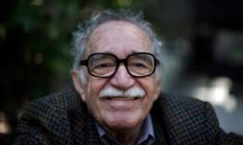

Film
- El laberinto del fauno Guillermo del Toro (2006)



Individual Research Project

Students must identify a subject or a key question which is of interest to them and which relates to a country or countries where Spanish is spoken. They must select relevant information in Spanish from a range of sources including the internet. The aim of the research project is to develop research skills. Students will demonstrate their ability to initiate and conduct individual research by analysing and summarising their findings, in order to present and discuss them in the speaking assessment.
Students may choose a subject linked to one of the themes or sub-themes or to one of the works. However, students must not base their research on the same literary text or film that they refer to in their written assessment.
Students within a school or college should each choose a different subject for their research. However, if more than one student selects the same general subject area, the title of their research and their approach must be different.

