St Chad’s C.E. Primary and Nursery School
Truth & Truthfulness
Class worship from the Vision Group (Display on reflection board)
Watch https://www.youtube.com/watch?v=BMsrFViLQzA
Questions to discuss
Luke 6:31 – What kinds of things can we do for others?
John 8:32 – What kinds of situations tempt you to lie? How do we stop of ourselves? Why do we lie?
Luke 8:16 – What sorts of things can we do to be light in school and stand out? Why is Jesus called the light of the world? How can we be lights in the world?

You could include drama photo or cartoon showing a situation you might want to lie in and what you should/should do.
Post-it ‘mouths’, which might ‘speak’ the truth or lie, with speech bubbles coming out of them.
Create a piece of artwork about being light in the school or the world.
Hearts with words we might say to fix things when we have lied or fallen out or broken a rule.
‘honesty/truth seeds’- ‘honesty/truth’ can spread like the seeds inside these petals.
Questions to explore: Why do I sometimes tell a lie? Why do I sometimes exaggerate the truth? Am I always honest with myself? Do I make an honest friend? Who do I trust always to be honest with me?
Week Beginning |  | Value – Truth and Honesty | Leader
Week 1 2/9/24  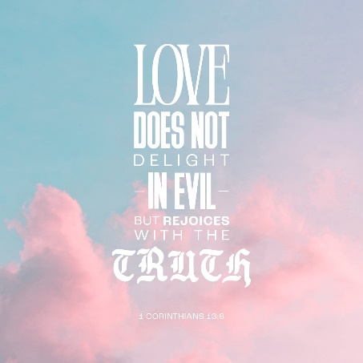 | Monday | INSET
 | Tuesday | INSET
 | Wednesday | Colour your world with kindness  https://www.assemblies.org.uk/pri/3544/pause-for-thought-every-little-counts | CS  All staff
 | Thursday | Reflection area start | Class based
 | Friday | First Impressions Awards | CS  All Staff
Week 2 9/9/24  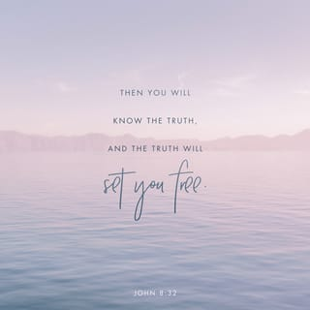 | Monday | 9.05 Front Row Music presentation | JH  All Tas
 | Tuesday | KS1 Rev Callum  KS2 Class Worship | Rev C  JH and NH
 | Wednesday | https://www.assemblies.org.uk/pri/4171/honesty-has-superpowers | Year 6 and CHa  HP and KA
 | Thursday | KS2 Window on the World  KS1 Class Worship | CS  KS2 Teachers
 | Friday | Celebration Worship  Prayers Year 1 | CS  All staff
Week 3 16/9/24  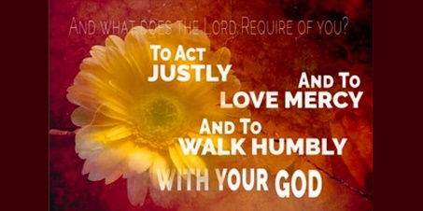 | Monday | Composer Launch | JH  DW and HS
 | Tuesday | KS2 Rev Callum  KS1 Class worship | Rev C  CHa and EC
 | Wednesday | https://www.assemblies.org.uk/pri/2351/truthfulness  https://www.assemblies.org.uk/pri/3896/truthtelling | Year 5 and JM  PA and LE
 | Thursday | KS1 Godly Play:  KS2: Class worship | CS  KS1 teachers
 | Friday | Chester zoo trip
Week 4 23/9/24  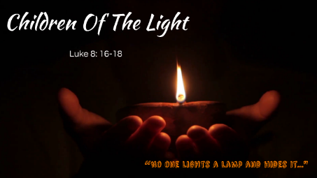 | Monday | Sing and Praise Worship | JH  JM and DW
 | Tuesday | KS1 Rev Callum  KS2 Class Worship | Rev C  HS and HP
 | Wednesday | https://www.assemblies.org.uk/pri/256/dont-hide-your-light  https://www.assemblies.org.uk/pri/3780/pause-for-thought-are-you-shining | Year 4 and PA  EC and KA
 | Thursday | KS2 Window on the World  KS1 Class worship | CS  KS2 Teachers
 | Friday | Celebration Worship  Prayers Year 3 | CS  All Staff
Week 5 30/9/24  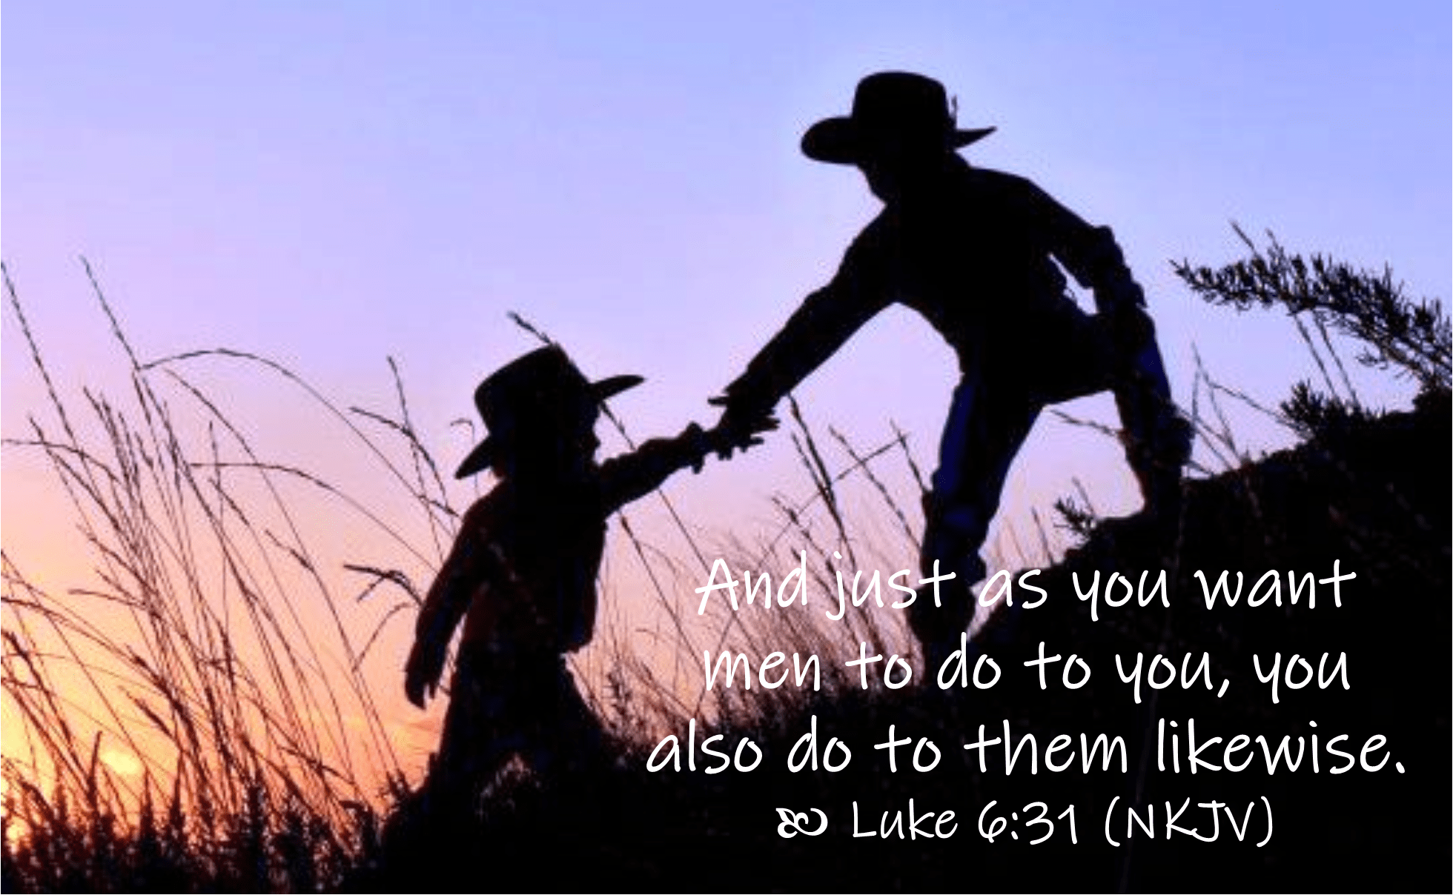 | Monday | Sing and Praise Worship | JH  PA and LE
 | Tuesday | Class worship due to RAF workshop
 | Wednesday | https://www.assemblies.org.uk/pri/4044/showing-consideration | Year 3 and EC  CHa and NH
 | Thursday | KS1 Godly Play:  KS2 Class worship | CS  KS1 teachers
 | Friday | Celebration Worship  Prayers Year 4 | CS  All staff
Week 6 7/10/24  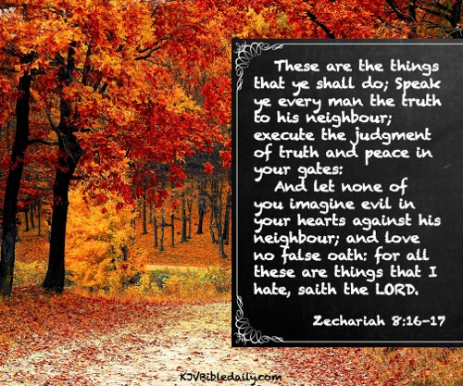 | Monday | Sing and Praise Worship | JH  KB and HS
 | Tuesday | Whole school Harvest practise | All staff
 | Wednesday | https://www.assemblies.org.uk/pri/1379/telling-the-truth | Year 2 and HS  EB and EC
 | Thursday | KS2: Window on the World  KS1 Class worship | CS  KS2 Teachers
 | Friday | Harvest at church 1.30pm
Week 7 14/10/24  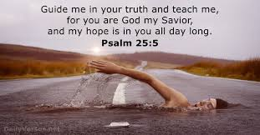 | Monday | Sing and Praise Worship | JH  KA and JM
 | Tuesday | KS2 Rev Callum  KS1 Class worship | Rev C  PA and LE
 | Wednesday | https://www.assemblies.org.uk/pri/3399/honestly | Rec and FD  HP and CHa
 | Thursday | KS1 Godly Play  KS2 Class worship | CS  KS1 Teachers
 | Friday | Celebration Worship  Prayers Year 5 | CS  All staff
Week 8 21/10/24  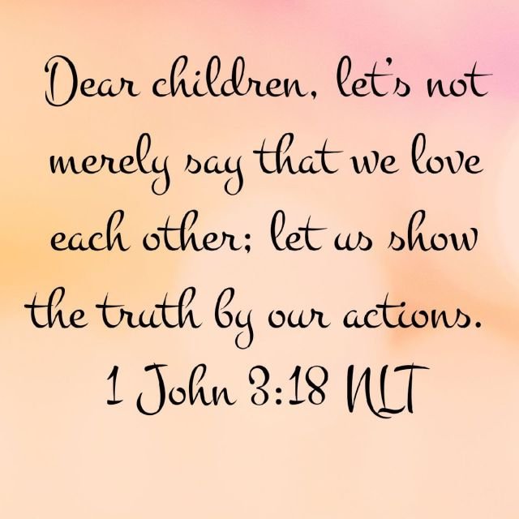 | Monday | Singing Worship | JH  LB and NH
 | Tuesday | KS1 Rev Callum  KS2 Class worship | JH and EB
 | Wednesday | https://www.assemblies.org.uk/pri/3115/the-truth-the-whole-truth---  https://www.assemblies.org.uk/pri/188/the-boy-who-cried-wolf | CHu and Vision Group  HS and KA
 | Thursday | KS2 Window on the World  KS1 Class worship | KS2 staff
 | Friday | Privilege cards  Class Reflection award from VG  Truthfulness and Honesty award from VG  Prayers vision Group | CS
Songs | My Lighthouse https://www.youtube.com/watch?v=lFBZJGSgyVQ  This Little Light of Mine https://www.youtube.com/watch?v=cKkbIZtqhyQ  Shine https://www.youtube.com/watch?v=UFplX5o754Y  Rise up and shine https://www.youtube.com/watch?v=pt62Vkws8vM  Christ in me https://www.youtube.com/watch?v=zundjUFazfg
Harvest songs | Creator God https://www.youtube.com/watch?v=GM4IVZuljEI  Harvest Samba  Beautiful world  Everybody Praise him  Harvest Song  Food colour

