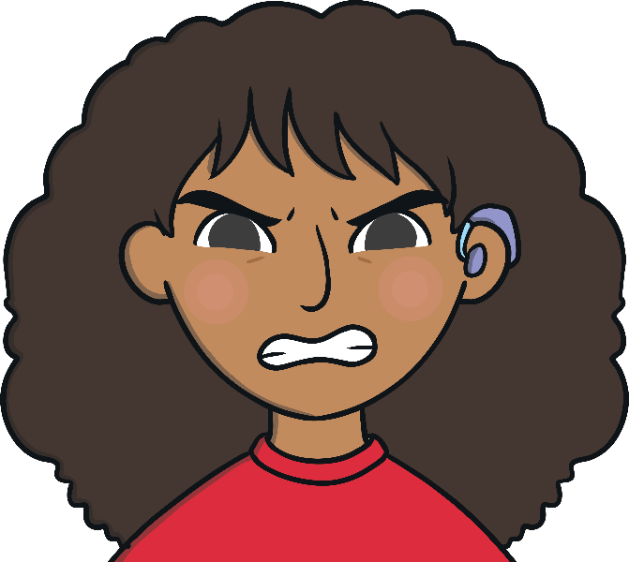
Sometimes, I feel frustrated.
When I am feeling frustrated, I feel cross and annoyed. Feeling frustrated is not a good feeling but we all feel frustrated sometimes.
I might feel frustrated when I cannot complete my schoolwork at home, when I want to go and play with my friends or visit my family.
When I feel frustrated, I need to tell my parents/carers (delete as appropriate) how
I feel.
I can take a deep breath and say ‘I feel frustrated’ then my parents/carers (delete as appropriate) will know how I am feeling.
My parents/carers (delete as appropriate) will help me to make a good choice. This could be telling me to:
Take 10 deep breaths
Count to 20
Talk to someone or draw how I feel
Have a drink of water
Have a break before going back to the task
I will try and tell my parents/carers (delete as appropriate) when I am feeling frustrated.
This will make my parents/carers (delete as appropriate) happy.
There are four seasons each year, autumn, winter, spring and summer.
seasons

