

***Perseverance Respect Honesty Friendship***

**SEND & Inclusion Policy**

|  |  |  |  |  |
| --- | --- | --- | --- | --- |
| **Date written** |  | **Authorised by** |  | **Review Date** |
|  |  |  |  |  |
| **November 2023** |  | **Governors** |  | **November 2025** |



**Contents**

1. Introduction 3
2. What are special educational needs? 4
3. Aims & objectives of the SEND and Inclusion policy 5
4. Role and Responsibilities relating to SEND and Inclusion 6

* The Role of the Inclusion Team 6
* The Role of the SENDCo 6
* The Role of the class teacher 7
* The Role of the SEND and Inclusion Governor 7
* The Role of the parents 7
* The Role of the child 8

1. Identification, Assessment and Provision 8

## Identification of additional needs using the Graduated Approach 9

## Pastoral Support 11

## Links with other schools and settings 12

* Levels of SEND support 12
* Applying for an Education, Health and Care Plan 13

1. The Importance of the home/school partnership in SEND Support 13
2. SEND support and resources on the school website 14
3. Staff CPD across school to support SEND 14
4. Monitoring and evaluation 14
5. Supporting Children in School with Medical Conditions 15
6. Supporting Children with self-care needs and Intimate Care 15
7. Accessibility 15

* Access to the environment 15
* Arrangements for providing access to learning and the curriculum 15
* Access to Information 16
* Admission Arrangements 16
* Incorporating disability issues into the curriculum 16
* Listening to disabled pupils and those identified with additional needs 17
* Working with disabled parents 17

1. Support from Trafford for pupils and families 17
2. SEND and Inclusion Information Report 18
3. Dealing with complaints 18

Appendix 1 – Example of a Pupil Profile 19

Appendix 2 - Identification of Concern pastoral referral 20

Appendix 3 – Provision map of Social, Emotional, Mental Health support at Brooklands 22

Appendix 4 - Example of a Wellbeing Profile 23

Appendix 5 - Intimate Care Policy 24

## Introduction

Brooklands Primary School has a named SENDCo (Mrs Jones) and a named Governor responsible for SEND (Mrs Madden). Mrs Jones is also the named SENDCo for Looked After and Cared for Children. They ensure that the Brooklands Primary School’s Special Educational Needs and Disabilities (SEND) and Inclusion policy works within the guidelines and inclusion requirements of the SEND Code of Practice (2014).

At Brooklands, it is our belief that all children have an equal right to a full and rounded education which will enable them to achieve their full potential. We have high aspirations for all children that attend our school. It is our commitment to support and challenge all children to be the very best they can be, to reach their potential and thrive.

Brooklands’ SEND and Inclusion policy aims to:

* Make sure our school fully implements national legislation and guidance regarding pupils with SEND
* Explain the roles and responsibilities of everyone involved in providing for pupils with SEND
* Make sure the SEND policy is understood and implemented consistently by all staff across the school community
* Set out how Brooklands will:
  + Support and make provision for pupils with special educational needs and disabilities, within all four areas of need: Communication and interaction, cognition and learning, social, mental and emotional health and sensory and/or physical
  + Ensure all children at Brooklands, including those with SEND, are included in and can enjoy all aspects of school life and extra-curricular activities
  + Support and challenge pupils with SEND to fulfil their aspirations and achieve their best
  + Communicate with parents of pupils with SEND and children and involve them in discussions and decisions about support and provision for the pupil, being transparent in communication to ensure effective home-school partnership
  + Help and support pupils with SEND to be prepared for and make a successful transition into secondary school

At Brooklands Primary School we have a dedicated Inclusion Team in school. This team reflect the school’s high aspirations for all children, including those with SEND. The team lead, drive and develop inclusive practise across school, reflecting the school’s dedication to raising the profile of inclusion and SEND support across school.

This team consists of:

* *Mr Shrimpling, Deputy Head Teacher - Leads the Inclusion Team and Inclusion support across school*
* *Mrs Jones, SENDCo - Leads and coordinates provision across school for SEND and inclusion*
* *Miss Mannion, Learning Mentor - Works with children across school to support emotional wellbeing*
* *Mrs Daly, Therapeutic Play Practitioner - Leads Play Therapy sessions for identified children to support emotional wellbeing*

**What are special educational needs?**

A child or young person has special educational needs if he or she has a learning difficulty or disability which calls for special educational provision to be made for him or her.

The SEND Code of Practice, 2014, defines special educational provision as educational or training provision that is additional to, or different from, that made generally for others of the same age in a mainstream setting in England.

Areas of needs fall into 4 broad areas:

*Please note that many children may fall into more than one category*

|  |  |
| --- | --- |
| 1. Communication and interaction | Pupils that have difficulty communicating with others. They may have difficulty understanding what is being said to them, have trouble expressing themselves, or do not understand or use the social rules of communication.  Pupils who are on the autism spectrum often fall into this category.  Pupils who have speech and language needs fall into this category. |
| 1. Cognition and learning | Pupils with learning difficulties usually learn at a slower pace than their peers.  A wide range of needs are grouped in this area, including:   * Specific learning difficulties, which impact 1 or more specific aspects of learning, such as: dyslexia, dyscalculia and dyspraxia * Moderate learning difficulties * Severe learning difficulties * Profound and multiple learning difficulties, which is where pupils are likely to have severe and complex learning difficulties as well as a physical disability or sensory impairment |
| 1. Social, emotional and mental health | These may reflect a wide range of underlying difficulties. Pupils may have:   * Mental health difficulties such as anxiety, depression * Attention deficit disorder (ADD), attention deficit hyperactive disorder (ADHD) or attachment disorder * Suffered adverse childhood experiences or trauma   These can manifest in many ways, for example as challenging, disruptive or disturbing behaviour, or by the pupil becoming withdrawn or isolated. |
| 1. Sensory and/or physical | Pupils with a disability that hinders them from accessing the educational facilities generally provided in the mainstream class.  Pupils may have:   * A sensory impairment such as vision impairment, hearing impairment or multi-sensory impairment * A physical impairment, such as cerebral palsy, epilepsy   These pupils may require ongoing additional support or equipment to allow them to access all opportunities available to their peers. |

## Aims and objectives of the SEND and Inclusion policy

The Brooklands SEND and Inclusion policy details how teachers identify and address any needs ensuring that the necessary provision is made for any pupil who has special educational needs and that they are known to all who are likely to work with them. We will ensure that teachers are able to identify and provide for those pupils with special educational needs, allowing them to access the curriculum effectively, make progress and thrive in all areas.

Through implementing this policy, Brooklands Primary School aims:

1. To ensure the guidance from the SEND and Disability Code of Practice (2014) is implemented effectively across the school
2. To ensure equality of opportunity for and to eliminate prejudice and discrimination against, children with special educational needs and disabilities
3. To continually monitor the progress of all pupils, to identify needs as they arise and to provide support as early as possible
4. To provide full access to the curriculum* through adapted planning by class teachers, SENDCo and support staff as appropriate. (*Except where disapplication, arising from an Education Health Care Plan occurs. Disapplication is very rare, and we will always aim to offer the full curriculum to all our pupils.)
5. To provide specific input where necessary, matched to individual needs, in addition to adapted classroom provision, for those pupils recorded as having SEND
6. To provide support, advice and training for all staff working with pupils with special educational needs
7. To raise the profile of inclusion across school and ensure that pupils with SEND are perceived positively by all members of the school community and that SEND and inclusive provision is positively valued, accessed and communicated with staff and parents/carers
8. To enable children to move on from us well equipped in the basic skills of literacy, numeracy and social independence to meet the demands of secondary school life and learning
9. To involve parents/carers at every stage in plans to meet their child’s additional needs
10. Where appropriate to involve the children themselves in planning and in any decision making that affects them

## Roles and Responsibilities relating to SEND and Inclusion

## The Role of the Inclusion Team

* Work closely with school staff to ensure children who may have an additional need that is becoming a barrier to learning are identified promptly. This ensures that appropriate support and adjustments are put into place quickly, so children can be supported to make progress
* Meet fortnightly to review the progress of children who may be receiving additional support and discuss any new referrals for children who may benefit from pastoral support. These referrals always include pupil and parent voice, ensuring the whole child is taken into account when implementing support
* Offer pastoral support for any child with an identified SEMH need. This could be through Learning Mentor in class support/targeted sessions, or through Play Therapy sessions
* Work closely with staff to offer support/advice to support any child that the teacher has identified that may require additional support
* Where appropriate, meet with parents to discuss concerns and offer/ signpost to available support
* Regularly communicate with parents to ensure they are involved in all aspects of child’s support, building the home/school partnership to ensure most effective support for the child

## The Role of the SENDCo

The Special Educational Needs Co-ordinator’s, SENDCo, responsibilities include:

* Overseeing the day-to-day operation of the school’s SEND policy
* Maintaining a register of children with SEND, and ensuring that the records on children with SEND are up-to-date
* Co-ordinating provision for children with SEND
* Supporting children with medical needs and coordinating specialist resources or equipment required to support them in school
* Supporting teachers who require guidance supporting individual or groups of children on the SEND register, which may involve lesson observations or support in setting outcomes for pupils
* The strategic deployment of Teaching Assistants to ensure that children’s needs are met both academically and pastorally
* Overseeing and maintaining the records of all children with SEND
* Liaising with parents of children with SEND, ensuring open, honest, regular communication to build the home/school partnership
* Co-ordinating and leading the CPD of teachers and Teaching Assistants in relation to SEND/inclusion training, ensuring staff have the training and support they required to support children in school, for example Dyslexia support CPD.
* Liaising with local high schools so that support is provided for Y6 pupils as they prepare to transfer
* Liaising with external agencies including Trafford’s SEN Support and Educational Psychology services, health and social services and voluntary bodies
* Co-ordinating and developing school based strategies for the identification and review of children with SEND
* Making regular visits to classrooms to monitor the progress of children on the first concerns and SEND registers
* Work closely with staff to develop inclusive practise and support strategies in class

## The Role of the class teacher

Each class teacher is responsible for:

* Planning and providing high-quality teaching that is adjusted (formerly differentiated) through a graduated approach
* The progress and development of every pupil in their class , including those with SEND or any additional need
* Working closely with any teaching assistants or specialist staff to plan and assess the impact of support and interventions, and consider how they can be linked to classroom teaching
* Meet with their Year Group Lead to review each pupil’s progress and development, and where appropriate, discuss any SEND concerns with the SENDCo to plan and implement any adjustments or interventions
* Ensuring they follow the school’s SEND policy and the SEND information report
* Communicating with parents regularly to ensure they are involved in and up to date with all aspects of support their child may be taking part in

## The Role of the SEND and Inclusion Governor

Mrs Madden, is the SEND Governor, who monitors the SEND provision at Brooklands Primary School. Mrs Madden meets with the SENDCo Mrs Jones on a termly basis to keep up-to-date with developments with SEND and inclusion within school. During the Governor visits, Mrs Madden is able to see examples of inclusive practise within school, discuss data relating to the attainment of SEND pupils, meet with staff and pupils to discuss SEND support and be a part of school events relating to SEND. Mrs Madden then feeds back this information to governors.

* **The Role of the** **Parents**

Open and honest communication is important to build and maintain the home/school partnership, ensuring the most effective support for the child can be put into place.

It is vital that parental voice is gathered and parents are involved in all stages of SEND support.

* Raising initial concerns with the child’s class teacher who will, if appropriate, pass these onto the SENDCo
* Attend parent meetings with school staff to keep up to date with in school support and progress
* Attend review meetings with any external agencies involved to review progress and outcomes
* Attend termly SENDCo drop in sessions with the class teacher/Inclusion Team as an opportunity to discuss SEND specific concerns and progress
* Work with school staff to complete any necessary paperwork required for any referrals to external agencies
* Support and build on the child’s progress in school by continuing any necessary support at home, for example continuing with speech and language programmes, additional reading support

* **The Role of the** **Child**

It is vital that to best support the whole child, the child’s voice and views are taken into account when implementing all stages of SEND support. The child will be given chances to talk about how they feel they are progressing and what they think at different opportunities.

This could include

* Attending termly review meetings with outside agencies, for example speech and language
* Being part of and contributing to termly EHCP review meetings
* Helping to set their targets or outcomes each term

## Identification, Assessment and Provision

The SEND Code of Practice, 2014, states that the purpose of identification is to work out the areas of particular need the child may have, and what action the school takes to support this. In practice, individual children often have needs that cross different areas and these may change over time.

At Brooklands Primary School, we considering the whole child, focussing on their strengths as well as any additional needs they may have (as mentioned above this may be in more than one area). The support provided to an individual will always be based on a full understanding of their particular strengths and needs, and seek to address them all using quality first teaching, targeted in-class support and adjustments and, where appropriate, well-evidenced interventions targeted at their areas of difficulty, or the use of specialist equipment or software.

Other issues may impact on the progress and attainment of a child which may be considered to be SEND. These may include for example, a disability where barriers to learning can be removed by ensuring we make reasonable adjustments; poor attendance and punctuality; health and welfare issues; English as an Additional Language. Class teachers will assess each child’s current skills and levels of attainment when they start at school. This will build on information from previous year groups, or, where appropriate, previous settings. School staff will also consider any evidence that the pupil may have a disability and if so, what reasonable adjustments the school may make.

Class teachers will regularly assess the progress of all pupils and identify any child whose progress:

* Is significantly slower than that of their peers starting from the same baseline
* Fails to match or better their previous rate of progress
* Fails to close the attainment gap between them and their peers
* Widens their attainment gap between themselves and peers

*Please note, this may include progress in* *other areas, alongside the 4 areas of SEND need, for example emotional wellbeing.*

## Identification of additional needs using the Graduated Approach

Once a pupil has been identified as having SEND, school staff will take action to remove any barriers to learning, and promptly put effective special educational provision in place. This support will be delivered through successive rounds of a cycle of support known as the graduated approach.

* **Assess**- through discussions, assessments and observations, class teachers and the SENDCo will work with parents to identify the children’s individual needs.
* **Plan**- using this information, through the processes detailed below, and always in consultation with the parents and the pupil, the class teacher and the SENCO will decide which adjustments, interventions and support will be implemented. As detailed below, this may begin with adjustments to universal support, or progress to targeted or specialist support. SMART targets will also be put into place for the child to work towards. This information will be documented on a document called a Pupil Profile (see Appendix 1 for an example Pupil Profile) which will be the ongoing, termly record of SEND support and progress.
* **Do**- using the steps below, the child’s class teacher will implement the planned support, and constantly monitor to keep track of the impact on the child’s progress. The class teacher is ultimately responsible for the child’s progress, but will seek advice from the SENDCo and Outside Agencies where appropriate.
* **Review**- the impact of this additional support and the child’s progress towards their individual targets will be reviewed termly, and evidenced through the child’s individual Pupil Profile. This Pupil Profile will be reviewed termly and will evidence the child’s progress towards their individual outcomes and the impact of any support or interventions in place.

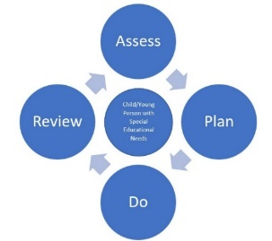

The following graduated approach and progression of processes are used in school to help to identify needs and the appropriate support for pupils experiencing barriers to their learning.

|  |  |
| --- | --- |
| 1. Teacher/Parent concerns | * Ongoing monitoring by staff in class through assessment for learning and feedback opportunities * Teaching adapted to meet any misconceptions. * Parents signposted to range of support and resources on the inclusion section of school website for range of different wellbeing and learning concerns * Open communication with parents regarding any concerns with learning behaviours at home |
| 1. ***Universal support***, quality first teaching and in-class support | * As the first line of support, teachers will target the pupil’s area of need with in class adjustments and quality first teaching in class. This is universal support in place for all children * Class teachers will discuss these initial concerns with parents to see if there is any additional factors that could impact progress, for example, home circumstances, pastoral concerns * In class adjustments and additional support put into place may include adjusted work, pre/overlearning opportunities, small group work, peer support or additional in-class adult support |
| 1. Meeting with SENDCo and/or Learning Mentor | * Where appropriate, if these concerns persist or increase, a meeting with parents and the SENDCo/Learning Mentor may be required to discuss concerns and support in more detail. |
| 1. Child discussed at termly pupil progress meetings | * All pupils’ attainment and progress is tracked using Insight. This may show that some children, particularly those with SEND, are not making the expected progress. For those children, progress will be measures in other ways including through the use of PIVATS and through qualitative data such as pupil work and pupil voice. * If a child is not making the expected progress, these concerns are then discussed further with class teacher and year group lead in dedicated progress meetings * Any child that is making less than expected progress, or with any identified need that may be a barrier to their learning is discussed with the SENDCo * Further in-class support, adjustments or targeted interventions will then be discussed |
| 1. ***Targeted support*** put into place | * If further support is required, targeted groups or individual support will be put into place to support the child and support them to make progress, for example Little Wandle phonics Rapid Catch Up sessions to support reading progress * If the area of need is a social, emotional, mental health concern, e.g. emotional wellbeing, it may be appropriate for class teachers to refer the child to in-school pastoral support through our Learning Mentor or Therapeutic Play Therapist. * Parents consulted and involved in all aspects of this process to implement targeted support. |
| 1. ***Specialist support*** from Outside Agencies | * If the school and parents recognise that they may require further, more specialist support in meeting the child’s needs, it may be appropriate for school to refer for specialist support from an Outside Agency * These include: * Speech and Language Therapy * Educational Psychologist * Trafford SENAS (SEN Advisory Service) * School Nurse * Trafford Sensory Impairment Support Service * Ongoing review and communication between Outside Agencies, SENDCo, class teachers and parents to regularly review progress and in school support |

## Pastoral concerns

* Concerns over a child’s emotional wellbeing can be raised by class teacher or parents at any point.
* Initial concerns, if appropriate, can be supported through in class monitoring and adjustments, in class friendship support, tailored PSHE teaching or additional Zones of Regulation support.
* If concerns persist or escalate, a detailed pastoral ‘Identification of Concern’ referral is completed by class teacher, including pupil and parent voice. The referral form must also contain details of previous universal or targeted support implemented and the impact of this on the child’s emotional wellbeing needs (see Appendix 2 for example referral form)
* Referrals discussed by Inclusion Team, in fortnightly meetings, to see what further pastoral support and next steps are appropriate.
* Targeted or Specialist support implemented - see Appendix 3 for provision map of Social Emotional Mental Health support available at Brooklands, including targeted in class or lunchtime support led by Teaching Assistants or Specialist support led by Learning Mentor or Therapeutic Play Therapist.
* This support is documented on a ‘Wellbeing Profile’ (see Appendix 4 for an example Wellbeing Profile), a support document clearly outlining the Emotional Wellbeing/ SEMH support in place and any strategies/ behaviours/ triggers for that particular child. As with Pupil Profiles, these documents are shared with parents and reviewed and updated regularly.

## Links with other schools and settings

* EYFS (Early Years Foundation Stage) staff will liaise with staff from private settings prior to pupils starting nursery/reception.
* Concerns about particular needs will be brought to the attention of the SENDCO after this meeting.
* Where necessary the SENDCo will arrange a further meeting with the previous setting and parents.
* For children joining Brooklands from other schools, any SEND information will be sent to the SENDCo prior to them starting.
* Where appropriate, the SENDCo will arrange a telephone conversation or visit the child in their current setting to discuss provision and support in place.
* Phased transition plans may be put in place to support the child to settle into Brooklands.
* For children transferring to another school from Brooklands or joining secondary school, the SENDCo will forward SEND information and will discuss these children with the new school staff.
* **Levels of SEND support**

As detailed above, once a child has been identified as having an additional need, there are different levels of support that they may access. This will differ for every child.

As discussed above, there are three main levels of SEND support that child may access:

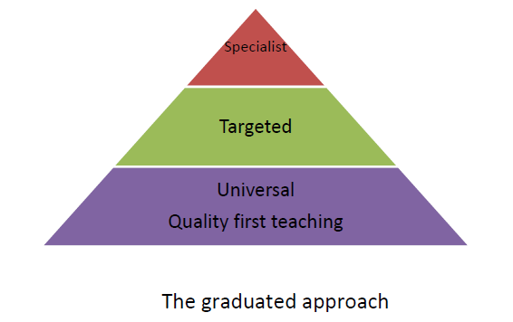**Specialist**- a few children may access this level of specialist Outside Agency support, for example support from the Educational Psychologist, specialist support for a sensory impairment. This includes children who have an Education, Health and Care (EHC) Plan

**Targeted**- a small group of children may require targeted additional support, as discussed above. This includes in school interventions and pastoral support. Children accessing this level of support will have a Pupil Profile (Appendix 1) and this support will be evaluated termly.

**Universal**- support in place for all children, including quality first teaching and in class adjustments.

Dependent on the level of support the child requires, will determine the level of SEND they are recorded as by the SENDCo on the school systems.

* **First Concerns register**- children receiving significant levels of targeted support that is recorded on a Pupil Profile (Appendix 1)
* **SEND register**- children with a diagnosed need e.g. ADHD, Dyslexia, Autism, or an EHCP in place

For all children who receive in school support (not those with an EHCP), they are classed as receiving SEND support and their support will be funded through the school’s SEND budget.

## Applying for an Education, Health and Care Plan

For a very small number of children, who may have significant additional needs, and despite several cycles of assess, plan, do, review support in school, they may still be making significantly inadequate progress, or may require significant specialist support. It may therefore, be appropriate to apply for an Education, Health and Care Plan (EHCP). This is a legal document authorised and set by the Trafford, the Local Education Authority, which describes the needs of the pupil, the provision that the school will put in place, any adaptions to the curriculum, and the individual targets and outcomes the child will be working towards. Having an EHCP in place means that the school will be allocated funding towards ensuring this specialist provision or support must be put in place.

To begin this process, school will work with parents to gather information and evidence of the support the child requires. Evidence from any Outside Agencies working with the child will also be gathered during this Needs Assessment process.

All of this information will be submitted as evidence to Trafford, who will assess this at a panel and decide what level of support the child requires, and what funding this will equate to. The provision for these pupils will be funded from the school’s notional SEND budget, and potentially additional funding from Trafford Local Authority. When the plan is finalised and funding issued, school are then responsible for allocating this funding in the most effective way to meet the provision outlined in the EHCP plan, for example this could be through additional adult support if appropriate, or specialist equipment/resources.

## The importance of the home/school partnership in SEND support

Partnership plays a key role in enabling children and young people with SEND to achieve their potential. Parents hold key information and have knowledge and experience to contribute to the shared view of the whole child. All parents of children with special educational needs are treated as partners, and are given support to play an active and valued role in their child’s education.

Children and young people with special educational needs often have a unique knowledge of the child and their views about what sort of help they would like. They will be encouraged to contribute to the assessment of their needs, the review and any transition process.

At all stages of the special needs process, the school keeps parents fully informed and involved. We take account of the wishes, feelings and knowledge of parents at all stages.

We encourage parents to make an active contribution to their child’s education and have regular meetings each term to share the progress of children with additional needs with their parents. We inform the parents of any targeted or specialist support, and share the process of decision-making by providing clear information relating to the education of their child.

School provide many opportunities for parents to communicate with school staff regarding SEND questions or concerns, such as

* Daily communication with teachers at drop off and pick up times
* Ability to contact class teacher/ SENDCo through school office email address
* Termly virtual learning conferences/progress reports from their child’s class teacher
* School open evening and meet the teacher events
* Termly SENDCo drop in sessions to discuss their child’s progress towards their Pupil Profile with their child’s class teacher and the SENDCo

## SEND support and resources on the school website

The school website now also has a dedicated Inclusion section, where parents can access further information about Inclsuion and SEND support at Brooklands. The website also contains comprehensive information/ resources and signposting information for a range of SEND and Emotional Wellbeing needs, for example Zones of Regulation, Sleep Support and Dyslexia support.

[Inclusion | (brooklands.trafford.sch.uk)](https://www.brooklands.trafford.sch.uk/parents/inclusion/)

**Staff CPD to support SEND across school**

Brooklands recognises the importance of supporting and empowering staff with relevant CPD and training, ensuring their own professional development but also ensuring staff are effectively trained to support all children, including children with additional needs. This is particularly important with SEND specific training. The SENDCo is responsible for coordinating and delivering CPD for Teaching Assistants across school. The SENDCo plans and tailors this weekly CPD to suit the learning of staff and also to ensure that the staff are trained and skilled to support children across school. CPD is targeted to support specific staff groups, for example, Higher Level Teaching Assistants (HLTAs), Teaching Assistants and teaching staff. Where appropriate, CPD will also be shared across staff groups, to ensure consistent school wide CPD and staff support for aspects of SEND and inclusion.

Brooklands also ensure that all staff are up to date with mandatory health and safety and safeguarding training. If required, staff are also trained to be able to support children in their class with any medical needs, for example asthma, epilepsy.

## Monitoring and evaluation

The SENDCo continually monitors the progress of all children with SEND and the impact of SEND processes and inclusive practise in different ways throughout the year, including

* Termly learning walks
* Regular classroom visits and discussions with staff
* Tracking pupils’ progress, including by using provision maps
* Termly pupil progress meetings
* Regular Inclusion team meetings
* Termly SENDCO drop-in events help for parents of children with SEND.
* Staff and pupil voice
* Parent feedback
* Staff CPD evaluations
* Getting feedback from the pupil and their parents
* Termly Governor visits

This policy will be reviewed annually by the SENDCo, Mrs Jones. It will also be updated with any new legislation, requirements by law or changes in procedures that may happen during the year.

## Supporting Pupils at School with Medical Conditions

The school recognises that pupils at school with medical conditions should be properly supported so that they have full access to education, including school trips and physical education. Children with an identified medical need will have these documented on a Wellbeing Profile (Appendix 4). This document will identify their specific medical need and in class support/ strategies or adjustments. It will also capture pupil and parent voice as to what helps the child best to support their medical need in school. Some children with medical conditions may be disabled and where this is the case the school will comply with its duties under the Equality Act 2010. Some children may also have special educational needs (SEND) and may have a Pupil Profile (Appendix 1) or Education, Health and Care Plan (EHC) which brings together health and social care, as well as their special educational provision and the SEND Code of Practice (2014) is followed.

## Supporting children with self-care needs and Intimate Care

Brooklands Primary School recognises that there may be children within the setting who struggle to independently meet their self-cares, such as for toileting. (Please see Appendix 5 for an example of school’s Intimate Care Policy).

## Accessibility

### Access to the Environment

* Brooklands Primary School is a single site school, with Foundation Stage, Key Stage 1 and Key Stage 2 departments. The school is built on two levels with stairs from ground floor. Entrance to the building is through the main lobby, which is level and therefore suitable for wheelchair access. Classrooms are accessed by corridors from which there is also wheelchair access. Year 2 classrooms are currently the only classrooms not on the ground floor and have lift access to the 1st floor.
* We have made sure that there are good lighting and safety arrangements (for example, markings on steps) for all visually impaired pupils. Our classrooms provide good acoustic conditions so that the effects of hearing difficulties are minimised (part-carpeting, curtains, quiet areas).
* We incorporate recommendations from our access audit into all repairs and maintenance programme.
* Children requiring equipment due to an impairment will be assessed in order to gain the support that they require or modifications to the building will be made to remove barriers to learning.
* Details of our plans and targets on improving environmental access are contained in the Access Plan. (see Appendix 6.)

### Arrangements for providing access to learning and the curriculum

The school will ensure that all children have access to a balanced and broadly based curriculum and that the National Curriculum’s programmes of study are flexible enough to meet every child’s needs. (No child will be excluded from any learning activity due to their impairment, learning difficulty or disability, unless it is clearly of benefit to that individual and leads towards inclusion.)

* Teaching styles will be multi-sensory and adapted to suit of all learners in the class, including those with SEND
* School use Dyslexia friendly teaching strategies and resources widely across school, to support children with Dyslexia but also support all children who may require further support in reading/writing
* Curriculum overviews are in place for all subjects and are adapted to include appropriate learning outcomes for all pupils.
* Children with sensory or mobility impairments or a specific learning difficulty will access the curriculum through specialist resources such as ICT where this is appropriate. Every child in Key Stage 2 has access to an individual Chromebook to use within lessons. Children in Key Stage One and EYFS have access to iPads.
* The school will ensure that any extra-curricular activities and clubs are open to all children, inclusive and do not exclude any pupils.

### Access to Information

* All children requiring information in formats other than print have these provided.
* We adapt printed materials so that children with literacy difficulties can access them, or ensure access by pairing children/peer support/extra adult support.
* We provide alternatives to paper and pencil recording where appropriate, or provide access through peer/extra adult scribing.
* When undertaking formal assessments, SEND pupils will be able to access a range of reasonable adjustments to ensure that they achieve their full potential. This may include a reader, scribe, extra time, a prompter and completing assessments outside of the classroom.
* Brooklands Primary School uses a range of assessment procedures within lessons (such as use of technology, photography, role-play and drama, video, drawing) to ensure children with additional needs are able to demonstrate their achievement appropriately.

### Admission arrangements

* Children with additional educational needs are considered for admission to the school on exactly the same basis as for children without additional educational needs.
* There are three reception classes with pupils being allocated to each class by age and gender to ensure that there is parity between classes. Children identified, prior to joining our school, as having additional needs will also be matched to each class to ensure a balance of both provision and opportunity.
* Admission to reception maybe on a part-time basis during the first week. These arrangements are flexible to cater for individual pupils.
* Prior to starting school, parents/carers of children with an EHCP or an EHCP pending will be invited to discuss the provision that can be made to meet their identified needs.
* **Incorporating disability issues into the curriculum**

* The PSHE curriculum includes issues of disability, difference and valuing diversity. Advice may be sought from disabled people’s organisations on appropriate resources.
* Disabled adults are invited to work with the children, as we believe it is important to have role models and we encourage disabled people to join our governing body.
* The library resources are regularly reviewed to ensure they include books that reflect the range of Special Educational Needs issues and come from a disability equality perspective and priority is given to the ordering of books with positive images and a positive portrayal of disabled people as they become available.

### Listening to disabled pupils and those identified with additional needs

* Brooklands Primary School encourages the inclusion of all children in the School Council and other consultation groups.
* We aim to include children in their target setting and encourage and support them to take an active part in their annual reviews, through preparation and making the information and meeting itself accessible and unintimidating.
* The staff has on-going training opportunities on issues relating to communication and listening skills.
* Regular pupil voice activities include representation from children identified as having SEND.

### Disability equality and trips or out of school activities

* Brooklands Primary School makes all trips inclusive by planning in advance and using accessible places. We aim to take all children on a residential visit during their education at Brooklands Primary School.
* Additional risk assessments will be put in place where necessary.
* All children are welcome at our after-school activities, however, if a pupil has severe and complex needs, we reserve the right to conduct a risk assessment prior to granting a place. This is to ensure that the child is safe and that their needs can be met within the setting.

### Working with disabled parents

* Brooklands Primary School recognises that there will be a number of disabled parents/carers of children within the school and we work to try to ensure that all parents are fully included in parents’ activities and events across school and endeavour to make necessary access arrangements if required.
* When a child starts at the Brooklands, school will ask the parents/carers about their access needs and act on this information accordingly.

## Support from Trafford for pupils and families

Local authorities must publish a Local Offer, setting out in one place information about provision they expect to be available across education, health and social care for children and young people in their area who have SEND or are disabled.

The Local Offer has two key purposes:

* To provide clear, comprehensive, accessible and up-to-date information about the available provision and how to access it.
* To make provision more responsive to local needs and aspirations by directly involving disabled children and those with SEND and their parents, and disabled young people and those with SEND, and service providers in its development and review.

Trafford Local Offer can be found via Trafford Service Directory online at:

[**Trafford Directory | Trafford SEND Local Offer**](https://www.trafforddirectory.co.uk/kb5/trafford/fsd/localoffer.page)

# SEND and Inclusion information report

Brooklands primary School also has an SEND Information Report, which outlines how this SEND and Inclusion Policy is implemented in practice in school. It is available in the Inclusion section on the school website [Inclusion | (brooklands.trafford.sch.uk)](https://www.brooklands.trafford.sch.uk/parents/inclusion/)

The SEND information report will be updated annually by the SENDCo, Mrs Jones, or as soon as possible after any changes to the information it contains.

## Dealing with complaints

If a parent wishes to complain about the provision or the policy, they should in the first instance, raise it with the SENDCo, who will try to resolve the situation. If required, the SENDCo will discuss this concern with the Inclusion Team lead, the Deputy Headteacher, for an additional resolution. If the issue cannot be resolved, the parent can then escalate this to the Headteacher.

Any issues that remain unresolved at this stage will be managed according to the school’s Complaint’s Policy. This is available, on request, from the school office and is also on the School website. Under the Equality Act 2010, parents who remain unsatisfied can take complaints about failure to provide reasonable adjustments to the First-Tier Tribunal (Special Education Needs and Disabilities).

**Appendix 1**

**Example of a Pupil Profile**

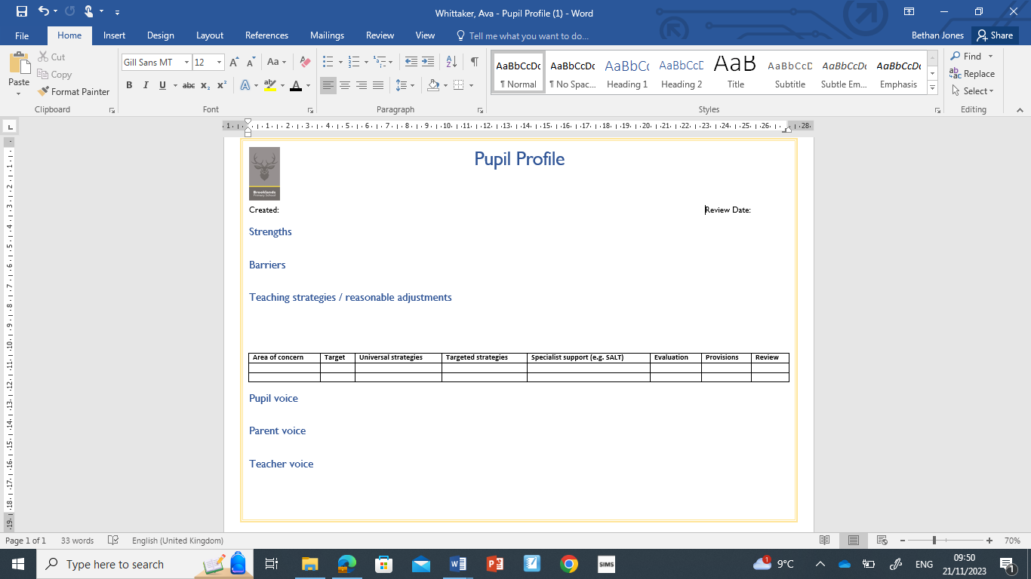

**Appendix 2**

**Identification of Concern referral**

|  |  |  |  |  |  |  |  |
| --- | --- | --- | --- | --- | --- | --- | --- |
| Name | | | Class | Gender | | DOB | |
| Referred by | | | Date of referral | | Term *(please circle)*  Autumn/Spring/Summer | | |
| Concern raised by home/school *(please circle)* | | | Parental consent gained  Yes/No | | | | |
| **Reason for referral - please tick:** | | | | | | | |
| Emotional development – low self confidence or self esteem |  | | Home/family difficulties or changes | | | |  |
| Life event eg bereavement |  | | New to school | | | |  |
| Problems managing emotions |  | | Medical/illness (themselves or someone in family) | | | |  |
| Social skills |  | | Anxiety | | | |  |
| Management of anger |  | | Co-operation skills | | | |  |
| **Child’s view on why they think support would help:** | | | | | | | |
| **Parents’ view on concerns, reasons for referral and desired outcome:** | | | | | | | |
| **School’s view on concerns and reason for referral:** | | | | | | | |
| **Agencies already involved:** | | | | | | | |
| **Current interventions/strategies tried and outcome:**  *(please link to pupil profile/EHCP outcomes if necessary)* | | | **Desired outcome after this referral:** | | | | |
| **Inclusion Team views:** Suitable for targeted Pastoral Support  Yes/No | | | | | | | |
| **If yes, please provide next steps regarding Learning Mentor support:** | | **If no, please indicate further QFT/ in class/parental support to be signposted:** | | | | | |

**Appendix 3**

**Example of a Wellbeing Profile**

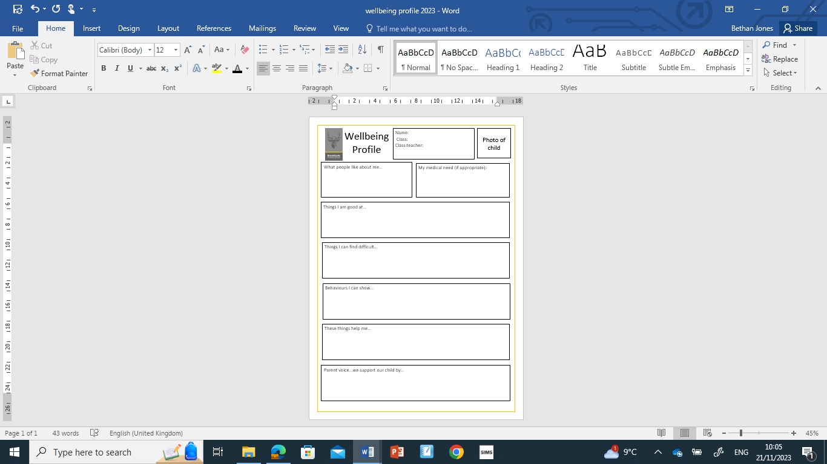

**Appendix 4**

**Provision map of Social, Emotional, Mental Health support at Brooklands**

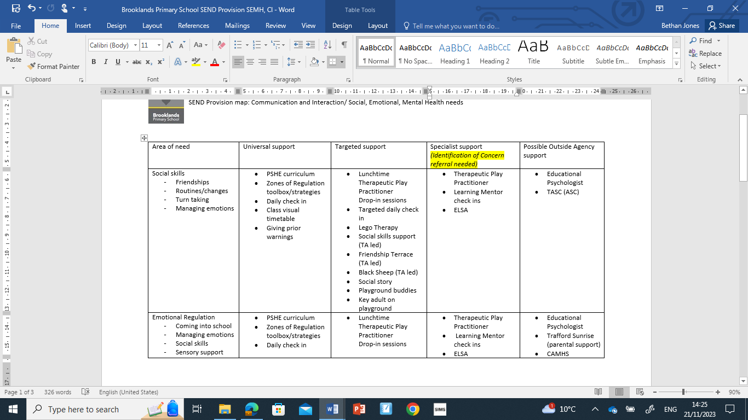

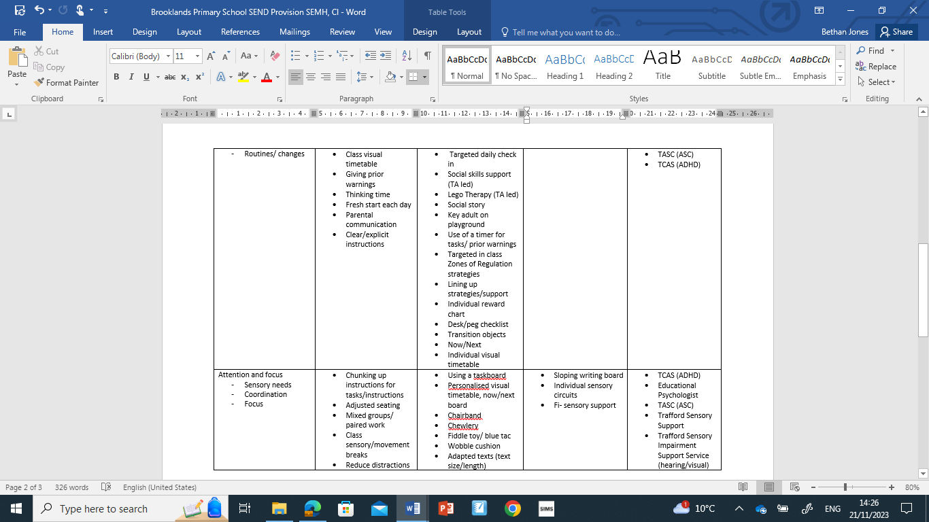

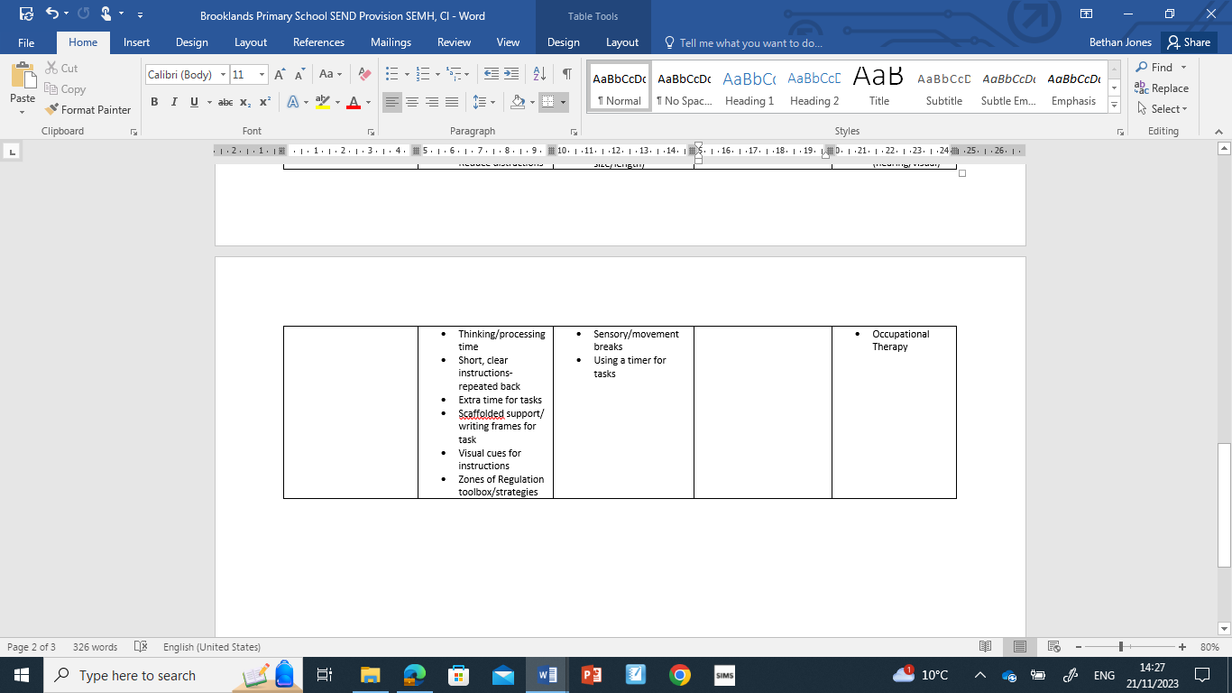

**Appendix 5**

## Intimate Care Policy

### Introduction

At Brooklands Primary School we recognise that all children have different rates of development and differing needs during their time in school. Most children achieve continence before starting full-time school. With the development of more early year’s education and the drive towards inclusion, however, there are many children in mainstream educational establishments who are not fully independent. Some children remain dependent on long-term support for personal care, while others progress slowly towards independence. The achievement of continence can be seen as the most important single self-help skill, improving the person’s quality of life, independence and self-esteem. The stigma associated with wetting and soiling accidents can cause enormous stress and embarrassment to the children and families concerned. Difficulties with continence severely inhibit a child’s inclusion in school and the community. Children with toileting problems who receive support and understanding from those who act in loco parentis are more likely to achieve their full potential. We are committed to ensuring that all pupils are able to access the whole curriculum and are able to be included in all aspects of school life. This includes providing suitable changes of clothing and attending to continence needs of our pupils where necessary.

### Aims

All children have the right to be safe, to be treated with courtesy, dignity and respect and to be able to access all aspects of the educational curriculum and Brooklands Primary School will work:

* To ensure that pupils with continence difficulties are not discriminated against in line with the Equalities Act 2010
* To provide help and support to pupils in becoming fully independent in personal hygiene
* To treat continence issues sensitively so as to maintain the self-esteem of the child
* To work with parents in delivering a suitable care plan where necessary
* To ensure that staff dealing with continence issues work within guidelines that protect themselves and the pupils involved.

### Pupils’ Needs

The staff work hard to build effective relationships with the parents and carers of the children attending Brooklands Primary School. Any particular need that a child may have will be dealt with sensitively and appropriately, working with parents/carers to ensure that each child can access the curriculum. Any child who has personal care or continence needs will be attended to in a designated area within the school. Parents will only be contacted in extreme cases where soiling is severe and/or linked to illness eg. Sickness and diarrhoea, or when a child refuses to let a member of staff help change their clothing.

### Care Plans

Where a pupil has particular needs (eg. wearing nappies or pull-ups regularly, or has continence difficulties which are more frequent than the odd 1accident1, staff will work with parents/carers (and health visitors/school nurse, if appropriate) to set out a care plan to ensure that the child is able to attend daily.

The written care plan will include:

* Who will change the child
* Where the changing will take place
* What resources and equipment will be used (Cleansing agents used or cream to be applied) and clarification of who is responsible (parent or school) for the provision of the resources and equipment
* How the product, if used, will be disposed of; or how wet or soiled clothes will be kept until they can be returned to parent/carer
* What infection control measures are in place
* What the staff member will do if the child is unduly distressed by the experience or if the staff member notices any marks or injuries
* Training requirements for staff
* Arrangements for school trips and outings
* Care plan review arrangements

### Care Plan Agreements

In these circumstances it may be appropriate for the school to set up an agreement that defines the responsibilities that each partner has, and the expectations each has for the other. This will include:

**The parent:**

* Agreeing to ensure that the child is changed at the latest possible time before being brought to the setting/school
* Providing the setting/school with spare nappies or pull-ups and a change of clothing
* Understanding and agreeing the procedures that will be followed when their child is changed at school – including the use of any cleanser or wipes.
* Agreeing to inform the setting/school should the child have any marks/rashes
* Agreeing to a ‘minimum change’ policy i.e. the setting/school would not undertake to change the child more frequently than if s/he were at home
* Agreeing to review arrangements should this be necessary

**The School:**

* Agreeing to change the child during a single session should the child soil themselves or become uncomfortably wet
* Agreeing how often the child would be changed should the child be staying for a full day
* Agreeing to monitor the number of times the child is changed in order to identify progress made
* Agreeing to report should the child be distressed, or if marks/rashes are seen
* Agreeing to review arrangements should this be necessary

This kind of agreement should help to avoid misunderstandings that might otherwise arise, and help parents feel confident that the setting/school is taking a holistic view of the child’s needs. Should a child with complex continence needs be admitted, the school will consider the possibility of special circumstances and/or provision being made. In such circumstances, an appropriate health care professional (school nurse or family health visitor) will be closely involved in forward planning.

### Personal Care Procedures

The staff at Brooklands Primary School will follow agreed procedures when attending to the care or continence needs of any pupil within the setting, whether this be a child with a care plan agreement or a child who has an occasional ‘accident’.

### Health and Safety Procedures

When dealing with personal care and continence issues, staff will follow agreed health and safety procedures to protect both the child and the member of staff.

### Child Protection

The normal process of changing continence or wet/soiled clothes should not raise child protection concerns, and there are no regulations that indicate that a second member of staff must be available to supervise the changing process to ensure that abuse does not take place. Few settings/schools will have staffing resources to provide two members of staff for changing and DBS checks are carried out to ensure the safety of children with staff employed in our school. If there is a known risk of false allegation by a child then a single practitioner will not undertake changing. A student on placement will not change a child unsupervised.

Wherever possible, the same member of staff will be allowed to change named children. This reduces the risk to the child and promotes their dignity. The care plan will outline back up or contingency measures in the event that the named member of staff is not available.

### Monitoring and Review

* The SENDCo will take responsibility for monitoring that agreed procedures are being followed and are supporting children and families
* It is the SENDCo’s responsibility to ensure that all practitioners follow the school policy • Any concerns that staff have about child protection issues will be reported to the Designated Safeguarding Lead (DSL) and subsequently the Head Teacher for further referral if appropriate.
* This policy runs alongside other school policies, particularly Safeguarding Children, SEND, and Health and Safety

**Brooklands Primary School Intimate Care Plan**

|  |  |
| --- | --- |
| **PERSONAL CARE NEEDS PLAN**    **For XXX in Nursery**    **Date of Plan: Sept 2021**  **Review Date: Dec 2021** | **CONFIDENTIAL** |
| This plan has been discussed with parents/carers. Signed permission has been obtained for this plan to be followed during the school day.    This plan is to be reviewed termly (or sooner if needs change) in consultation with parents/carers. |
| **Teachers:**    The staff involved in routinely meeting XXX’s personal care needs: Mrs XXX, Mrs XXX, Mrs XXX, Mrs XXX, Mrs XXXl | |
| **Medical information:** N/A    **Mobility:** N/A    **Communication skills:** | |
| **Details of the Plan** | |
| **Changing Procedure:** | |
| **Facilities, resources & equipment needed:**     * Wet wipes * Clean underwear * Clean clothing * Plastic bags to return soiled clothes in | **Management of personal care needs**    Management and review of the personal care needs plan with staff and parents/carers are the responsibility of the SENDCo. Day to day responsibility for the implementation of the personal needs care plan remains the responsibility of the class teacher and named  TA            **Level of supervision**: 1 to 1 |
| **Confidentiality Agreement**    Parent/carer agrees that this is to be shared with key staff who will treat all information  confidentially and will respect the dignity of XXX | **Additional roles of support staff:**     * Monitor the number of accidents, log in a diary and inform parent/carer when stock of resources may be running low * Maintain good health and safety practices, such as wearing gloves and aprons, etc. * Maintain hygiene/cleanliness of the equipment/area. * Maintain standards of personal hygiene |
| I have read and agreed that this is a safe procedure for XXX:      _______________________________________________ (Parent/Carer)    _____________ (Date)      _______________________________________________ (TA)    _____________ (Date)      _______________________________________________ (Class Teacher)    _____________ (Date)      _______________________________________________ (SENDCo)    _____________ (Date) | |

**Brooklands Primary School**

### Intimate Care Plan Agreements

The parent/carer:

* I agree to ensure that my child is changed at the latest possible time before being brought to school
* I will provide the school with spare pull ups (where required) and a change of clothing
* I understand and agree the procedures that will be followed when my child is changed at school – including the use of any cleanser or wipes
* I agree to inform the school should my child have any marks or rashes
* I agree to a ‘minimum change’ policy i.e. the school will not undertake to change my child more frequently than if s/he were at home
* I agree to review arrangements should this be necessary

Signed: __________________________________ (parent/carer)

School

* We agree to change your child during a single session should they soil themselves or become uncomfortably wet
* We agree to monitor the number of times the child is changed in order to identify progress made
* We agree to report to you should your child be distressed or if any marks/rashes are seen
* We agree to review arrangements should this be necessary

Signed ____________________________________ (school member of staff)

Signed ____________________________________ (school member of staff)

Signed ____________________________________ (school member of staff)

Date: _____________

### Personal Care Procedures

The staff at Brooklands Primary School will follow agreed procedures:

* Change the child’s clothing as appropriate, as soon as possible
* Use appropriate cleaning products and adhere to health and safety procedures
* Report any marks or rashes to parents/carers and Head Teacher if appropriate
* Inform [aren’t/carer that a continence issue has arisen during the session
* Contact a parent/carer only where soiling is severe and/or linked to illness e.g. sickness and diarrhoea, or when a child refuses to let a member of staff help change their clothing.
* Ensure that privacy and dignity are maintained during the time taken to change the child

### Health and Safety Procedures

When dealing with personal care and continence issues, staff will follow agreed health and safety procedures:

* Staff to wear disposable gloves and aprons while dealing with the incident
* Soiled continence product to be double wrapped, or placed in a hygienic disposal unit
* Changing area to be cleaned after use
* Hot water and liquid soap available to wash hands as soon as the task is completed (hand gel also available)
* Paper towels available for drying hands