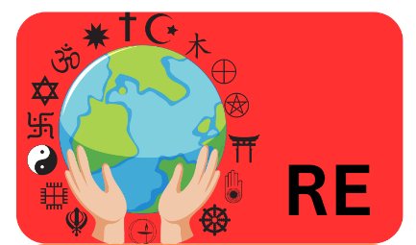

**What is it like to follow God?**

Lesson 1: I am learning the Christian story of Noah’s Ark..

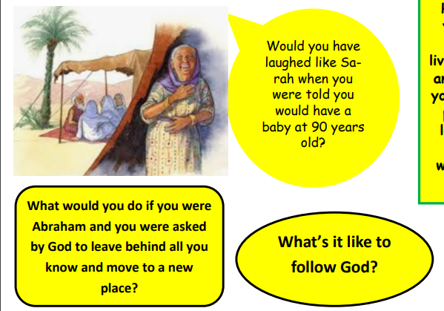

Lesson 2: I am learning to understand the actions and qualities of Noah.

Lesson 3: I am learning to understand what a covenant is.

Lesson 4: I am learning to explore a Christian wedding ceremony

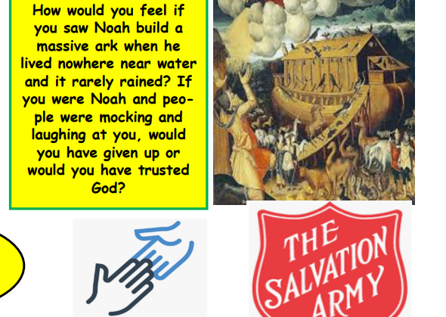

Lesson 5: I am learning the story of Abraham.

Lesson 6: I can research someone who made sacrifices to God.

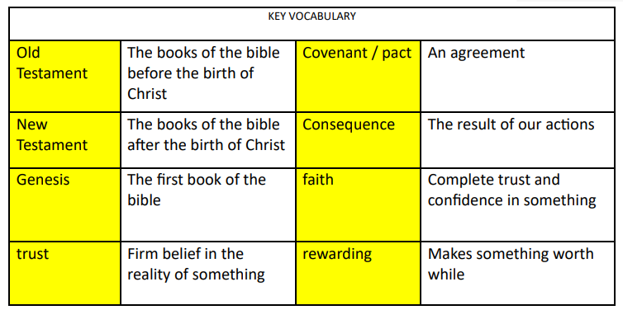



**What is it like to follow God?**

**At the end of Autumn 2****:**

**At the beginning of Autumn 2:**