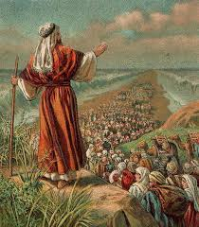
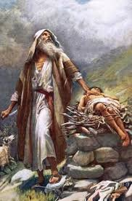


Moses led the Jewish people to escape from slavery.
Moses was a descendant of Abraham.
Abraham helped people understand there is only one God.
Abraham answered God’s call to go on an unknown journey.
OUR BIG QUESTION
Why is Abraham special?

JUDAISM – Abraham & Moses
Year 1
Abraham is the father of the Jewish nation.
KEY VOCABULARY
Abraham Moses
leaders promised
Pharaoh

