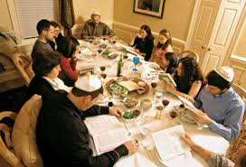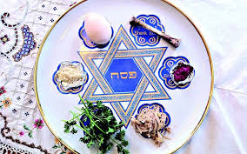

Hospitality is important at Pesach.

It is a time people thank God for their freedom.

Pesach or Passover is a spring festival which lasts for 7 or 8 days.

**OUR BIG QUESTION**

Why would Jews want to celebrate Pesach in Jerusalem?

Pesach comes from the paschal lamb which was once sacrificed.

The name Passover comes from the story of the angel of death passing over the house of the Israelites.

**KEY VOCABULARY**

Passover seder

kosher mezuzah

remembering

**JUDAISM – Pesach**

Year 5