Wigston College
A level Chemistry - Transition Pack

Topic | Score |  | Topic | Score
Balancing equations |  |  | Rearranging equations and units
Ionic formulae |  |  | Significant figures and decimal places
Writing equations |  |  | Moles and mass
Laboratory equipment |  |  | Moles and concentration
Total

Name: ………………………………

Introduction
This pack contains a range of activities and resources to prepare you to start A level in Chemistry in September. It is aimed to be used after you complete your GCSE, throughout the remainder of the summer term and over the summer holidays to ensure you are ready to start your course in September.

Contents Page
The Periodic Table of the Elements 3
Balancing equations 4
Ionic formulae 5
Writing equations 6
Laboratory equipment 7
Rearranging equations and converting units 8
Significant figures, decimal places and rounding 9
Moles and mass 10
Moles and concentration 11

Balancing equations
Balancing chemical equations is the stepping stone to using equations to calculate masses in chemistry. There are loads of websites that give ways of balancing equations and lots of exercises in balancing.
https://www.bbc.co.uk/bitesize/guides/zg2h4qt/revision/6

Some of the equations to balance may involve strange chemicals- don’t worry about that, the key idea is to get balancing right.

Balance the equations below.

1. …..C + …..O₂ |  | …..CO
2. …..Ba + …..H₂O |  | …..Ba(OH)₂ + …..H₂
3. …..C₂H₆ + …..O₂ |  | …..CO₂ + …..H₂O
4. …..HCl + …..Mg(OH)₂ |  | …..MgCl₂ + H₂O
5. …..N₂ + …..O₂ |  | …..NO
6. …..Fe₂O₃ + …..C |  | …..Fe + …..CO₂
7. …..CH₃CH₂OH + …..[O] |  | …..CH₃COOH + …..H₂O
8. …..HNO₃ + …..CuO |  | …..Cu(NO₃)₂ + H₂O
9. …..Al³⁺ + …..e– |  | …..Al
10. …..[Fe(H₂O)₆]³⁺ + …..CO₃^{2–} |  | …..Fe(OH)₃(H₂O)₃ + …..CO₂ + …..H₂O

(10 marks)

Score | /10
Constructing ionic formulae
The ability to determine the formulae for an ionic substance is an essential skill for a chemist so at A-level you will be expected to write the ionic formulae quickly.
For now, take your time and try to get the following formulae right.

1. For each of the following ionic salts, determine the cation and anion present and use these to construct the formula of the salt.
 | Ionic salt | Positive ion  (cation) | Negative ion  (anion) | Formula
a | Magnesium oxide
b | Sodium sulfate
c | Calcium hydroxide
d | Aluminium oxide
e | Copper(I) oxide
(5 marks)

2. When an acid is added to water it dissociates to form H⁺ ions (which make it acidic) and an anion. These acidic hydrogen atoms can be used to determine the charge on the anion.

Deduce the charge on the anions in the following acids. The acidic H atoms, H⁺, have been underlined for you. (5 marks)
- H₂SO₃
- HNO₃
- H₃PO₄
- HCOOH
Score | /10
- H₂CO₃

Writing equations from text
The following questions contain a written description of a reaction. In some cases the products may be missing as you will be expected to predict the product using your prior knowledge.
For more advanced equations you may be given some of the formulae you need.

For each one, write a balanced symbol equation for the process.

1. The reaction between silicon and nitrogen to form silicon nitride Si₃N₄.

2. The neutralisation of sulfuric acid with sodium hydroxide.

3. The preparation of boron trichloride from its elements.

4. The reaction of nitrogen and oxygen to form nitrogen monoxide.

5. The combustion of ethanol (C₂H₅OH) to form carbon dioxide and water only.

6. The formation of silicon tetrachloride (SiCl₄) from SiO₂ using chlorine gas and carbon.

7. The extraction of iron from iron(III) oxide (Fe₂O₃) using carbon monoxide.

8. The complete combustion of methane.

9. The formation of one molecule of ClF₃ from chlorine and fluorine molecules.

10. The reaction of nitrogen dioxide with water and oxygen to form nitric acid.

Score | /10

Laboratory equipment
Practical work is a key aspect in the work of a chemist.
At A-level, you will be expected to plan your own practical work, so it is important that you are familiar with the common laboratory equipment available to you.
For each piece of equipment, state its name and its use.
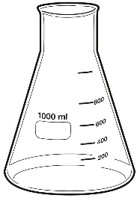 | Name:  Use: |  | Name:  Use:
 | Name:  Use: | 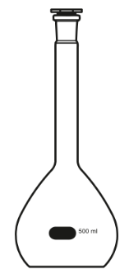 | Name:  Use:
 | Name:  Use: |  | Name:  Use:
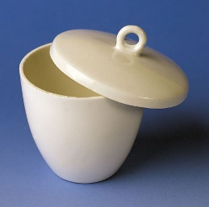 | Name:  Use: | 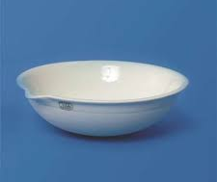 | Name:  Use:
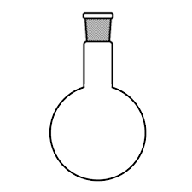 | Name:  Use: |  | Name:  Use:

Score | /10
Rearranging equations and converting units
- The amount of substance in moles (n) in a solution can be calculated when the concentration given in mol/dm³ (c) and volume (v) in dm³ are known by using the equation:
$$\text{n = cv}$$
- Rearrange this equation making c the subject of the equation. (1 mark)

- Rearrange this equation making v the subject of the equation. (1 mark)

- The density of a substance can be calculated from its mass (m) and volume (v) using the equation:
$$density=\frac{mass(g)}{volume ({cm}^{3})}$$
- Rearrange this equation so that the mass of a substance can be calculated given its density and volume. (1 mark)

- Determine the units for density (1 mark)

- A block of iron has a length of 1.2 cm. Calculate its length in metres (1 mark)

- The width of the classroom is 7200 cm. Calculate its length in metres. (1 mark)

- A reaction reaches completion after 4.5 minutes. Convert this time into seconds. (1 mark)

- The stop clock reads 2 min 34 s. Convert this time into seconds. (1 mark)

- A paper reports that 0.0265 kg of copper oxide was added to an excess of sulfuric acid. Convert this mass of copper oxide into grams. (1 mark)

- A packet of aspirin tablets states that each tablet contains 75 mg of aspirin. Calculate the minimum number of tablets that contain a total of 1 g of aspirin. (1 mark)

Score | /10
Significant figures, decimal places and rounding

For each of the numbers in questions 1–6, state the number of significant figures and the number of decimal places.

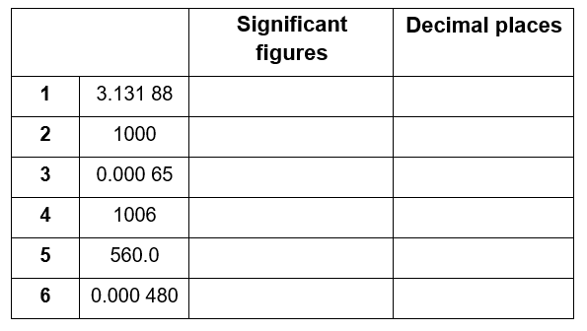

(6 marks)

Round the following numbers to (i) 3 significant figures and (ii) 2 decimal places.
- 0.075 84

- 231.456

(4 marks)

Score | /10

Moles and mass
From this point on you need to be using an A level periodic table, not a GCSE one. You can find one at the back of this pack.

One mole of a substance is equal to 6.02 × 10²³ atoms, ions or particles of that substance. This number is called the Avogadro constant.
The value of the Avogadro constant was chosen so that the relative formula mass of a substance weighed out in grams is known to contain exactly 6.02 × 10²³ particles. We call this mass its molar mass.
We can use the equation below when calculating an amount in moles:
amount of substance (mol) | = | mass (g)
molar mass
(g mol^{–1})
Use the equation above to help you answer the following questions.
- Calculate the amount of substance, in moles, in: (3 marks)
a. 32 g of methane, CH₄ (molar mass, 16.0 g mol^{–1})
b. 175 g of calcium carbonate, CaCO₃
c. 200 mg of aspirin, C₉H₈O₄

- Calculate the mass in grams of: (3 marks)
a. 20 moles of glucose molecules (molar mass, 180 g mol^{–1})
b. 5.00 × 10^{–3} moles of copper ions, Cu²⁺
c. 42.0 moles of hydrated copper sulfate, CuSO₄•5H₂O

- 3.09 g of a transition metal carbonate was known to contain 0.0250 mol.
a. Determine the molar mass of the transition metal carbonate. (1 mark)

b. Choose the most likely identity for the transition metal carbonate from the list below:
CoCO₃ | CuCO₃ | ZnCO₃ | - mark)
- 4.26 g of a sample of chromium carbonate was known to contain 0.015 mol.
Which of the following is the correct formula for the chromium carbonate? (2 marks)
CrCO₃ | Cr₂(CO₃)₃ | Cr(CO₃)₃

Score | /10

Moles and concentration
To calculate the concentration of a solution we use the equation:
concentration (mol dm^{–3}) | = | amount of substance (mol)
 |  | volume (dm³)
Use the equation to help you complete each of the statements in the questions below.

- 1.5 mol of NaCl dissolved in 0.25 dm³ of water produces a solution with a concentration of ______________mol dm^{–3}. (1 mark)
- 250 cm³ of a solution of HCl(aq) with a concentration of 0.0150 mol dm^{–3} contains ______________moles. (1 mark)
- A solution with a concentration of 0.85 mol dm^{–3} that contains 0.125 mol has a volume of ______________dm³. (1 mark)

In this question you will need to convert between an amount in moles and a mass as well as using the equation above.
- 5.0 g of NaHCO₃ dissolved in 100 cm³ of water produces a solution with a concentration of mol dm^{–3}.
(2 marks)

- 25.0 cm³ of a solution of NaOH(aq) with a concentration of 3.8 mol dm^{–3} contains g of NaOH.
(2 marks)

6. The volume of a solution of cobalt(II) chloride, CoCl₂, with a concentration of 1.3 mol dm^{–3}
that contains 2.5 g of CoCl₂ is cm³.
(3 marks)

Score | /10

