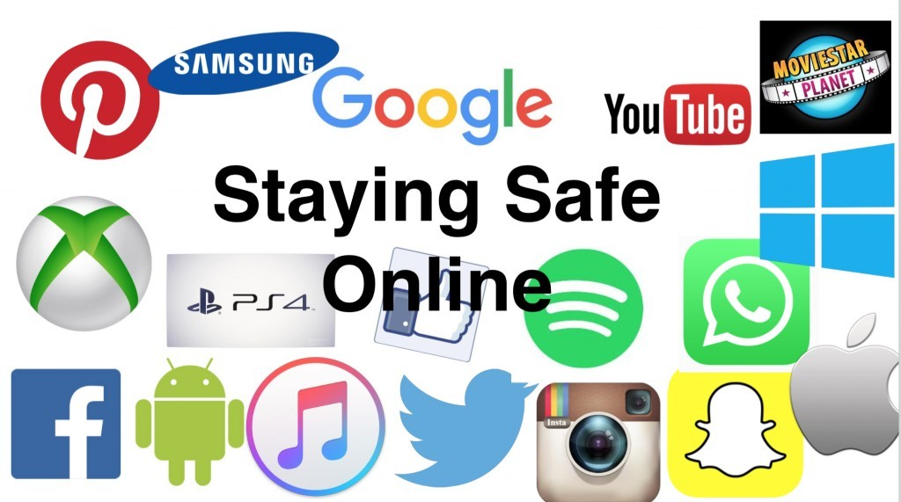

**Keeping your children safe online can seem quite daunting but it can sometimes be as simple as setting rules or just having a chat.**

While children and young people fearlessly dive into new apps, games and services, parents tend to be more cautious and stick with what you know and understand. But as parents, you don’t necessarily need to know everything about technology; however it’s vital you do take an interest in what your children are doing online and talk to them about some simple ways they can still have fun, whilst staying safe when they are doing it.

**Here are some simple things to get you started:**

* With many games now allowing you to play with strangers and friends from all over the world - Who are they playing with? Friends from school or online friends? Do they understand the difference?
* Come up with a list together of things they can share about themselves online (Favourite games, films or bands; hobbies) and things which they shouldn’t share (real name, address, age or school)
* Get them to show you the things they enjoy online. Ask them if they can block people who are horrible and get them to show you how – blocking is a vital digital skill
* Remember technology can be used in a positive and negative way, and sometimes things can go wrong. Try to be open with technology and encourage your child to be too. If other people are causing upset or if something does go wrong, it’s important that they can talk to someone about it.

**PLEASE PHONE SCHOOL FOR SUPPORT OR ADVICE!**

**SEE FORTUNA SCHOOL WEBSITE FOR LINKS http://www.fortuna.lincs.sch.uk/**

Fortuna School with support from Lincolnshire Children Safeguarding Board