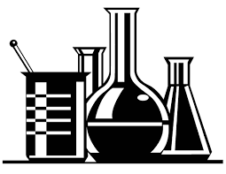
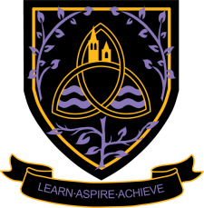
Chemistry
A Level 2024 - 2026
Wigston College

Examination Board
OCR A
Entry Requirements:
A GCSE grade 6, 6 in Combined Science or grade 6 in GCSE Chemistry and a minimum grade 5 in GCSE Maths is also necessary.
What will I be studying?
In the A Level course there are six teaching modules. These organise the subject into rational bodies of knowledge.
Module 1: Development of Practical Skills in Chemistry. (Year 12 and 13)
Practical skills are embedded throughout all the content of this specification. Learners will be required to develop a range of practical skills throughout their course in preparation for the written examinations.
Module 2: Foundations in Chemistry. (Year 12)
This module allows learners to develop important quantitative techniques involved in measuring masses, gas and solution volumes, including use of volumetric apparatus. Learners are also able to develop their mathematical skills during their study of amount of substance and when carrying out quantitative practical work.
Module 3: Periodic Table and Energy. (Year 12)
The focus of this module is inorganic and physical chemistry, the applications of energy use to everyday life and industrial processes, and current environmental concerns associated with sustainability. The content within this module assumes knowledge and understanding of the chemical concepts developed in Module 2: Foundations in chemistry.
Module 4: Basic organic chemistry. (Year 12)
This module introduces organic chemistry and its important applications to everyday life, including current environmental concerns associated with sustainability.
Module 5: Physical Chemistry and Transition Elements. (Year 13)
This module extends the study of energy, reaction rates and equilibria, and the periodic table.
Module 6: Organic Chemistry and Analysis. (Year 13)
This module introduces several new functional groups and emphasises the importance of organic synthesis. This module also adds NMR spectroscopy to the instrumentation techniques used in organic and forensic analysis.

How will I be studying?
You will be taught with a combination of tutorials, individual work, practical sessions, independent research and independent learning and presentations to the rest of the class.

How will I be assessed?
Assessment is by three exams in total taken at the end of year 13. There are two exams of 2 hours 15 minutes. One covers physical and inorganic chemistry and the other deals with organic chemistry. The other 26% is from a synoptic paper embracing all aspects of chemistry. Papers 1 & 2 assess content from modules 2, 3 & 5 and 2, 4 & 6 respectively. Paper 3 assesses content from modules 1 - 6. All three papers will have questions set based on considerations from module 1.
Core Mathematics:

As this subject contains elements of mathematical content within its specification and assessments, we strongly advise that you should also elect to take the Core Mathematics course to support your studies (if not already taking A Level Mathematics). The Core Mathematics course is a one-year course specifically designed for this purpose. You would still need to pick three main Level 3 subjects plus Core Mathematics. Please see the Core Mathematics information sheet for more details.

What could I go on to do after the course?
Students of A level chemistry may study chemical science or any related science or engineering course. Chemistry is essential for studying medicine, pharmacy, veterinary medicine and dentistry.
It is highly regarded as a support subject for non-science subjects; in particular for entry to numerate or technical professions e.g. accounting and patent law.

