

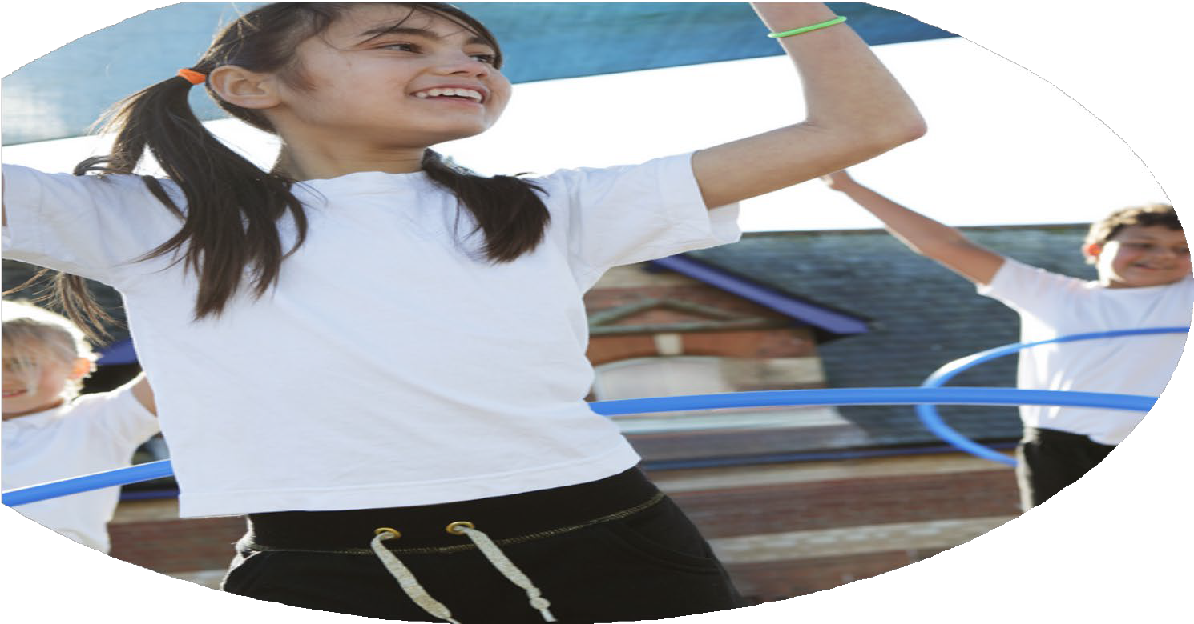
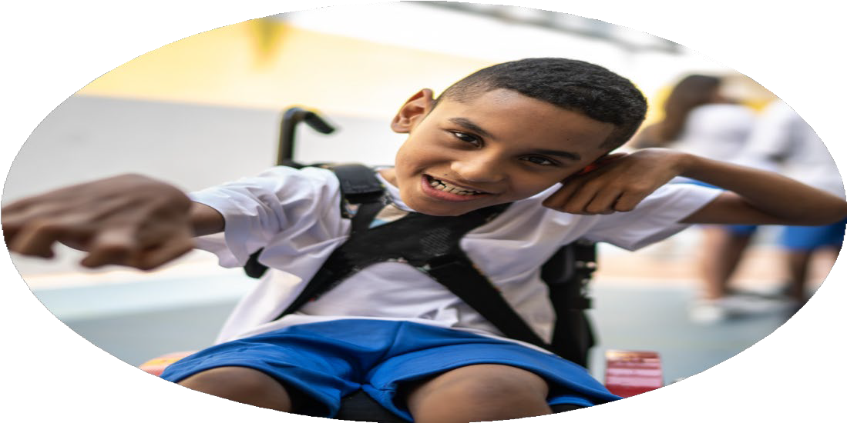




PE and Sports
Premium Funding
2024-2025

Commissioned by

Created by

Images courtesy of Youth Sport Trust
Funding Allocation
Did your school carry forward any grant funding from previous years for use in academic year 2024 to 2025? | No
Total amount of grant funding received for academic year 2024 to 2025 | £17,200
Did your school have any unspent grant funding from the allocation for academic year 2024 to 2025? | No

Categories of Grant Spend

CPD | Has your school spent any of its PE and sport premium grant on CPD? | Yes
CPD | How much has your school spent on CPD external training courses? | £0
CPD | How much has your school spent on CPD upskilling staff to deliver swimming lessons? | £0
CPD | How much has your school spent on CPD internal learning and development? | £314
CPD | How much has your school spent on CPD inter-school development sessions? | £400
CPD | How much has your school spent on CPD online training/resource development? | £214
CPD | How much has your school spent on CPD external coaches supporting confidence and competence? | £0
CPD | Total spend on CPD | £928
Internal Activities | Has your school spent any of its PE and sport premium grant on internal activities? | Yes
Internal Activities | How much has your school spent on internal school based extra-curricular opportunities? | £1600
Internal Activities | How much has your school spent on internal sports competitions? | £600
Internal Activities | How much has your school spent on internal top-swimming lessons or broadening aquatic opportunities for pupils? | £7150
Internal Activities | How much has your school spent on internal active travel? | £600
Internal Activities | How much has your school spent on internal equipment and resources? | £2600
Internal Activities | How much has your school spent on internal membership fees? | £154
Internal Activities | How much has your school spent on internal use of educational platforms and resources? | £514
Internal Activities | Total spend on internal activities | £13,218
External Activities | Has your school spent any of its PE and sport premium grant on external activities? | Yes
External Activities | How much has your school spent on external activities organised by School Games organiser network? | £0
External Activities | How much has your school spent on external - other inter-school sports competitions? | £400
External Activities | How much has your school spent on external coaching staff? | £1725
External Activities | Total spend on external activities | £2125
Total spend of PE and Sports Premium

Opportunities, Impact and Sustainability Details
Opportunities in Sport
Has your school targeted any spending on providing or improving opportunities in PE, sport and physical activities for pupils with SEND or long-term medical conditions? | Yes
SEND: | - Supporting participation in extra-curricular opportunities or competitions,  - Top-up swimming lessons for pupils requiring additional assistance  - Peer to peer led activity  - Youth leadership and volunteering opportunities
Has your school targeted any spending on increasing or improving girls' access to PE lessons or access to extra-curricular sport and physical activities? | Yes
Has your school targeted any spending on providing or improving opportunities in sport and physical activities for disadvantaged pupils? | Supporting participation in extra-curricular opportunities or competitions  Specialist focused activities for girls  Peer to peer led activity  Youth leadership and volunteering opportunities
Confirm how for disadvantaged pupils: | Peer to peer led activity , Insight and data capture to better understand and support these pupils
Perceived Impacts and Improvements
What impact has this funding had on increasing all staff's confidence, knowledge and skills in teaching PE and sport? | Positive impact
What impact has this funding had on increasing engagement of all pupils in regular physical activity and sport? | Positive impact
What impact has this funding had on raising the profile of PE and sport across the school to support whole school improvement? | Positive impact
What impact has this funding had on offering a broader and more equal experience of a range of sports and physical activities to all pupils? | Positive impact
What impact has this funding had on increasing participation in competitive sport? | No impact
What has your school's PE and sport premium spending achieved: | An increase in the number of pupils participating in school sport , An increase in the number of pupils participating in extracurricular activities , An increase in pupils’ attainment in swimming and water safety
What impact has your school's spending of this funding had on PE attainment? | Positive impact
What impact has your school's spending of this funding had on increasing teachers' confidence and competence in teaching PE and school sport? | Not sure
What impact has your school's spending of this funding had on increasing teachers'  confidence and competence in teaching PE and school sport? | Positive impact
What impact has your school's spending of this funding had on increasing pupil participation in extra-curricular activities? | Positive impact
Sustainability
What impact has your school's spending of this funding had on ensuring that the improvements made are sustainable? | Positive impact
Swimming
Does your school have year 6 pupils? | Yes
What percentage of pupils in your current year 6 cohort can swim competently, confidently, and proficiently over a distance of 25 metres? | 95%
What percentage of pupils in your current year 6 cohort can use a range of strokes effectively (e.g. front crawl, backstroke, and breaststroke)? | 95%
What percentage of pupils in your current year 6 cohort can perform safe self-rescue in different water-based situations? | 100%
What impact has your school's spending of this funding had on swimming and water  safety attainment? | Positive impact

Declarations
1 | The information contained in the PE and sport premium assurance return is accurate and has been signed off by the school headteacher
2 | The information contained in the PE and sport premium assurance return is accurate and has been authorised by the Chair of Governors
3 | The reported spending detailed within the submission will be published on our school's website
4 | I am authorised to submit this PE and sport premium assurance return on behalf of my school

