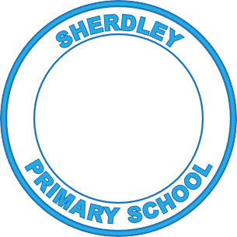

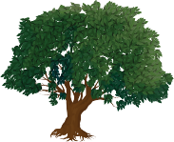

Art Curriculum Map
2024-25
Sherdley Primary School 2024-25
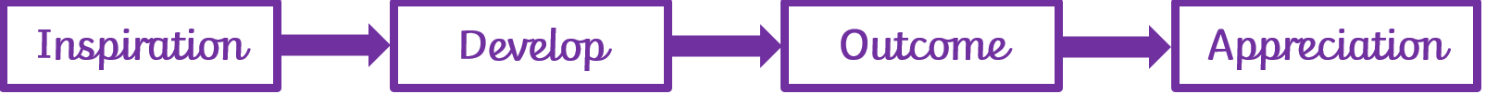
Art Pre-School Curriculum Map
 | Autumn | Spring | Summer
Physical Development | Fine Motor Skills  Using a palm grip to hold a pencil and make marks.  Using snippers independently to make snips.  To use tweezers to move large equipment (pom poms)  Big scoops sand and water  Hammering golf tees into a pumpkin  Holding a pencil - mark making  To use a stick, finger, and paintbrush to mark make in different materials  Big spoons and ladles in water  Squeezing, squashing playdough to change its shape introduce scissors and snipping  Manipulating playdough with scissors and rolling pins  Large pegs and boards | Fine Motor Skills  Scooping rice crispies with a spoon  Knives and soft foods, apply pressure to make a cut  Smaller scoops in sand and water  To use pincher grip to apply pressure  Pipettes in the water tray  Rolling eggs with playdough  Holding a pencil drawing letter shapes  Mark making drawing different animals  Introduce tripod grip  Holding a pencil some writing letter shapes from their name  Drawing left to right  Pouring with watering cans  Making beans and beanstalks with playdough, rolling different lengths  Painting/ mark making  Threading pasta  Apply pressure to spray bottles for watering flowers. | Fine Motor Skills  Threading cereal vertically and horizontally  Holding a pencil writing letters from name  To use a tripod grip  To have a dominant hand  To write letters from their name  Using knives in the playdough  Holding a pencil writing their name  Smashing and crushing cereal  Pouring potion bottles and funnels  Small pegs and boards  Holding a pencil writing their name  Smashing and crushing cereal  Pouring into potion bottles and funnels  Small pegs and boards

Expressive Arts Links  (Including Art, DT, Music, Drama Links) | Artists  Jackson Pollock- firework paintings – paint flicking.  Banksy – Calendars spray paint from water sprays.  2D Art  To name colours they are using  Exploring paint and forming enclosures  Painting their own face  Painting families  Exploring colour- mark making with pens, chalks, pencils, crayons  Painting pumpkins with faces  Painting to music  Mark making with their finger/tool in rice/ glitter/ sand/ foam  Christmas cards – handprints.  Drawing stickman and his family.  3D Art  To explore 2D and 3D structures  Autumn pictures- make an arrangement or shape  Structures with natural materials.  Making pumpkin faces in the playdough.  Potato Man faces – using different features.  Making their own stickman with playdough. | Artists  Monet – Lilypad – using finger paints.  2D Art  Painting snowmen and bears  To paint/draw shapes to form a picture  To draw shapes to represent objects  To use glue to attach materials together  Drawing and painting ducks and plants  Mother’s Day cards  Easter Cards  Painting and chalking plants and flowers  Colour mixing – 2 colours  3D Art  Making a cave  To start attaching 2D and 3D materials  To make enclosures with construction kits  Easter baskets  Paper plate ducks  Making beanstalks  Attaching boxes  Making playdough lily pads for the frogs.  Making eggs and beanstalks with the playdough. | Artists  Yayoi Kusama – patterns polka dots  2D Art  Drawing/ Painting Gruffalo with his features  Gruffalo masks  Gruffalo character stick puppets  Painting and drawing with increasing details  Colour mixing- two colours talk about the changes, name the colour.  Painting emotions (pigs faces)  Painting/drawing to different types of music/different sounds  3D Art  Building animal homes  To think about how they may use materials  To make imaginative and complex buildings and models  Making houses for the pigs using masking tape.  Making simple models and talking about them  Making houses with the playdough.

Sherdley Primary School 2024-25
Art EYFS Curriculum Map
 | Autumn | Spring | Summer
Physical Development | Fine Motor Skills  Using knives, scissors, mashers, graters, tweezers and sieves.  Using trowels and forks when digging. Undressing and dressing dolls.  Threading beads and cotton reels.  Manipulating playdough – rolling eggs and cut them with a knife once they have made them.  Making imprints in playdough. Making impressions using textures.  Manipulating playdough –brooms by rolling into a sausage shapes.  Manipulating playdough –using rolling pins and Christmas cutters to make cookies.  Holding a pencil – tracing lines, circles and spirals – anti-clockwise.  Learning the formation of Phase 2 phonemes /graphemes.  Folding, rolling, cutting and wrapping using paper. | Fine Motor Skills  Using jugs and funnels for pouring and stirring investigations.  Using clay tools, peelers, pipettes, and water sprays.  Manipulating playdough –Gingerbread cutters, 2D shape cutters and rolling pins.  Manipulating playdough – making different types of bread and experimenting with the techniques.  Manipulating playdough –animals, fruit.  Kneading clay and manipulating it to make simple pots.  Clay imprints.  Cutting out different features and making a gingerbread man.  Making 3D maps with blocks and junk materials.  Curling paper for feathers to create 2D hens.  Paper plate animals – using different paper techniques.  Holding a pencil – learning the formation of Phase 2/3 phonemes/graphemes. | Fine Motor Skills  Using syringes, whisks and a hole punch.  Attaching fruit together by sewing using a needle and thread.  Attaching paper using treasury tags.  Making 3D minibeasts using a variety of materials.  Manipulating playdough –making 2D and 3D shapes, mini beasts, sea creatures, dinosaurs.  To make a salt dough model of Gaudi’s dragon.  Holding a pencil – focusing on ascenders and descenders – writing on lined paper.  Focusing on lower case letters and capital letters.

Expressive Arts Links  (Including Art, DT, Music, Drama Links) | Artists  Andy Goldsworthy – how he uses nature to create pictures, focusing on autumnal materials. Colours, shapes and texture in the natural world.  Vincent Van Gogh – looking at the Starry Night painting – talk about his techniques.  2D Art  Drawing their family – black and white pictures.  Drawing their face – looking at eye and hair colour.  Drawing and painting the characters from the story.  Paper collage of owls – cut out an oval and stick simple features on.  Imprints of natural materials in play dough.  Making impressions using textures.  Create our own Starry Night using chalks and pastels.  Paint Mixing – adding white and black.  Making brown.  Create repeating pattern wrapping paper using printing techniques.  Paper plate robins – cut out a shapes and stick simple features on.  3D Art  Making towers – tall and short with the various construction kits.  Making owls with the junk materials.  Rolling eggs with the playdough Making brooms with the construction kits.  To make a Truly Magnificent Broom with the large blocks with a group that they can all sit on.  Rolling and folding paper to make their own broomstick.  Manipulating playdough –brooms by rolling into a sausage shapes.  Making 3D baubles for the Christmas Tree – cutting shapes, folding them and gluing them together.  Making paper chains – manipulating the paper to make links and attaching them, together. | Artists  Kandinsky – 2D shape pictures – using paint.  2D Art  Use charcoal to create pictures of The Gingerbread Man  Collage pictures of their own gingerbread man.  Adding flour to paint and painting with thick paint.  Painting pictures of hens. Paint Mixing – mixing primary colours to see what happens  Painting pictures of animals using a range of brushes.  3D Art  Create their own 3D maps with boxes for the gingerbread man’s route.  Make a big gingerbread house outside with the large construction blocks.  Junk boxes for the gingerbread house.  Create farm buildings using wooden blocks.  Curling paper to make the little red hen.  Toilet roll characters.  Use clay to make beads for a necklace.  Use clay to create a simple pot – thumb pot.  Making paper plate – animal faces focusing on their features. | Artists  Matisse – looking at The Snail picture – talk about the shapes he has used and the techniques.  Gaudi – looking at The Dragon Fountain picture, talk about his techniques. The use of shapes in the natural world.  2D Art  2D shape collages.  2D shape printing creating spirals.  Sketching mini beasts using different pencils.  Painting using rollers and cotton buds to create an underwater scene or a seascape.  Shiny/reflective collages.  Make their own mosaic based on Gaudi’s dragon.  Painting pictures of dinosaurs.  3D Art  Make their own mini beast using junk materials.  Make their own sea creature using any materials.  Creating fans and making fan fish using this technique.

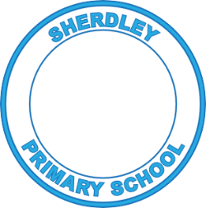
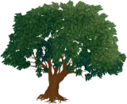
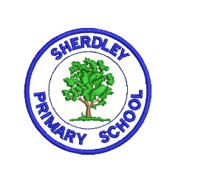
Sherdley Primary School 2024-25
Art - Curriculum Map

 | Autumn | Spring | Summer
Year 1 | I am learning about artwork produced by Mark Rothko and Jackson Pollock.  Skills to focus on:  - I can describe and compare features between two different artists’ work.  - I can recognise ‘warm’ and ‘cool’ colours.  - I can apply colour using different tools (brush, sponge, printing, cardboard scraping etc).  - I can describe my artwork using artistic vocabulary I have been taught.  Outcome:  Mark Rothko inspired artwork using paint?  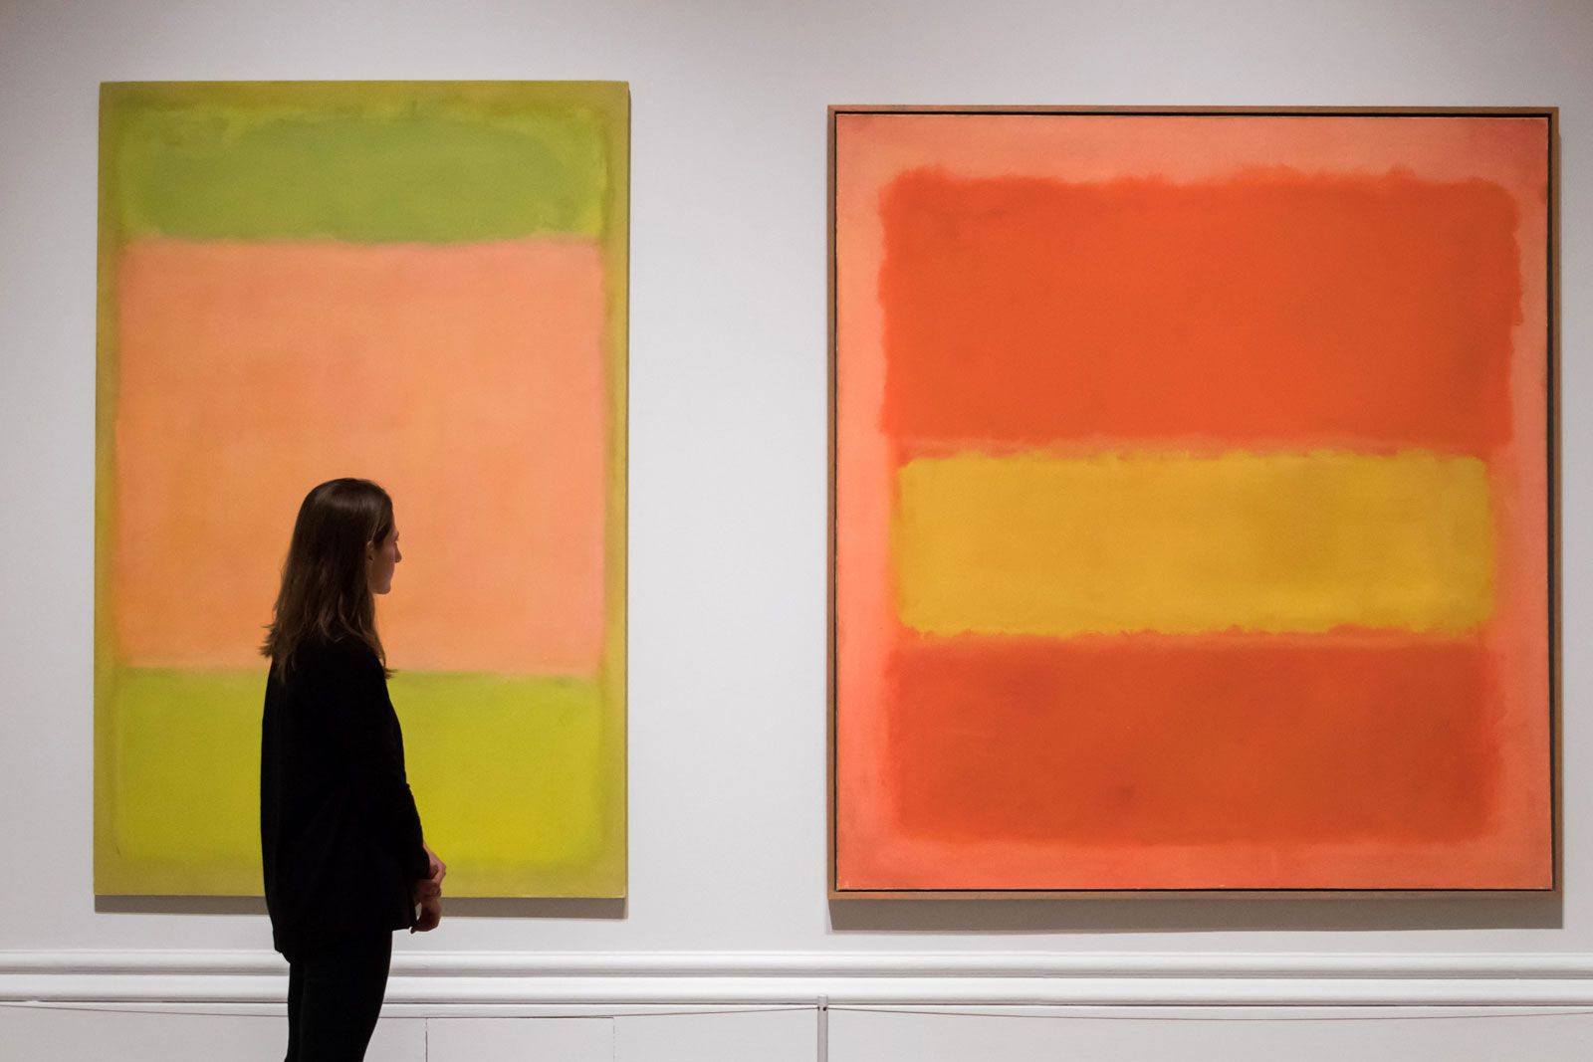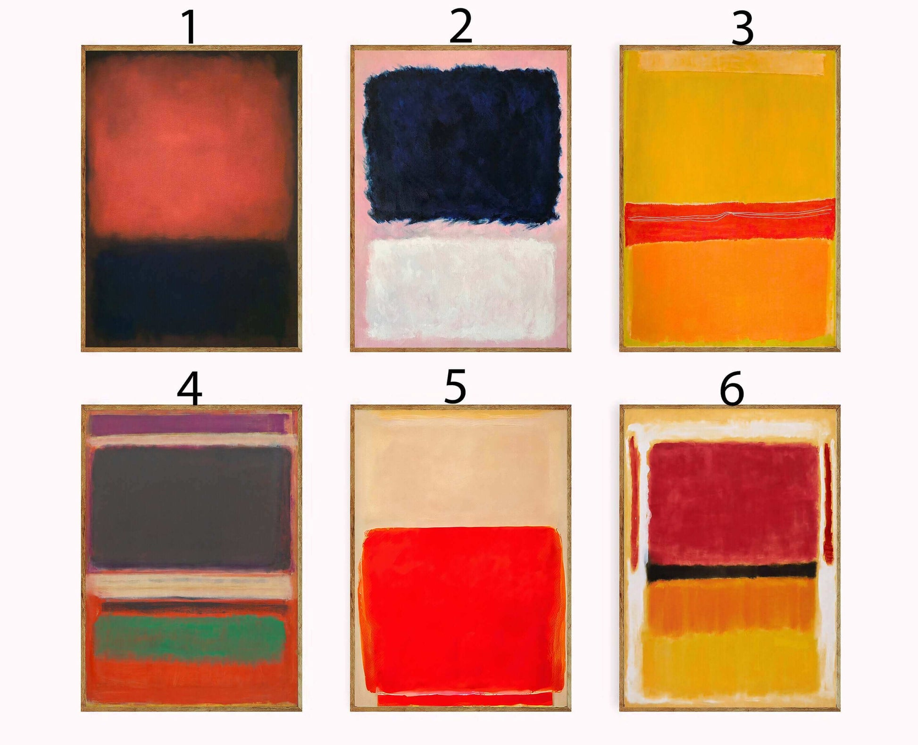  CONCEPT:  Painting | I am learning about artwork produced by Anthony Gormley.  Skills to focus on:  - I can describe how I think a sculpture has made created and which materials have been used to create it.  - I can use my hands to manipulate a range of modelling materials.  - I can design and make something that is imagined or invented.  - I can compare my artwork to someone else’s using artistic vocabulary I have been taught.  Outcome:  Dream inspired sculpture using modelling clay?  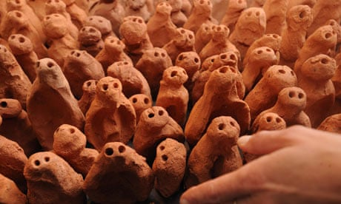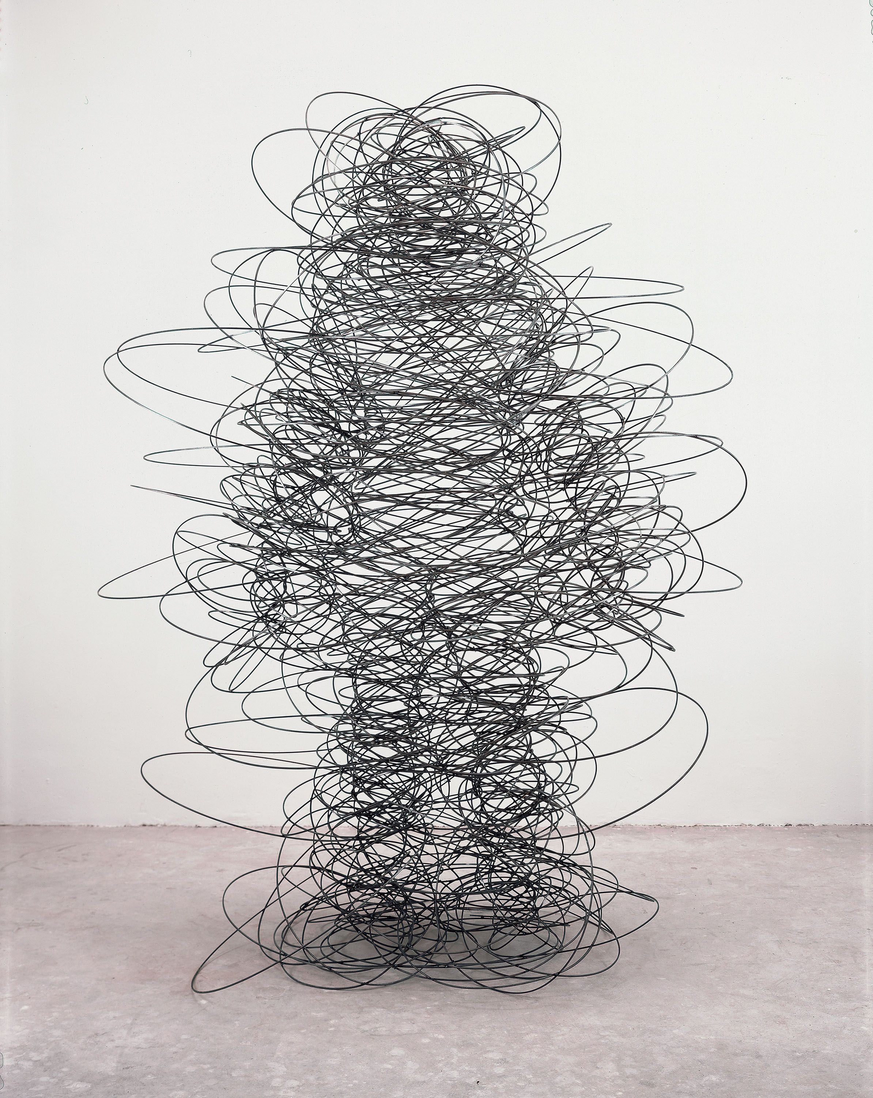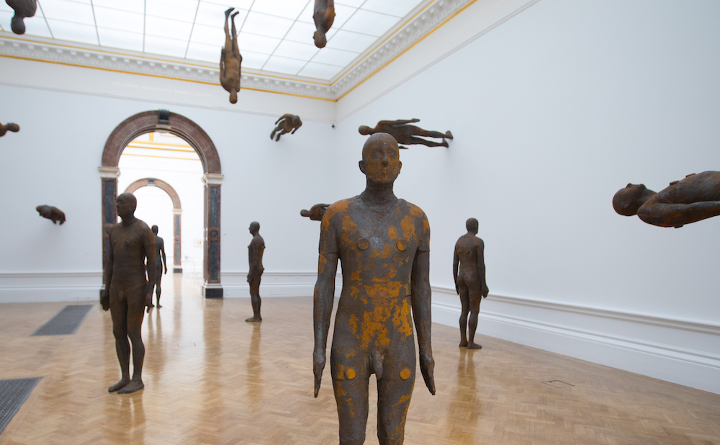  CONCEPT:  Sculpture | I am learning about artwork produced by Yayoi Kusama.  Skills to focus on:  - I can describe the texture that pieces of artwork have or appear to have.  - I can name the primary colours and that they can be mixed to make secondary colours.  - I can create different marks can be used to represent the textures of objects.  - I can describe and compare my artwork to someone else’s using artistic vocabulary I have been taught.  Outcome:  Yayoi Kusama inspired artwork – cut out shape, paint and then print shapes inside it to create texture? Print or draw patterns around outside too?  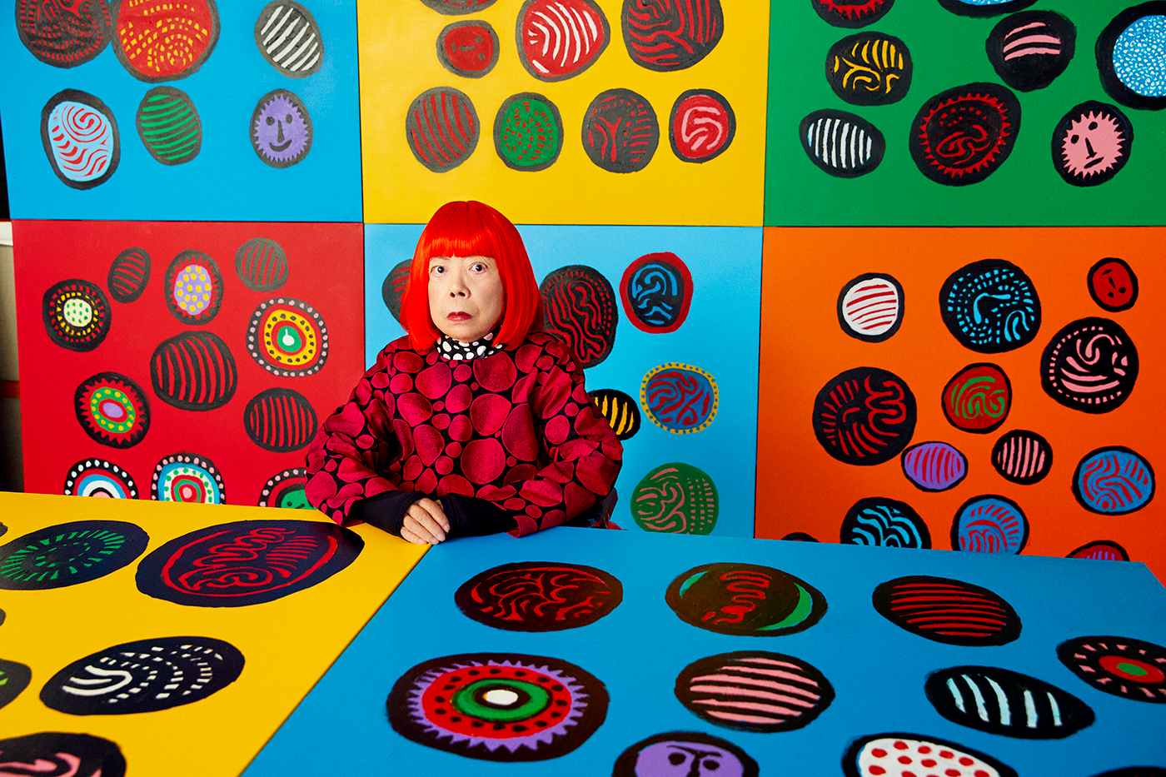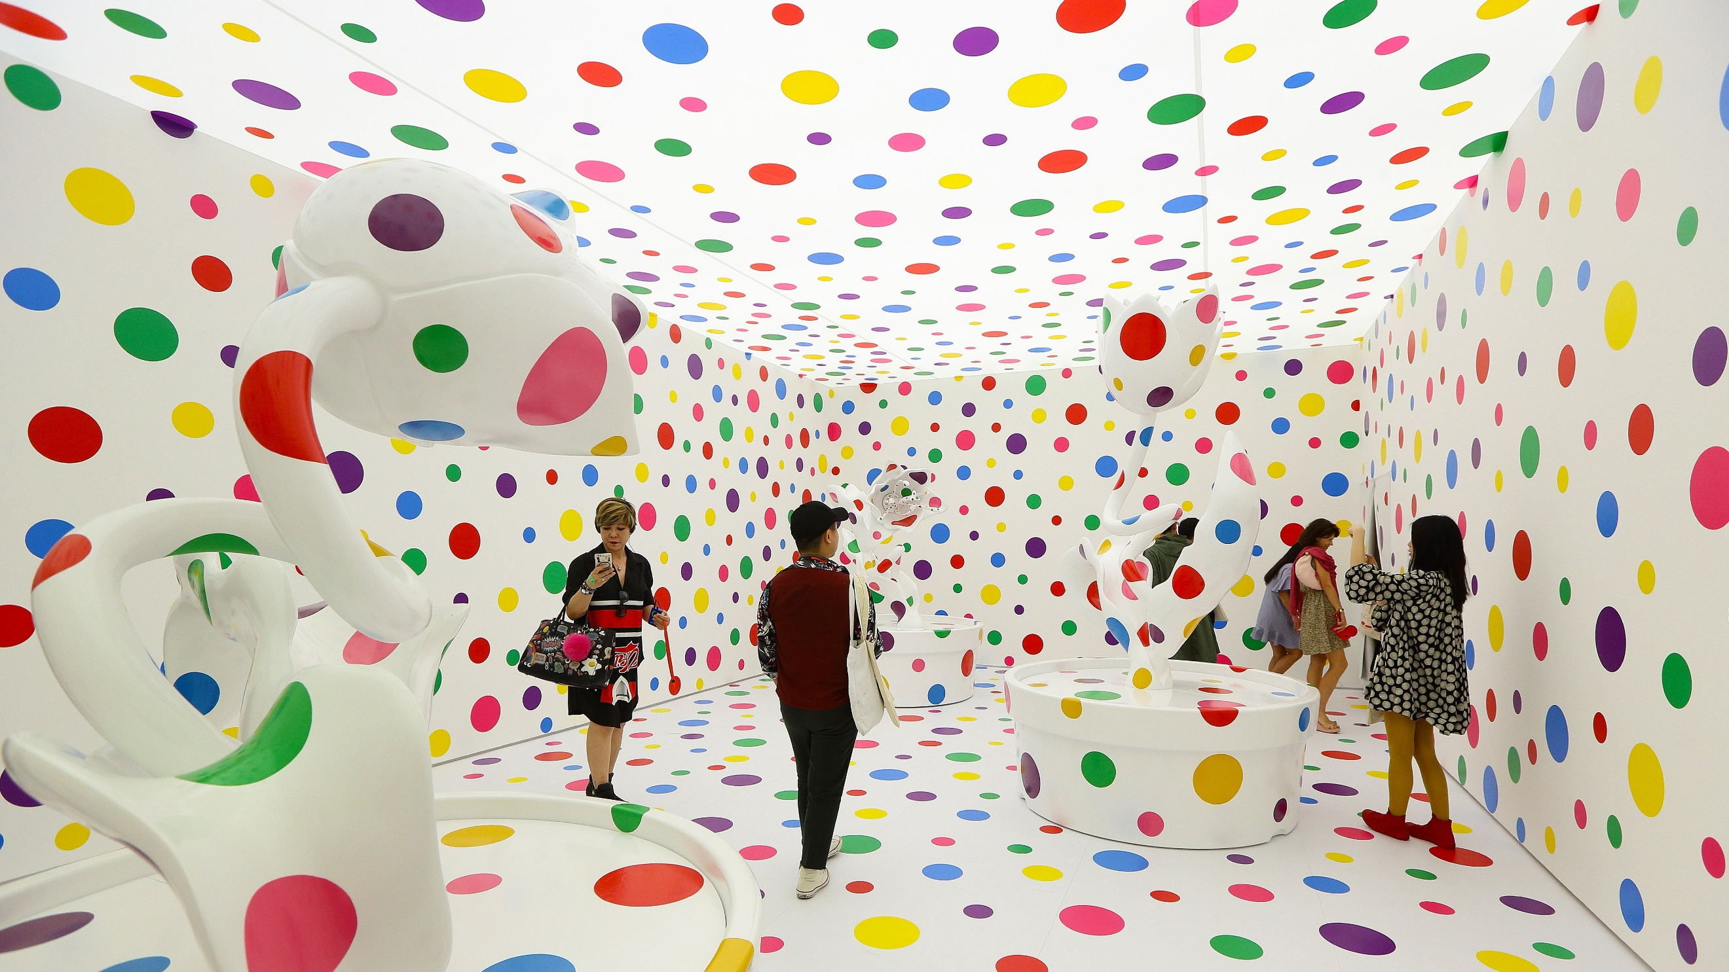  CONCEPT:  Craft & Mixed Media
 | KEY VOCABULARY: | KEY VOCABULARY: | KEY VOCABULARY:

 | Autumn | Spring | Summer
Year 2 | I am learning about artwork produced by Anthony Browne.  Skills to focus on:  - I can describe how I think a drawing has been created using different drawing techniques.  - I can experiment with drawing on different surfaces using a variety of pencil grade to begin to explore tone.  - I can overlap collage materials to add texture to my artwork.  - I can describe how I have used composition in some of my collage artwork to show how shapes have been arranged with purpose.  Outcome:  Anthony Browne inspired collage – draw and shade objects, cut out objects, stick onto a (drawn?) background?  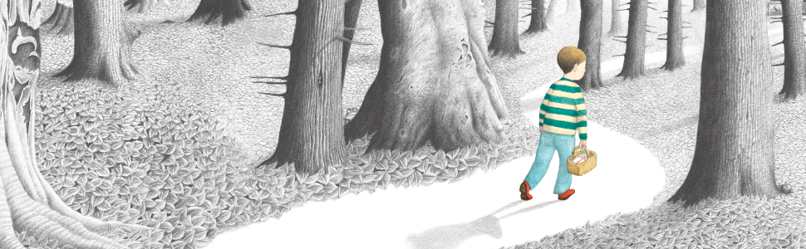  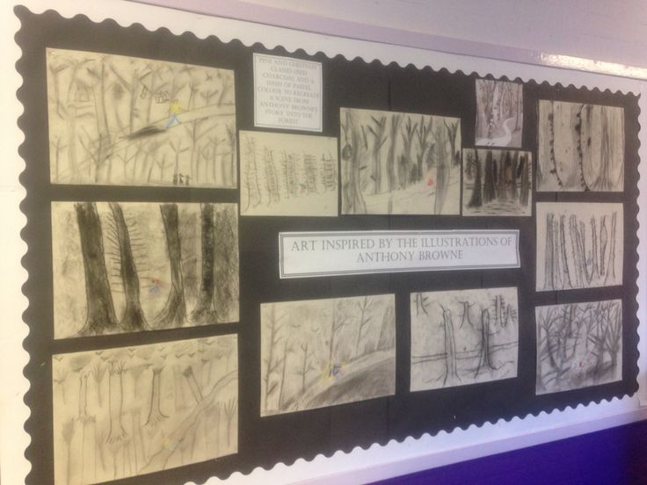  CONCEPT:  Craft & Mixed Media | I am learning about artwork produced by Christopher Wren.  Skills to focus on:  - I can identify artwork where shading helps make drawn objects look more three dimensional.  - I can experiment with drawing using a variety of drawing tools and pencil grades to create light/dark lines and build tone.  - I can develop observational skills to look closely and reflect surface texture through mark-making.  - I can identify in my own or someone else’s artwork where tone has been used to a good effect.  Outcome:  Christopher Wren inspired artwork of a drawn London building?  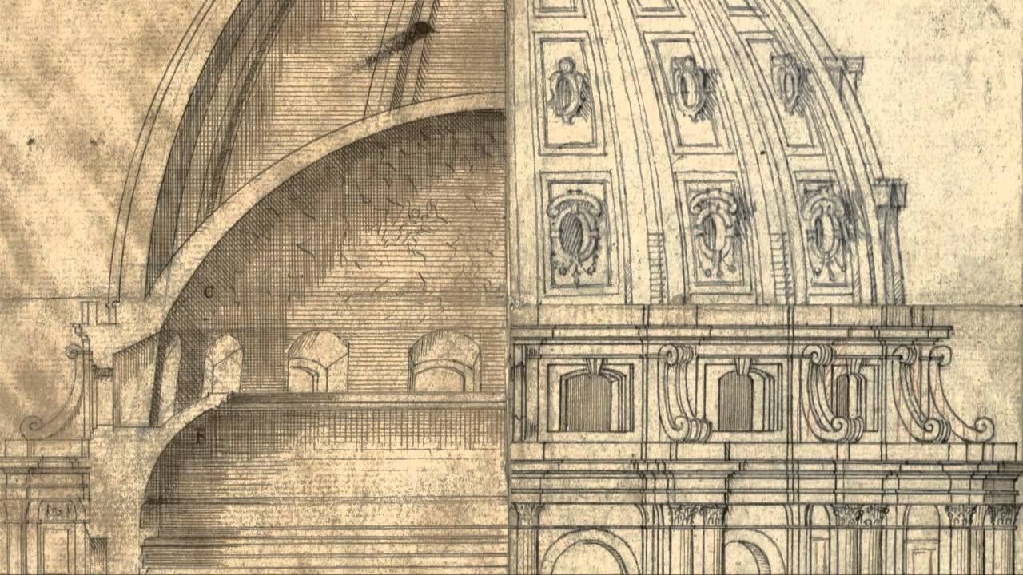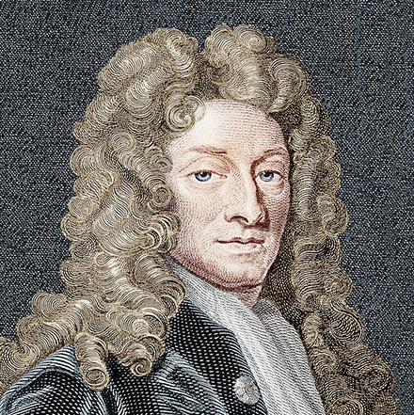  CONCEPT:  Drawing | I am learning about artwork produced by Esther Mahlangu.  Skills to focus on:  - I can describe how the pattern and colour used within artwork can make me feel.  - I can experiment and develop my own pattern work by considering different colours, textures and shapes.  - I can print with a range of objects and materials to create a pattern.  - I can describe the process that has been used to create my artwork.  Outcome: Esther Mahlangu inspired artwork using paint?  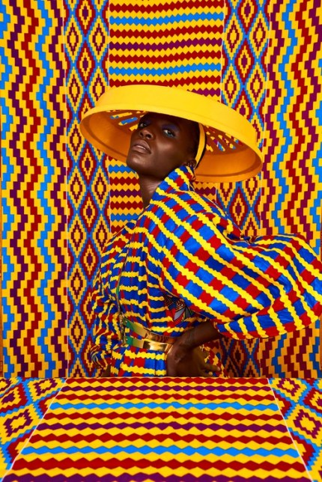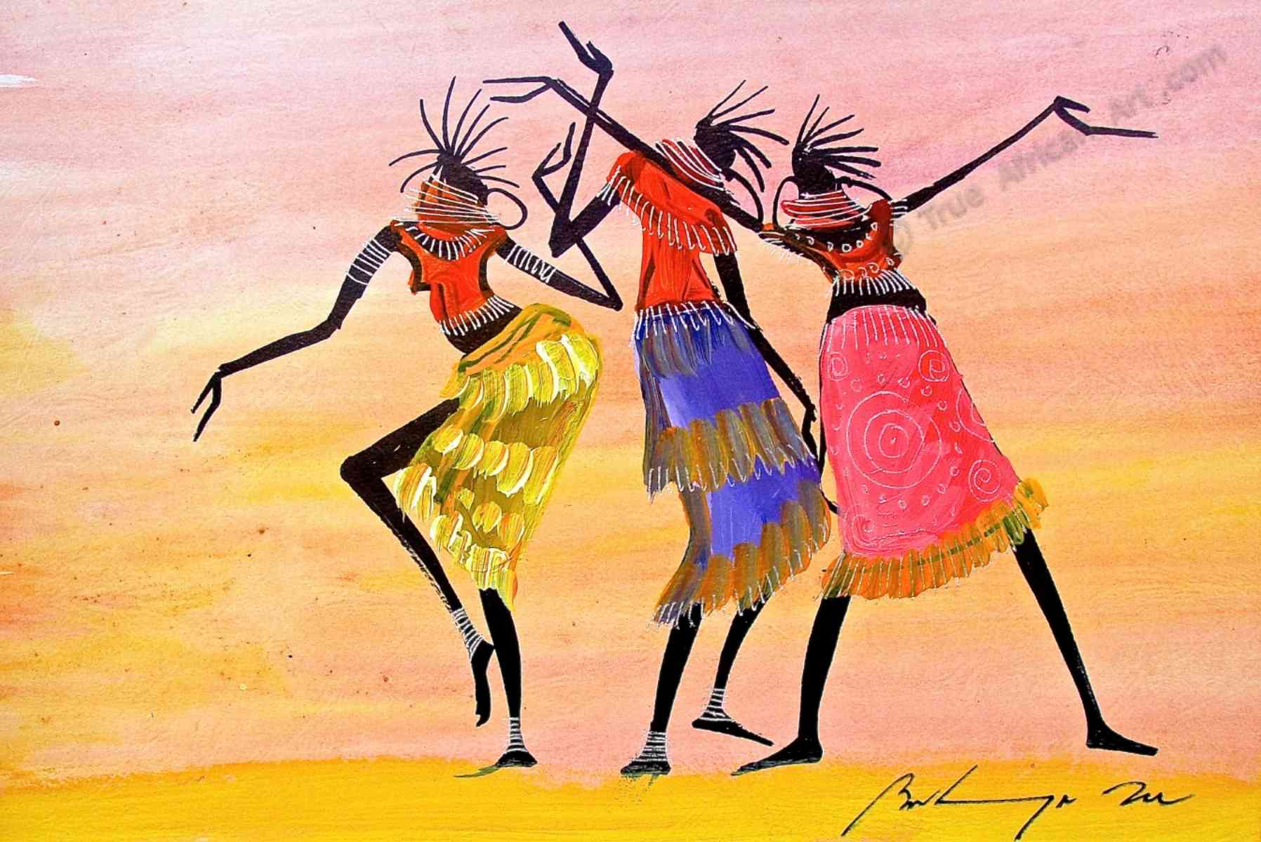  CONCEPT:  Painting
 | KEY VOCABULARY: | KEY VOCABULARY: | KEY VOCABULARY:

 | Autumn | Spring | Summer
Year 3 | I am learning about artwork produced by Stone Age people.  Skills to focus on:  - I can identify where paint colours that have been used in artwork have been mixed by adding black to create a shade and by adding white to create a tint.  - I can show that different drawing tools can create different types of lines.  - I can develop drawing through direct observation, using tonal shading and starting to apply an understanding of shape to communicate form and proportion.  - I can use my sketchbook to discuss my planning process which produced a finished piece of artwork.  Outcome:  Stone Age inspired artwork using paint/wax crayons/chalk?  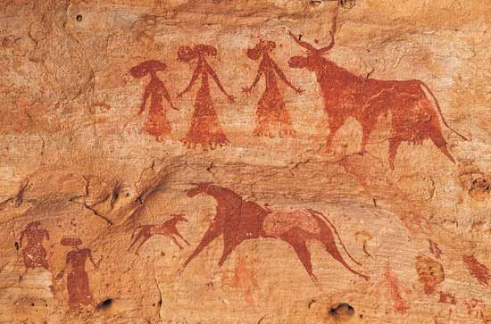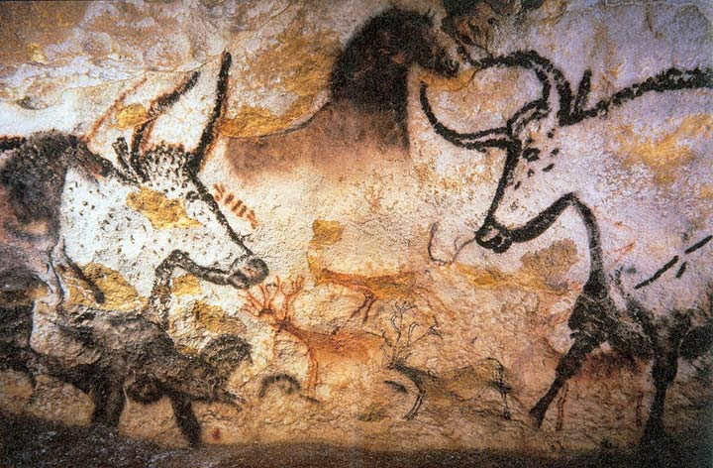  CONCEPT:  Drawing | I am learning about artwork produced by Frank Bowling.  Skills to focus on:  - I can use my own experiences to explain how a piece of artwork may have been made.  - I can mix colours with greater accuracy and begin to consider how colours can be used expressively by exploring contrasting and complimentary colours.  - I can create an abstract piece of artwork to convey a chosen action/emotion.  - I can discuss my choice of colours and textures within artwork I have produced, giving appropriate reasons.  Outcome:  Frank Bowling inspired artwork using paint?  https://www.accessart.org.uk/volcano-painting-inspired-by-frank-bowling/  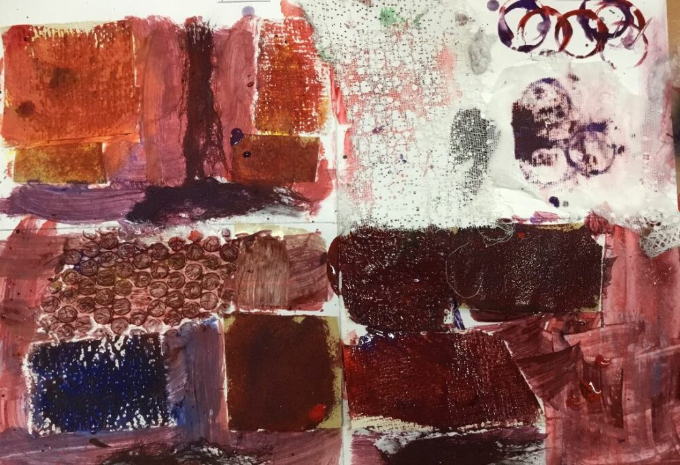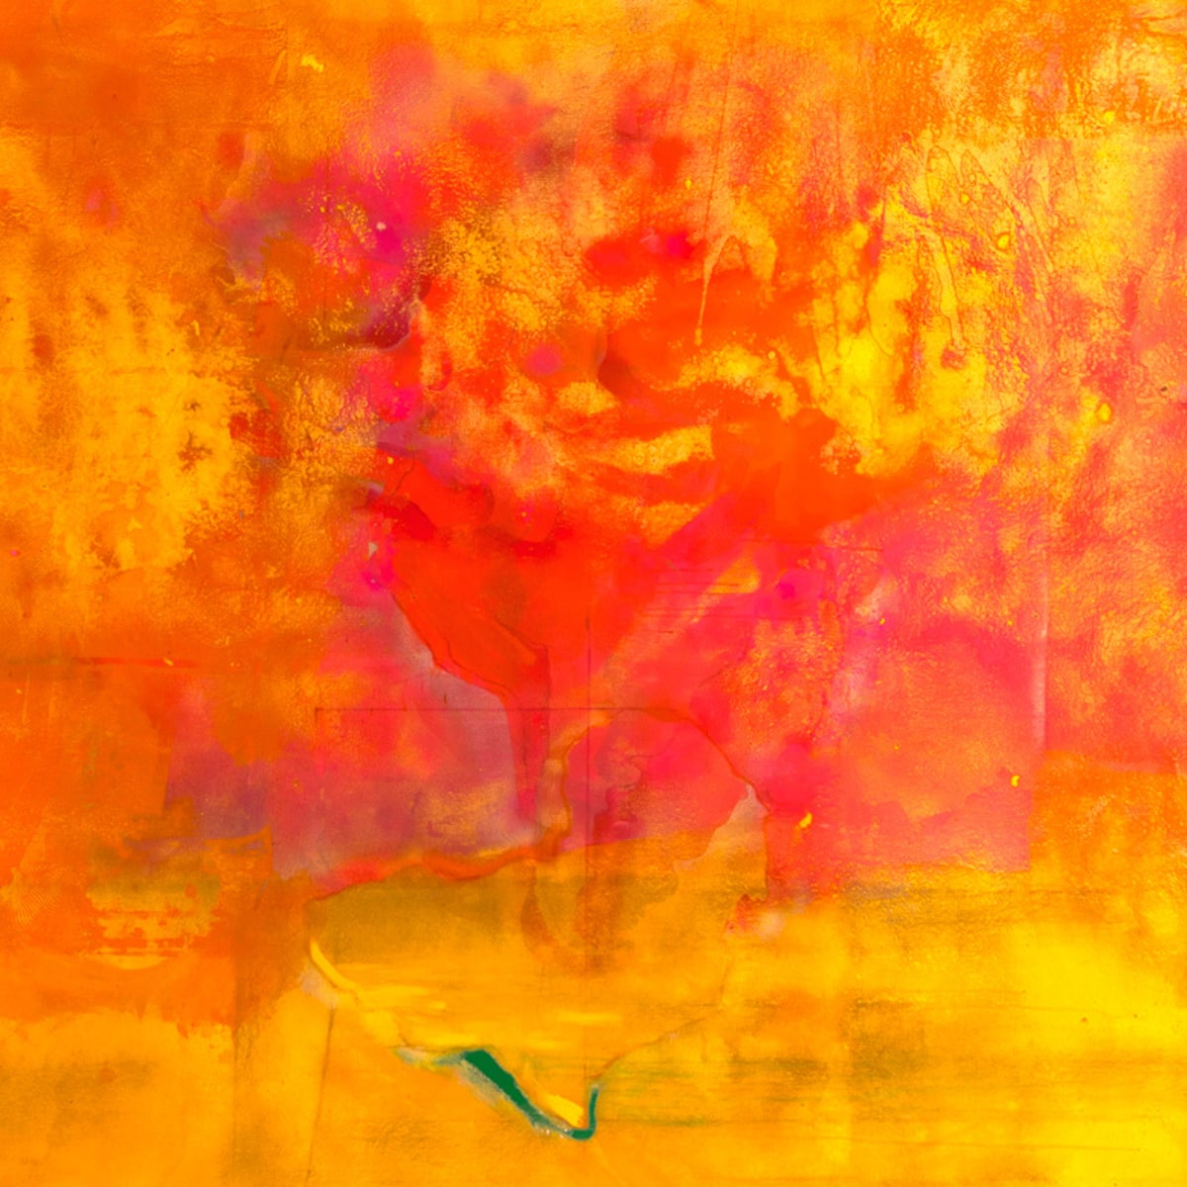  CONCEPT:  Painting | I am learning about artwork produced by Henri Matisse.  Skills to focus on:  - I can identify where negative shapes have been used in artwork to show space around and between objects.  - I know that contrasting colours appear opposite to each other on the colour wheel and when placed next to each other, a strong contrast or ‘clash’ is created.  - I can modify chosen collage materials in a range of ways e.g., by cutting, re-sizing, reflecting or overlapping to create artwork.  - I can explain my ideas and opinions about my own and other’s artwork, giving reasons using appropriate artistic vocabulary.  Outcome:  Henri Matisse inspired collage using ‘negative space’ cut out shapes?  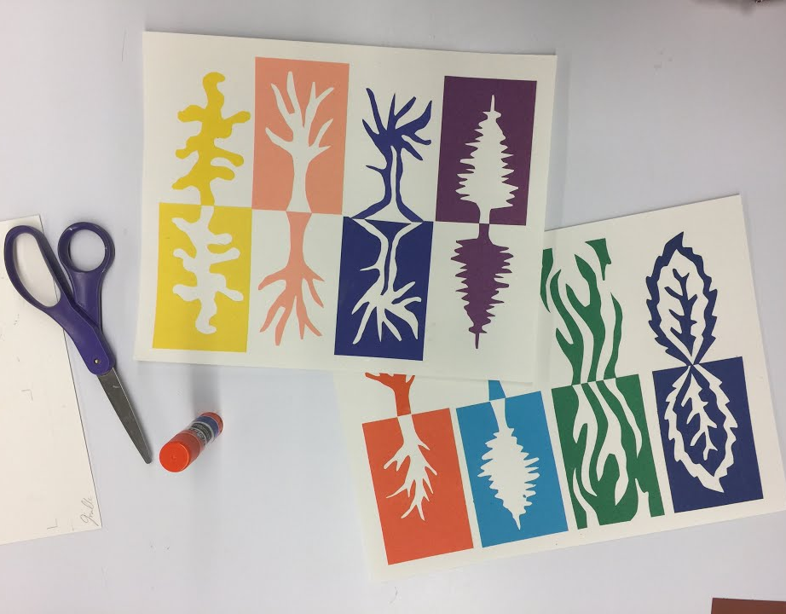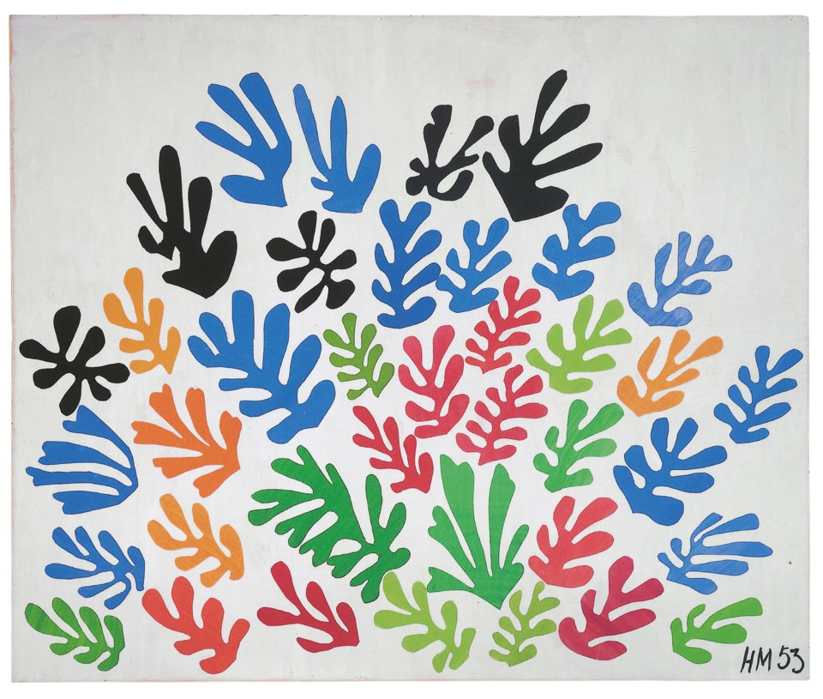  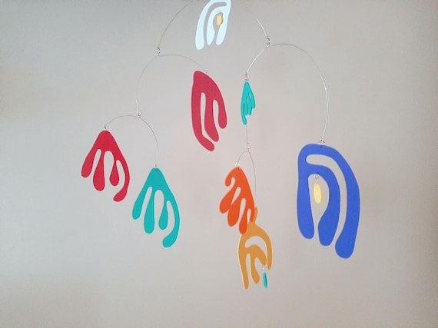  CONCEPT:  Craft & Mixed Media
 | KEY VOCABULARY: | KEY VOCABULARY: | KEY VOCABULARY:

 | Autumn | Spring | Summer
Year 4 | I am learning about artwork produced by Hokusai.  Skills to focus on:  - I can discuss how art is used for different purposes and begin to consider how this works in creative industries.  - I can explore the way paint can be used in different ways to create a variety of effects, e.g., creating a range of lines, shapes and textures through printing in paint.  - I can respond to a stimulus and begin to make choices about the materials I use to create my artwork.  - I can show where lines and/or shapes have been used purposely in my own or other’s artwork to achieve a specific effect.  Outcome:  Hokusai inspired artwork? Create a foam printing block of a mountain scene, print a colour for the background, different colour for each different element working towards the foreground? Add further detail afterwards?  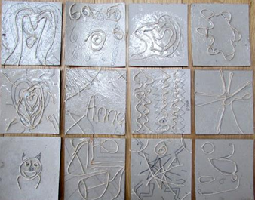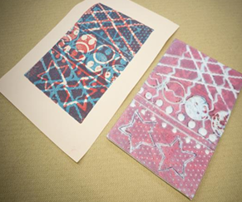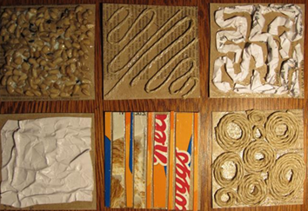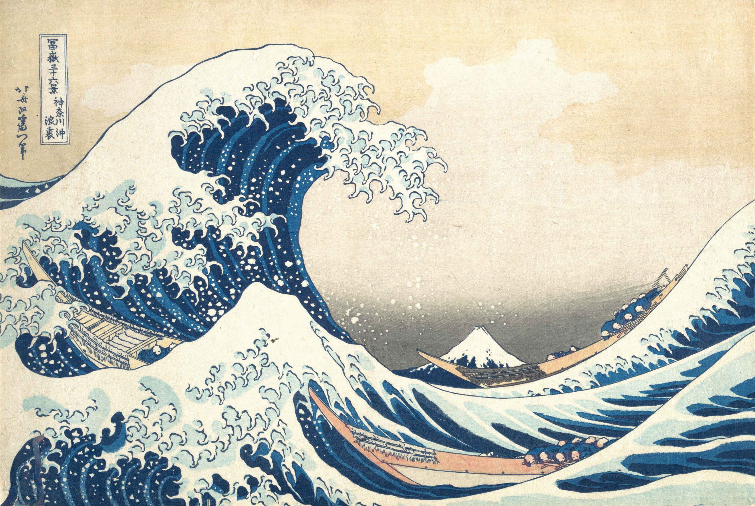  CONCEPT:  Craft & Mixed Media | I am learning about artwork produced by Shara Hughes.  Skills to focus on:  - I can identify different lines in artwork - lighter or darker, thicker or thinner, sharp or flowing - and that this can add expression or movement to a drawing.  - I can demonstrate control when using drawing tools to show awareness of proportion.  - I can develop greater skill and control when using paint to depict forms, e.g., using shades and tints to create a 3D effect.  - I can use my sketchbook to communicate how my planning and improvement process helped to produce my finished piece of artwork.  Outcome:  Shara Hughes inspired artwork using paint?  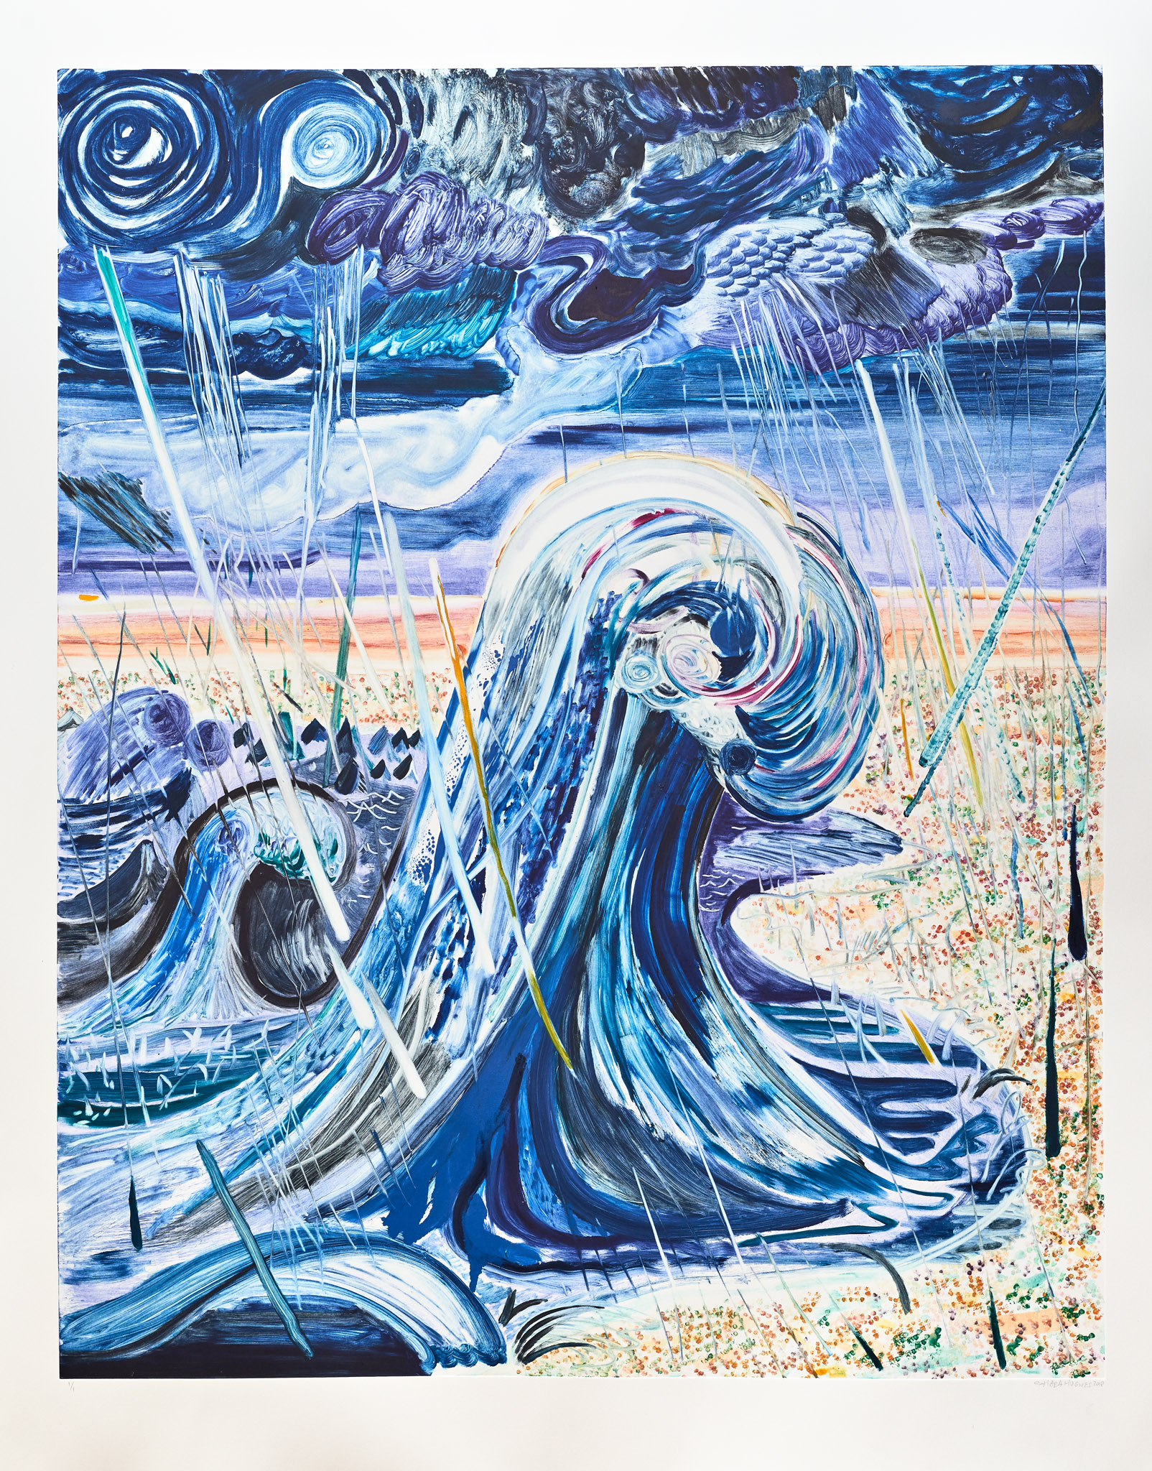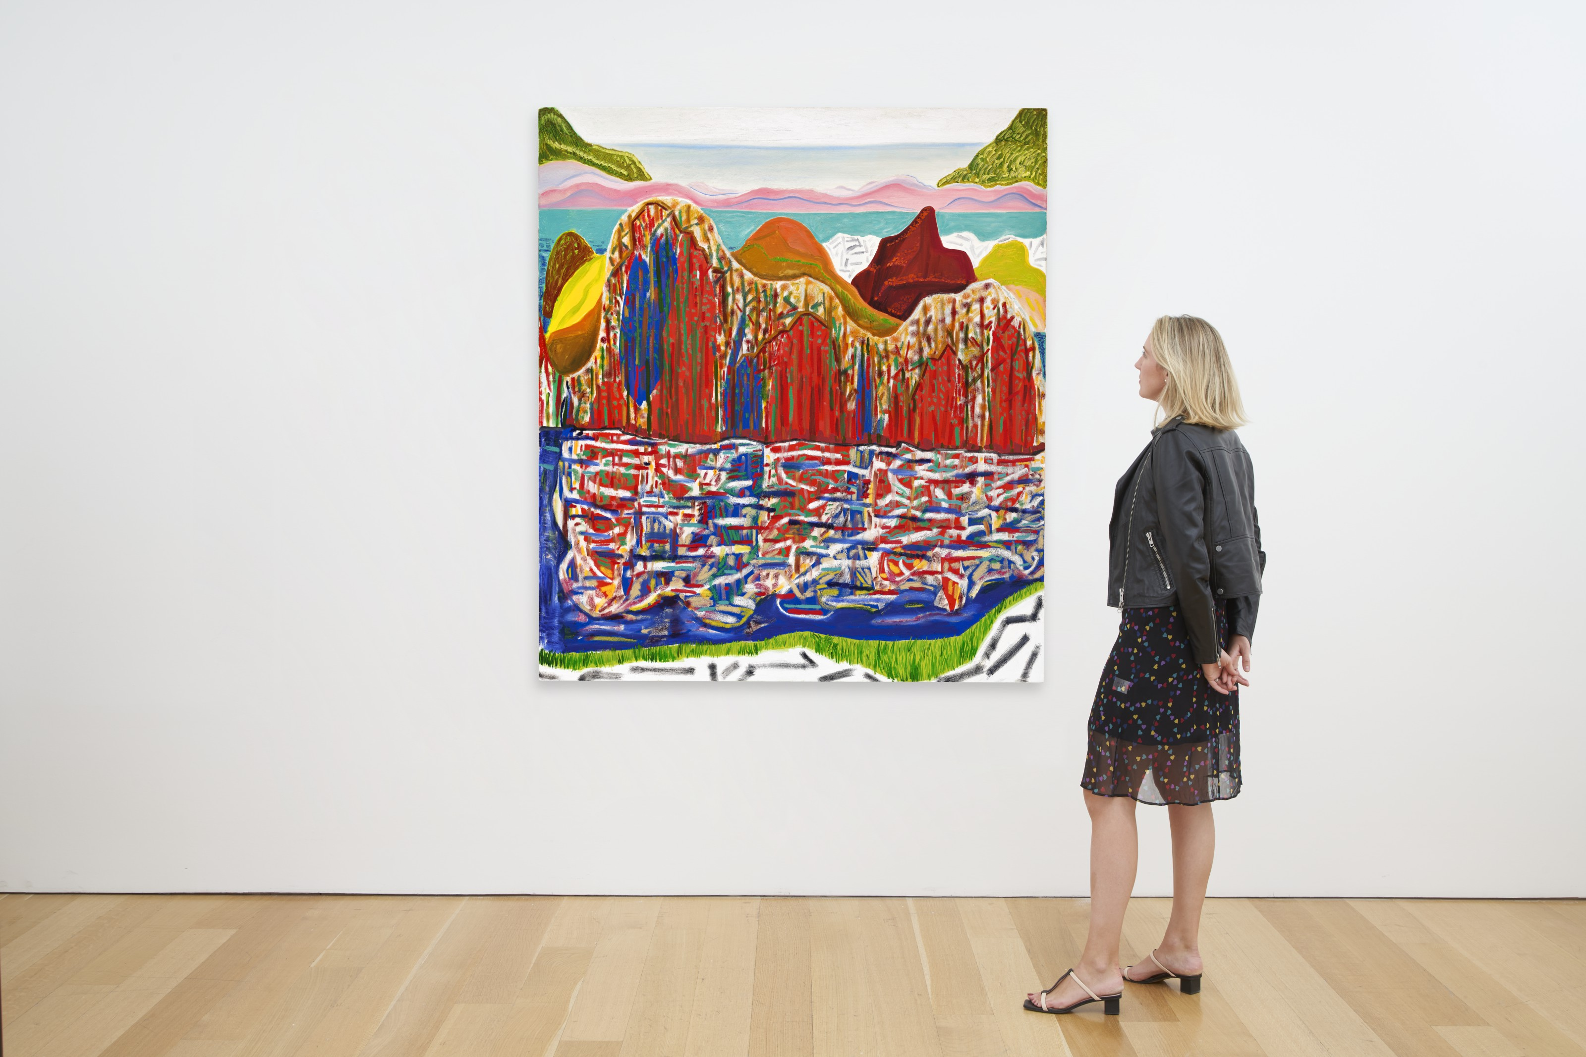  CONCEPT:  Painting | I am learning about artwork produced by Grayson Perry.  Skills to focus on:  - I can describe and compare creative 3D artwork, saying what I like and dislike about them.  - I can generate ideas from a range of stimuli, using research and evaluation of drawings and patterns to plan purposely for an outcome.  - I can use more complex techniques to mould and form malleable materials, such as the coil pot technique in clay and adding detailed surface decoration.  - I can use appropriate artistic vocabulary to describe my thoughts and feelings about my own or other people’s sculpture.  Outcome:  Grayson Perry inspired pottery using clay and painted?  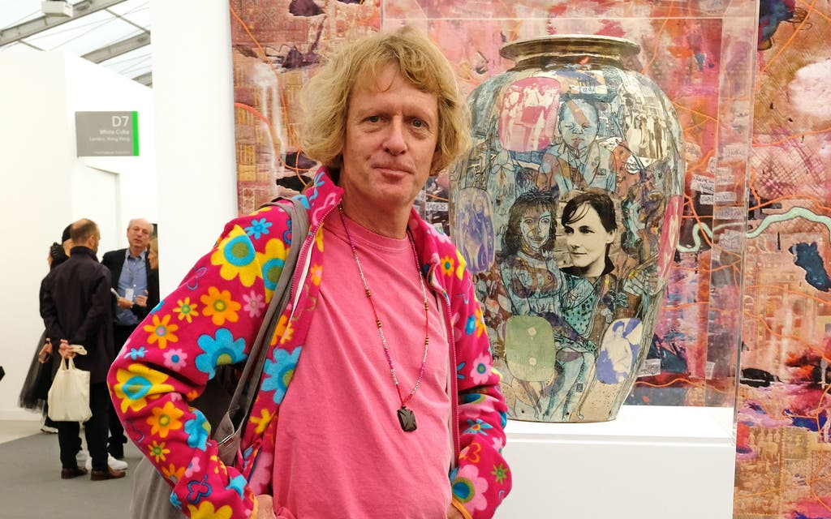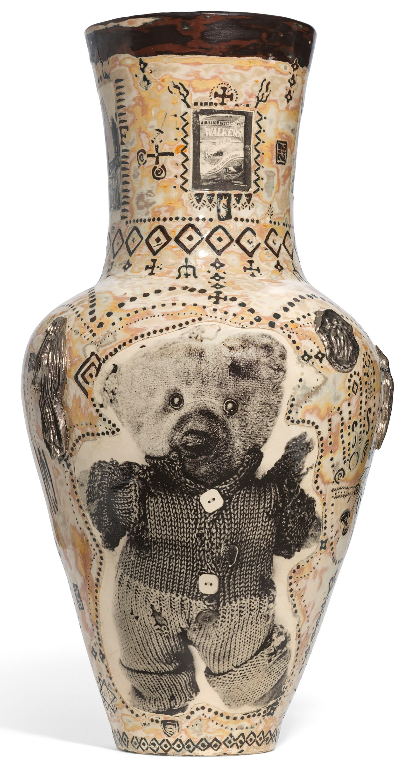  CONCEPT:  Sculpture
 | KEY VOCABULARY: | KEY VOCABULARY: | KEY VOCABULARY:

 | Autumn | Spring | Summer
Year 5 | I am learning about artwork produced by Peter Thorpe.  Skills to focus on:  - I can discuss the ideas and approaches of an artist by describing the historical context which many have influenced their creative work.  - I can use a sketchbook for a purpose by recording observations and research, testing materials and working towards an outcome more independently.  - I can draw in a more sustained way, revisiting a drawing over time and applying my understanding of tone, texture, line, colour and form.  - I can discuss the process used by myself and by other artists, and describe the particular outcome that has been achieved.  Outcome:  Peter Thorpe inspired artwork using own choice of tools for adding colour?  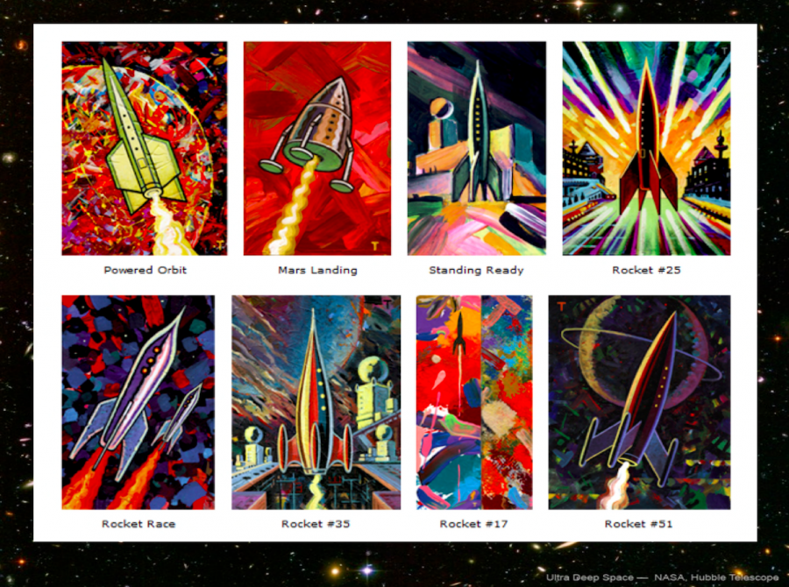  CONCEPT:  Drawing | I am learning about artwork produced by Andy Goldsworthy.  Skills to focus on:  - I can discuss how an art installation can be in a room or environment in which the viewer ‘experiences’ the art all around them and how this makes me feel.  - I can explore a greater range of materials to create 3D forms e.g., found natural materials.  - I can plan a sculpture, developing an idea in 2D into a three-dimensional piece.  - I can give an example of how my peers and I have persevered when constructions have been challenging and how I have worked to problem solve more independently.  Outcome:  Andy Goldsworthy inspired sculpture and then photographed?  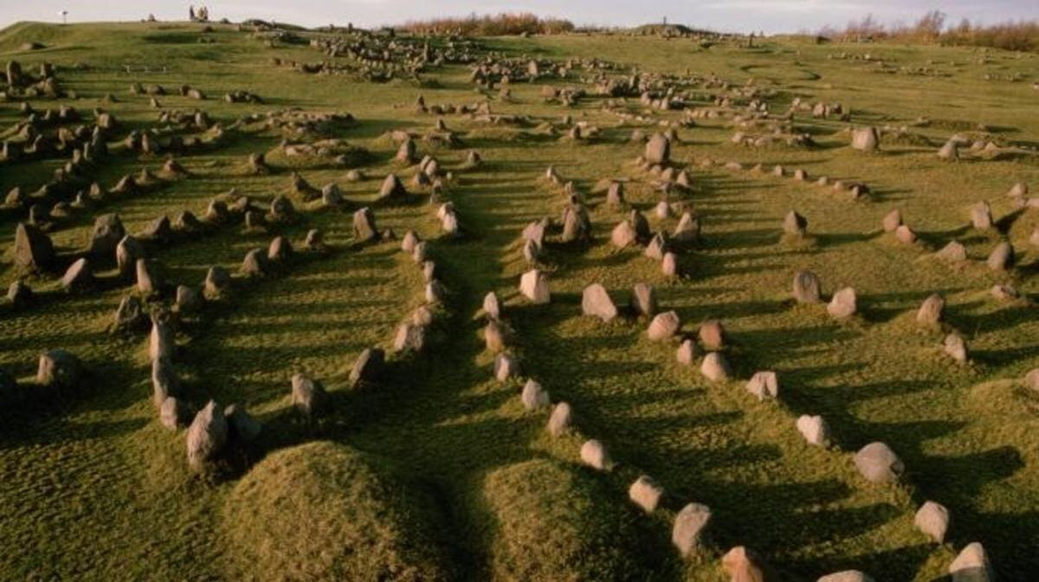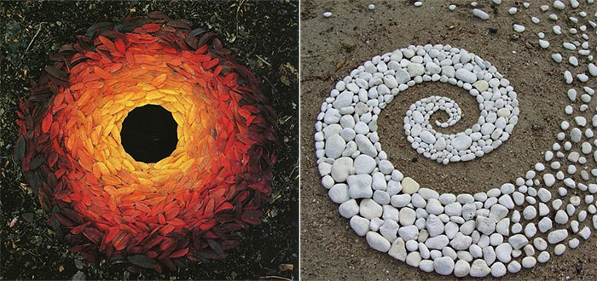  CONCEPT:  Sculpture | I am learning about artwork produced by Shepard Fairey.  Skills to focus on:  - I can research and discuss the ideas and approaches of an artist by describing the cultural and historical context which many have influenced their creative work.  - I can explore how collage can extend original ideas (e.g., combining digital effects with other media) and that artists use colour to create an atmosphere or to represent feelings in an artwork (e.g., by using warm or cool colours).  - I can create texture on different materials and create pattern to add expressive detail to artwork.  - I can discuss how I have used lines, patterns and/or colours to control what I want the viewer to look at in my artwork.  Outcome:  Shepard Fairey inspired collage using chosen (a variety?) tools for adding colour.  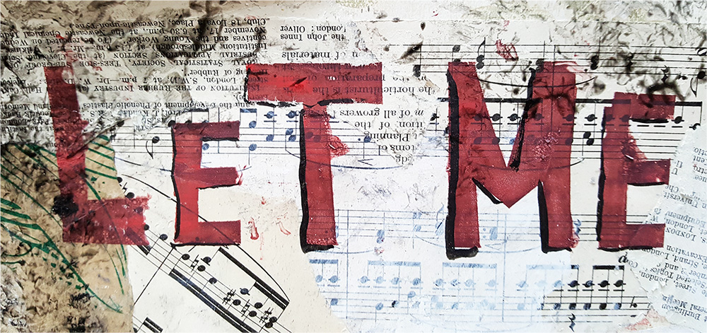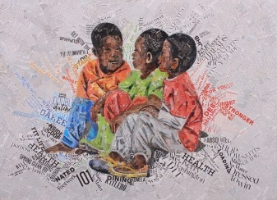  CONCEPT:  Craft & Mixed Media
 | KEY VOCABULARY: | KEY VOCABULARY: | KEY VOCABULARY:

 | Autumn | Spring | Summer
Year 6 | I am learning about artwork produced by Paul Nash.  Skills to focus on:  - I can describe, interpret and evaluate the work, ideas and processes used by artists in a piece of artwork.  - I can demonstrate control when using drawing tools to show awareness of proportion and perspective.  - I can manipulate paint and painting techniques to suit a purpose, such as applying thick layers of paint to a surface to create texture.  - I can demonstrate where I have independently used my knowledge of tools, materials and processes to try alternative solutions to make improvements to my work.  Outcome:  Paul Nash inspired artwork using paint?  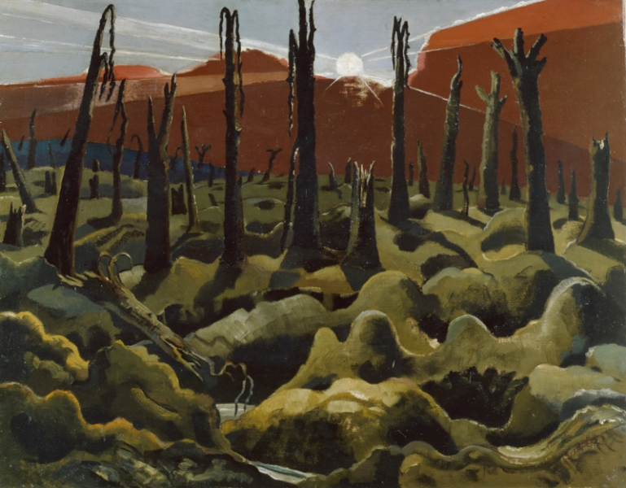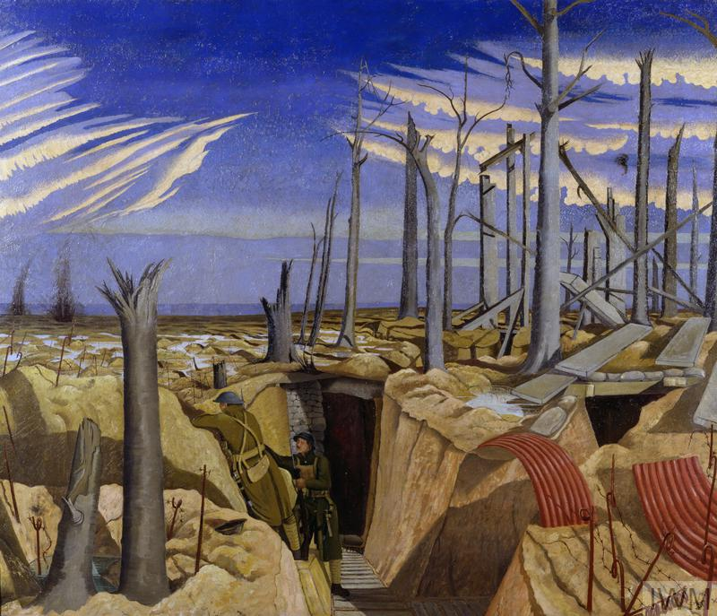  CONCEPT:  Painting | I am learning about artwork produced by David Hockney and Picasso.  Skills to focus on:  - I can use artistic vocabulary to describe and compare creative works and use my own experiences to explain how artwork may have been made.  - I can push the boundaries of mark-making to explore new surfaces, e.g., incorporating digital drawing techniques.  - I can draw expressively in my own personal style and in response to my choice of stimulus, showing the ability to develop a drawing independently.  - I can give reasoned evaluations of my own and others work which takes account of context and intention.  Outcome:  Picasso inspired artwork using own choice of tools to draw and add colour (including digital media)?  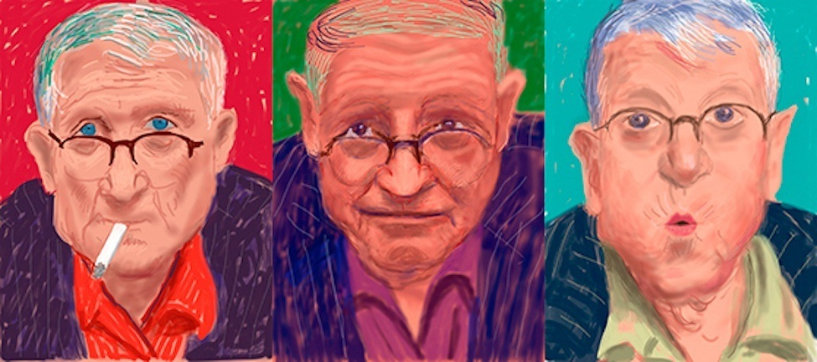  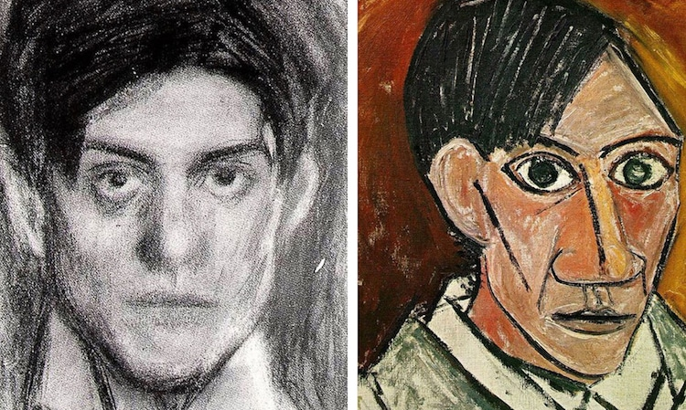  CONCEPT:  Drawing | I am learning about artwork produced by Frido Kahlo.  Skills to focus on:  - I can describe, interpret and evaluate the work, ideas and processes used by artists across a variety of disciplines, being able to describe how the cultural and historical context may have influenced their creative work.  - I can work in a sustained way over several sessions to complete a piece of artwork.  - I can select and use a variety of painting techniques, including applying my drawing skills, using my knowledge of colour mixing and making choices about suitable tools for a task e.g., choosing a fine paintbrush for making detailed marks.  - I can confidently explain my ideas and opinions about my own and other’s artwork, giving reasons for what I like and do not like.  Outcome:  Frida Kahlo inspired collage using own choice of materials and tools to draw and add colour?  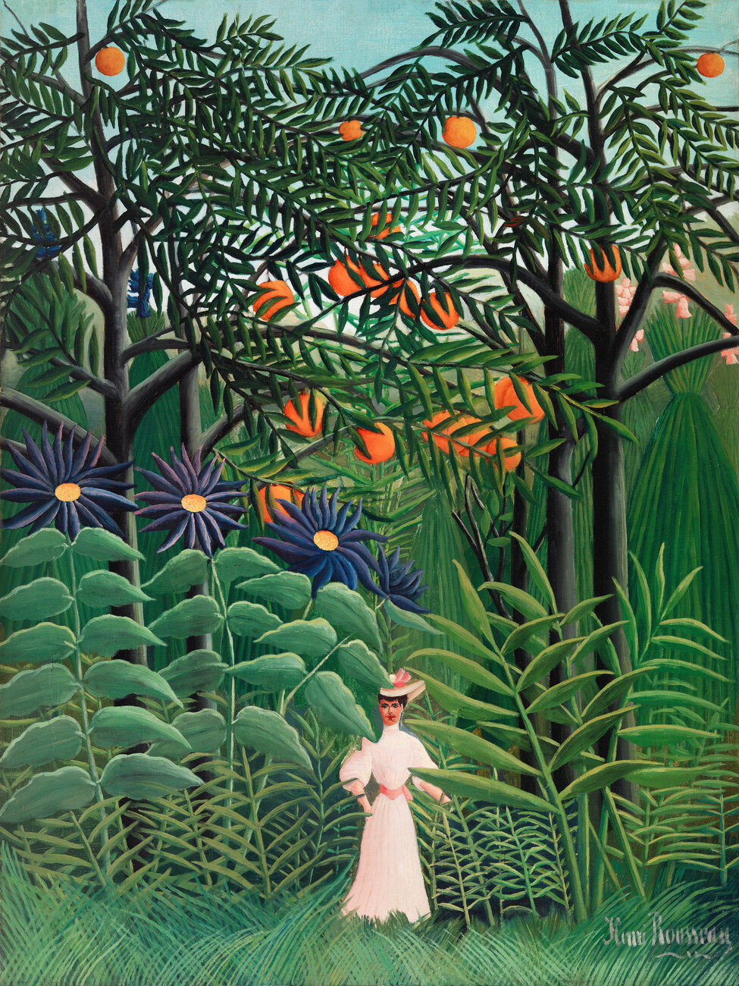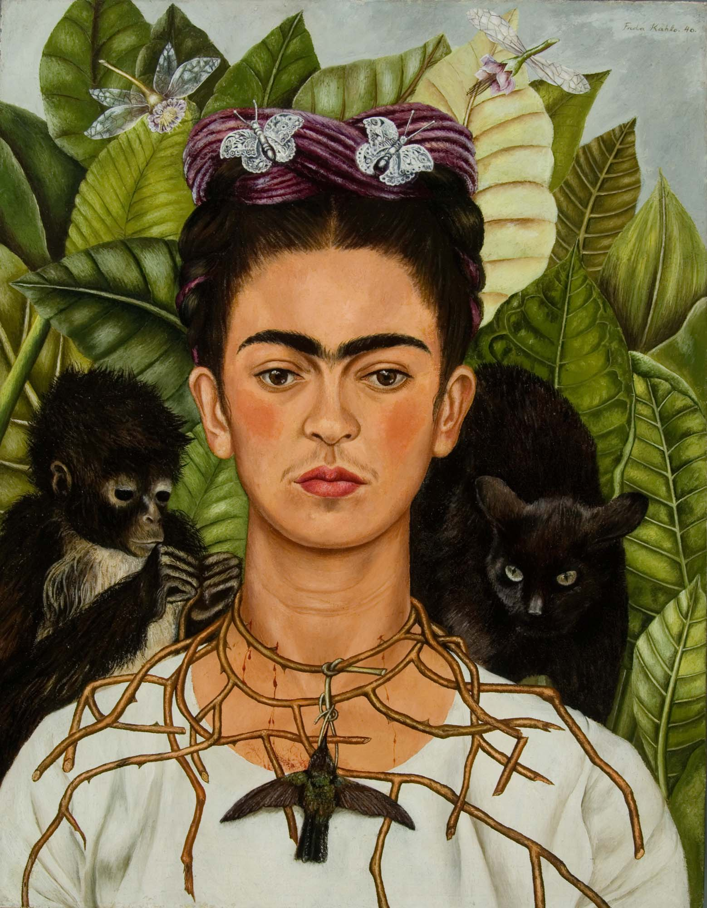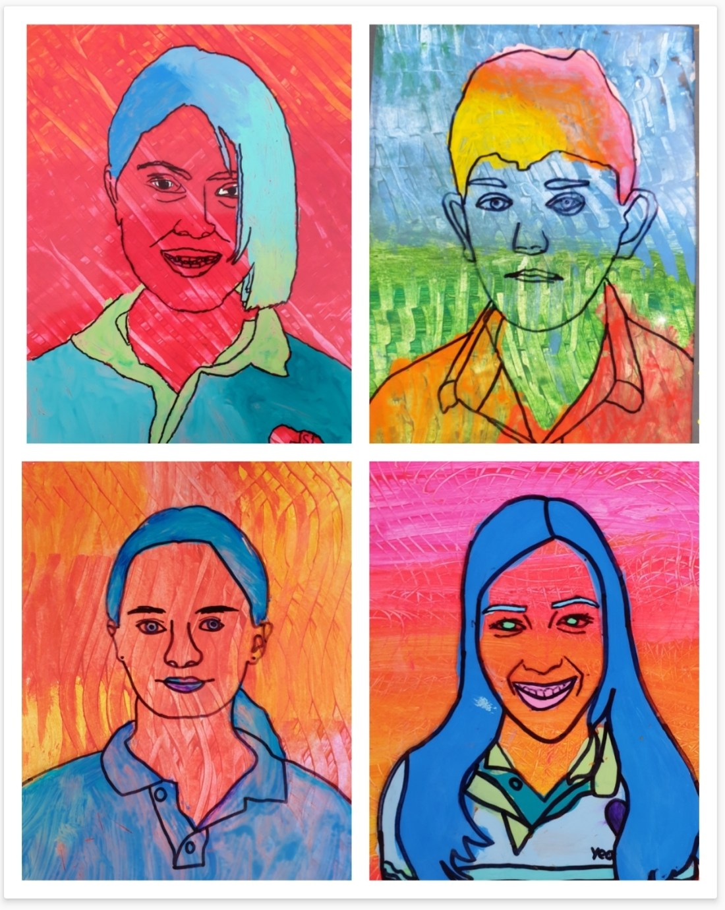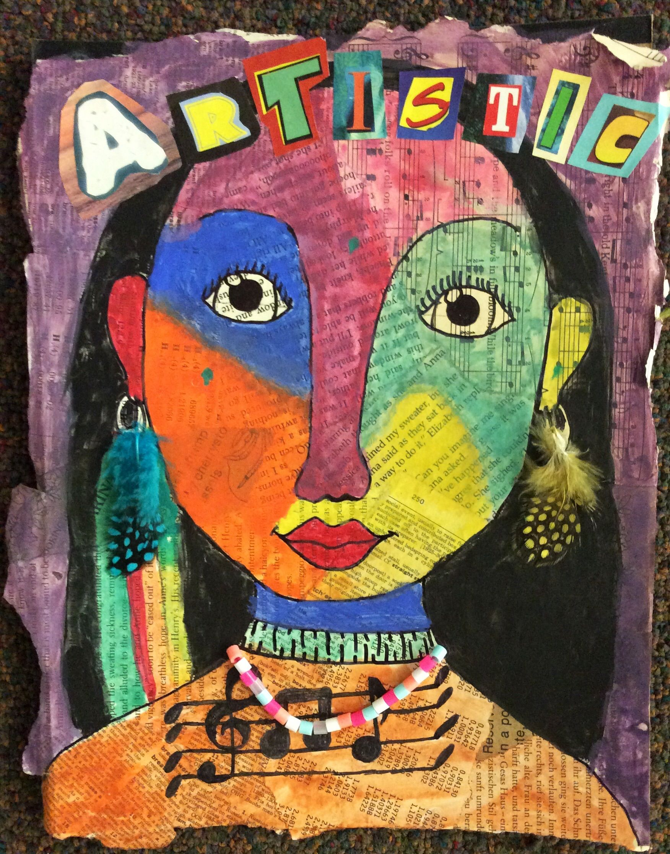  CONCEPT:  Craft & Mixed Media
 | KEY VOCABULARY: | KEY VOCABULARY: | KEY VOCABULARY:

