\

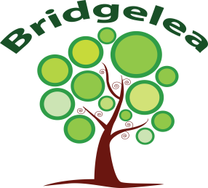
Bridgelea Primary School Curriculum Overview
PHSE
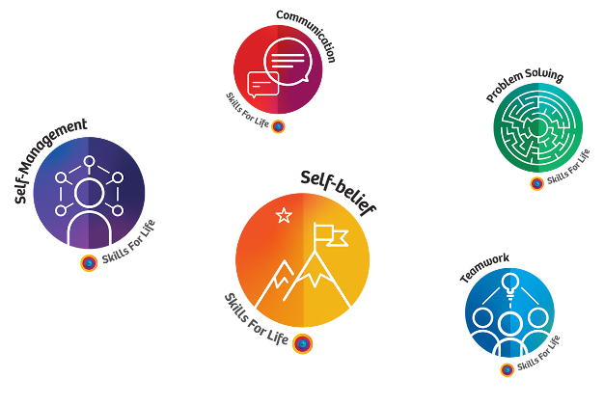
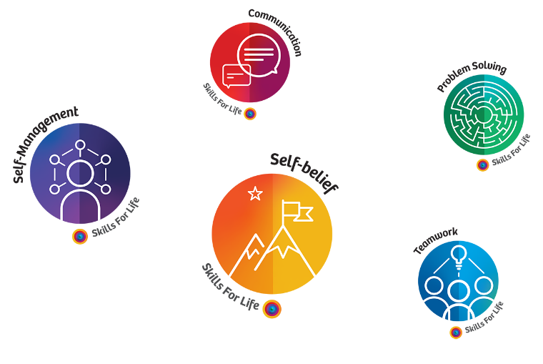
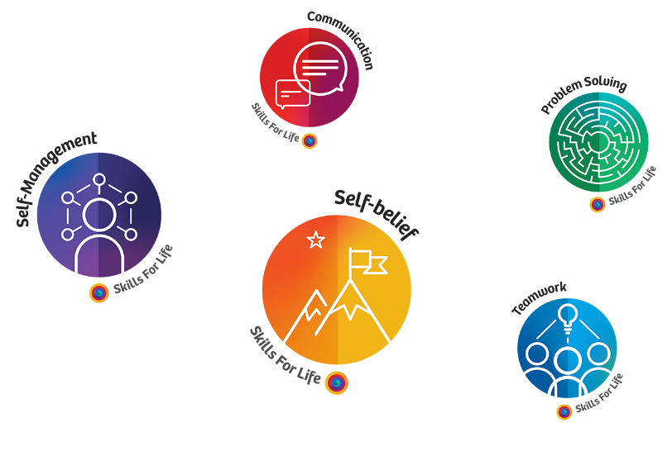
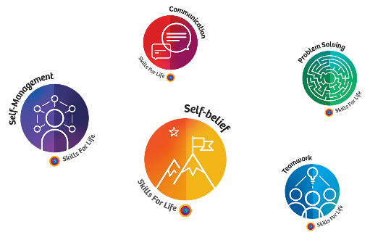
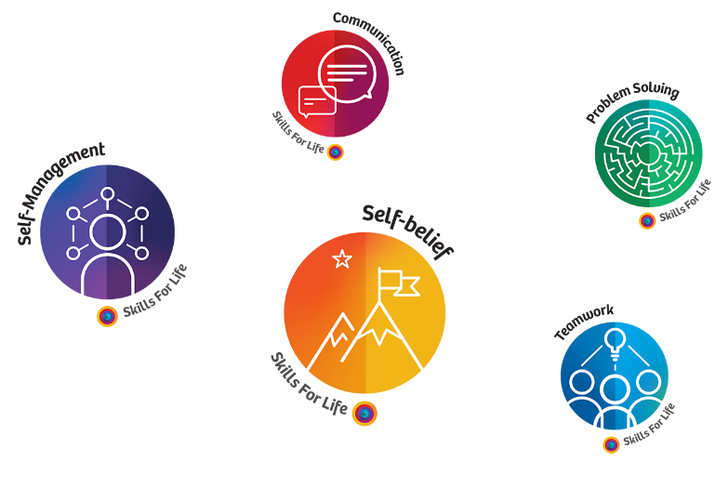

Early Years
(IMatters V3)
Strand | End of Early Years
Autumn 1  Living in the wider world | - Talk about members of their immediate family and community.  - Name and describe people who are familiar to them.  - Recognise that people have different beliefs and celebrate special times in different ways.
Autumn 2  Relationships and RSE | - Continue developing positive attitudes about the differences between people.  - Know that there are different countries in the world and talk about the differences they have experienced or seen in photos.  - See themselves as a valuable individual.  - Build constructive and respectful relationships.  - Identify and moderate their own feelings socially and emotionally.  - Think about the perspectives of others. | 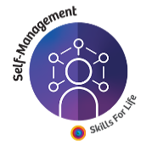
Spring 1  Keeping Safe | - Use talk to help work out problems and organise thinking and activities, and to explain how things work and why they might happen.  - Develop social phrases.
Spring 2  Mental and Emotional Health  (Including Online safety) | - Recognise that people have different beliefs and celebrate special times in different ways.  - Understand what the internet is and what they use he internet for (E.G. watching videos, playing games, learning things.)  - Express their feelings and consider the feelings of others.  - Show resilience and perseverance in the face of challenge.
Summer 1  Healthy Lifestyles | - Use talk to help work out problems and organise thinking and activities, and to explain how things work and why they might happen.  - Develop social phrases.  - Identify and moderate their own feelings socially and emotionally.  - Think about the perspectives of others.  - Manage their own needs.
Summer 2  Transition | - Identify changes that may happen in school next year.  - Discuss having a new teacher/ new classroom.

Mile Post One
(IMatters V4)
Strand | End of MP1 | Manchester Skils4Life
Autumn 1  My Connections | - Why are families important for helping us feel loved, safe, and secure?  - What makes a caring and happy family?  - Why are friendships important?  - How can we help others feel included?  - Why do friendships sometimes have problems, and how can we solve them?  - How can we tell if a family or friendship situation feels unsafe or upsetting?
Autumn 2  My safety and choices | - How can I share and be safe with others?  - What is personal space and how can we keep safe?  - Is it ok to keep secrets?  - Who can we talk to if something makes us feel unsafe or unsure?  - How can we recognise dangers around us and how can we keep safe?  - How can we stay safe near roads, railways and water, including following simple safety rules?
Spring 1  Health and wellbeing | - How can we recognise different feelings and talk about them?  - What activities help us feel happy and well?  - What should we do if we feel lonely, sad, or worried, and who can help?  - How can we be kind to others and understand how bullying affects people?  - What does a healthy diet look like, and why is it important for our bodies?  - Why is being active good for our bodies and minds?
Spring 2  Online wellbeing and awareness.  (Including Online safety) | - What is the internet and how do people use it?  - How can we be kind and respectful if I am online?  - How much time should we spend online?  - Why are some apps, videos and games not suitable for us?  - Who should I share information with?  - What should I do if I see something that makes me feel uncomfortable?
Summer 1  Growing up and Staying well | - How can we keep our body clean and healthy?  - How can we look after our teeth?  - How can we stay safe in the sun?  - Why do we need good sleep, and how can we develop healthy bedtime routines?  - How can I understand me and my body?  - How can change or loss make us feel different emotions?
Summer 2  My Future, Our world. | - What are class rules? (British Values)  - What groups of communities am I part of?  - What is the environment?  - How can we look after the environment?  - Where does money come from?  - How do we make choices about spending money?

Mile Post Two
(IMatters V4)
Strand | End of MP2 | Manchester Skils4Life
Autumn 1  My Connections | - What qualities make a friendship trusting, respectful, and enjoyable?  - How can we tell when a friendship is becoming unkind or unhealthy?  - Why is it important to think about other people’s needs, and why can balancing everyone’s needs be difficult?  - What are healthy boundaries in relationships, and how can we respect them?  - How can we express our feelings safely and manage conflict?  - What is the difference between being assertive and being controlling, and how can we be kind without forgetting our own needs?
Autumn 2  My safety and choices | - How can we understand privacy and body boundaries?  - How can we recognise when a situation, relationship or request is unsafe?  - What are the risks of smoking, vaping, alcohol and other harmful substances?  - How can we recognise hazards in different places and make safer choices?  - How can we stay safe near roads, railways and water by using safety codes and spotting danger?  - How can we safely respond to injuries and know what to do when someone needs basic first aid?
Spring 1  Health and wellbeing | - How can different emotions affect us?  - How do we know if our feelings and behaviour are appropriate?  - What can we do to look after our general wellbeing each day and practice healthy routines?  - What does self-care look like for me and how can I communicate my needs?  - How can we build regular physical activity into our routines and why is it important?  - What makes a healthy relationship with food, and how do we make choices about eating?
Spring 2  Online wellbeing and awareness.  (Including Online safety) | - How do online relationships compare with in-person relationships, and what are their advantages and disadvantages?  - How can we tell if online relationships or information are trustworthy, especially from people we’ve never met?  - How can we use privacy settings and careful sharing to protect our information online?  - Why is there a minimum age for social media, and how does it help keep children safe?  - What happens when something is shared online, and why might people behave differently when online?  - How can negative experiences online impact wellbeing?
Summer 1  Growing up and Staying well | - How can we talk about our own boundaries and understand that our bodies belong to us?  - How does the human body change as we grow?  - How do our bodies change and why is personal hygiene important?  - How do vaccines work, and why are immunisations offered to protect our health?  - Why are regular dental check-ups and good oral hygiene important?  - How can we improve the quality of our sleep, and how does poor sleep affect our body and mood?
Summer 2  My Future, Our world. | - How do rules and laws protect us?  - What’s the difference between my local British communities and global communities?  - How do we look after our money?  - What are the links between work and money?  - What are the rights of the child?  - What is sustainability?

Mile Post Three
(IMatters V4)
Strand | End of MP3 | Manchester Skils4Life
Autumn 1  My Connections | - Why is it important to respect others, especially people who are different from us?  - What practical skills can we use to build strong, healthy relationships in different situations?  - How do good manners and courtesy help us get along with others?  - What is self-respect, and how can we develop our confidence and identity?  - What kinds of bullying exist (including online), how does bullying affect people, and what should we do if we see it?  - What are stereotypes, why are they harmful, and how can we challenge them and ask for help when we feel unsafe?
Autumn 2  My safety and choices | - How can we identify unsafe relationships, understand who to trust and how to respond safely?  - How can we report unsafe situations or things that concern us?  - What are the facts and risks of legal and illegal harmful substances, including nicotine addiction and vaping products?  - How do we assess risks in different environments and take steps to keep ourselves and others safe?  - How can we apply the water safety code and understand risk around roads and railways?  - How do we make an efficient emergency call and use basic first-aid skills to help with common injuries?
Spring 1  Health and wellbeing | - How can we understand and talk about a wide range of emotions, including feeling worried or low?  - What is the impact of bullying, including cyberbullying, on wellbeing, and how can we help ourselves or others?  - How can we keep ourselves mentally and physically healthy through active lifestyles and positive wellbeing habits?  - What are the risks of being inactive, and how can we make healthy choices to protect our physical health?  - How can we plan and prepare healthy meals and understand the effects of poor diet on the body?  - How do rest, hobbies, community involvement, and supportive relationships contribute to long-term wellbeing?
Spring 2  Online wellbeing and awareness.  (Including Online safety) | - How can we show responsibility and respect through our online behaviour and understand its impact on others?  - How can we make respectful choices online, even when people are anonymous or pressure us?  - How can too much screen time or certain online content affect our mental and physical wellbeing?  - Why are some websites, games, apps, and online activities age-restricted, and what risks do they protect us from?  - How can we recognise online risks such as scams, monetisation in games, financial harm, or addictive behaviours?  - How can we take a critical approach to online information, understand how it is targeted, protect our data rights?
Summer 1  Growing up and Staying well | - What can we do to protect our long-term health?  - How can change, loss or bereavement impact our wellbeing, and how do people respond differently?  - What’s normal for my body and my health?  - How do we maintain good personal hygiene during puberty, and why is it important?  - What are the physical and emotional changes of puberty?  - How are babies made?
Summer 2  My Future, Our world. | - How are rules and laws made and changed?  - What is Fairtrade?  - How do people manage money?  - How can I develop my enterprise skills?  - Why is it important to be critical of the media online and offline?  - What is racism?  - What do I want to be?

