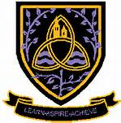

Transition Pack
Cambridge Technical
Sport and Physical Activity Level 3

Summer 2024

Sport and Physical Activity Level 3

Cambridge Technicals are vocational qualifications designed for students aged 16+.
The qualification comprises of a range of units both internally and externally assessed. Completion of the single qualification will allow achievement of the Cambridge Extended Certificate. Completion of the double qualification will result in achievement of the Cambridge Diploma in Sport. The overall grade achieved depends on the result you get in the units when combined together.

The Extended Certificate has the following compulsory units:

- Unit 1: Body Systems and the Effects of Physical Activity
  - This unit covers the structure and function of the key body systems (Heart and Circulatory System, Skeleton, respiratory system etc) and how these are affected by or impact on sports performance
  - This unit is an externally assessed unit – assessed through an examination
- Unit 2: Sports Coaching and Activity Leadership
  - This unit teaches the qualities and characteristics of an effective sports leader along with how to deliver effective lessons as a coach or a leader.
  - This unit is an internally assessed unit – assessed through a range of pieces of course work and practical assessments.

Unit 2 -Sports Coaching and Activity Leadership
Transition Work.

This work is set to be completed during the summer holidays ready for the start of year 12. It forms an essential part of the course.

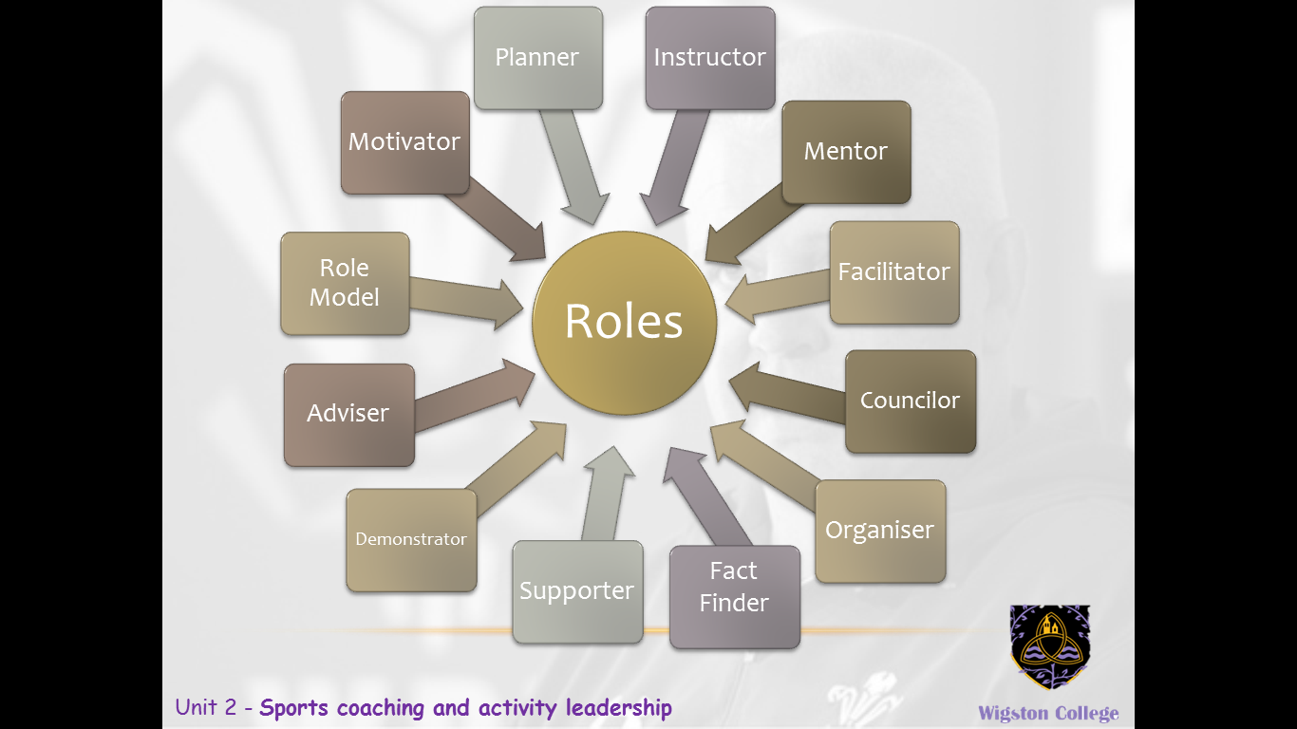
Task 1

- You need to pick 6 of the 12 Roles identified above.
- You need to give a definition on what that role means.

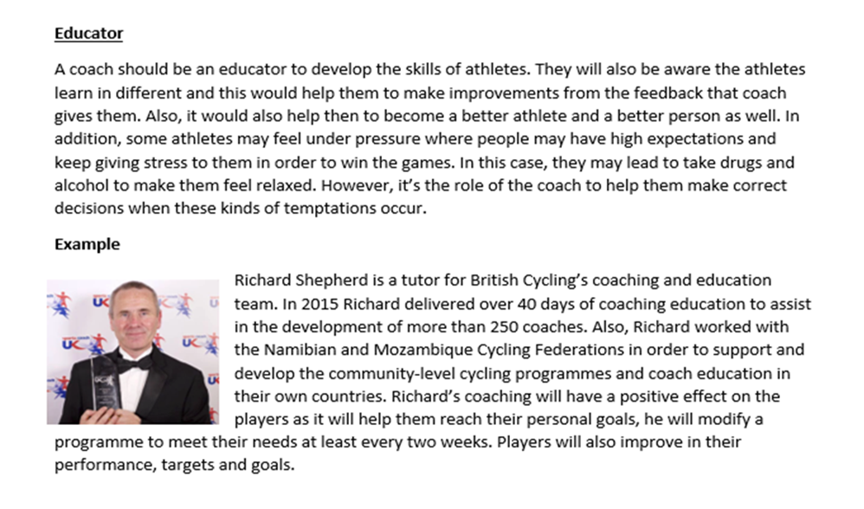
You then need to give an example of a coach that is particularly good at the “role” identified, including a picture of him/her.

This is an example of one of the roles. You need to repeat this for 5 other roles

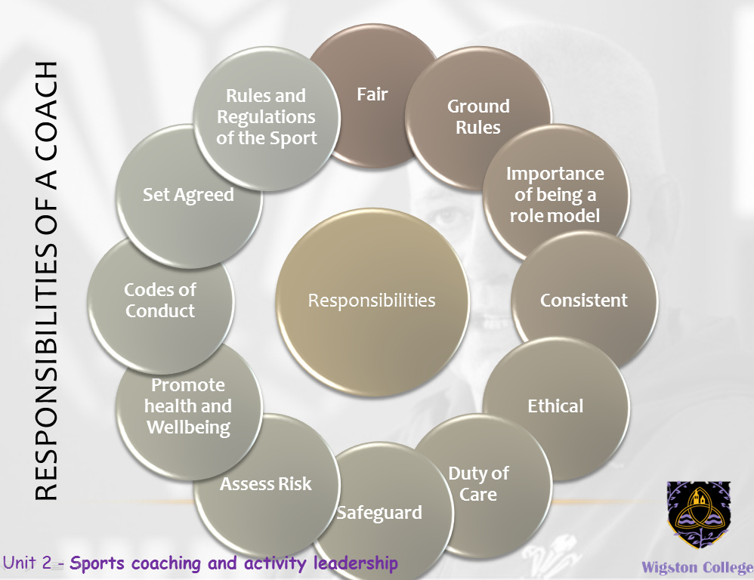

Task 2

You need to pick 6 of the 12 Responsibilities identified above.

You need to give a definition on what that responsibility means.

You then need to give an example of a coach that is particularly good at the “responsibility” identified, including a picture of him/her

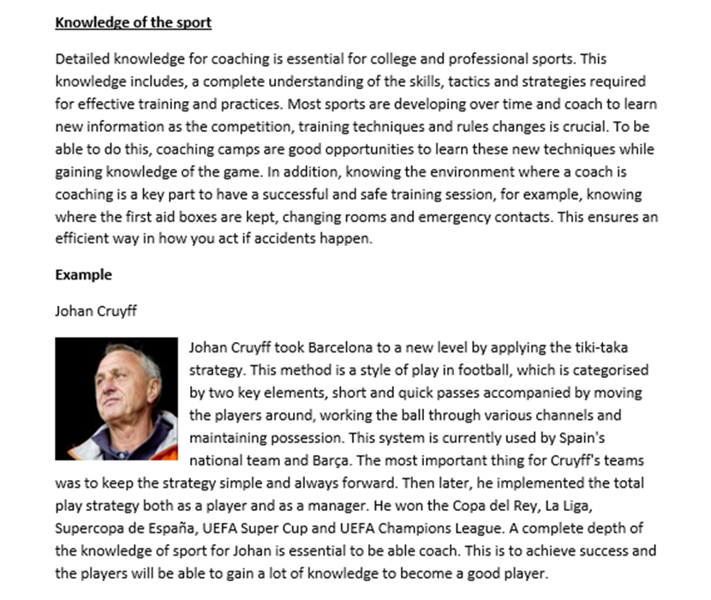

This is an example of one of the responsibilities, you need to repeat this for 5 other responsibilities of a coach

Unit 1- Body Systems and the effects on physical activity

Task 1 : Colour in the skeleton image in 2 different colours showing the Axial and Apendicular Skeleton (see below for help)

Task 2 : Label each of the bones listed below on the diagram

Axial skeleton:
cranium,
sternum,
ribs,
vertebral column, i.e.(cervical vertebrae, thoracic vertebrae, lumbar vertebrae, sacrum, coccyx)

Appendicular skeleton
scapula,
clavicle,
humerus,
radius
BE READY TO LABEL THESE ON A DIAGRAM IN THE FIRST LESSON BACK

ulna
carpals
metacarpals
phalanges
ilium
ischium
pubis
femur
patella
tibia
fibula
tarsals
talus
metatarsals

Task 3: find 3 examples of bones for long, short and flat bones and 1 for irregular and sesamoid:

Type of Bone | Examples
Long
Short
Flat
Irregular
Sesamoid

