Sight Word Rocket – Set 2
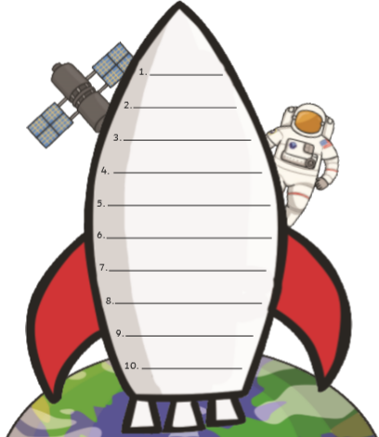
Can you practise reading and writing these sight words?
we
no
is
my
me
do
so
it
a
on

