PERTON FIRST SCHOOL

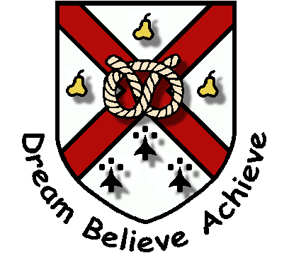

CHARGING AND REMISSIONS POLICY

Approved by Finance Committee: January 2023

Next review: January 2025

OVERVIEW
The education we provide wholly or mainly during school hours will be free but, on some occasions a ‘voluntary’ contribution towards the cost of an activity may be requested by the school. Parents are free to decide whether or not to contribute. This policy sets out the principles upon which the school will operate charges and remissions
OBJECTIVES
- To make clear what will be provided without charge and what will be offered with a charge being made.
- To clarify what is meant by any request for voluntary contributions.
STRATEGIES
- No charge will be made for admitting pupils to school.
- The school may request voluntary contributions towards the cost of some activities planned during school hours.
- Where parents are asked to make a voluntary contribution towards the cost of an activity that takes place during school hours or to school equipment or school funds, the contribution will be genuinely voluntary. The school will not discriminate against pupils whose parents are unable or unwilling to contribute. When there are fewer than 80% voluntary contributions to make an activity possible, it will be cancelled.
- Children whose parents satisfy the LA criteria for pupil premium funding will be entitled to the remission of charges relating to educational visits, Year 4 Residential trip, school dinner, milk term after 5th birthday, reduced rate snack (years 3&4), one club per week (not EBNO).
- Where music tuition or singing tuition is not an essential part of the national curriculum, charges may be made.
OUTCOMES
The funding of activities will be a clear and open process understood by all. We intend that our charging and remissions policy will be in line with that of the LA and that it will meet the requirements of the law.

