Sight Word Rocket – Set 1
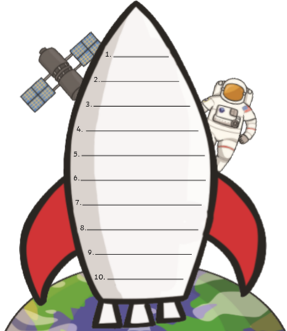
Can you practise reading and writing these sight words?
the
she
he
into
dad
mum
to
and
go
I

