Our local libraries

Hythe Library – 1 Stade Street, Hythe, CT21 6BQ
https://local.kent.gov.uk/kb5/kent/directory/service.page?id=yRPsOKHNzPU

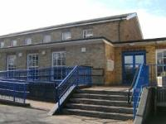

Sandgate Library - Sandgate High Street, Sandgate. CT20 3RR
https://local.kent.gov.uk/kb5/kent/directory/service.page?id=r1ABkQnexZ4

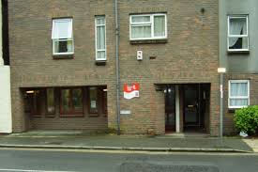

Folkestone Library – 2 Grace Hill, Folkestone, CT20 1HD
https://local.kent.gov.uk/kb5/kent/directory/service.page?id=YRWoQMs70mE

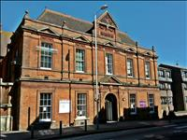

Cheriton Library – 64 Cheriton High Street, Folkestone, CT19 4HB
https://webapps.kent.gov.uk/KCC.Libraries.Web.Sites.Public/LibraryDetails.aspx?aid=0&lid=33&uprn=50028955
