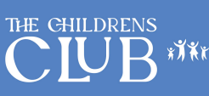

The William Hogarth School – from September 2024

Morning Sessions - 7.40am – 8.45am
Daily Rate: £4.50
Weekly Rate: £20.25

Afternoon Sessions - 3.30pm – 6pm
Daily Rate: £8.50
Weekly Rate: £38.20

Full Day Session – Morning & Afternoon
Daily Rate: £12
Weekly Rate: £54

Club Sporters (During School Holidays/Inset Days)
Daily Rate: £30
Weekly Rate: £150
Starting from Monday 21st - Friday 25th October 08:00-18:00

www.clubsporters.co.uk


