HFW Rocket – Set 6
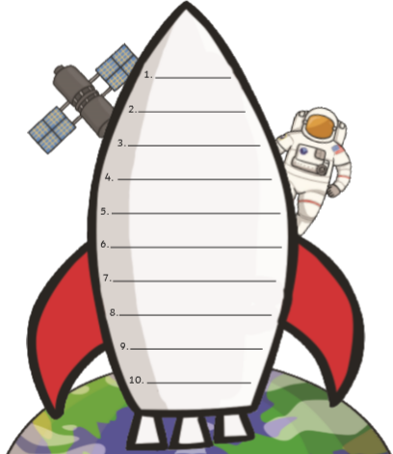
Can you practise reading and writing these sight words?
your
that
but
got
not
had
off
our
out
for

