PARENT/CARERS - PLEASE SUPPORT YOUR CHILDREN IN THEIR LEARNING. ALL YOU NEED IS A PENCIL/PEN AND SOME PAPER TO COMPLETE THIS LEARNING JOURNEY

Home Learning Journey 2 – 1st Person Recount
Stimulus - https://www.literacyshed.com/aviatrice.html
During your time away from school, you will have a writing learning journey to complete as you would normally do in school. Below is a brief summary of what a 2 week learning journey would look like:
Day 1 | Introduction to genre we are writing. Looking at a WAGOLL (What a good one looks like) and highlighting the writing tools and vocabulary used. | Day 6 | Writing the first draft trying to include all skills we have learnt to date but focussing on the two skills we are learning/revising for this learning journey. This will normally take two sessions.
Day 2 | Looking in depth at the first skill we are learning/revising and completing a task based on this. | Day 7 | As above.
Day 3 | As above. | Day 8 | Editing and improving using the footnote system. You are familiar with this as it is something we do in school for every learning journey.
Day 4 | Looking in depth at the second skill we are learning/revising and completing a task based on this. | Day 9 | Writing your final drafts to include your editing and improving. It is vital that you make continuous improvements as you go along. This means that you are further improving on your first draft as you write (beyond the editing and improving you have already done in your editing and improving session). This will normally take two sessions.
Day 5 | Planning our first draft using a planning template. | Day 10 | As above.

Each day will be set out in task cards where you will be given an explanation of the task and example where appropriate. We have designed these so that they can be done on sheets of paper or on the task cards themselves. For ease, the genre and the stimulus (what we are using to base our writing on) will be the same across the school. The skills you are covering will be specific to each year group. So, please work together if you have siblings and help each other. Parents – we have included the writing objectives for each year group to help you see the expectations.
Stimulus for Learning Journey 1
This learning journey will be based on a video and be used to write a 1st person recount (diary entry). Watch the video a few times to familiarise yourself with it. https://www.literacyshed.com/aviatrice.html. You can find this by typing Literacy Shed Aviatrice into Google.

Day 1 Task Card (40 minutes) – Below is a WAGOLL of the start of a diary entry. Your task is to highlight or underline writing tools/grammatical tools we have used in one colour and the carefully selected vocabulary used in another colour. See the year group objectives to give you an idea of what writing tools you should be looking out for. Year 5 and 6, you are required to also give an explanation of their use and talk about the impact on the reader. See the examples below. Do this on a piece of paper by re-write the writing tools or vocabulary you spot. If you are able to print this out, then you may do this on the sheet. Once you have done this, continue our version of the diary entry by writing the next paragraph, try to include writing tools we have not used (for example, we have not used any relative clauses). You can do this on a separate piece of paper. See the year group objectives to give you an idea of what writing tools you should include.

Magnificent – this will help the reader realise that this is no ordinary plane. It is more than special, it is a thing of beauty. Something to marvel at.
Relative clause – form of parenthesis to add information. This gives the reader a clearer idea of how much work and effort has gone into making this plane.
My hearth quickened as I stepped out of the shack and saw the magnificent sight of my jet. It was sleek, polished and beautiful beyond words. The engineers, who had been working relentlessly for the past six months, were making final preparations ready for my test flight. Although I was excited, my legs felt like jelly. This may be the last flight I ever take I thought to myself.
I approached the plane and smiled to the mechanic nearby. He told me the plane was ready to go. I clasped my fingers around the gleaming metal of the ladder that led to the cockpit. Each step I took upwards felt like a lifetime worth of hard work. The cushioned leather of the pilot’s seat hugged me as if to say, don’t worry… you’re safe with me. The plane was my soulmate, my friend.

.

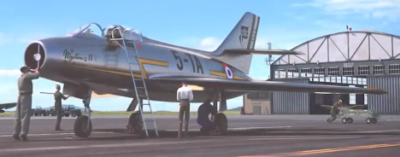
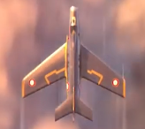
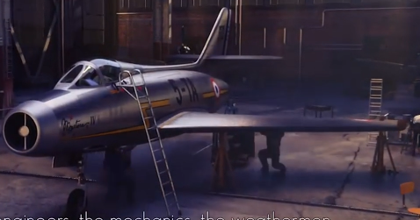
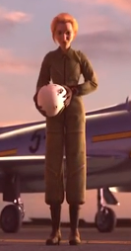
Day 2 and 3 Task Card (2 hours over 2 days – split as appropriate) – today and tomorrow, we will be writing a description based on the plane and the pilot from the video. Below is a table showing you what skill you are learning/revising based on your year group with a short explanation and an example. Your parents/carers will help you with this and together, you can research the skill on the internet. Please take some time before you start to research the writing skill you are learning about with your parents or carers.

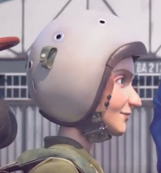
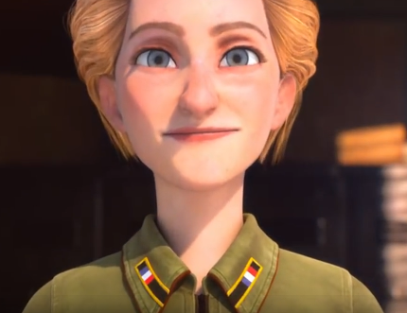
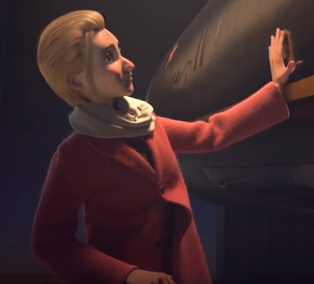

Year group | Skill | Explanation (please do further research if needed). | Example
Year 1 | Use a capital letter and a full stop mostly accurately at the beginning and end of sentences. | A sentence is a grammatical unit made up of one or more words. Every sentence begins with a capital letter and ends with a full stop or punctuation mark. It is a single thought or idea and will normally consist of a subject, verb and object. Not all sentences will have all three however. | The plane flies very quickly through the sky.  Here, the ‘plane’ is the subject, ‘flies’ is the verb and ‘sky’ is the object.  It had long wings that looked like blades.  Here, ‘it’ is the subject, ‘had’ is the verb and ‘wings’ is the object.
Year 2 | Use co-ordinating (e.g. or / and / but) and some subordination (e.g. when / if / that / because) conjunctions to join clauses. | A conjunction is a word that links two clauses together in order to create a complex sentence.  A co-ordinating conjunction is used to join two main clauses. Main clauses are sentences that make sense on their own.  A subordinating conjunction links a main clause to a subordinating clause. A subordinating clause does not make sense on its own. | The plane looked majestic but at the same time overpowering.  You would have to have nerves of steel to fly this plane or you will crash and burn!  Loud and fierce was the sound of the engine when it roared through the sky.  My nose stung as I walked closer to the plane because of the smell of jet fuel.
Year 3 | Use prepositions, mostly accurately, to inform time, place or cause. | 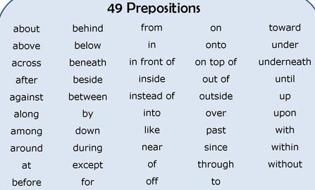  A preposition is a word that shows the relationship between a noun or pronoun and another word in the sentence. There are over 140 prepositions in the English language so please take some time to research these. Write yourself a list of prepositions you can use. Here are a few – |  | Sitting inside the cockpit of the plane and soaring rapidly through the sky, I felt a rush of excitement.  Stepping onto the gleaming metal of the ladder, my heart fluttered as I had waited for this moment for so long.
Year 4/5/6 | Use apostrophes for possession with plural and singular nouns mostly correctly. | Apostrophes for possession are used to show where there is one noun that has ownership of another. This can be singular (apostrophe before the s) when one noun is owing something.  This can be plural (apostrophe after the s) when more than one noun is owning something. | The jet’s windows gleamed in the light of the sun.  Hurtling through the sky, the cockpit’s controls responded to every movement of the pilot.  The engines’ roars were enough to deafen you.

You are required to write two descriptions. One of the plane and one to describe the pilot. Your description of the plane should include what it sounds like, looks like, smells like and how it moves. Your description of the pilot should include her appearance, her personality and how she might speak.
Year 1 and 2 – you should write descriptive sentences to describe the plane and pilot.
Year 3 to 6 – you should write in paragraphs.

Day 4 Task Card (20 min researching and 40 min on the task) – today, you will be doing some research with your parent or carer on the pilot, Jacqueline Auriol. Learn facts about her life and her achievements. Once you have done this, write a letter to her. Think about what you would say or what you would ask her. What about her life amazes you? Tell her. What challenges did she overcome? Mention these and ask her about them. Your letter should be between 4 – 6 paragraphs and should have your return (school) address in the top right corner.
Year group | Skill | Explanation (please do further research if needed). | Examples
Year 1 and 2 | Use some question marks or exclamation marks accurately. | Question marks are used when a question is posed to the reader or between characters.  Exclamation marks are used to demonstrate to the reader a feeling of shock, anger or when a character is shouting. It is generally used to highlight strong feelings. | How did you remain calm when your plane started to fail?  What made you want to break speed records?  I can only imagine how exciting it must be to move that fast!  I think you are amazing!
Year 3 | Use ‘a’ or ‘an’ before a word starting with a vowel sound or a consonant. | When writing a word that starts with a consonant sound, the determiner used before it would be ‘a’.  When writing a word that starts with a vowel sound, the determiner used before it would be ‘an’. | It must have been an amazing experience to fly at such speeds.  I am an extremely big fan of fighter jets.  You are a superb example of what can be achieved if you work hard.  Such a fast moving vehicle must have been hard to control.
Year 4 | Use paragraphs to organise ideas mostly correctly and consistently. | Paragraphs help to structure text; every new paragraph starts on a new line. We start a new paragraph to signal that the person, place, time or topic of the sentences has changed.  In fiction text, paragraphs are usually used to mark breaks in time. A new paragraph may also be started if the point of view switches from one character to another.  In a non-fiction text, a paragraph is a group of sentences that usually all have one theme in common. | 1st paragraph subject matter – who you are and why you are writing.  2nd paragraph subject matter – Jacqueline’s achievements and how they might inspire people.  3rd paragraph subject matter – questions you would want to ask and what aspects of her life amaze you.  Your letter should be between 4 to 6 paragraphs.
Year 5 and 6 | Use relative clauses beginning with who, which and that to add detail and description. | Relative clauses add information to sentences by using a relative pronoun such as who, that or which.  The relative clause is used to add information about the noun, so it must be ‘related’ to the noun.  Here are some examples of relative clauses (in purple):  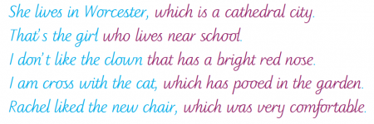  A relative clause can also be an embedded clause if it is positioned in the middle of a sentence, for example:  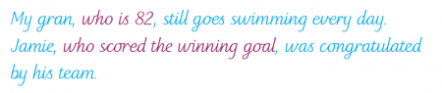 | The planes you flew, which must have been so advanced at the time, look truly amazing in the pictures I have seen online.  The engineers, who built these marvellous machines, must have been some of the smartest people in the world.  My research about you, taught me the importance of hard work, which always pays off.
Day 5 Task Card (1 hour or 2 x 30 min) – today, you will be planning your recount of the day you flew a jet plane from the point of view of Jacqueline Auriol. Please follow the template below. If you can print this template off to complete then great but if you cannot, ask your parent or carer to draw out labelled boxes on lined paper for you to use. There are sections for you to complete based on the two skills you are focussing on for this learning journey but it is also important for you to think about other writing tools and skills you can include. Please see the year group objectives at the bottom. This should be filled out using words, bullet points and short sentences. This is NOT the point at which you write your recount.
Paragraph 1 – What is happening today? How do you feel? Describe getting ready for the flight. | Paragraph 2 – Approaching the plane. Speaking to the mechanic. Climbing into the plane. Describe the plane.
Vocabulary you will use in this paragraph. | Vocabulary you will use in this paragraph.
Examples of writing tools you will use in this paragraph. | Examples of writing tools you will use in this paragraph.
Paragraph 3 – Starting the plane. How do you feel? Describes the sounds. Describe the smells. | Paragraph 4 – Taking off and flying through the sky. What does it feel like? Describe the sky. Describe the way the plane is moving.
Vocabulary you will use in this paragraph. | Vocabulary you will use in this paragraph.
Examples of writing tools you will use in this paragraph. | Examples of writing tools you will use in this paragraph.
Paragraph 5 – Talk about your plane stalling. How it felt when you were plummeting to earth. What was going through your head? | Paragraph 6 – Regaining control of the plane and landing safety back on the ground.
Vocabulary you will use in this paragraph. | Vocabulary you will use in this paragraph.
Examples of writing tools you will use in this paragraph. | Examples of writing tools you will use in this paragraph.

Day 6 and 7 Task Card (45 min over two days) - today, you will be writing the first draft of your recount. There are a few vital points for you to think about and discuss with your parents/carers before you begin.
- You must think about how to include different writing tools and skills you have learnt since the start of the year. It would be useful to look at your year group’s writing objectives within this pack.
- Give special consideration to the two skills that you have covered in this home learning journey.
- It is vital that you look back at the learning and work you have done to help you with your writing, especially your plan!
- Carefully think about the vocabulary you will be using. Normally, we will have Words of the Learning Journey at school, so at home, come up with 6 adventurous words you will use in your first draft. Any words you do come up with, please use them in the correct context.
- Flow is important and you must make sure your writing makes sense.
Day 8 Task Card (40 min) - today’s task is the editing and improving phase. This is one of the most important parts of the learning journey: annotating your first draft in a different coloured pen.
- (All year groups) - There should be a minimum of 10 corrections or single word improvements within the body of your writing. This includes, correcting spellings, improving or adding single words and correcting or adding punctuation.
- (Year 3 – 6 only) - There should be a minimum of 5 footnotes. These are written below your first draft and are used to add in whole sentences or to re-write and improve sentences.
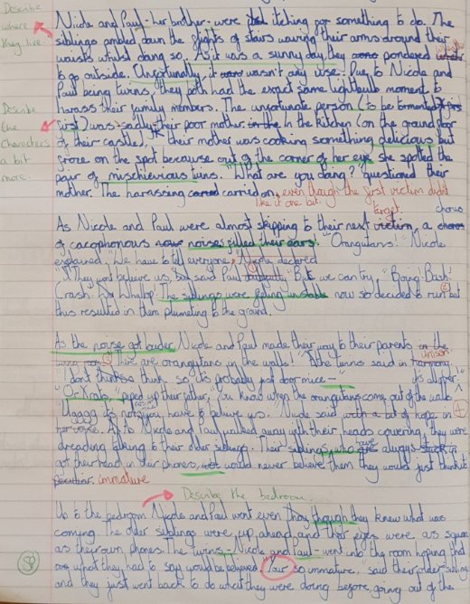
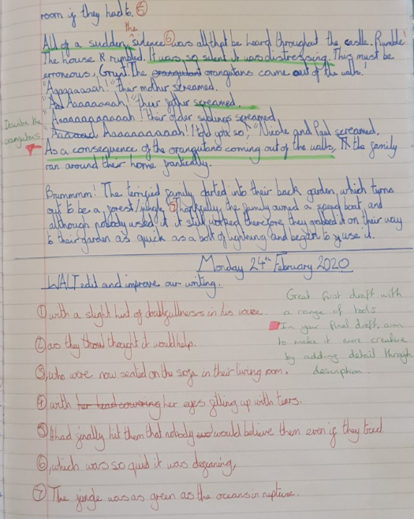
Please see below for an example of what your editing and improving should look like.

Day 9 and 10 Task Card (45 min over two days) - today, you will be writing – or typing - your final draft. This does not mean just writing up your first draft as neat as possible. You must remember to include all your editing and improvement annotations and footnotes but more importantly, there must be continuous improvements made. These are improvement you think of in your head as you are writing. We do this as adults and this is a skill you must develop yourselves.

