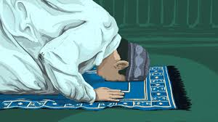
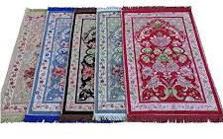
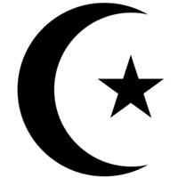

Muslims can pray anywhere that is clean and quiet.
A prayer mat is used and should face the holy city.
Prayer is the most important part of a Muslim’s day.
OUR BIG QUESTION
Why do people pray?

Islam – Prayer mats
EYFS
KEY VOCABULARY
prayer
mat
Makkah

