Extracurricular PE Opportunities

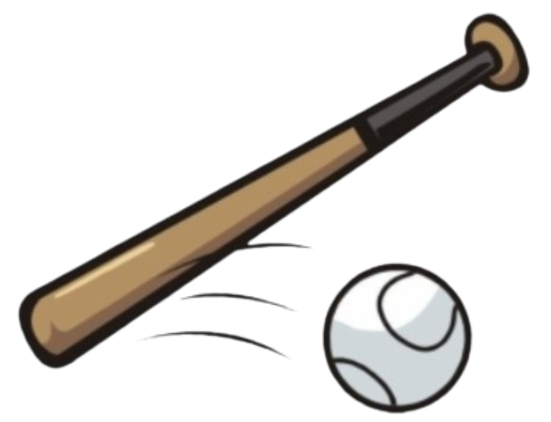
Rounders Club
In the Summer term, Mrs Bell and Mrs Brooks run a rounders club for Years 3 and 4 and Years 5 and 6. The children have the opportunity to learn the skills and tactics and to play games of rounders. The children have great fun playing against each other in a supportive yet competitive environment.


SH Active Clubs
Led by SH Active, Mr Simon offers a range of sporting clubs throughout the year. From archery and trampolining to laser tag and ball skills. Mr Simon is a qualified football coach who puts his skills to good use across all the extracurricular activities. His clubs are popular and enjoyable.


Athletics Training
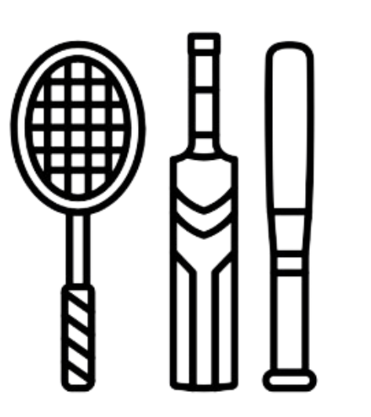
Every Year 5 and 6 child, if they want to, has the opportunity to come to athletic trials in the spring term so we can select a team ready for the Indoor Athletics county tournament that is held in March/April. This gives the children time to try new events and to refine their skills if they are chosen to represent The Coppice at the Indoor Athletics competition.

Athletics/Football/Multi-Skills by CSS
An external club that runs twice weekly by CSS. The club runs twice a week. Key Stage 1 on a Tuesday and Key Stage Two on a Thursday. This club gives the children an opportunity to explore lots of different sports in a controlled and supportive environment. Dave Morris and his team coach the children to achieve the best they can possibly achieve.

Summary
Our extracurricular PE programme is designed to inspire a love of physical activity, build athletic skills, and connect children with the wider world of sport and healthy living. Through clubs, competitions, and community engagement, we provide rich opportunities for every child to stay active, develop teamwork and resilience, and grow in confidence through sport. 🏃‍♂️⚽🏅

