BRILLIANT BOOKS FOR 8-12 YEAR-OLDS

- 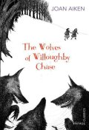

The Wolves of Willoughby Chase
by Joan Aiken
There are wolves outside the walls of Willoughby Chase, but for cousins Bonnie and Sylvia, the real danger lies inside.

- 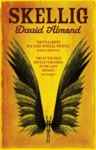

Skellig
by David Almond
Hodder Children's Books
Exploring a ramshackle garage with his new-found friend, Mina, Michael discovers a strange, magical creature.

- 

Carrie's War
by Nina Bawden
Puffin
During World War II, Carrie and her younger brother Nick are evacuated to Wales and billeted with the fierce old Mr Evans and his mousy sister, Louise.

- 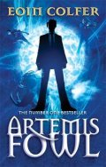

Artemis Fowl
by Eoin Colfer
Puffin
Twelve-year-old criminal mastermind Artemis Fowl hatches an ingenious plot to steal all the gold in fairy land.

- 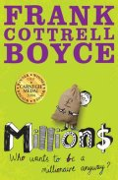

Millions
by Frank Cottrell Boyce
Macmillan Childrens books
One night, a bag containing £229,370 falls from the sky and flattens the hermitage. Damian is convinced it is a gift from God.

- 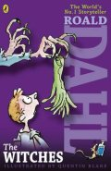

The Witches
by Roald Dahl
Puffin
Real witches disguise themselves as lovely ladies, when secretly they want to squish and squelch all the wretched children they despise.

- 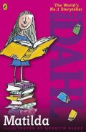

Matilda
by Roald Dahl and Quentin Blake
Puffin
This modern fairy-tale with a brilliantly inspiring young heroine is one of Roald Dahl's best loved stories.

- 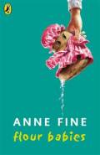

Flour Babies
by Anne Fine
Puffin
As part of a Child Development project, each boy in Class 4C is given a 'flour baby', a sack of flour which must be looked after for three weeks, ensuring it does not get lost or dirty.

- 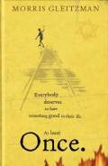

Once
by Morris Gleitzman
Puffin
Morris Gleitzman brings heart and humour to the difficult subject of the Holocaust in this ground-breaking children's book.

- 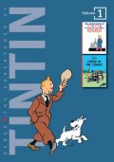

The Adventures of Tintin
by Hergé
Egmont
Resourceful junior reporter Tintin embarks on a series of exciting international adventures, accompanied by his faithful dog Snowy, in this favourite series.

- 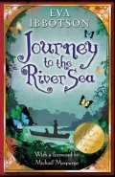

Journey to the River Sea
by Eva Ibbotson
Macmillan Children's Books
Orphan Maia is thrilled to learn she is to live with relatives in South America and cannot wait to experience the sights, sounds and smells of the Amazon.

- 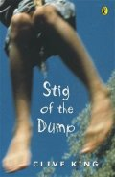

Stig of the Dump
by Clive King
Puffin
Exploring an old chalk pit, Barney meets a strange boy who wears a rabbit skin and speaks in grunts.

- 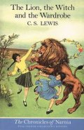

The Lion, the Witch and the Wardrobe
by C S Lewis
HarperCollins Children's
When Peter, Susan, Edmund and Lucy - step through a wardrobe door in the strange country house where they are staying, they find themselves in the land of Narnia.

- 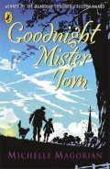

Goodnight Mister Tom
by Michelle Magorian
Puffin
Willie Beech, a lonely and deprived child, is evacuated to a tiny English village just before the Second World War, and finds himself living with reclusive widower Thomas Oakley.

- 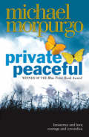

Private Peaceful
by Michael Morpurgo
HarperCollins Children's Books
Set during World War I, Private Peaceful charts eight hours in the life of Tommo, a young soldier at the Front.

- 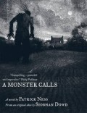

A Monster Calls
by Patrick Ness
Walker Books Ltd
Connor's mum has cancer and life is changing. There is the nightmare, then there is school, where people avoid him, or persecute him. And then there is the immense, mythic Monster.

- 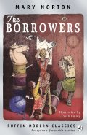

The Borrowers
by Mary Norton
Puffin
The Borrowers are tiny people who live in the secret places of old houses - behind the mantlepiece, inside the harpsichord, under the kitchen clock.

- 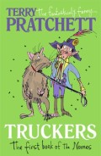

Truckers
by Terry Pratchett
Corgi Children's
The first title in the Bromeliad trilogy, this is an enchanting fantasy from favourite author Terry Pratchett.

- 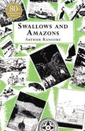

Swallows and Amazons
by Arthur Ransome
Red Fox
It's the summer holidays, and the Walker children are excited to set sail on their boat Swallow and camp on Wild Cat Island.

- 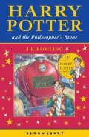

Harry Potter and the Philosopher's Stone
by J K Rowling
Bloomsbury Children's Books
After the misery of life with his ghastly aunt and uncle, Harry Potter is delighted to have the chance to embark on an exciting new life at the Hogwart's School of Wizardry and Witchcraft.

- 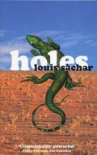

Holes
by Louis Sachar
Bloomsbury
Stanley Yelnats' family has a history of bad luck, so he is not entirely surprised when a miscarriage of justice sends him to the Camp Green Lake Juvenile Detention Centre

- 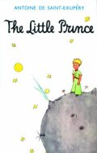

The Little Prince
by Antoine de Saint-Exupery
Egmont
An air pilot makes a forced landing deep in the Sahara Desert. There, he makes a mysterious Little Prince, who tells him a series of wise and enchanting stories.

- 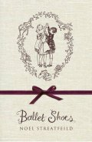

Ballet Shoes
by Noel Streatfeild
Orion Children's Books
First published in the 1930s, this classic story of three very different girls who work hard to master their talents has captivated children's imaginations for decades

- 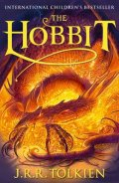

The Hobbit
by J R R Tolkien
HarperCollins Children's
This well-loved fantasy story has delighed readers ever since its first publication in 1937.

- 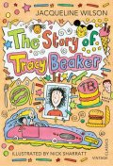

The Story of Tracy Beaker
by Jacqueline Wilson
Vintage

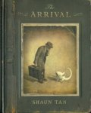

The Arrival
by Shaun Tan
Hodder Children's Books
In this unusual book, we follow a young man as he packs his bags and leaves his family to go and start a new life in another country

