

***Perseverance Respect Honesty Friendship***

**Behaviour for Learning Policy**

|  |  |  |  |  |
| --- | --- | --- | --- | --- |
| **Date written** |  | **Authorised by** |  | **Review Date** |
|  |  |  |  |  |
| November 2023 |  | Governors |  | November 2025 |



# Contents

1. Introduction 3
2. Responsibilities 3
3. Understanding pupils’ behavior 5
4. Managing pupils’ behavior 7
5. Rewards & Consequences 9
6. Investigating, Escalating and Reporting Incidents 11
7. Bullying 12
8. Persistent behaviour incidents 13
9. Active Learning Behaviours 13
10. Conduct beyond the classroom 14
11. Zones of Regulation 15

12. Appendices – A) Examples of whole class reward systems 17

B) Individual Behaviour Plan

C) Zones of Regulation

D) Whole class reward systems

E) Home-School Agreement

# Introduction

Supporting pupils to manage their behaviour is the responsibility of all members of school staff. This policy outlines a whole-school approach to promoting a culture of positive behaviour amongst pupils and outlines how to respond when pupils struggle to manage their behaviour.

*All children want to behave well. All children can behave well. All children are capable of restoring their mistakes.*

We all make mistakes, including adults. Staff at Brooklands help children to remedy these mistakes and ensure each day is a new start. We are ‘curious not furious’ about children’s behaviour.

# Responsibilities

**Who is responsible for this policy?**

Managing the behaviour of pupils is the responsibility of all members of staff. Inappropriate behaviour should be addressed by any member of staff that encounters it, e.g. running in the corridor, being inside at lunch-time, etc. addressed by admin/premises staff.

“Children’s behaviour is not our fault, but is our responsibility” (Brooklands staff, 2023).

**Teachers’ responsibility**

Teachers are responsible for managing pupils’ behaviour in line with the DfE’s Teachers’ Standards and as part of QFT (quality first teaching). Teaching standard 7 states that teachers must - M*anage behaviour effectively to ensure a good and safe learning environment:*

* maintain good relationships with pupils, exercise appropriate authority, and act decisively when necessary
* understanding the root of pupils’ behaviour (see ‘Understanding Pupils’ Behaviour)
* have clear rules and routines for behaviour in classrooms, and take responsibility for promoting good and courteous behaviour both in classrooms and around the school, in accordance with the school’s behaviour policy
* have high expectations of behaviour, and establish a framework for discipline with a range of strategies, using praise, sanctions and rewards consistently and fairly
* manage classes effectively, using approaches which are appropriate to pupils’ needs in order to involve and motivate them
* effectively report behaviour incidents to parents
* write and monitor Individual Behaviour Plans (see below - as necessary)

**Leaders’ responsibility**

* Ensuring that the school environment encourages positive behaviour
* Ensuring that staff deal effectively with challenging behaviour
* Monitoring that the policy is implemented by staff consistently with all groups of pupils
* Providing new staff with a clear induction into the school’s behavioural culture to ensure they understand its rules and routines, and how best to support all pupils to participate fully
* Offering appropriate training in behaviour management, and the impact of special educational needs and disabilities (SEND) and mental health needs on behaviour to all staff working directly with children
* Ensuring that the data from the behaviour log is reviewed regularly, identifying trends and ensuring that no groups of pupils are being disproportionately impacted by this policy
* Offer support to staff, parents and pupils in the event of extreme or escalated behaviour
* Ensure systems are in place to communicate incidents of behaviour with parents

**Governors’ responsibility**

The governing board is responsible for:

* Reviewing this behaviour policy in conjunction with the headteacher
* Monitoring this policy’s effectiveness
* Holding the headteacher to account for its implementation

The Headteacher reports to governors termly, providing numbers and details of significant behaviour incidents to monitor levels and identify trends.

**Parents’ responsibility**

Parents and carers, where possible, should:

* Get to know the school’s behaviour policy and reinforce it at home where appropriate
* Support their child in adhering to the school’s behaviour policy
* Inform the school of any changes in circumstances that may affect their child’s behaviour
* Discuss any behavioural concerns with the class teacher promptly
* Take part in any pastoral work following misbehaviour (for example, attending reviews of specific behaviour interventions)
* Raise any concerns about the management of behaviour with the school directly, while continuing to work in partnership with the school
* Take part in the life of the school and its culture
* Accept that their child is capable of making mistakes, trust school’s processes and support the school in helping their child to improve their behaviour

The school will endeavour to build a positive relationship with parents and carers by keeping them informed about developments in their child's behaviour and the school’s policy, and working in collaboration with them to tackle behavioural issues.

**Pupils’ responsibility**

Pupils are expected to:

* Be a role model for the school values – perseverance, respect, honesty and friendship
* Follow the school/class rules and routines
* Demonstrate positive behaviour both in and beyond the classroom/school
* Be ambassadors for the school when on educational visits
* Take responsibility for and be honest about their mistakes and accept help in remedying them
* Demonstrate the same respect to all members of school staff and volunteers, regardless of familiarity or role

# Understanding pupils’ behaviour

**Relationships**

The foundation to achieving positive classroom behaviour is to develop strong relationships with pupils. Adults work hard to develop connections with children, particularly in the first few weeks of a new term. Children are incredibly intuitive and pick up on energy and authenticity. They need to know that their teacher is their champion, cares about them and has their best interests at heart. They need to know they are ‘held in mind’ and that they matter to their teacher, whilst also being clear on boundaries and expectations. When pupils display challenging behaviour, they are dealt with firmly but with compassion and dignity and are praised when displaying positive behaviours.

Teaching standard 1 states that teachers must - *Set high expectations which inspire, motivate and challenge pupils*:

* establish a safe and stimulating environment for pupils, rooted in mutual respect
* set goals that stretch and challenge pupils of all backgrounds, abilities and dispositions
* demonstrate consistently the positive attitudes, values and behaviour which are expected of pupils

**Behaviour as Communication**

At Brooklands Primary School we see children’s behaviour as communication. When children struggle to manage their behaviour, they may be communicating feelings of anger, fear or sadness. The child may be communicating that something at home is not OK. It could be a manifestation of trauma, attachment or abuse. The child may be finding the work too challenging, or not challenging enough. Staff are trained on various child development and behaviour theory such as Maslow, Skinner and Piaget, along with areas such as attachment.

It is easy for staff to see behaviour as a personal affront. It is not personal. As adults we often bring our own social, cultural, generational and personal thoughts, feelings and experiences around behaviour and project these onto the situation, or use these as a barometer to judge and deal with behaviour (“it’s just not acceptable, if it was me I would…, I don’t understand why they just don’t…, when I was a child I would never have…”). Staff are most effective at managing behaviour when the emotion is removed and viewed as a pragmatic dilemma (not a problem). If staff seek to understand the root of the behaviour they are more likely to a) understand it b) help the child find a solution c) lessen the impact on their own feelings/emotions.

At Brooklands, we recognise the power of language and therefore have a shared lexicon when discussing behaviour. For example, we describe children’s behaviour as “dysregulated” rather than “kicking off” and avoid sweeping, unqualified statements such as “(a certain child) needs a specialist provision”. We also separate our feelings towards children (all of whom we love) from our feelings about their behaviour (which can at times be challenging).

We provide our pupils with clear boundaries and expectations of behaviour. When these are not met, we help our pupils to understand, accept and own the consequences of the behaviour. We support all children to maintain and/or improve their behaviour in the same way we support children if they have fallen behind in any other area of their learning, such as reading or mathematics. We work in an inclusive – not an exclusive – education sector, and children who are vulnerable are those most in need of the support of school staff and resources, including time.

# Managing pupils’ behaviour

At Brooklands, we are proud of our children’s exceptional behaviour and conduct. Pupils at our school are respectful, courteous, well-mannered, compliant, follow instructions, work hard, treat their peers appropriately, and follow the class and school rules (Ofsted Inspection report, Oct ’21). However, there are times when children become dysregulated and struggle to manage their behaviour. In this instance, teachers should use a range of preventative strategies. These include:

* Positive praise (either of the child or of good examples of behavior – ‘catch’ children doing something good!)
* Reassurance
* Engage the child (through questioning or tasks)
* Non-verbal communication (a hand on the shoulder, a longer gaze, finger to the lips, raised hand, etc.)
* Distraction/diversion
* Tactical ignoring
* Humour
* Negotiation
* Zones of Regulation language/strategies (see Appendix C)
* Sensory Movement Breaks (see Appendix C)
* Corridor conversation (to avoid shame/embarrassment)
* Firm direction
* A change of adult (one adult at a time)
* Consequences (see below)

**General Strategies**

Some useful general strategies to ensure positive behaviour in lessons are as follows:

* Invest in developing strong, positive relationships with pupils – show that you like them and care about them. Get to know their likes/dislikes/personal circumstances. Create a happy classroom (Standard 1)
* Plan high quality, engaging lessons that are pitched, resourced and adjusted appropriately (Standards 4 & 5)
* Set clear expectations and boundaries – refer to them at the start of lessons and back to them within the lessons as necessary (Standard 7)
* Use positive praise frivolously, both to individual children, groups of children and those children whose behaviour you wish others to replicate (Standard 7)
* Consider your body position – bend or kneel at pupils’ level, positioning yourself so you can see the whole classroom. Teach from different points around the room.
* Use non-verbal cues (a touch on the shoulder, removing a pen that’s being fiddled with, a prolonged gaze, etc.)
* Teachers should avoid shouting. Use your voice as a tool – use it sparingly to gain attention, starting loudly before lowering your voice.
* Don’t ask, thank. E.g. ‘Stop rocking on your chair. Thank you’ as opposed to ‘Please stop rocking on your chair.’
* Children are not doing things for you, they are doing it for themselves. E.g. avoid ‘Please will you do one more maths problem for me.’
* Create positive perceptions: ask what went well or what will go well at play time if pupils are reporting issues at playtime
* Identify vulnerable times and make reasonable adjustments for these through preventative behavior management strategies, e.g. if the transition from lunchtime to afternoon lessons is an issue, embed calming strategies into afternoon routine (quiet reading, story time, breathing exercises, musical appreciation, etc.)
* Adults to be aware of and regulate their own emotions (Zones of Regulation, perspective, gratitude, support from colleagues, breathing exercises, breaks, reflection, don’t panic! etc.)

**Teachers as reflective practitioners**

Our teachers are reflective practitioners who do not blame pupils for their actions, and instead begin by considering their own practice and reflect on the following considerations (this can be conceptualised in the diagram below):

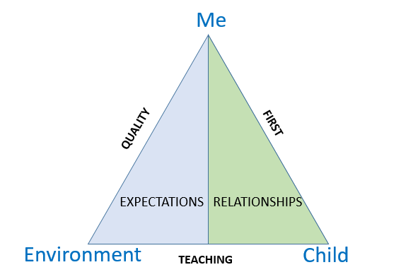

* What role did I play in the behaviour?

*What was my body language portraying? What did I say? Did I plan/adjust effectively? How was my energy? Am I bringing something from outside the classroom into the classroom? Is the work I set too challenging/too easy/interesting enough? Did I hold them in mind (verbal and non-verbal)? Did I engage them in the learning?*

* What impact did the environment have on the behaviour?

*Was the classroom/desk too noisy/cluttered? Did the child have the correct resources to access the learning? Are they sat in the right seat? Can they see the board? Can they hear/see me?*

* What role did the child play in the behaviour?

*What happened last night/at play/at lunch? Where is their confidence/self-esteem? Is there any trauma/fear/anger/sadness that I’m unaware of? Why aren’t they demonstrating the school values/class rules? What were the possible triggers? (there is always a trigger, either known or unknown)*

# Rewards and consequences

**Rewards**

We want our children to be motivated by their own successes, not motivated by material or conceptual rewards. The most rewarding reinforcement for a child is a genuine, authentic, heartfelt piece of verbal praise. School no longer uses individual public behaviour rewards or charts (e.g. Class Dojo) due to the competition, comparison and inconsistency this can cause. Instead, teachers use the following ways to recognise pupils’ effort and achievement:

* a whole class reward system (to which rewards can be added but never removed), culminating in a whole class reward at the end of each half-term – see Appendix D.
* weekly ‘Values’ Certificate for demonstrating any of the 4 school values (Perseverance, Respect, Honesty, Friendship). These must be awarded on merit and not quota-filled.
* upon receiving all 4 certificates, pupils will then receive a further certificate to be presented in front of the whole school (Values Award). Children to present all 4 certificates to the Headteacher rather than teachers tracking.
* showcasing work to the headteacher or deputy headteacher
* teachers actively contact parents to feedback regarding pupils’ good work or attitude. This can be done face-to-face, via telephone or email, through the school app or physically handing a photocopy of the work

**Consequences**

At Brooklands we help our children understand the need for consequences that are proportionate and relevant to the situation and the behaviour, rather than issuing punitive punishments, e.g. missed playtime. Consequences are co-constructed with the child and issued at an appropriate time based on both the situation and the child involved (either immediately or, at the very latest, the following day). It is key that the situation is de-escalated and the child is regulated before attempting to discuss consequences. At Brooklands we use ‘Restorative Justice’ to restore situations (see below). Examples of proportionate and relevant consequences are as follows:

|  |  |
| --- | --- |
| **Action** | **Consequence** |
| Work not completed due to lack of effort | Work completed at alternative time (e.g. play, at home – age dependent) |
| Dropping litter | Time spent picking up litter |
| Damage to property | Contribution to the repair/replacement cost |
| Lack of respect to school property | Tidying the classroom |
| Use of unkind language | Use of kind, positive language for remainder of the day |
| Child’s behaviour renders them unsafe on the playground | Indoor play |
| Not following school/class rules | Unable to represent the school in competitions |

**Restorative Justice**

At Brooklands we recognise that it is natural for children to fall out and fall in, and that this process may actually help improve relationships. Adults support children with this process. Restorative Justice brings those harmed and those responsible for the harm together in communication to understand the reasons for and impact of their choices, and to work together to resolve the situation. At Brooklands we use restorative practices and principles to restore situations, both between pupils and with staff. It is important children understand the impact of their actions (linked to the school values) and work with adults to agree proportionate and relevant consequences (see Appendix A). This approach is recognised by the Anti-Bullying Alliance (see below). For more information, see [www.restorativejustice4schools.co.uk](http://www.restorativejustice4schools.co.uk)

# Investigating, Escalating and Reporting Incidents

**Investigating incidents**

When investigating incidents, it is important all members of the school staff take the time to ascertain what has happened to ensure proper resolutions and accurate record keeping. Staff should structure and facilitate conversations to allow all parties the time and space to share their version of events. In the event of a disparity between versions, staff should speak with a neutral third party to obtain their account. Written accounts should be recorded and stored in the event of serious incidents.

**Escalating incidents**

Should the strategies used in this policy fail to regulate pupils’ behaviour, teachers should seek support in the following order:

**Year Group Lead 🡪 Assistant Headteacher 🡪 Deputy Headteacher 🡪 Headteacher**

Any incidents against those with protected characteristics (e.g. racist incidents), serious physical violence or bullying should be immediately escalated to the Deputy Headteacher or Headteacher. The staff member dealing with the situation will use consequences/Restorative Justice as appropriate. Parents should be invited to meet with the relevant staff members at the appropriate stage.

**Reporting, recording and evaluating behaviour incidents**

Mid/high level behaviour incidents (see below) are reported to parents either face-to-face or via telephone as appropriate and recorded using CPOMs. The headteacher also reports high level behaviour incidents to governors termly for their evaluation. Examples of low/mid/high level behaviours can be seen below, although context must also be taken into consideration:

|  |  |
| --- | --- |
| Low-level | Lack of focus in lessons, talking at inappropriate times, shouting out in class, running in corridors, etc. |
| Mid-level  *(reported to parents, logged on CPOMs)* | Pushing a child over on the playground, ignoring a teacher’s instruction, inappropriate language, etc. |
| High-level  *(dealt with by DH/HT, reported to parents and governors, logged on CPOMs)* | Bullying (see definition below), acts of extreme physical violence towards pupils or staff, incidents against those with protected characteristics, e.g. racism |

# Bullying

Children at Brooklands Primary School have the right to feel safe and happy at school. As a result, school has a zero tolerance policy towards bullying. School adopts the [Anti-Bullying Alliance’s](https://anti-bullyingalliance.org.uk/) definition of bullying – ‘The repetitive, intentional hurting of one person or group by another person or group, where the relationship involves an imbalance of power. Bullying can be physical, verbal or psychological. It can happen face-to-face or online'.

Children are taught how to avoid, recognise and report bullying through assemblies linked to our school values, PSHE lessons and circle time. Children are asked to list 3 trusted adults to whom they would report incidents of bullying (along with knowing they can talk with their peers) and an anonymous way of sharing concerns, e.g. worry box. Parents may also raise concerns with their child’s class teacher. The below outlines school’s response to a bullying allegation:

|  |  |
| --- | --- |
| 1 | Relevant Year Group Lead to investigate the allegation |
| 2 | YGL meets with parents to share outcome of investigation and associated actions |
| 3 | If bullying is found to have taken place, the Deputy Headteacher or Headteacher meets with parents of the child carrying out the behaviour (and child if appropriate). Parents must not confront one other and situation should be dealt with in school |
| 4 | School monitors the situation to ensure the bullying has ceased |
| 5 | In the event of a repeat incident, school informs both sets of parents. Appropriate actions are taken to protect the safety and wellbeing of the child experiencing the behaviour |
| 6 | If parents are dissatisfied with the school’s actions, they should follow the school’s Complaints Procedure (available on the website) |
| 7 | School carries out a ‘lessons learnt’ procedure |

# Persistent Behaviour Incidents

**Individual Behaviour Plans**

A very small number of pupils at Brooklands may display persistent, extreme behaviour. As a result, some elements of this policy will not be applicable to them and they will instead have their own Personal Behaviour Plan (see Appendix B). We provide these children with what they need rather than simply saying they must follow the same rules as everyone else as this will not work for vulnerable pupils. This does not equate to special treatment, and these pupils will still be issued with proportionate and relevant consequences when appropriate. Agreed strategies should be persevered with as they may not prove instantly successful, but should be reviewed and adjusted over time.

**Exclusions and suspensions**

In extreme circumstances the Headteacher may decide that a child’s behaviour consistently puts other pupils, staff or themselves at the risk of significant harm, and warrants their exclusion or suspension from school. In this event, school will take the steps outlined in our ‘Exclusions and Suspensions Procedure’.

1. **Active Learning Behaviours**

Whilst our children are well-behaved and compliant, there are times when they can display passive learning behaviours. We want our pupils to be active learners; confident and enthusiastic about their learning, willing to contribute readily to class discussions and activities. These active learning behaviours can be developed as follows:

* Oracy techniques (see ‘Learning, Teaching & Assessment Policy)
* Teacher : pupil talk ratio (aim roughly for 30:70)
* Cold-calling and other questioning strategies
* Attributing roles in group work
* Use of floor books
* Formative assessment strategies (see ‘Learning, Teaching & Assessment Policy), e.g. peer assessment
* Shared modelling
* Thinking, discussing, investigating, creating and proposing solutions
* Learning beyond the classroom

1. **Conduct beyond the classroom**

We expect our children to demonstrate the same behaviour and conduct that they do in classrooms around the wider school. The same principles apply in the playground, corridors and when off-site. Pupils treat all members of staff with respect, regardless of their role in the school. They play respectfully and considerately. They line up quickly and orderly at the end of play/lunch. When travelling around school they must:

* Walk quietly/silently as appropriate and directed by their teacher
* Walk on the left hand-side of the corridor
* Remove hats/hoods indoors, and wear coats/jumpers properly (e.g. with their arms through jumpers/coats not round their waists, on their shoulders/heads)
* Hold doors open sensibly without distracting those children walking through them

All members of staff are responsible for behaviour and staff at play-time and lunch-time must follow the steps outlined in this policy.

**Toileting**

We encourage children to go to the toilet during their break and lunchtimes to avoid disruption to learning - for the child involved, other children who are learning and adults delivering/supporting the lesson.

However, we also understand that requiring the toilet is both a very natural and potentially unpredictable process, and needing the toilet is going to negatively impact attention, engagement and quality of work.

Children's requests to visit the toilet should be granted as long as the teacher judges these requests to be genuine, e.g. not an attempt to avoid learning, attempt to socialise with other children, etc. Teachers should err on the side of caution if unsure to avoid accidents or potential medical issues. If a child is asking to go regularly, teachers are advised to reach out to parents to information gather/share.

The above should be shared with children each year by the class teacher.

1. **Zones of regulation**

Through our work in school on Zones of Regulation, all our children are encouraged to develop their personal toolbox of strategies to support their own emotional regulation.

This means that children are able to adjust their state of alertness, energy levels and emotions to meet the demands of different situations, meet goals and gain a sense of wellness.

At times, children may need support to become regulated - this is called ‘co-regulation’. This means that an adult or peer will help the child to recognise and name their emotions, describe how this is making them feel and think about ways they can work together to make sure the child feels settled, in control and ready to learn again.

As children develop an understanding of their own emotions, they will become more skilled at self- regulating. Even as adults, we are not able to self-regulate all of the time and will still need co-regulation and support from others, depending on the situation.

As our children develop their regulation skills, it is important to still know that there are times when dysregulation will happen. This is normal for children and adults. Through school’s work on Zones of Regulation, the key message is that all emotions are normal and acceptable to feel at times. The important thing is how we recognise and deal with these emotions when we feel them.  For more information see Appendix C.

**Appendix A – Restoration Resources**

**Restoration Frame**

**

*Article 28- Discipline in schools must respect children’s dignity and their rights*

How did you feel and what did you do?

……………………………………………………………………….……….

Which of the school values and articles did you not follow?

…………………………………………………………………………………….

Who has been affected by what you did (including yourself, other pupils and adults)?

……………………………………………………………………………………

How did your actions affect them?

……………………………………………………………………………………

How do you now feel about what you did?

…………………………………………………………………………………

What can you do now to make things right?

……………………………………………………………………………………

What will you do in the future?

……………………………………………………………………………………

**Restoration Letter**

*Article 28- Discipline in schools must respect children’s dignity and their rights*

Dear ……………………..

Paragraph 1

Write what you did and what you’re sorry for.

Share what mistake you have made.

Paragraph 2

Identify the school values that you did not follow.

Paragraph 3

Who was affected by your actions?

Explain how your actions affected each of them (including you).

Paragraph 4

Suggest how you would like to make things right.

Ask for an opportunity to be able do this.

Pupil signature:

apology apologise opportunity perseverance democracy

understanding democracy respect responsibility

impact disappointed frustrated upset angry

disrespect trust reflect reflection

Yours sincerely

**Appendix B – Individual Behaviour Plan**

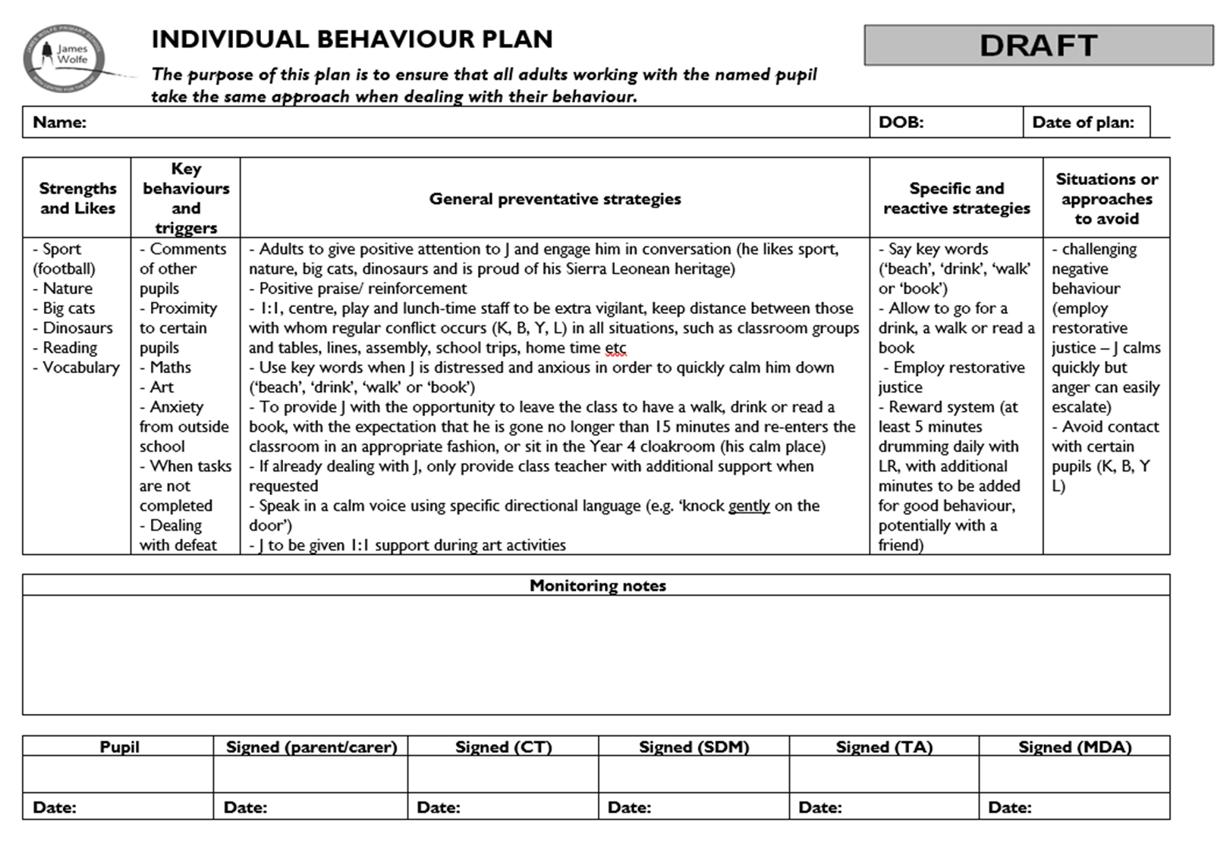

**Appendix C – Zones of Regulation**

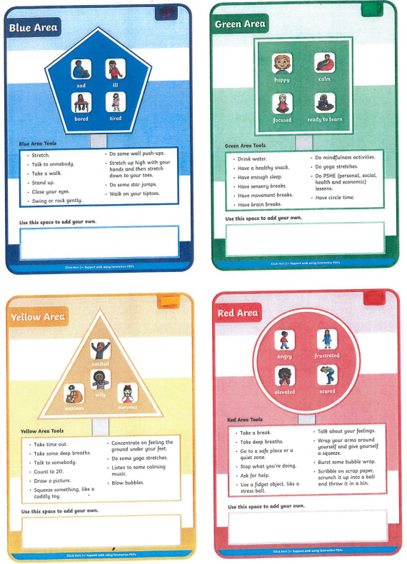

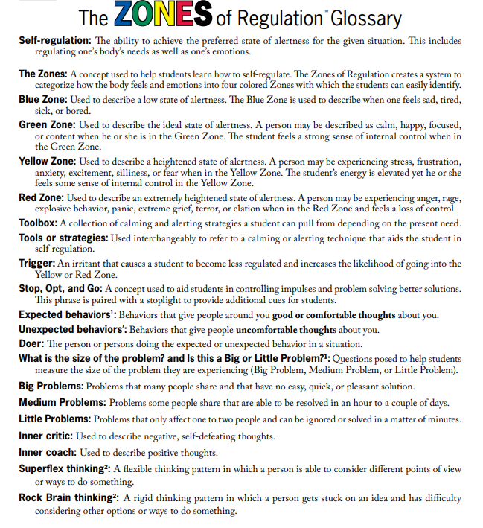

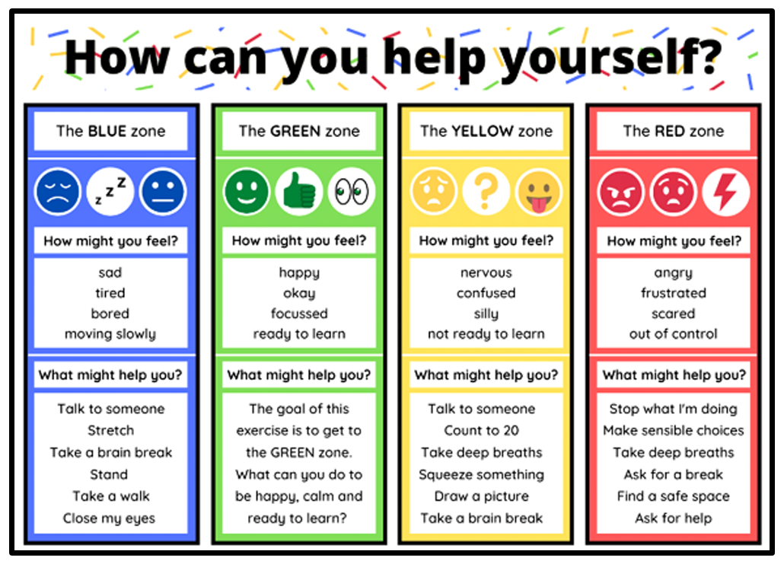

**Appendix D – Whole Class Reward Systems**

