Literacy & Numeracy Support

Name:
Form:
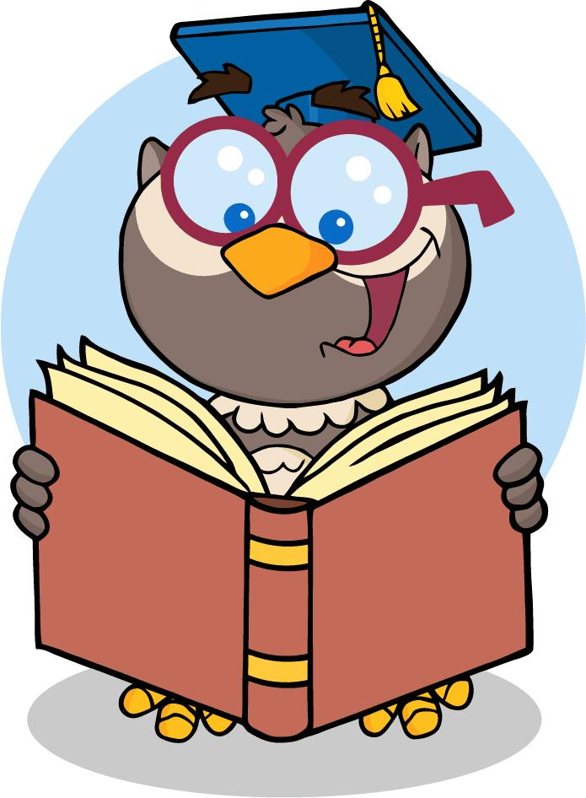
NAME:
FORM:

Name:
Form:
This booklet has been designed to help you over the summer period with areas of numeracy and literacy that you may struggle with.
NUMERACY
Times Tables
Time tables help with mental arithmetic skills. Memorising times tables 1 to 10 makes you far more responsive in solving maths problems.

Try your best to memorise the multiplication table and then answer the following questions on the next page without looking back.
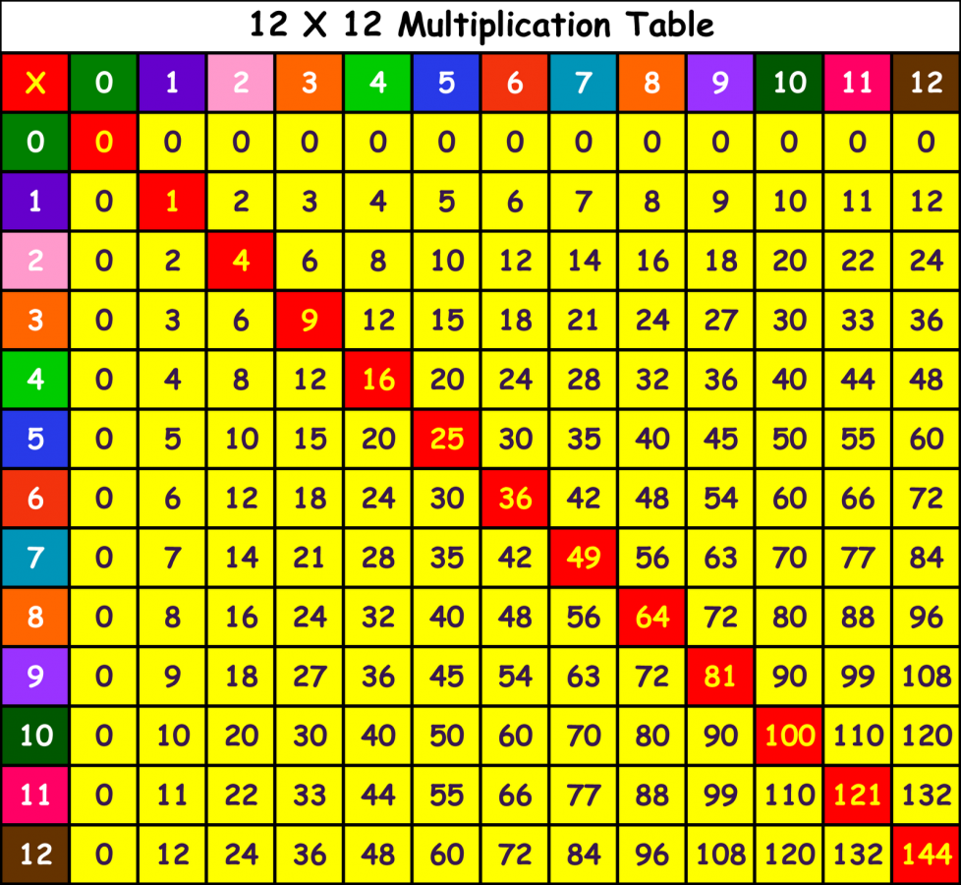

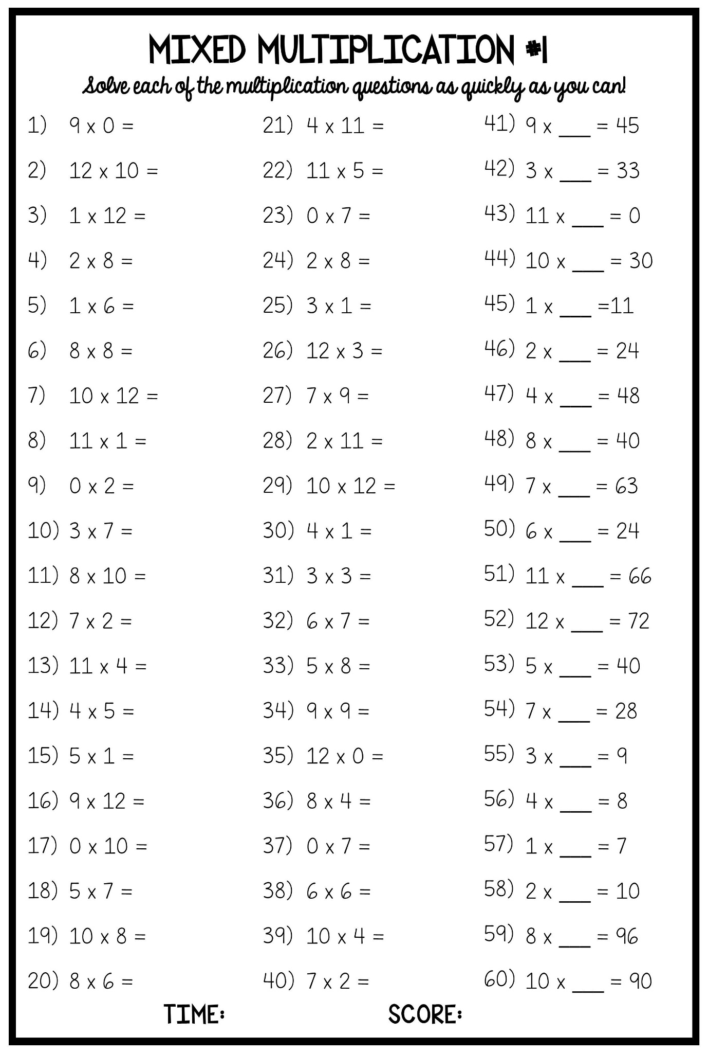
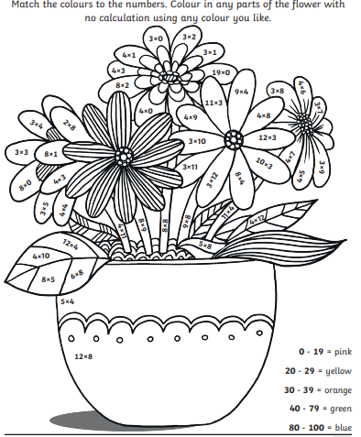
Multiplication
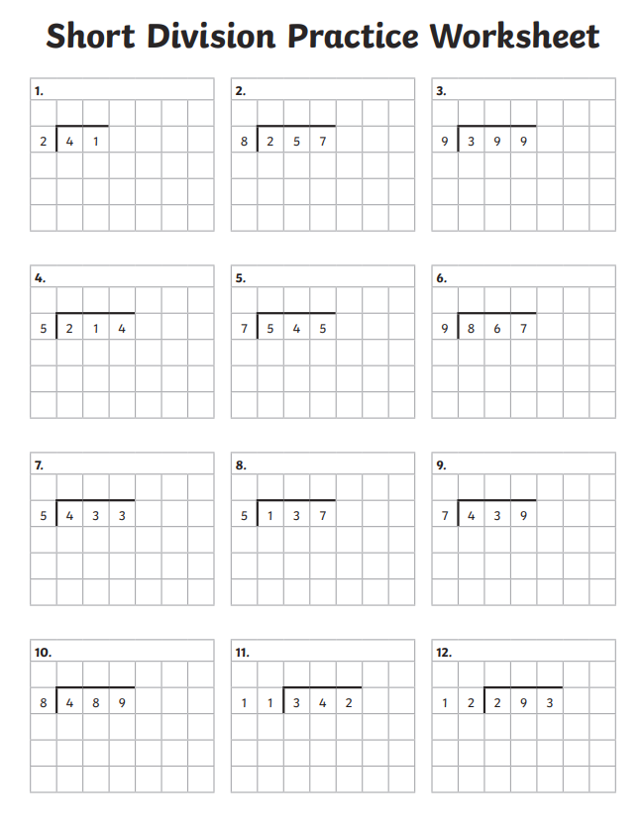
Division

Rounding up & Down
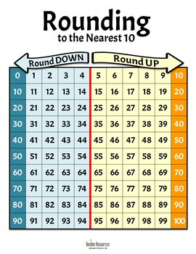
The chart below indicates if the number you are working with is less then 5 or the 2nd unit is less then 5, then you need to round down. Anything above 5 and over requires you to round up.

Round the following numbers to the nearest 10.
- 5
- 3
- 7
- 8
- 6
- 2
Round the following numbers to the nearest 10.
- 68
- 72
- 81
- 44
- 32
- 28
- 19

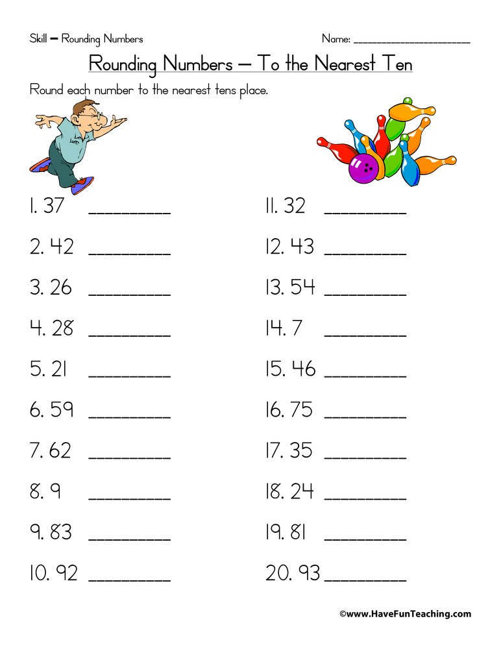

Fractions
Quite simply, fractions represent parts of a whole.
- Fractions are used to represent smaller pieces (or parts) of a whole.
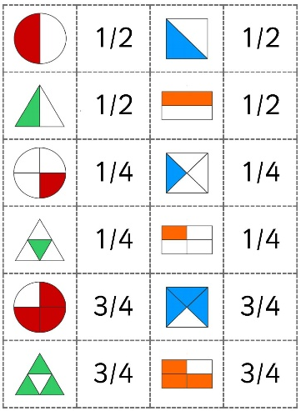
- The parts might make up one thing, or more than one thing.
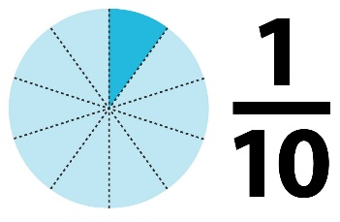

These pictures represent commonly used fractions in everyday life. Use this information to help you answer the following questions.

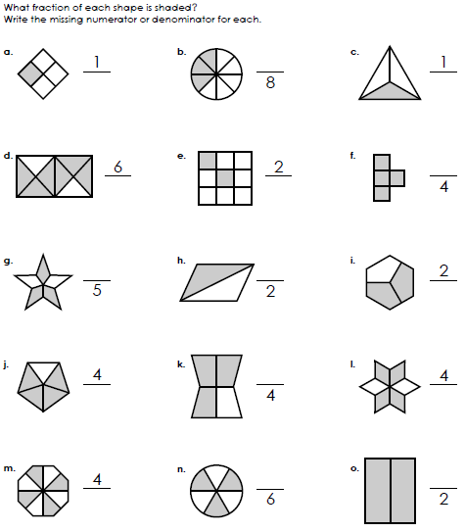

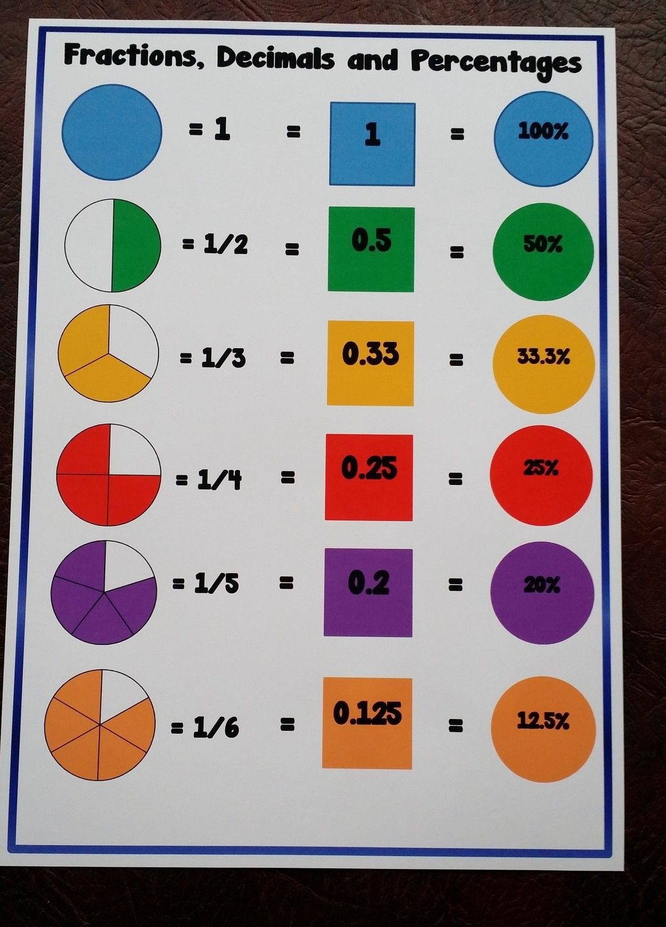
Fractions converted to Decimals
- In fractions, the numerator is the number above the line and the denominator is the number below.
- The line in a fraction that separates the numerator and the denominator represents division.
- To convert a fraction to a decimal, divide the numerator by the denominator.

Fraction | Percentage
1/10

2/10

3/10

4/10

5/10

6/10

7/10

8/10

9/10

10/10

Fraction | Percentage
¼

½
¾
4/4

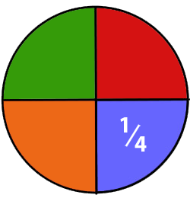

Equivalent Fractions
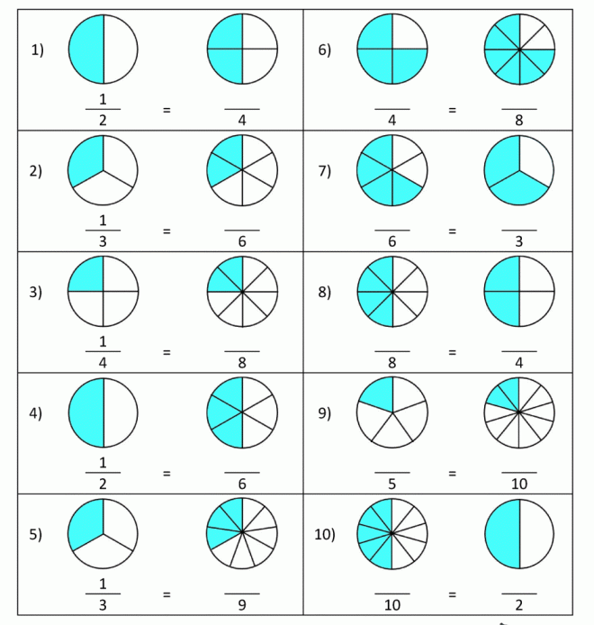
If two fractions are equivalent it means that they are equal, or represent the same amount. Use the diagrams to work out the equivalent fractions.

Converting Time
- To convert time to a number of hours, multiply the time by 24, which is the number of hours in a day.
- Add 12 to the first hour of the day and include “AM.” In 24-hour time, midnight is signified as 00:00.
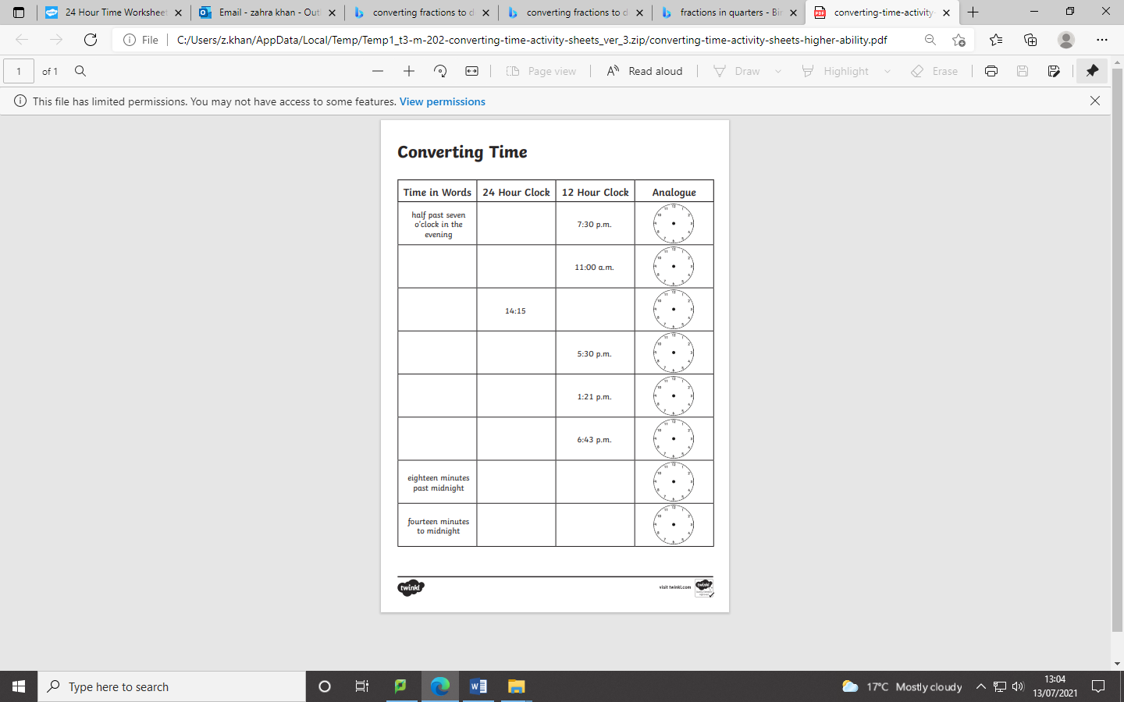
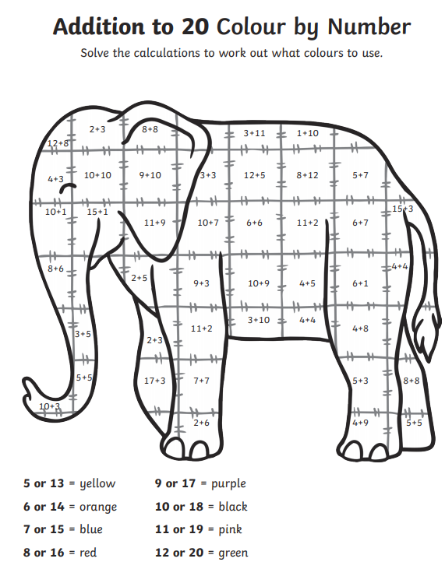
Addition
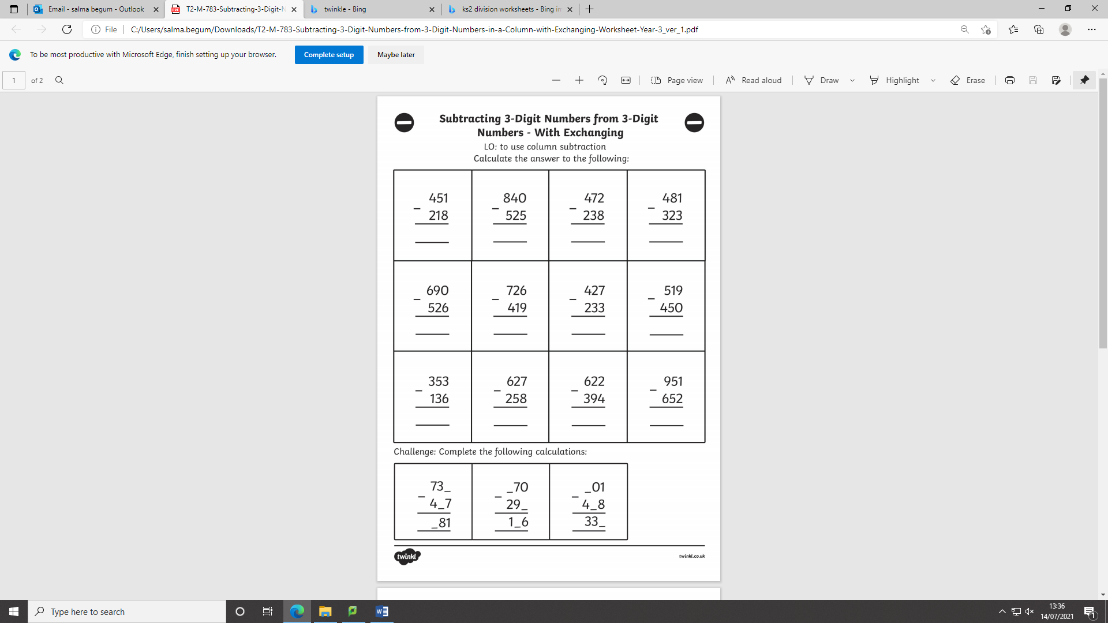
Subtraction
LITERACY
VERBS

A verb is a word used to describe an action, state, or occurrence. Complete the word search on verbs.
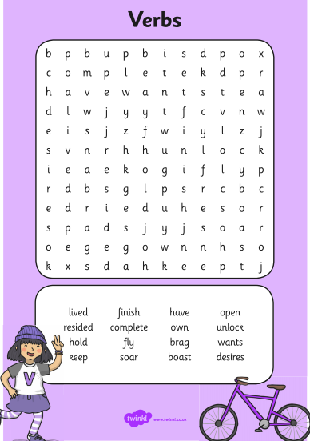
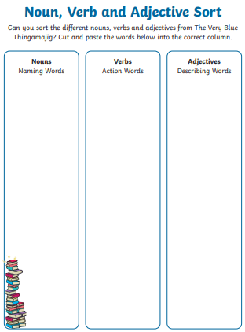
+

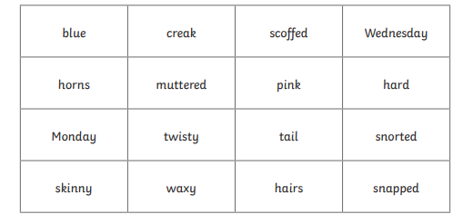
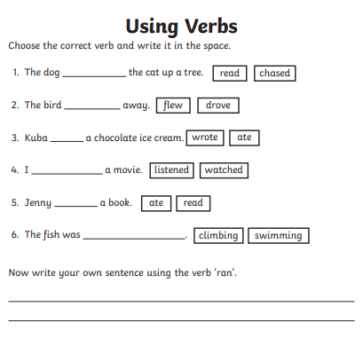

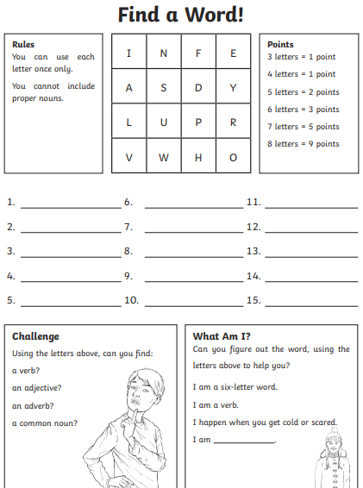
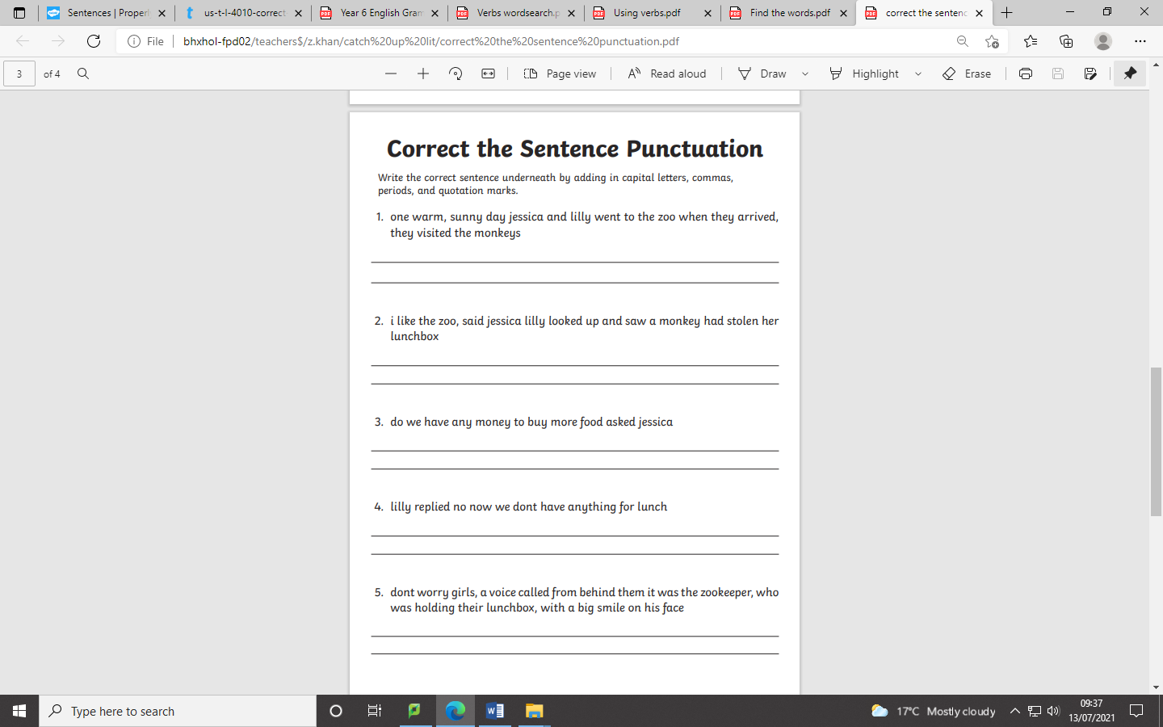
CORRECTING PUNCTUATION
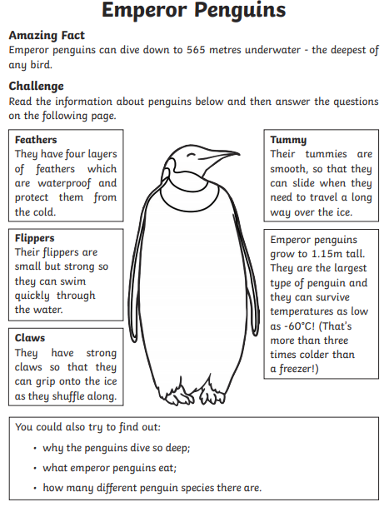
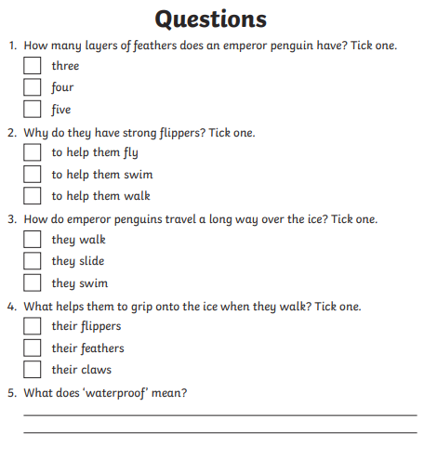
Read & answer the questions
Correct the Spelling Mistakes
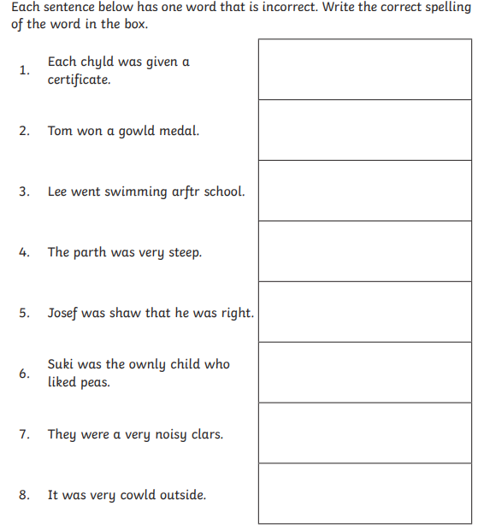
Correct the spelling Mistakes
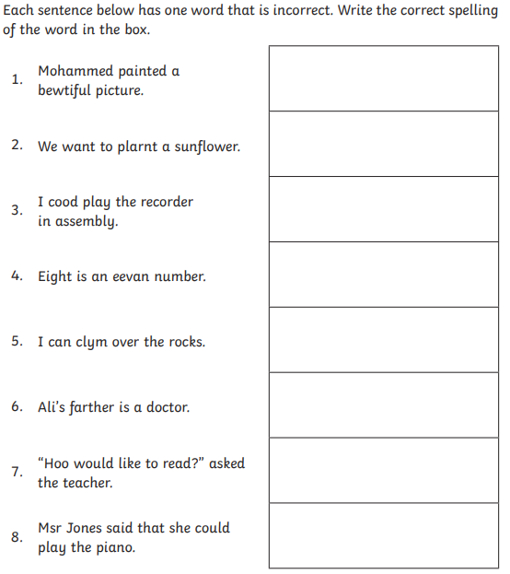
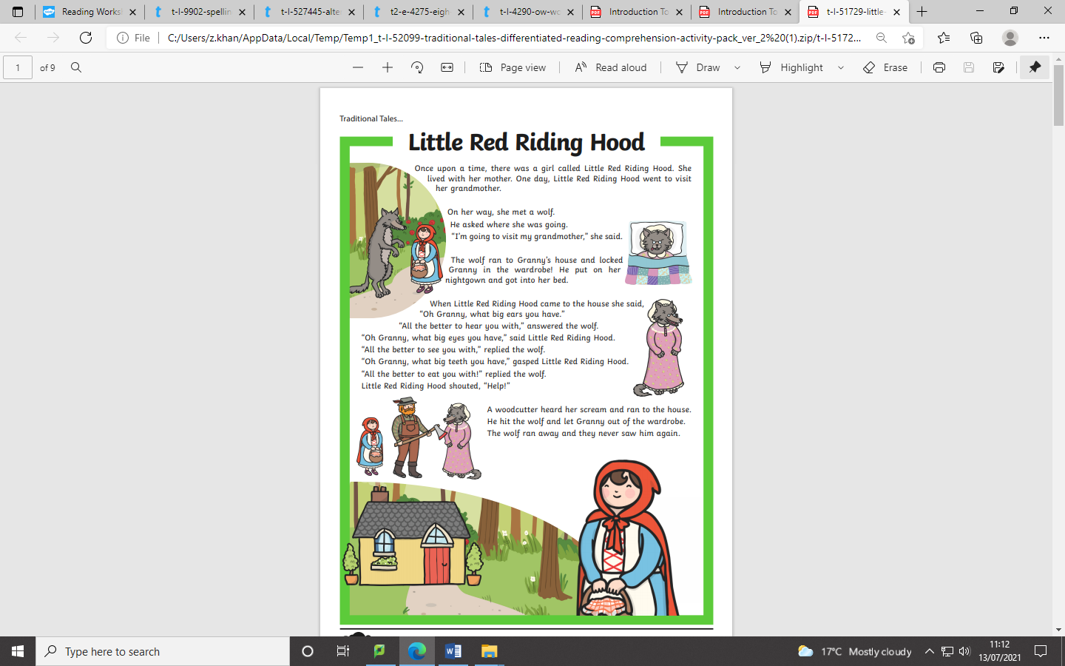
Reading Comprehension
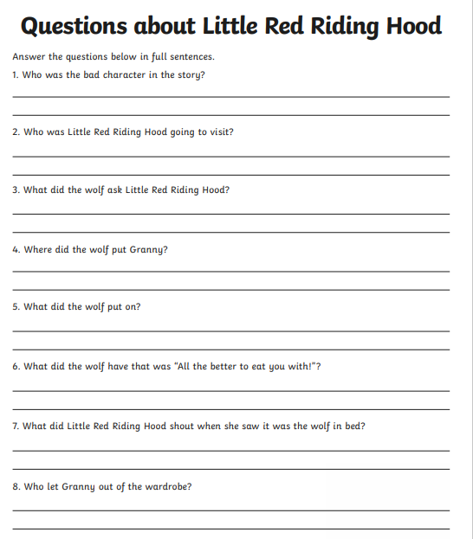
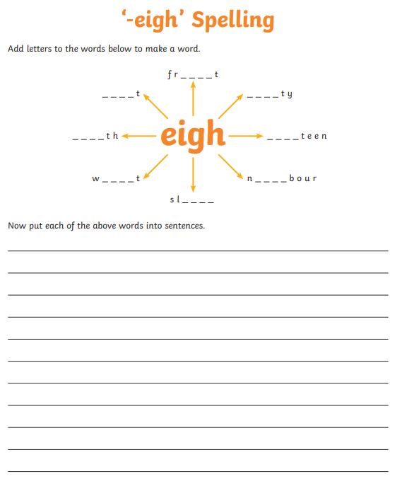
Spelling & Writing
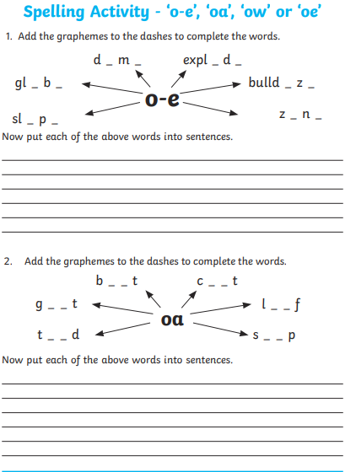
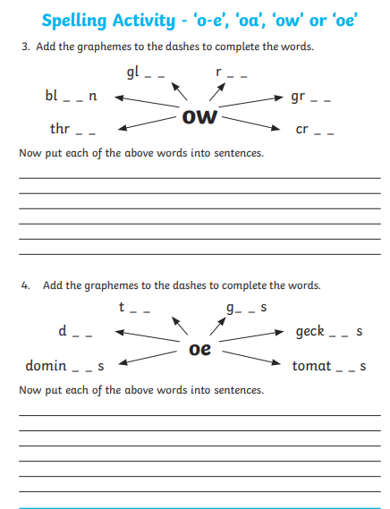
Handwriting
Read the following extract and copy it in you best handwriting on the next page.
