Provider Access Policy
Provider Access Policy – Wigston Academy and Wigston College

1. Introduction

This policy statement sets out the Wigston Academy and Wigston College's arrangements for managing the access of providers to the school and college for the purpose of giving them information about the provider's education or training offer. This policy fulfils the requirements of what was known as ‘The Baker Clause’.

This complies with the school's legal obligations under Section 42B of the Education Act 1997.

2. Student entitlement - Students in Years 8 to 13 are entitled to:
- ﻿﻿find out about technical education qualifications and apprenticeships opportunities, as part of a careers programme which provides information on the full range of education and training options available at each transition point;
- ﻿﻿hear from a range of local providers about the opportunities they offer, including technical education and apprenticeships - through options events, assemblies and group discussions and taster events;
- ﻿﻿understand how to make applications for the full range of academic and technical courses.

For students of compulsory school age these encounters are mandatory and there will be a minimum of two encounters for students during the 'first key phase' (year 8 to 9) and two encounters for students during the 'second key phase' (year 10 to 11). For students in the third key phase' (year 12 to 13), particularly those that have not yet decided on their next steps, there are two more provider encounters available during this period, which are optional for students to attend.

These provider encounters will be scheduled during the main school hours and the provider will be given a reasonable amount of time to, as a minimum:
- ﻿﻿share information about both the provider and the approved technical education qualification and apprenticeships that the provider offers;
- ﻿﻿explain what career routes those options could lead to
- provide insights into what it might be like to learn or train with that provider (including the opportunity to meet staff and students from the provider)
- answer questions from students.

3. Meaningful provider encounters

One encounter is defined as one meeting/session between students and one provider. We are committed to providing meaningful encounters to all students using the "Making it meaningful" checklist.
Meaningful online engagement is also an option, and we are open to providers that are able to provide live online engagement with our students.

Previous providers
In previous terms/years we have invited the following providers from the local area to speak to our students:
- North Warwickshire and South Leicestershire College
- Leicester College
- Apprenticeship providers (including ASK, WorkPays and LEBC)
- Brooksby Melton College

4. Destinations of Academy and College students in 2024

Year 11 students moved to range of providers in the local area after school:

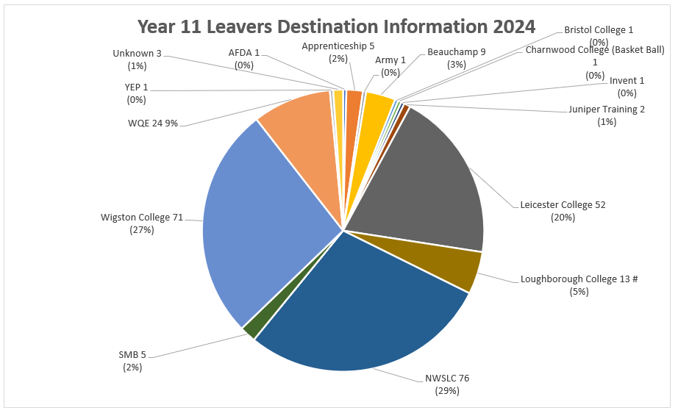

Year 13 students moved to range of providers, in the local area, as well as universities across the country.

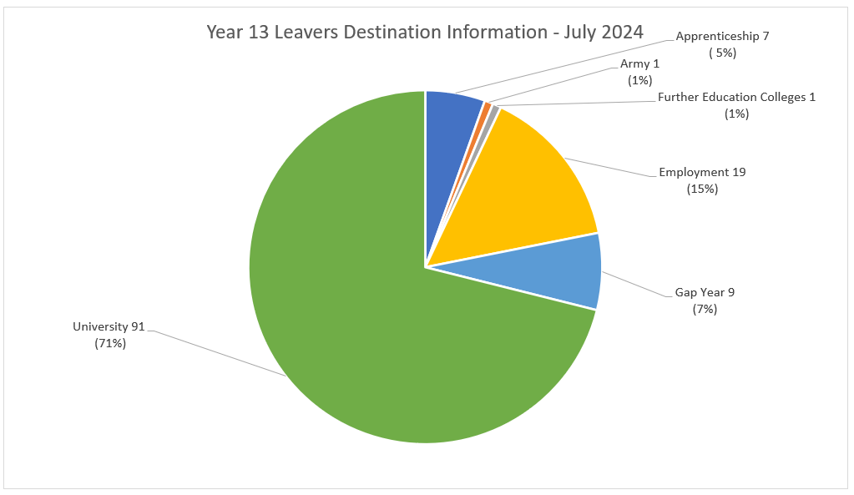

5. Management of provider access requests

A provider wishing to request access should contact Natasha Box, Careers Lead via email: Careers@wigstonmat.org

The is a wide range of opportunities for providers to engage with our students. Please speak to our Careers Leader to identify the most suitable opportunity for you. The school and college offer at least the six provider encounters required by law.

Year 8
- NWSLC – Spring term 2
Year 9
- Apprenticeships (LEBC) – Autumn Term 2
- Wigston College – Autumn Term 2
Year 10
- Apprenticeships (ASK) – Summer Term 1
Year 11
- Colleges of FE (NWSLC, LC, SMB) – Autumn Term
- Sixth form college (Wigston College) – Autumn Term
Year 12
- Apprenticeships (ASK) – Autumn Term 2
- Vocational opportunities post 18 NWSLC – Spring Term
Year 13
- LEBC apprenticeships – Spring term 1
- Leicester College – Spring term 1

There are a number of additional events integrated into the school careers programme including:
- Careers Fair – March 2025
- National Apprenticeship Week – February 202
- National Careers Week – March 2025

The school policies on Safeguarding and visitors sets out the school’s approach to allowing providers into school as visitors to talk to our students.

6. Premises and facilities
The Trust will make available an appropriate space for the activity. This could include an assembly hall, classroom or area to meet with targeted students. The Trust will also make available projectors and other specialist equipment to support provider presentations if available. The use of Microsoft Teams can also be arranged if required. This will all be discussed and agreed in advance of the visit with the Careers Lead or a relevant member of staff.

Providers are welcome to leave a copy of their prospectus or other relevant course
literature at the main reception or provide an electronic copy to be placed on the website.

Natasha Box
Careers Lead
October 2024

