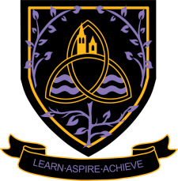
Sociology
A Level 2024 - 2026
Wigston College

Examination Board
AQA
Entry Requirements:
GCSE Grade 5 in Sociology. If you have not studied this subject at GCSE level you will need GCSE Grade 5 in English Language or English Literature.
What will I be studying?
Paper 1 – Education with Methods in Context
In this unit, students will discover the role of education within our society including differences in attainment of social groups by social class, gender and ethnicity. Students will also consider the functions of the education system as well as relationships and processes within schools.
Paper 2 – Topics in Sociology (Family and Households, Media)
In Families and Households, students will explore the changing nature of the family, such as marriage, divorce and childhood. In the Media topic, students will consider the role that the mass media play in today’s society. We will explore the positive and negative aspects of the mass media, including new media, such as networking, and issues of consumer choice and control.
Paper 3 - Crime and Deviance with Theory and Methods
In this Crime and Deviance, students consider who really commits crime by looking at recent patterns and trends in relation to ethnicity, gender and social class. In Theory and Methods, students will discuss the use of different research methods sociologists use to investigate social phenomena.
How will I be studying?
You will be taught using a variety of methods including group work, individual work, written projects, independent research and independent learning.
Trips will take place where there are sufficient numbers
How will I be assessed?
Paper 1 – Education with Methods in Context: 2 hour written examination.
Paper 2 – Topics in Sociology: Culture and Identity, Media, 2 hour written examination.
Paper 3 - Crime and Deviance with Theory and Methods: 2 hour written examination.
Where Next?
This specification provides a suitable foundation for the study of sociology or a related area through a range of higher education courses, progression to the next level of vocational qualifications or employment. Students studying sociology can move successfully on to courses in psychology, sociology, criminology, law and police studies, social work, teaching and human resources and many others. These can be studied via the usual apprenticeship or university route.

