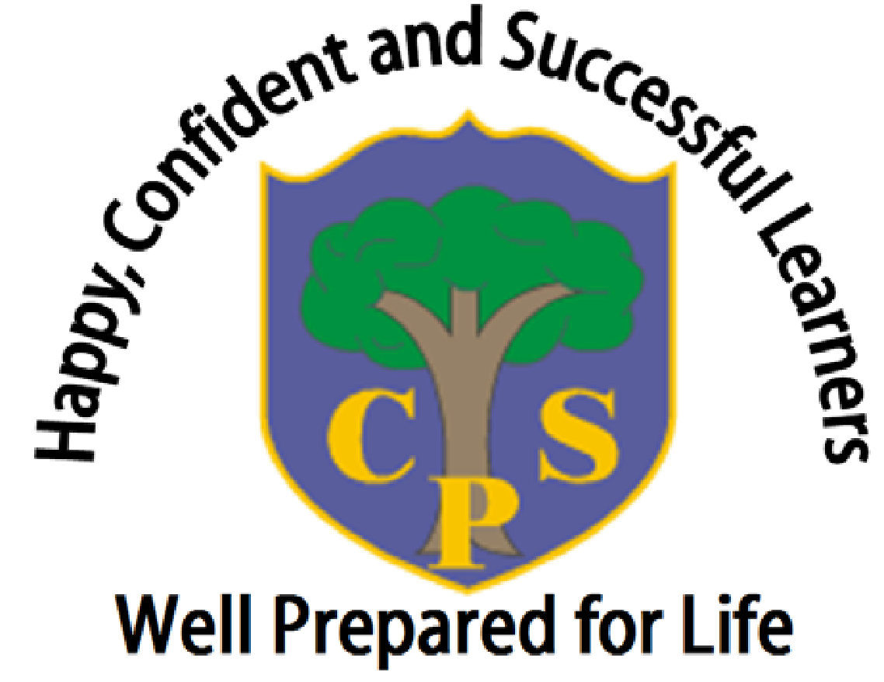

The Coppice Primary School

Science Policy
‘Science teaches an understanding of natural phenomena. It aims to stimulate a child’s curiosity in finding out why things happen in the way they do.’

Written by | Lauren Cox & Kirsty Dixon
Approved by Trustees | April 2025
Date for Review | April 2026

1 School Vision:

‘Happy, confident and successful learners that are well prepared for life’

2 Purpose:

2.1 This policy reflects the school values and philosophy in relation to the teaching and learning of science at The Coppice Primary School. It sets out a framework within which teaching and non-teaching staff can operate and sets out the school expectations of planning, teaching and assessment. The policy should be read in conjunction with each year group’s curriculum planning.

2.2 This document is intended for:

- All teaching and school management staff.
- All Teaching Assistants and pupil support staff.
- School Trustees.
- Parents.
- Inspection teams.

3.Introduction: Science Vision:

At The Coppice Primary School Science is a time for children to explore their curiosity while developing their leadership, higher order and thinking skills. Children are taught the scientific knowledge and then have the opportunity to undertake practical experiments to investigate questions they pose while becoming enthused. They predict and then explore questions on a number of topics. In addition, they build skills around scientific enquiry and learn about life processes and living things, materials and their properties and physical processes. Children are confident in doing Science by demonstrating a willingness to ask questions, modify ideas and take risks. They seek to collaborate and work cooperatively with their peers. Science is part of the wider curriculum and links are made where they naturally fit.
4. Aims and objectives:

4.1This policy aims to:

Provide clear guidelines for all stakeholders on our approach to teaching and learning in science across the school and how our Phiz Lab is used within the science curriculum and for wider enrichment opportunities for our children.
  - Principles of effective Science learning at The Coppice:

-Science knowledge is clearly planned and taught to a direct sequence of learning steps.
Science knowledge is always taught and embedded before it is used in enquiry level work.
Children can ask and answer scientific questions effectively.
-Pupils are taught to plan and carry out scientific investigations, using equipment safely and correctly.
-Children know and understand the life processes of living things.
-Children know and understand the physical processes of materials, electricity, light, sound and natural forces.
-Children know about the nature of the solar system, including the earth.
-Children can evaluate evidence and present their conclusions clearly and accurately.
-We create an ethos of exciting and fun lessons that are regularly taught in our dedicated science lab (The Phiz Lab).
-Take into account the differing needs of individual children. (See also SEND policy, Curriculum and Equal Opportunities policy).

5. Teaching and Learning Style:

5.1 We use a variety of teaching and learning styles in science lessons. Our principal aim is to develop children’s knowledge followed by skills, and understanding of the five different scientific enquiry types (observing over time; fair testing; secondary sources; identify, classify and group and pattern seeking). Sometimes we do this through whole-class teaching, while at other times we engage the children in an enquiry-based research activity. We encourage the children to ask, as well as answer, scientific questions. They have the opportunity to use a variety of data, such as statistics, graphs, pictures, and photographs. They use ICT in science lessons where it enhances their learning. They take part in role-play and discussions and they present reports to the rest of the class. They engage in a wide variety of problem-solving activities. Children are taught about influential scientists from a range of eras, genders and ethic groups throughout the planned curriculum.

5.2 Each science lesson is taught using a set structure.
- Introduction to the lesson focus including the science discipline - KS2 (Chemistry / Biology / Physics).
- Lesson objectives (directly lifted from Science Curriculum Plan).
- Recall quiz / questions - last lesson / last term / last year.
- Reference to the current knowledge organiser and how it links to the lesson.
- Key lesson vocabulary (with picture cue for KS1).
- Main lesson teaching / activities to teach the knowledge.
- Summary slide to recap main focus of each lesson.
- Addressing misconceptions / feedback for future learning.

5.3 We have a fully resourced science lab in our school, The Phiz Lab. It is the expectation that this is regularly used by all children. It must be used for teaching science for Year 2-6 especially for enquiry and investigative science. The wealth of resources ensure learning is not ‘capped’ and children have the opportunity to use resources that extend their enquiry, thinking and investigative skills. Each class must be taught an investigation skill each term and this must be recorded as evidence in the children’s books. In EYFS there is scientific equipment to support the continuous provision in the environment.
5.4 Oracy skills should be used in all science lessons where children are given the opportunity to express their thoughts and ideas fluently through speech.. Oracy is important in the scientific classroom, as it gives pupils the chance to explore and verbalise their ideas and to develop their thinking. It also gives teachers the chance to assess what pupils know and understand as assessment for learning where they can identify children who may need more support or address misconceptions.

6.Inclusion and Adaptive Teaching:

We recognise that there are children of widely different scientific abilities in all classes and we ensure that we provide suitable learning opportunities for all children. We achieve this in a variety of ways by:

-setting common tasks which are scaffolded, where necessary, so all children have an equal opportunity to achieve.
-providing resources of different complexity, matched to the ability of the child; specifically through questioning and levels of modelled support.
-using teaching assistants to support the work of individual children or groups of children.
- STEM sentences used within whole class teaching.
- Lesson delivery and tasks are chunked to support working memory.
- Using Communication in Print / widget software to overcome reading boundaries.
- Recognising the more able and gifted and talented scientists in our school.

7. Teaching time:

Science is taught weekly as pure science lessons Over the year science is taught for one and a half hours per week for KS1 (equivalent to 54 hours per year). For KS2 pupils 2 hours per week (equivalent to 72 hours per year).

8.0 Science Planning:

8.1 The school uses the 2014 National Curriculum for science as the basis of its curriculum planning. The National Curriculum has been adapted to the local circumstances of the school in that we make use of the local environment in our fieldwork and we choose a locality where the physical environment differs from that which predominates in our immediate surroundings.

8.2 All teachers plan directly from our Science curriculum document that clearly states new / previous and future learning in a sequence of lessons. It states the vocabulary that must be explicitly taught during the lesson.

8.3 We have planned the topics in science so that they build upon prior learning, developing and embedding key concepts. We ensure that there are opportunities for children of all abilities to develop their skills and knowledge in each unit and we also build progression into the science scheme of work, so that the children are increasingly challenged as they move up through the school.

8.4 Each academic year every class holds a science day. This is held in the Spring Term to compliment National Science Week. The planning for this week is to use science concepts to drive all areas of the curriculum for that day while giving opportunity for enrichment, visitors and events to raise the profile of science in our school.

8.5 The Early Years Foundation Stage:

We teach Knowledge and Understanding, The World, in Reception and Nursery classes as an integral part of the topic work covered during the year. As the reception class is part of the Early Years Foundation Stage (EYFS), we relate the scientific aspects of the children’s work to the objectives set out in the Early Years Outcomes which underpin the curriculum planning for children aged three to five. Science makes a significant contribution to the objective in the Foundation Stage Profile (FSP) of developing a child’s knowledge and understanding of the world, e.g. through investigating what floats and what sinks when placed in water. Much of the science taught is during Forest Ranger sessions and science lessons (in Reception). Nursery and Reception children both have the opportunity to use science play based learning areas that give the children opportunity to explore and investigate.

9. Assessment and recording:

9.1 We assess children’s work in science in a number of ways. One of these is by making informal judgements as we observe them during lessons and while taking part in group activities or experiments. Also on completion of a piece of work, the teacher marks the work and comments as necessary. This work is then assessed against the National Curriculum programmes of study statements for that unit. All assessment tasks are recorded on green paper in the child’s science books. At the end of each taught unit of science, teachers assess children using the objectives on the school’s computerised tracking system, Insight Tracker. At the end of each term: autumn, spring, summer the teacher judges the overall level of each pupil as a ‘best fit’ on Insight Tracker.

9.2 Science achievement and attainment are reported to parents at the end of each year via reports.

10. Resources:

We have a wide range of resources for all science teaching units in the school. This is continually reviewed and built on to provide the best possible scientific environment for our children. We keep these in a central store (Phiz Lab) where there is equipment for each unit of work, plus other materials available to help deliver the curriculum. A flavour of the resources we have include digital and desk top microscopes, large scale models, a wide range of scientific equipment such as beakers, conical flask, pipettes, digital stop watches, torches, Ogden Trust resource boxes ( for all physics based topics) and resource books and a science library.

11.Display:

It is everyone’s responsibility (managed by the science leaders) to ensure science display is current and displayed around the whole school to reflect the importance of science in our school. The Phiz Lab has four display boards and science should also be evident in classrooms. The expectation is that science is displayed so it reflects our good practise and high standards.
It will have a scientific theme, reflecting that science is a subject that children enjoy and is hands on and fun with an investigative approach.

12. Monitoring and review:

It is the responsibility of the science subject leaders to monitor the standards of children’s work and the quality of teaching in science. The science subject leaders is also responsible for supporting colleagues in the teaching of science, for being informed about current developments in the subject and for providing a strategic lead and direction for the subject in the school. The science subject leaders gives the headteacher and Trustees an annual development plan that is BRAG rated termly to monitor progress towards the aims and objectives for that academic year. Reviews are in collaboration with the science trustee who has a termly overview of science across the school.

13. GDPR (see GDPR Policy):

Data Protection Statement:
The procedures and practice created by this policy have been reviewed in the light of our GDPR Data Protection Policy. All data will be handled in accordance with the school’s GDPR Data Protection Policy.

Name of policy | Content | Reason for policy | Who does it relate to? | Where is it stored?
Science | Key information concerning the use of and procedures for assessment in school | To inform all stakeholders on how assessment is used in school | Children, Teachers, Parents, Trustees and Ofsted. | On the school’s central system – the ‘P’ Drive.

As such, our science is that this policy :

Has Few / No Data Compliance Requirements | Has A Moderate Level of Data Compliance Requirements | Has a High Level Of Data Compliance Requirements
X

-This policy has been compiled by: Lauren Cox and Kirsty Dixon (Science Subject Leaders)

-To be reviewed: ?

