Dear Parents and Carers,
Below you will find information to support the use of ParentPay. After returning from half-term, the lunch selections for everyday must be made through ParentPay. The previous procedure of the children selecting their lunch during registration will be replaced by the electronic system. Continuing, cash payments will not be possible and therefore money must be uploaded onto ParentPay and the relevant selections made for your child to receive lunch. Regarding children receiving free school meals, selections must still be made on ParentPay, however no monetary transactions will take place because ParentPay acknowledges every child registered to receive free school lunches. Regardless of whether you pay for lunch or are free school meals, every child must make selections on ParentPay to receive lunch.
The deadline for submitting selections will be 9.00am the morning of the lunch and likewise to cancel any meals selected you can either remove the selections (information provided below) or contact the ABM Catering Manager: Lisa before 9.00am, either by telephone on 01564 826709 or email pp.coppiceschool@abm.co.uk. Below, I have provided step-by-step instructions to activate the account, add money onto the account and book meals through the make selections tab.

a) Access ParentPay
1. Google ParentPay > 2. Enter Website > 3. Click Login > 4. Enter Username and Password
(Login information is obtained from the Office at the school for first-time users)
5. Enter Information to Activate > 6. Enter Security Information (Optional)
(To Activate, leave ParentPay and visit personal email to Activate)
After, revisit ParentPay and login > 7. Homepage
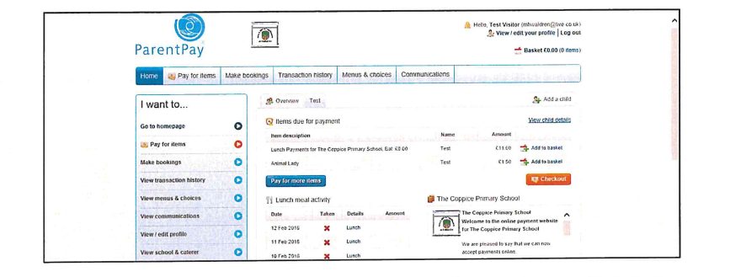

Once activated, there are several ways you could make selections and add money to the account.
The next section explains the procedure for adding money to the account:
b) Add Money
l . Click Basket > 2. Click Pay for Items
- See Lunch Payments for The Coppice Primary School
- Click Edit Amount or Add Notes > 5. Enter Amount and Click Add to Basket
- Click Checkout > 7. Click Pay Securely Now > 8. Enter Payment Information to Conclude

After adding money, you will need to make bookings. You are able to add any amount of money at any time, however the amount added must be at least £11.00.

Below, is provided information on to make bookings:
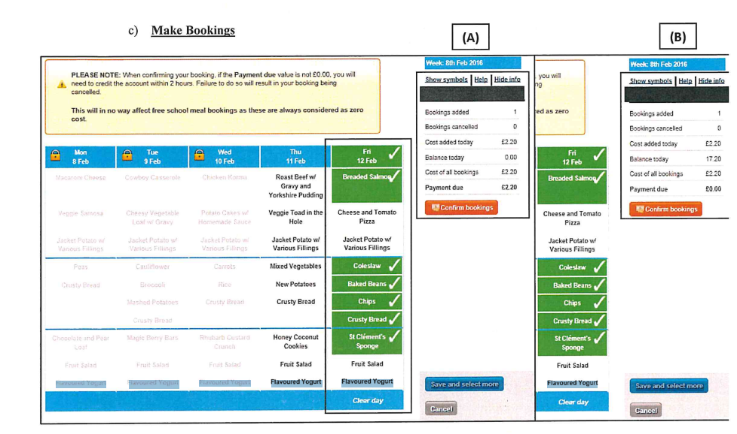

If the account already contains money, no payment will be taken (B) and continuing no money will leave the account until the following day after the meal has been taken. Instructions are provided below:
l . Click Make Booking > 2. Select Name, Booking Type (Lunch-time) and Week Commencing
3. Click Make Selections > 4. Select the Meals > 5. Click Confirm Booking
If you do not have money on the account after you have made selections, payment will be required (A).
Again, I will stress the minimum payment amount is £11.00 therefore although the Payment Due in the example is ±£2.20, the basket will read £11.00. Therefore, if your child will likely only require one lunch per week, we suggest you either book five weeks ahead, or you add any amount of money and then book the meal weekly before the 9.00am deadline. Also, if your children are free school meals, Reception to Year 2 or otherwise, you should not be charged. If for any reason you are asked to Pay Securely Now after you have made selections, please contact the school office. We stress that children on free school meals do not have to pay but you must make selections to receive lunch.
To make bookings and pay thereafter, follow the instructions below.
l. Click Make Booking > 2. Select Name, Booking Type (Lunch-time) and Week Commencing
3. Click Make Selections > 4. Select the Meals > 5. Click Confirm Booking
If your children receive free school meals, the booking process will conclude after Confirm Booking, however if you are paying, please follow the instructions below:
6. Click Pay Securely Now > 7. Enter Payment Information to Conclude
To make the selections you must select one meal, unlimited sides and one dessert.

The Next and Previous tabs provided above to booking screen allow you to book several weeks ahead. If you want to cancel any meals selected, simply use the Make Booking tab, select the week and simply click Clear Day to cancel the selections and click Confirm Bookings to conclude. If you wish to cancel the meal after the deadline, please contact the school office on the information above.
Hopefully the information provided above will support the use of ParentPay.

